SUPPLEMENTARY FIGURES AND TABLES
Table S1 – Collection locations and resequencing statistics for Coregonus artedi (CA), C. hoyi (CH), C. kiyi (CK), and C. nigripinnis (CN) samples. Resequencing statistics for each individual include total number of reads, average sequencing depth, breadth of the reference genome covered, the percentage of reads that aligned to the reference, and the percent of paired end reads that are correctly oriented to one another.
Sample | latitude | longitude | read count | average depth | breadth of coverage% | alignment% | proper pair%
CA01 | 46.80628 | -90.78238 | 216,228,232 | 14.51 | 84.03 | 95.78 | 87.51
CA02 | 46.95411 | -90.47148 | 195,120,830 | 13.26 | 84.23 | 95.39 | 86.32
CA03 | 46.95411 | -90.47148 | 215,793,796 | 14.47 | 84.00 | 96.02 | 88.19
CA04 | 46.95411 | -90.47148 | 193,652,272 | 13.02 | 83.76 | 95.62 | 87.67
CH01 | 46.89205 | -90.53256 | 198,414,328 | 13.26 | 84.00 | 95.86 | 86.88
CH02 | 46.88541 | -91.21529 | 192,030,676 | 12.84 | 83.78 | 95.57 | 87.29
CH03 | 46.88541 | -91.21529 | 195,800,072 | 13.21 | 83.77 | 95.53 | 87.41
CH04 | 46.88541 | -91.21529 | 210,419,234 | 14.06 | 83.96 | 96.83 | 88.28
CK01 | 46.89205 | -90.53256 | 193,206,744 | 12.96 | 83.86 | 96.23 | 87.37
CK02 | 47.49668 | -89.99913 | 195,395,138 | 13.20 | 83.79 | 95.9 | 87.71
CK03 | 47.15712 | -89.96871 | 201,485,816 | 13.50 | 83.93 | 95.59 | 86.89
CK04 | 47.41659 | -88.46418 | 191,827,972 | 12.98 | 83.75 | 95.49 | 87.6
CN01 | 49.67605 | -88.26014 | 255,236,148 | 16.56 | 84.12 | 96.82 | 87.56
CN02 | 49.67605 | -88.26014 | 209,838,086 | 13.91 | 83.84 | 96.23 | 87.33

Table S2 – Strain identification and sequencing statistics for Salvelinus namaycush samples. Resequencing statistics for each individual include total number of reads, average sequencing depth, breadth of the reference genome covered, the percentage of reads that aligned to the reference, and the percent of paired end reads that are correctly oriented to one another.
sample | strain | read count | average depth | breadth of coverage% | alignment% | proper pair%
LS01 | lean | 248,817,553 | 20.45 | 97.68 | 97.19 | 92.77
LS02 | lean | 215,033,259 | 17.51 | 97.58 | 97.10 | 92.79
LS05 | siscowet | 212,805,221 | 17.12 | 97.53 | 97.22 | 92.81
LS07 | lean | 197,718,905 | 16.30 | 97.58 | 97.07 | 92.68
LS08 | siscowet | 206,829,006 | 16.78 | 97.41 | 97.32 | 92.98
LS09 | siscowet | 209,119,345 | 16.96 | 97.22 | 97.39 | 93.97

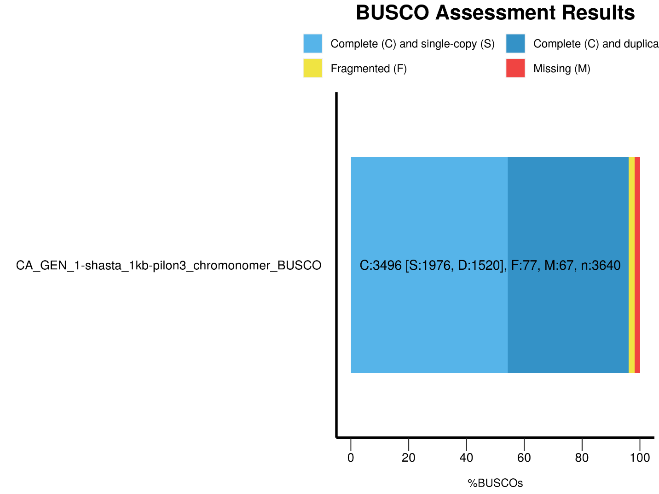
Figure S1 – Coregonus artedi genome assembly BUSCO completeness following polishing with Pilon and scaffolding with Chromonomer.

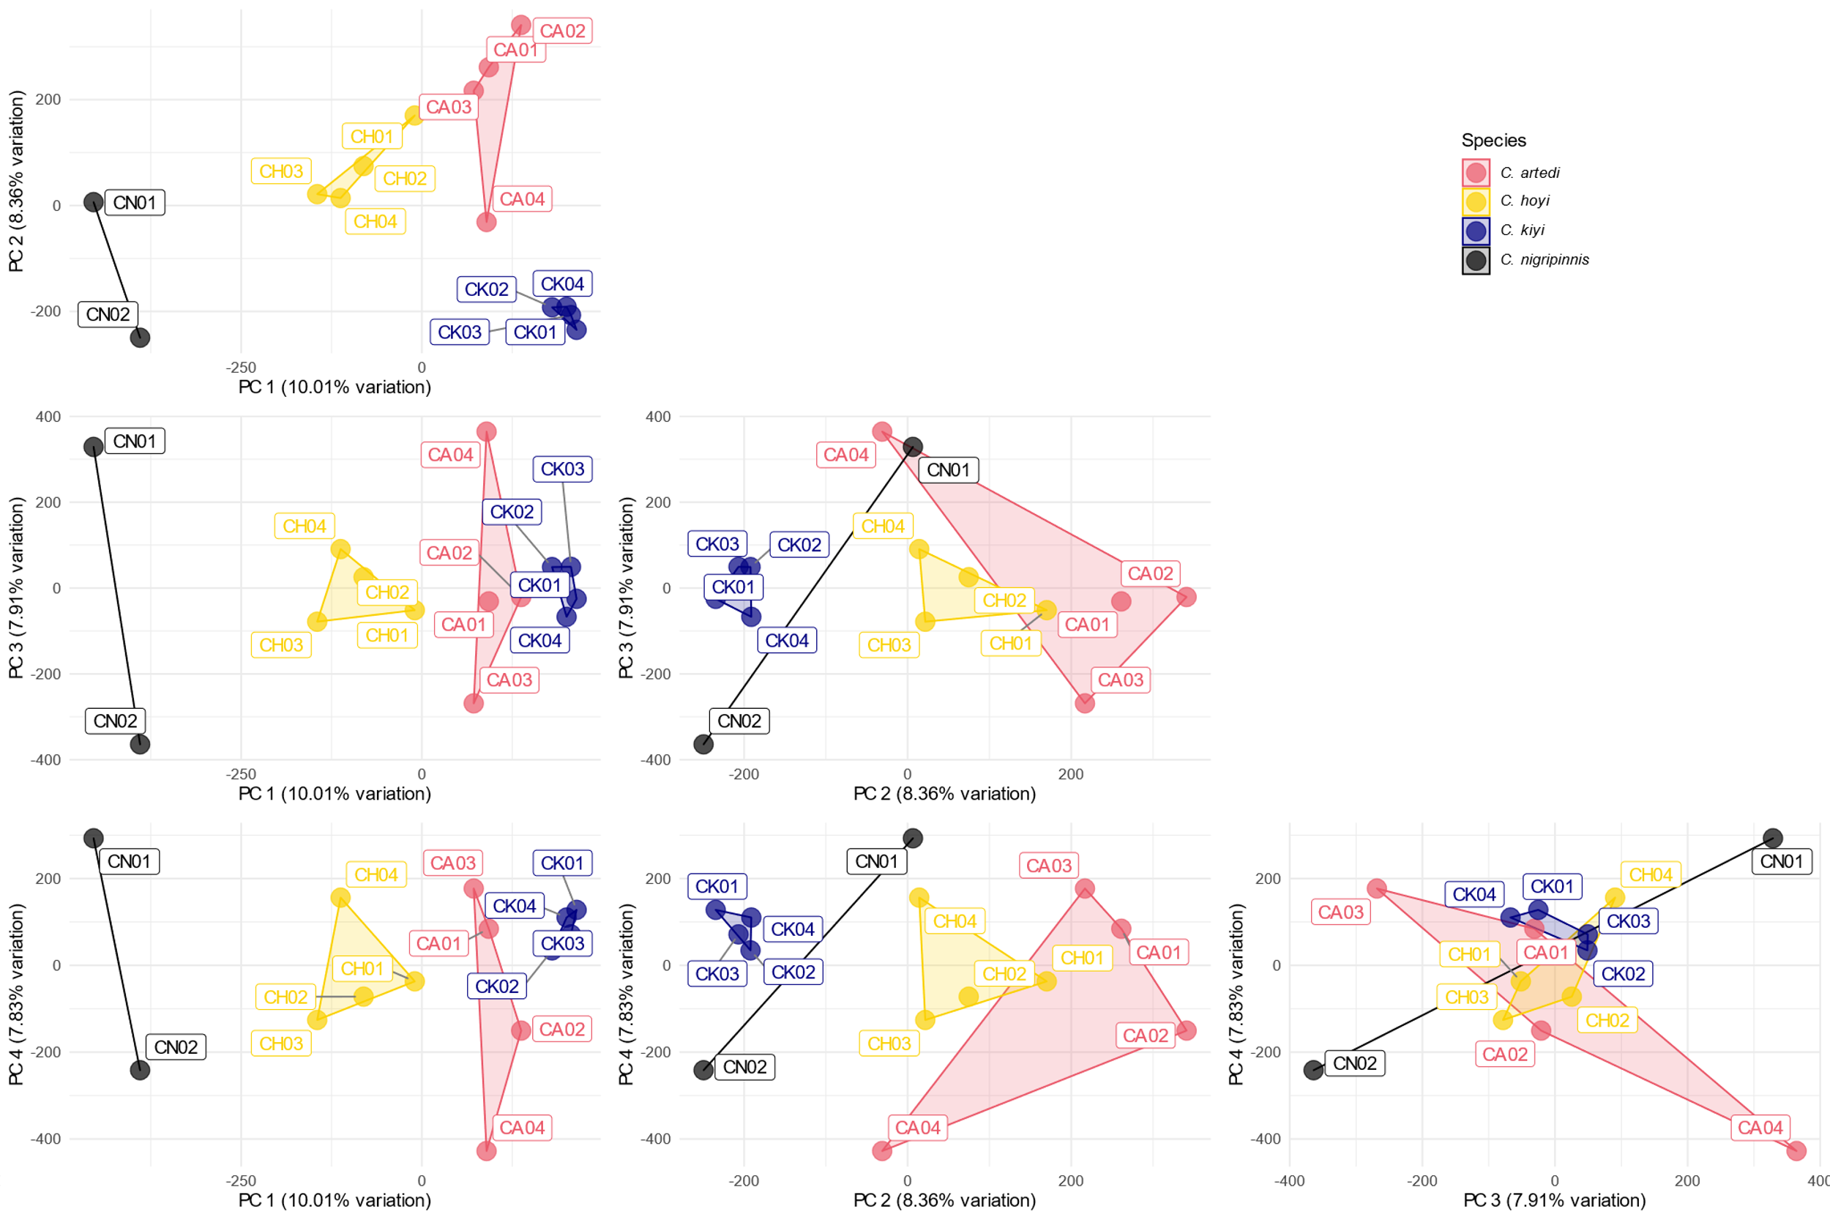
Figure S2 – Principal component analysis plots of 4,090,641 bi-allelic SNPs from C. artedi, C. hoyi, C. kiyi, and C. nigripinnis.

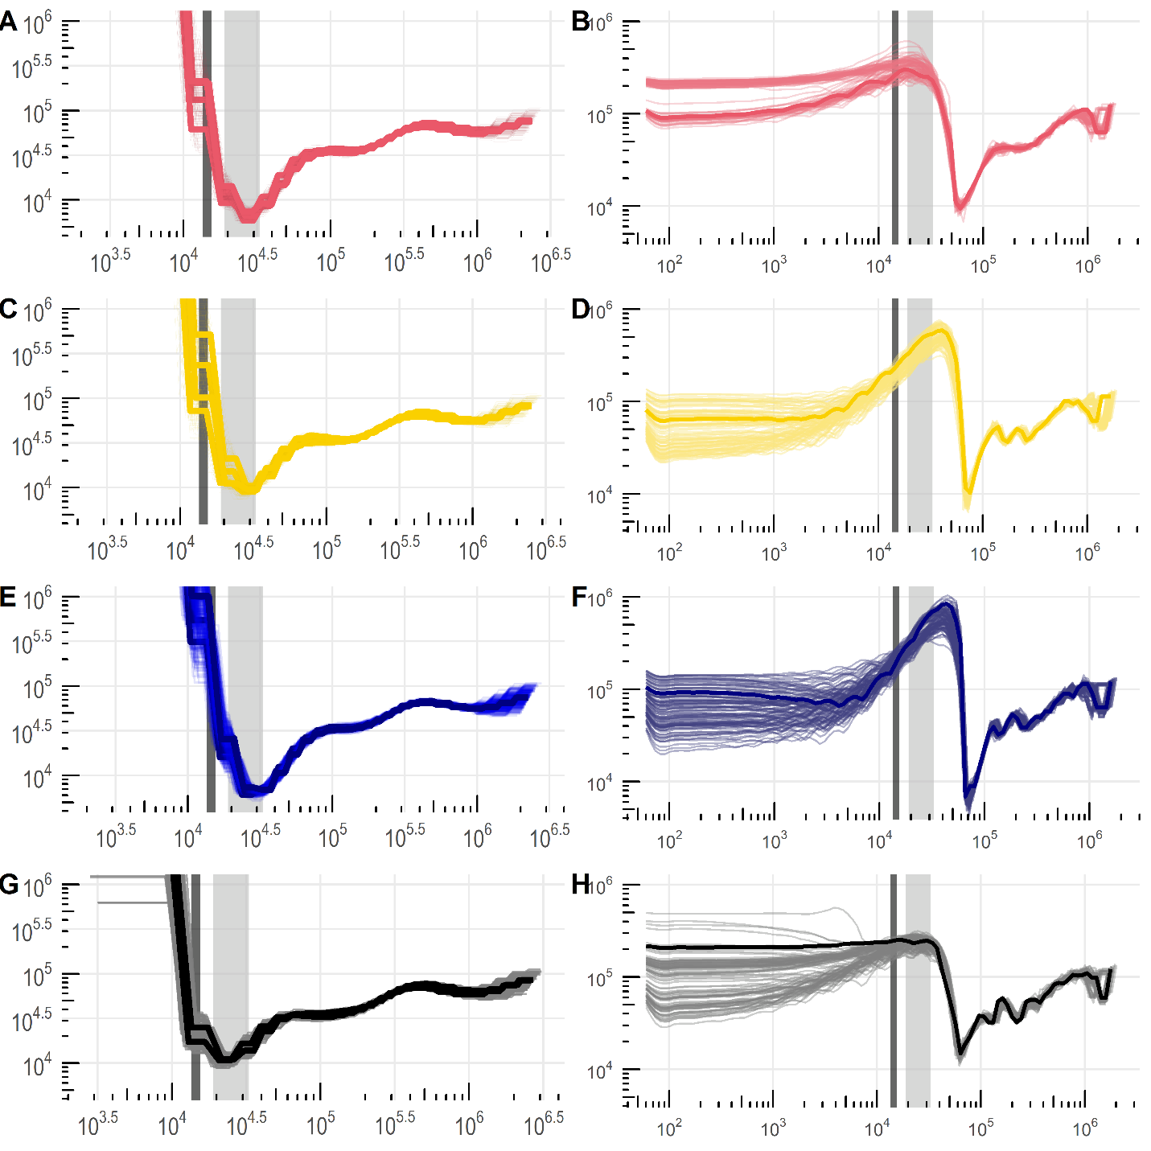
Figure S3 – Inferred trajectories of effective population size through time using PSMC (left column) and SMC++(right column) for Coregonus artedi (a,b), C. hoyi (c,d), C. kiyi (e,f), C. nigripinnis (g,h). The light grey bar represents the time point of the last glacial maximum (19-33 ka) with the dark grey bar representing the time point when the Laurentide ice sheet was no longer covering the present borders of the Great Lakes (10.3 ka).

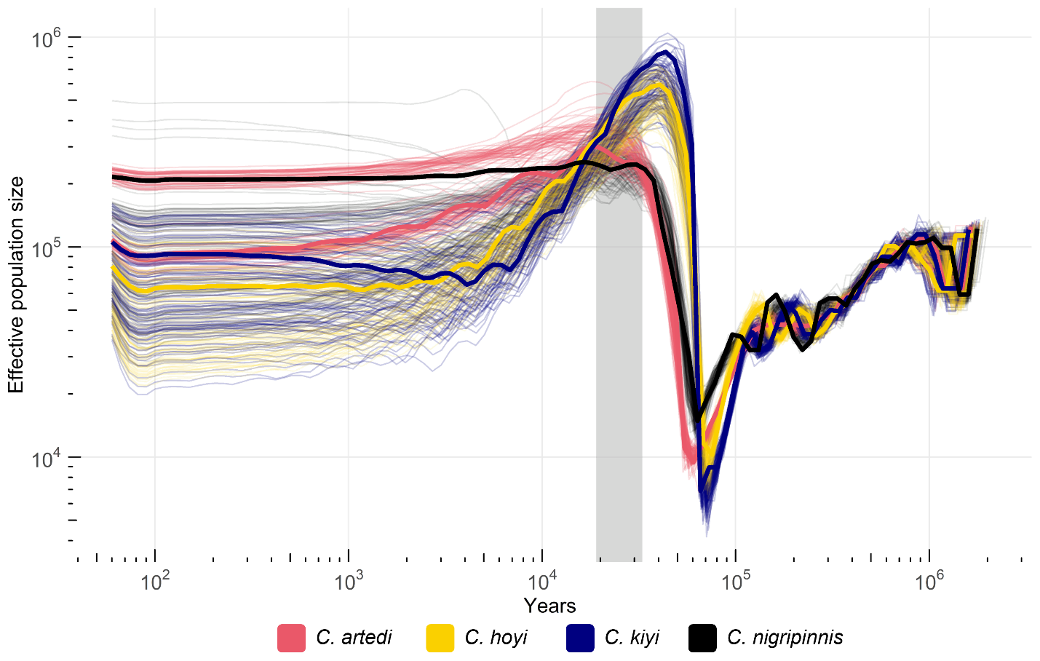
Figure S4 – Estimated SMC++ effective population size trajectories through time for four species of Coregonus (C. artedi, C. hoyi, C. kiyi, C. nigripinnis). Estimates of variation for each sample were estimated by running SMC++ with 100 bootstrap replicates from a 5 mb window of the genome. The generation time for all samples was set to six years and the mutation rate (µ) to 7.26e⁻⁰⁹ mutations per site per generation. The light grey bar indicates the time range of the last glacial maximum (19-33 ka).

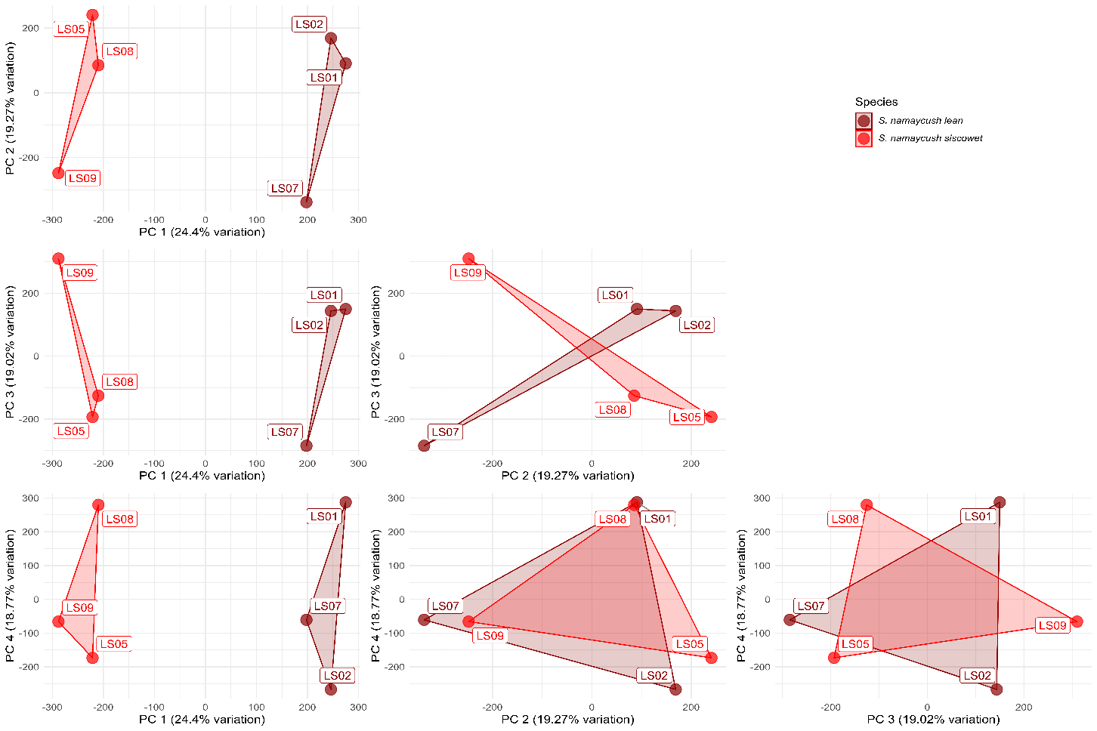
Figure S5 – Principal component analysis plots of 3,534,068 bi-allelic SNPs from S. namaycush lean and siscowet.

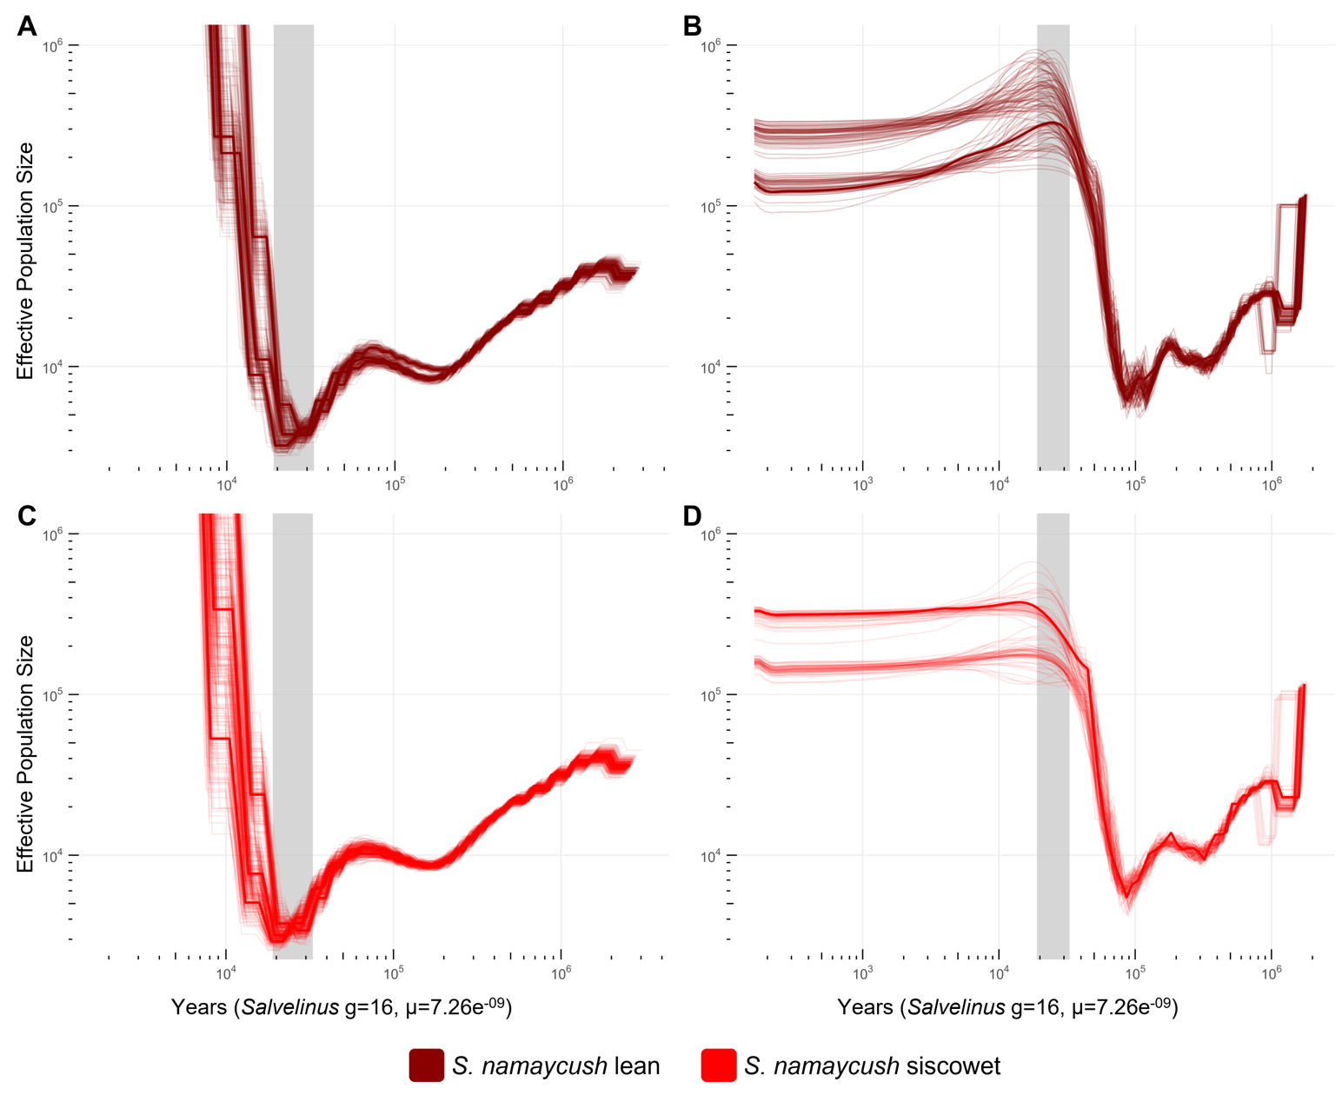
Figure S6 – Estimated effective population sizes of Salvelinus namaycush lean (a,b) and siscowet (c,d) strain samples with 100 bootstrap replicates for each sample produced by PSMC (a,c) and SMC++ (b,d). The light grey bar represents the time range of the last glacial maximum (19-33 ka).

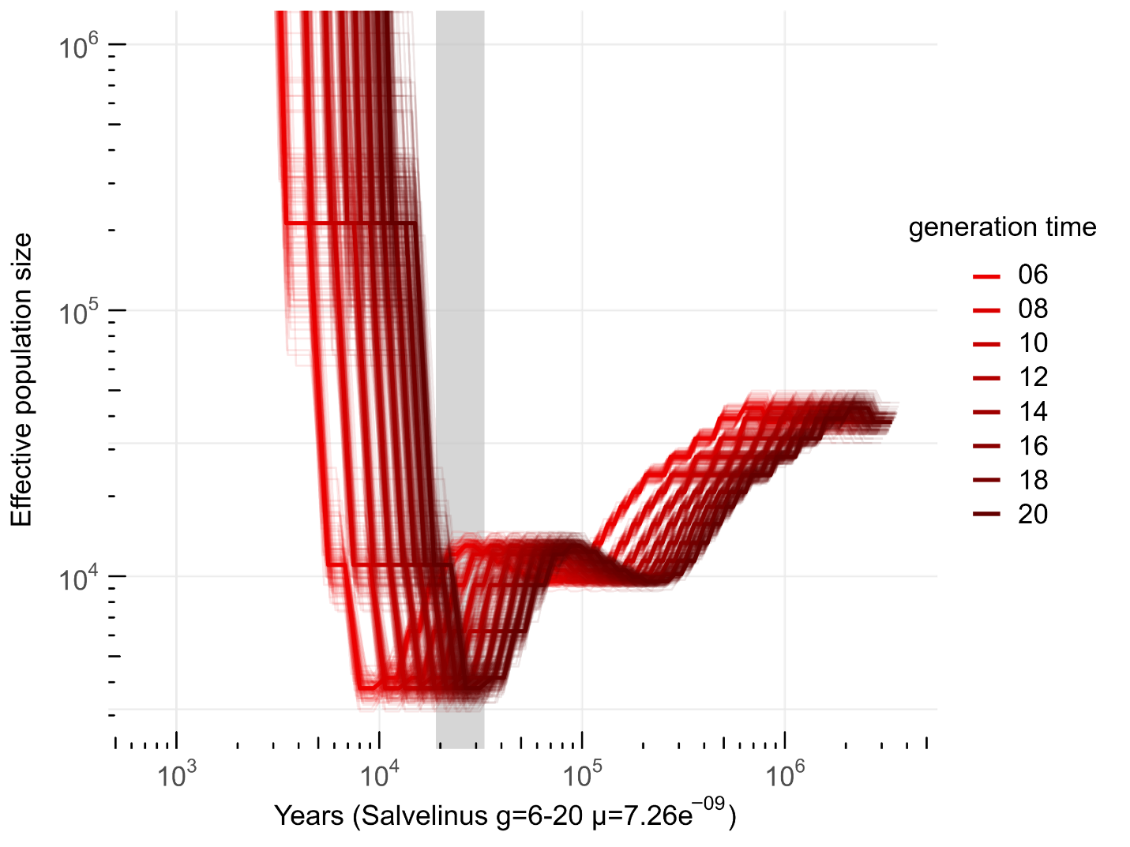Figure S7 – Estimated effective population size through time for one individual of the S. namaycush lean strain (LS01) from PSMC. Each set of lines indicates bootstrap replicates plotted with different generation times ranging from six to twenty years. Mutation rate parameters were set at a constant rate of 7.26e-09 mutations/site/generation.

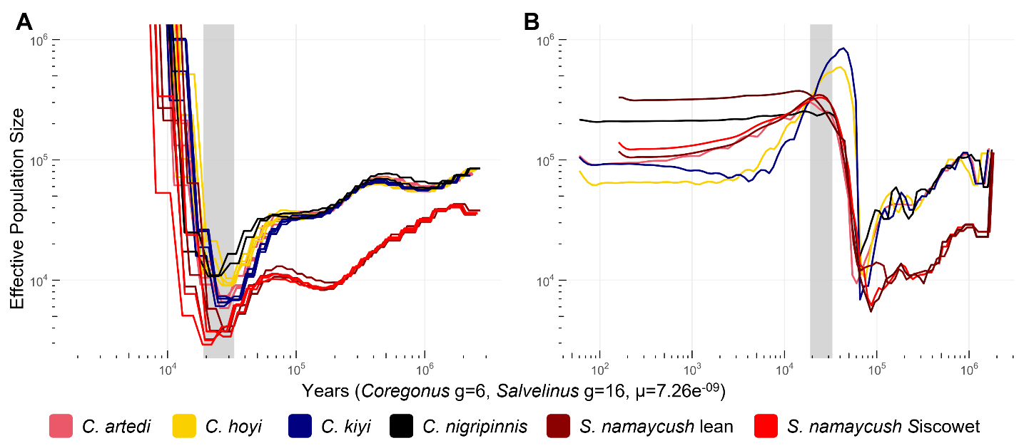
Figure S8 – a) Salvelinus namaycush and Coregonus species estimates of effective population size using PSMC. b) Estimated effective population sizes using SMC++. For both salmonid species the mutation rate was set at 7.26e⁻⁰⁹ mutations per site per generation. Generation times for Coregonus species and S. namaycush were set at 6 years and 16 years respectively. The light grey bar in both plots indicates the time range of the last glacial maximum (19-33 ka).

SUPPLEMENTAL METHODS
Resequenced sample read statistics
All Illumina reads for the resequenced Coregonus samples were concatenated for each individual and read counts for were calculated with seqkit ‘stats’ (Shen, Le, Li, & Hu, 2016). Following mapping and variant calling the average depth of coverage was generated from alignment data files using samtools ‘depth’. Also from the alignment files, the percentage of the reference genome that had reads mapped to it (breadth of coverage) were calculated using samtools ‘mpileup’. The alignment rate for all reads and proper pair reads for each individual were assessed with samtools ‘flagstat’
Appendix I – Estimation of generation time of Lake Superior coregonines
We used the method of Leslie (1966) to estimate mean generation time (T) using age-specific elements in a life table: $T=\sum{xl_{x}m_{x}}$/R₀, where x = age in years, l_{x} = age-specific relative survivorship, m_{x} = age-specific fecundity, and R₀ = $\sum{l_{x}m_{x}}$.
We were able to acquire necessary information to model T for C. artedi, C. hoyi, and C. kiyi. To estimate relative survivorship by age, we used estimates of total instantaneous mortality rate (Z) provided by Pratt and Chong (2012) for Lake Superior (C. artedi Z = 0.321; C. hoyi Z = 0.322; C. kiyi Z = 0.487). Estimates of age-specific fecundity for C. artedi were obtained from Yule et al. (2020).
The development of life tables for C. hoyi and C. kiyi involved some additional steps. We used von Bertalanffy growth equations for these species (Pratt & Chong, 2012) which predicted fork length (FL) from age. We converted FL to total length (TL) based on measurements from digital images (C. hoyi TL/FL = 1.1011, N=45, length range = 83-310 mm TL; C. kiyi TL/FL = 1.095, N =37, length range = 9.4 – 25.9 mm). A C. kiyi total fecundity versus TL relationship was taken from Vinson et al. (2022). C. hoyi fecundity was obtained from Dryer and Beil (1968). These authors provided estimates of average C. hoyi fecundity in eight length bins, ranging from 21.3-29.7 mm TL (their Table 15). We developed a model predicting log (fecundity) from log (L) by weighting the bin estimates by sample size. The resulting model was as follows:
Log (Fecundity) = 2.7742 x Log (TL) – 0.1030: adjusted R² = 0.91).
Predictions of TL at age for C. hoyi were used to predict age-specific fecundity with this relationship.

Results
The estimates of mean generation time of C. artedi equaled 6.41 years, C. hoyi was 6.32 years, and C. kiyi 5.96 years.
Table 1 - Life table for Lake Superior C. artedi.
Age (x) | Relative N (l_{x}) | Fecundity (m_{x}) | l_{x}m_{x} | xl_{x}m_{x}
3 | 1.0000 | 12,453 | 12,453 | 37,359
4 | 0.7254 | 15,797 | 11,460 | 45,838
5 | 0.5262 | 18,789 | 9,888 | 49,438
6 | 0.3817 | 21,429 | 8,180 | 49,083
7 | 0.2769 | 23,717 | 6,568 | 45,975
8 | 0.2009 | 25,653 | 5,153 | 41,227
9 | 0.1457 | 27,237 | 3,969 | 35,723
10 | 0.1057 | 28,469 | 3,010 | 30,096
11 | 0.0767 | 29,349 | 2,251 | 24,758
12 | 0.0556 | 29,877 | 1,662 | 19,945
13 | 0.0404 | 30,053 | 1,213 | 15,767
14 | 0.0293 | 29,877 | 875 | 12,245
15 | 0.0212 | 29,349 | 623 | 9,349
16 | 0.0154 | 28,469 | 439 | 7,017
17 | 0.0112 | 27,237 | 304 | 5,175
18 | 0.0081 | 25,653 | 208 | 3,744
19 | 0.0059 | 23,717 | 139 | 2,650
20 | 0.0043 | 21,429 | 91 | 1,828
21 | 0.0031 | 18,789 | 58 | 1,221
22 | 0.0022 | 15,797 | 35 | 780
23 | 0.0016 | 12,453 | 20 | 466
 |  |  | 68,600 | 439,687
 |  | Mean generation time (T) |  | 6.41

Table 2 - Life table for Lake Superior C. hoyi.
Age (x) | Relative N (l_{x}) | Fecundity (m_{x}) | l_{x}m_{x} | xl_{x}m_{x}
3 | 1.0000 | 2,524 | 2,524 | 7,571
4 | 0.7247 | 2,791 | 2,023 | 8,090
5 | 0.5252 | 3,058 | 1,606 | 8,031
6 | 0.3806 | 3,324 | 1,265 | 7,592
7 | 0.2758 | 3,588 | 990 | 6,927
8 | 0.1999 | 3,848 | 769 | 6,153
9 | 0.1449 | 4,103 | 594 | 5,349
10 | 0.1050 | 4,352 | 457 | 4,569
11 | 0.0761 | 4,596 | 350 | 3,846
12 | 0.0551 | 4,833 | 266 | 3,197
13 | 0.0400 | 5,062 | 202 | 2,629
14 | 0.0290 | 5,285 | 153 | 2,142
15 | 0.0210 | 5,500 | 115 | 1,731
16 | 0.0152 | 5,707 | 87 | 1,389
17 | 0.0110 | 5,907 | 65 | 1,107
18 | 0.0080 | 6,098 | 49 | 877
19 | 0.0058 | 6,282 | 36 | 691
20 | 0.0042 | 6,459 | 27 | 542
21 | 0.0030 | 6,627 | 20 | 423
22 | 0.0022 | 6,789 | 15 | 329
23 | 0.0016 | 6,943 | 11 | 255
 |  |  | 11,624 | 73,438
 |  | Mean generation time (T) |  | 6.32

Table 3 - Life table for Lake Superior C. kiyi.
Age (x) | Relative N (l_{x}) | Fecundity (m_{x}) | l_{x}m_{x} | xl_{x}m_{x}
4 | 1.0000 | 2,082 | 2,082 | 8,329
5 | 0.6145 | 2,330 | 1,432 | 7,158
6 | 0.3776 | 2,567 | 969 | 5,815
7 | 0.2320 | 2,794 | 648 | 4,538
8 | 0.1426 | 3,012 | 429 | 3,435
9 | 0.0876 | 3,220 | 282 | 2,539
10 | 0.0538 | 3,420 | 184 | 1,841
11 | 0.0331 | 3,611 | 119 | 1,314
12 | 0.0203 | 3,794 | 77 | 925
13 | 0.0125 | 3,970 | 50 | 644
14 | 0.0077 | 4,138 | 32 | 445
15 | 0.0047 | 4,299 | 20 | 304
16 | 0.0029 | 4,453 | 13 | 206
17 | 0.0018 | 4,601 | 8 | 139
18 | 0.0011 | 4,742 | 5 | 93
19 | 0.0007 | 4,878 | 3 | 62
20 | 0.0004 | 5,008 | 2 | 41
21 | 0.0003 | 5,132 | 1 | 27
22 | 0.0002 | 5,251 | 1 | 18
23 | 0.0001 | 5,366 | 1 | 12
 |  |  | 6,359 | 37,885
 |  | Mean generation time (T) |  | 5.96

REFERENCES

Dryer, W. R., & Beil, J. (1968). Growth changes of the bloater (Coregonus hoyi) of the Apostle Islands region of Lake Superior. Transactions of the American Fisheries Society, 97(2), 146-158.
Leslie, P. (1966). The intrinsic rate of increase and the overlap of successive generations in a population of guillemots (Uria aalge Pont.). Journal of Animal Ecology, 35(2), 291-301.
Pratt, T., & Chong, S. (2012). Contemporary life history characteristics of Lake Superior deepwater ciscoes. Aquatic Ecosystem Health & Management, 15(3), 322-332.
Shen, W., Le, S., Li, Y., & Hu, F. (2016). SeqKit: a cross-platform and ultrafast toolkit for FASTA/Q file manipulation. PloS one, 11(10), e0163962.
Vinson, M. R., Herbert, M. E., Ackiss, A. S., Dobosenski, J. A., Evrard, L. M., Gorman, O. T., . . . Yule, D. L. (2022). Lake Superior Kiyi (Coregonus kiyi) reproductive biology. Transactions of the American Fisheries Society, n/a(n/a). doi:https://doi.org/10.1002/tafs.10389
Yule, D. L., Dobosenski, J. A., Myers, J. T., Ebener, M. P., Claramunt, R. M., McKenna, J. D., . . . Gorman, O. T. (2020). Does Fecundity of Cisco Vary in the Upper Great Lakes? North American Journal of Fisheries Management, 40(4), 973-985.

