Supplementary Materials for

Discerning Rise Time Constants: Connecting the Time and Frequency Domain Response of Perovskite Solar Cells

Sandheep Ravishankar,^{1*} Lennard Kruppa¹, Sandra Jenatsch², Yueming Wang¹
¹IEK-5 Photovoltaik, Forschungszentrum Jülich, 52425 Jülich, Germany
²Fluxim AG, Katharina-Sulzer-Platz 2, 8406 Winterthur, Switzerland

*author for correspondence, email: s.ravi.shankar@fz-juelich.de

Table S1 Parameters used to carry out the drift-diffusion simulations using SETFOS, unless stated otherwise in the caption.

parameter | hole  transport layer | perovskite | electron  transport  layer
thickness (nm) | 10 | 300 | 10
relative permittivity | 3 | 3$×$10⁵ | 3
electron affinity (eV) | 2.33 | 3.93 | 3.93
bandgap (eV) | 3.2 | 1.6 | 2
effective DOS CB (cm⁻³) | 10¹⁸ | 10¹⁸ | 10¹⁸
effective DOS VB (cm⁻³) | 10¹⁸ | 10¹⁸ | 10¹⁸
electron mobility (cm²/Vs) | variable | 20 | variable
hole mobility (cm²/Vs) | variable | 20 | variable
radiative recombination coefficient (cm³/s) | 0 | 6 × 10⁻¹¹ | 0
acceptor trap energy level (eV) |  | 0.8
ion density (cm⁻³) |  | 0
trap density (cm⁻³) |  | 10¹⁶
electron capture coefficient (cm³/s) |  | 10⁻⁹
hole capture coefficient (cm³/s) |  | 10⁻⁹

Laser pulse width – 2 nanoseconds.

Table S2 Parameters used to carry out the equivalent circuit simulations in figure 4 in the main paper. No recombination is considered in the transport layers.

parameter | perovskite | transport layers
thickness (nm) | 300 | 10
relative permittivity | 30 | unneeded
bandgap (eV) | 1.6 | unneeded
effective DOS CB (cm⁻³) | 10¹⁸ | 10¹⁸
effective DOS VB (cm⁻³) | 10¹⁸ | 10¹⁸
electron mobility (cm²/Vs) | unneeded | 0.01
hole mobility (cm²/Vs) | unneeded | 0.01
radiative recombination coefficient (cm³/s) | 6 × 10⁻¹¹
Shockley-Read-Hall recombination lifetime (s) | 2 × 10⁻⁶
built-in electrostatic voltage (V) | unneeded | 0.75
ion density (cm⁻³) | 0
series resistance = 1 $Ωcm^{2}$.

A1. Discussion of simulation parameters

Relative permittivity: The relative permittivity value for the transport layers was chosen as 3, since typical values for fullerenes lie between 2 and 4.¹ The relative permittivity of the perovskite layer was set arbitrarily high to ensure no electric field inside the perovskite layer. However, the simulations in figure S3 use the perovskite permittivity chosen from ref.².

Bandgap: The PTAA layer bandgap was chosen from ref.³. The perovskite bandgap was chosen arbitrarily. The PCBM layer bandgap was chosen based on ref.⁴.

Electron affinities: The perovskite electron affinity was slightly modified from the value reported in ref.³. For simplicity, no band offsets were considered at the perovskite/transport layer interface. Therefore, the electron affinities were chosen based on the bandgaps in table S1.

Effective density of states (DOS): The effective DOS for the conduction and valence band of the perovskite layer was chosen from ref.⁵. The DOS of the transport layers were chosen to be the same as that of the perovskite layer for simplicity.

Radiative recombination coefficient: The order of the perovskite layer radiative recombination coefficient was chosen from ref.⁵. No recombination in the contact layers was assumed.

Mobilities: The electron and hole mobilities were set equal in all cases for simplicity. Based on the generally large mobilities reported for perovskite layers,⁶ we chose a value of 20 cm²/Vs. For the equivalent circuit simulations, the mobility is considered high enough to create a uniform carrier concentration in the perovskite layer and its value is hence unneeded.

Ion densities: Ionic effects in perovskite solar cells are known to occur at low frequencies (below 10³ Hz).⁷ Since we are interested in only electronic processes within the perovskite solar cell, we set the ion densities to zero and focus only on the high frequency region of the spectra. However, the simulations in figure S3 include ionic densities.

Trap densities and capture coefficients: We focus on the effects of deep traps on the perovskite solar cell response and hence choose trap densities at mid-gap for the simulations. The trap density was chosen arbitrarily and the capture coefficients were set to obtain Shockley-Read-Hall lifetimes of ${10}^{-7}$ s for electrons and holes.

Built-in electrostatic voltage: The built-in electrostatic voltage in the transport layers was chosen arbitrarily, with a factor 2 assigned to the modification of this electrostatic voltage by the external voltage by assuming that the external voltage is split equally between the two transport layers to modify their respective electrostatic voltage.

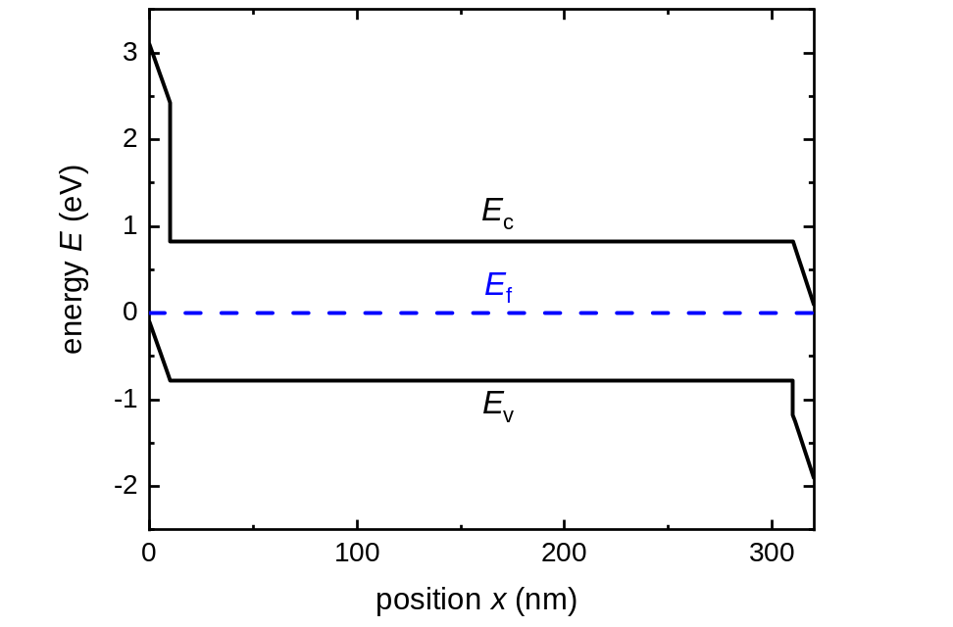
Figure S1 Band diagram of the perovskite solar cell used for the SETFOS simulations. No conduction band offset and valence band offset was considered at the perovskite/electron transport layer and perovskite/hole transport layer interfaces respectively. The permittivity of the perovskite was increased arbitrarily to ensure no electric field in the perovskite layer. No ionic densities were considered in the simulation.

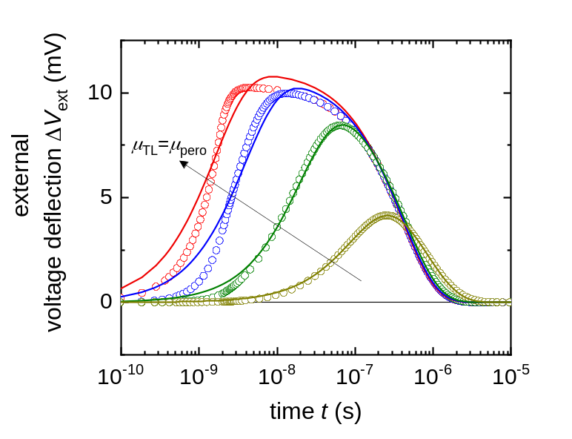
Figure S2 Fitting (solid lines) of the simulated TPV spectra (open symbols) in figure 2(a) in the main paper, using equation 4 in the main paper.

A2. Calculation of the time constant from -imag $W$
The IMVS transfer function given by equation 4 in the main paper is
$W=W_{0}\left(\frac{τ_{V,decay}}{1+iωτ_{V,decay}}-\frac{τ_{V,rise}}{1+iωτ_{V,rise}}\right)$ , (S1)
where $W_{0}$ is a constant. We consider a situation where the decay of the photovoltage is much slower than the rise of the photovoltage i.e. $τ_{V,decay}≫τ_{V,rise}$. The negative imaginary part of $W$ is then given by
$-imag W=W_{0}\left(\frac{ωτ_{V,decay}^{2}}{1+ω^{2}τ_{V,decay}^{2}}-\frac{ωτ_{V,rise}}{1+ω^{2}τ_{V,rise}^{2}}\right)$ , (S2)
where $W_{0}$ is a pre-factor. Differentiating equation S2 versus angular frequency $ω$, we obtain
$\frac{d(-imag W)}{dω}=W_{0}\left(\frac{τ_{V,decay}^{2}\left(1-ω^{2}τ_{V,decay}^{2}\right)}{{\left(1+ω^{2}τ_{V,decay}^{2}\right)}^{2}}-\frac{τ_{V,rise}^{2}\left(1-ω^{2}τ_{V,rise}^{2}\right)}{{\left(1+ω^{2}τ_{V,rise}^{2}\right)}^{2}}\right)$ . (S3)
The characteristic frequencies are calculated by setting the LHS of equation S3 to zero. We thus obtain
$0=\left(τ_{V,decay}^{2}-ω_{char}^{2}τ_{V,decay}^{4}\right)\left(1+2ω_{char}^{2}τ_{V,rise}^{2}+ω_{char}^{2}τ_{V,rise}^{4}\right)-\left(τ_{V,rise}^{2}-ω_{char}^{2}τ_{V,rise}^{4}\right)\left(1+2ω_{char}^{2}τ_{V,decay}^{2}+ω_{char}^{2}τ_{V,decay}^{4}\right)$ . (S4)
Dividing both sides of equation 4 by $τ_{V,decay}^{4}$ and noting that ${\left({τ_{V,rise}}/{τ_{V,decay}}\right)}^{2}→0$, we obtain
$ω_{char}=\frac{1}{τ_{V,decay}}$ . (S5)
Therefore, when the time constants $τ_{V,decay}$ and $τ_{V,rise}$ are well separated in magnitude, the negative imaginary part of the transfer function plotted versus $ω$ shows only the larger (slower) of the time constants as its maximum.

A3. Calculation of the time constants from -imag $M_{W}$
The negative imaginary part of the transformed IMVS transfer function is given from equation 10 in the main paper by
$-imag M_{W}=M_{W,0}\left(\frac{ωτ_{V,rise}}{1+ω^{2}τ_{V,rise}^{2}}-\frac{ωτ_{V,decay}}{1+ω^{2}τ_{V,decay}^{2}}\right)$ , (S6)
where $M_{W,0}$ is a constant. Differentiating equation S6 versus angular frequency $ω$, we obtain
$\frac{d(-imag M_{W})}{dω}=M_{W,0}\left(\frac{τ_{V,rise}\left(\left(1+ω^{2}τ_{V,rise}^{2}\right)-2ω^{2}τ_{V,rise}^{2}\right)}{{\left(1+ω^{2}τ_{V,rise}^{2}\right)}^{2}}- \frac{τ_{V,decay}\left(\left(1+ω^{2}τ_{V,decay}^{2}\right)-2ω^{2}τ_{V,decay}^{2}\right)}{{\left(1+ω^{2}τ_{V,decay}^{2}\right)}^{2}}\right)$ . (S7)
The characteristic frequencies are obtained by setting the LHS of equation S7 to zero, yielding
$C^{3}x^{3}-C\left(3C+D\right)x^{2}-\left(3C+D\right)x+1=0$ , (S8)
where $x=ω_{char}^{2}$, $C=τ_{V,decay}τ_{V,rise}$ and $D=τ_{V,decay}^{2}+τ_{V,rise}^{2}$. Solving numerically for the roots of equation S8 yields the rise and decay time constants from $τ_{char}=1/ω_{char}$.

A4. Calculation of the amplitude of the negative real part of $W$
The IMVS transfer function from equation 4 in the main paper is given by
$W=W_{0}\left(\frac{τ_{V,decay}}{1+iωτ_{V,decay}}-\frac{τ_{V,rise}}{1+iωτ_{V,rise}}\right)$ . (S9)
The real part of equation S9 is given by
$real W=W_{0}\left(\frac{τ_{V,decay}}{1+ω^{2}τ_{V,decay}^{2}}-\frac{τ_{V,rise}}{1+ω^{2}τ_{V,rise}^{2}}\right)$ . (S10)
For well-separated time constants in magnitude ($τ_{V,rise}≪τ_{V,decay}$), equation S10 can be approximated using the Taylor expansion at high frequencies as
$real W=W_{0}\left(\frac{1}{ω^{2}τ_{V,decay}}-\frac{τ_{V,rise}}{1+ω^{2}τ_{V,rise}^{2}}\right)$ . (S11)
Equation S11 transitions to negative values at high frequencies, with a corresponding minimum. We calculate the amplitude of this transition by finding the root $ω_{min}$ of the derivative of real $W$ versus $ω$ and plugging it back in equation 11. We thus obtain
$real W\left(ω_{min}\right)=W_{0}\left(- \frac{τ_{V,rise}}{\frac{τ_{V,rise}}{τ_{V,decay}-τ_{V,rise}}+\frac{\sqrt{τ_{V,decay}τ_{V,rise}}}{τ_{V,decay}-τ_{V,rise}}+1}+ \frac{τ_{V,rise}^{2}}{\frac{τ_{V,decay}τ_{V,rise}}{τ_{V,decay}-τ_{V,rise}}+\frac{\sqrt{τ_{V,decay}τ_{V,rise}}}{τ_{V,decay}-τ_{V,rise}}}\right)$ . (S12)
For well-separated time constants, we have the approximations $τ_{V,decay}-τ_{V,rise}≅τ_{V,decay}$ and ${τ_{V,rise}}/{τ_{V,decay}≅0}$. Therefore, equation S12 simplifies to
$real W\left(ω_{min}\right)=-W_{0}τ_{V,rise}$ . (S13)

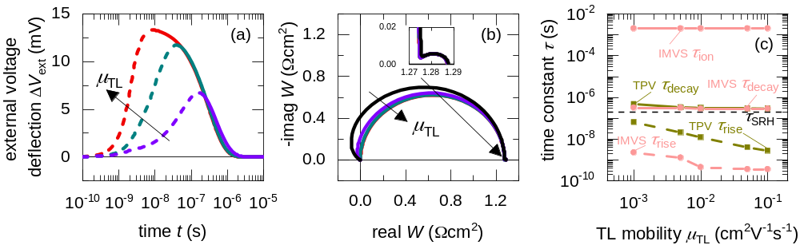
Figure S3 Simulated evolution of (a) TPV and (b) IMVS spectra at DC open-circuit conditions under 100 mW/cm² illumination with a blue LED (459 nm), for different transport layer mobilities of a PSC with uniform cation and anion densities of ${10}^{17}$ cm⁻³. (c) shows the corresponding calculated rise (dashed lines) and decay (solid lines) time constants. An additional time constant is seen in the low-frequency region of the IMVS spectra as shown in the inset of (b), which is also plotted in (c). The rise and decay time constants in TPV are unaffected by the inclusion of ions at this DC condition. The permittivity of the perovskite layer was set to $ε_{r}=30$.

A5. Subtraction of $R_{s}$ from impedance transfer function to obtain $M_{Z}$
We consider a general impedance $Z_{1}$ given by
$Z_{1}=Z_{1}^{'}(ω)+iZ_{1}''(ω)$ , (S14)
where the real and imaginary parts are denoted using $'$ and $''$ respectively. We transform the impedance transfer function to $M_{Z_{1}}$, given by
$M_{Z_{1}}=iωZ_{1}=iωZ_{1}^{'}-ωZ_{1}''$ . (S15)
The characteristic frequency $ω_{1}$ is thus obtained from the peak of the negative imaginary part of $M_{Z_{1}}$ given by
$\frac{d(-im(M_{Z_{1}}))}{dω}=0=-\left(Z_{1}^{'}+ω\frac{dZ_{1}^{'}}{dω}\right)→ω_{1}=\frac{-Z_{1}^{'}\left(ω_{1}\right)}{\left({\left.\frac{dZ_{1}^{'}}{dω}\right|}_{ω=ω_{1}}\right)}$ . (S16)
We now consider an impedance $Z_{2}$ given by
$Z_{2}=R_{s}+Z_{1}$ , (S17)
where $R_{s}$ is the series resistance. The corresponding transformed transfer function $M_{Z_{2}}$is
$M_{Z_{2}}=iωZ_{2}=iω({R_{s}+Z}_{1}^{'})-ωZ_{1}''$. (S18)
The characteristic frequency $ω_{2}$ is thus calculated from the peak of the negative imaginary part of the transfer function in equation S18 as
$ω_{2}=\frac{-(R_{s}+Z_{1}^{'}\left(ω_{2}\right))}{\left({\left.\frac{dZ_{1}^{'}}{dω}\right|}_{ω=ω_{2}}\right)}$ . (S19)
Equation S19 shows that the characteristic frequency $ω_{2}$ of the modified transfer function $M_{Z}$ is influenced by the series resistance and is equal to the characteristic frequency $ω_{1}$without a series resistance only when $R_{s}$ tends to zero. We therefore subtract the series resistance from the measured spectra to remove the influence of $R_{s}$.
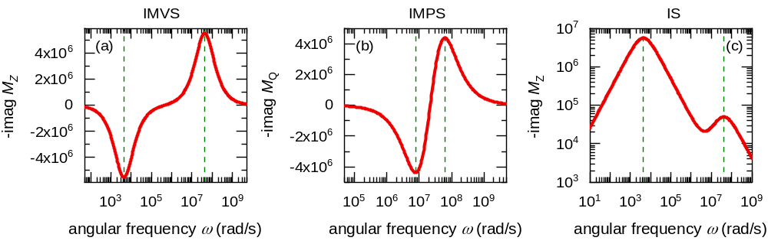
Figure S4 Extrema (dashed lines) of the imaginary part of the transformed (a) IMVS, (b) IMPS and (c) IS transfer functions versus angular frequency, simulated using the equivalent circuit in figure 4 in the main paper. These extrema correspond to the rise and decay time constants.

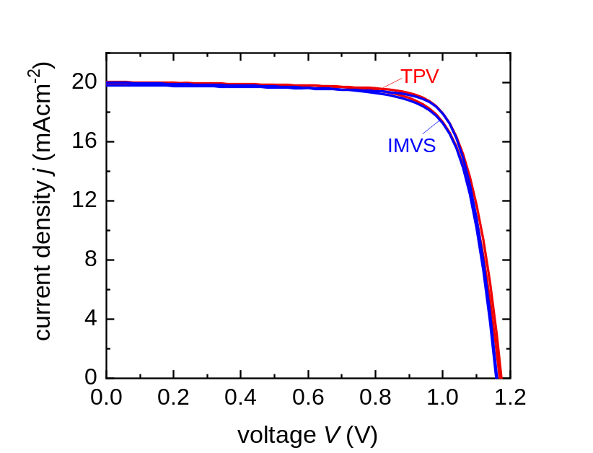
Figure S5 Current-voltage curves of the perovskite solar cells used to make the TPV and IMVS measurements.

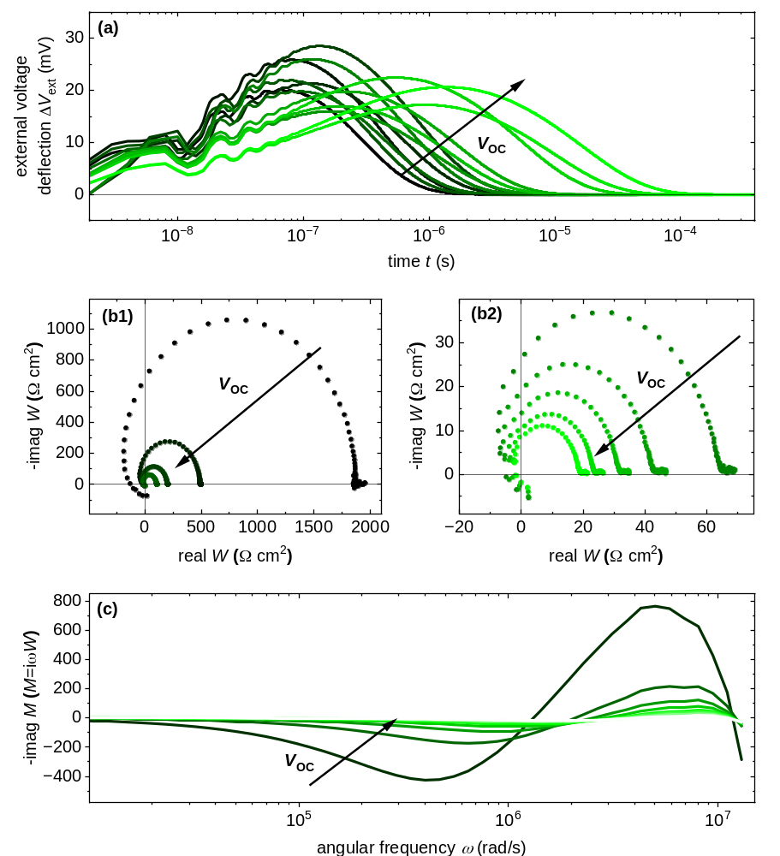
Figure S6 All measured (a) TPV spectra and (b1, b2) real versus negative imaginary parts of the IMVS transfer function $W$ of a Cs_{0.05}FA_{0.8}MA_{0.15}PbI_{2.25}Br_{0.75} perovskite solar cell at different DC open-circuit voltages. (c) shows the negative imaginary part of the transformed IMVS transfer function $M_{W}$ ($M_{W}=iωW$) versus angular frequency $ω$, whose peaks correspond to the rise and decay time constants of the photovoltage.

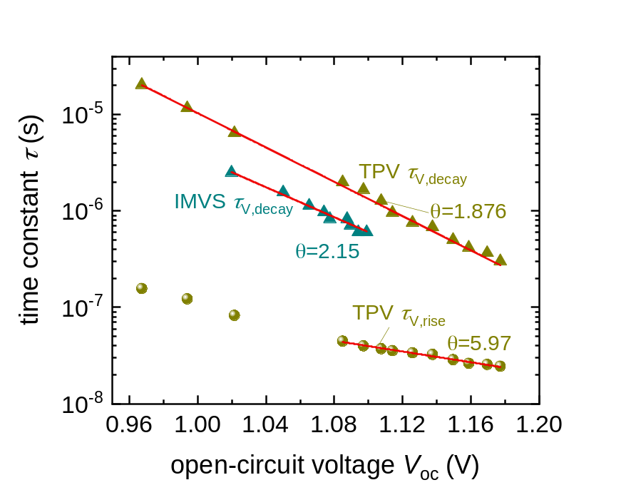
Figure S7 Calculated slope factors $ϴ$ for the measured IMVS and IS time constants, using equation 20 in the main paper.

References

1. Sami, S., Haase, P. A., Alessandri, R., Broer, R. & Havenith, R. W. Can the dielectric constant of fullerene derivatives be enhanced by side-chain manipulation? A predictive first-principles computational study. J. Phys. Chem. A 122, 3919-3926 (2018).

2. Sendner, M. et al. Optical phonons in methylammonium lead halide perovskites and implications for charge transport. Mater. Horiz. 3, 613-620 (2016).

3. Liu, Z. et al. Open-circuit voltages exceeding 1.26 V in planar methylammonium lead iodide perovskite solar cells. ACS Energy Lett. 4, 110-117 (2019).

4. Maibach, J., Mankel, E., Mayer, T. & Jaegermann, W. The band energy diagram of PCBM–DH6T bulk heterojunction solar cells: synchrotron-induced photoelectron spectroscopy on solution processed DH6T: PCBM blends and in situ prepared PCBM/DH6T interfaces. J. Mater. Chem. C 1, 7635-7642 (2013).

5. Staub, F. et al. Beyond bulk lifetimes: insights into lead halide perovskite films from time-resolved photoluminescence. Phys. Rev. Appl. 6, 044017 (2016).

6. Herz, L. M. Charge-carrier mobilities in metal halide perovskites: fundamental mechanisms and limits. ACS Energy Lett. 2, 1539-1548 (2017).

7. Wang, H., Guerrero, A., Bou, A., Al-Mayouf, A. M. & Bisquert, J. Kinetic and material properties of interfaces governing slow response and long timescale phenomena in perovskite solar cells. Energy Environ. Sci. 12, 2054-2079 (2019).

