Graphics 1 and 2 - LDPE/TPS DSC Heating and Cooling Curves and their compositions with the MMT-E and MMT-C hybrids, respectively.
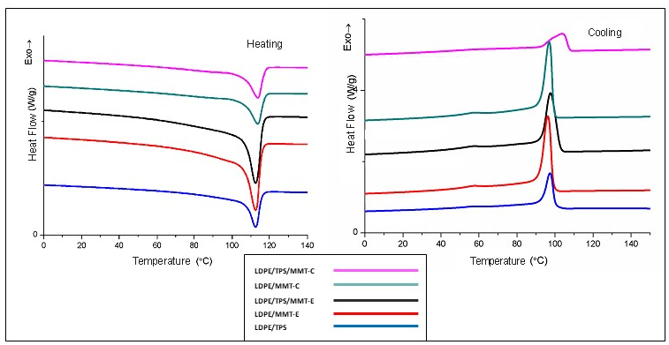

Graphis 3 and 4 - Full infrared spectra of the LDPE/TPS blend and their interactions with the MMT-E and MMT-C hybrid and the TPS bands and their compositions, respectively.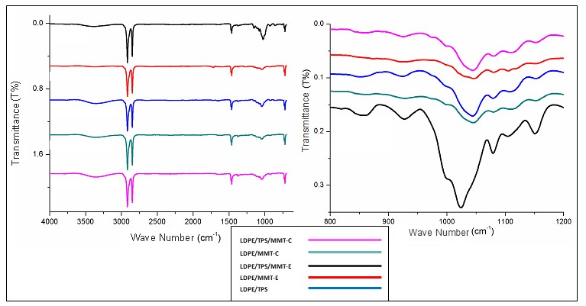

Graph 5 - Migration analysis of LDPE/TPS blends and their incorporation with the MMT-C and MMT-E hybrids.
