Supplementary material

Unprecedented mortality induced by extreme hot-drought in mature planted Pinus spp stands is locally modulated by soil characteristics

Gabriel Gatica1,*¹, Javier Gyenge^{1,2}, Nardia Bulfe³, Norberto Pahr³, Fernando Dalla Tea⁴ & María Elena Fernández^{1,2}

Table S1. Basic statistics for each forestry Species planted in our study system. For each species we show the area planted (measured in ha), number of forest stands, and mortality proportion (measured as the proportion of pixels with high mortality level at stand level). The last three columns show the number of forest stands into mortality categories defined by high = stands with >80% of pixels, Med = >40% and ≦ 80% of pixels; and Low = < 40% of pixels under the high mortality class (Fig. S1). Forest stands are polygons that represent the basic unity of the National Forestry Inventory of Argentina (MAGyP, 2022).

Species | Planted Area (ha) | Stand number | Stand size (ha) |  |  | Mortality  (% pixeles) | Mortality Classes  (frequency of stands)
Species | Planted Area (ha) | Stand number | Mean ± SD | Min | Max | Mean ± SD | High | Med | Low
Pinus taeda | 12993.45 | 3054 | 4.25 ± 2.02 | 0.01 | 10.96 | 17.47 ± 27.4 | 172 | 407 | 2475
Pinus elliottii | 636.25 | 180 | 3.53 ± 1.62 | 0.47 | 6.18 | 15.88 ± 28.11 | 14 | 14 | 152
Pinus sp. | 192.31 | 42 | 4.58 ± 2.51 | 0.49 | 6.46 | 3.75 ± 4.64 | 0 | 0 | 42
Pinus halepensis | 108.27 | 18 | 6.02 ± 0.39 | 5.48 | 6.32 | 1.1 ± 2.41 | 0 | 0 | 18

Table S2. General topographic and edaphic characteristics correspond to each site quality in Pinus plantations studied. Site quality is based on a Site Index adapted by the forestry company the highest suitability for Pinus (sites P) and Eucalyptus (sites E) species. The numbers indicate the mean annual increment (MAI) at harvest time for each species. Additionally, we have included information on elevation (masl) and slope (in degree) extracted from a digital elevation model (SRTM, 30 m of the spatial resolution). Physical soil characteristics for P21, E35 and Rc sites were estimated by means of in situ soil excavation during August 2022.

 | Site Qualities
 | Ba | P15 | P18 | P21 | P25 | E35 | Rc
Topography | Floodplain | Floodplain | Flattened hill | Hill with irregular relief | Flattened hill | Higher and steepest hill | Elevated hill, basaltic outcrop
Drainage | Nill | Nill | Imperfect |  | Moderated | Good | Moderated
Run-off | Nill | Nill | Very slow |  | Slow | Fast | Middle
Permeability | Low | Low | Slow to very slow |  | Slow to Moderated | Moderated | Slow
Surface Texture |  |  | Sandy loam |  | Loam | Sandy Loam | Sandy Loam
Deep Texture |  |  | Silt Loam |  | Silt Loam to Loam-Clay-Silt | Loam-Clay-Silt | Loam
Note | Long-lasting  waterlogged | Frequent and long-lasting waterlogged | Bt Sub-superficial |  | Bt Sub-superficial, in 45-50 cm depth (in situ field observation) | Deeper soils  >100 cm | Shallow depth, 50 cm contact with the original material
Elevation (asl) | 70.84 ± 0.34 | 71.39 ± 0.35 | 72.91 ± 1.16 | 76.3 ± 6.56 | 77.98 ± 4.09 | 85.93 ± 4.92 | 85.63 ± 8.31
Slope (%) | 1.8 ± 0.12 | 1.85 ± 0.28 | 1.85 ± 0.25 | 2.02 ± 0.37 | 2.06 ± 0.35 | 2.31 ± 0.86 | 2.36 ± 0.4
Sample | 10 | 55 | 55 | 165 | 131 | 78 | 55
Bulk Density 0-10 cm (gr/cm3) |  |  |  | 1.54 ± 0.09 |  | 1.4 ± 0.12 | 1.65 ± 0.05
Bulk Density10-30 cm (gr/cm3) |  |  |  | 1.67 ± 0.06 |  | 1.63 ± 0.03 | 1.68 ± 0.07
Total Porosity 0-10 cm (%) |  |  |  | 41.8 ± 3.4 |  | 47.1 ± 4.5 | 37.7 ± 1.8
Total Porosity 10-30 cm (%) |  |  |  | 37 ± 2.3 |  | 38.6 ± 1.01 | 36.5 ± 2.6
Actual soil moisture 0-10 cm (%) |  |  |  | 22.2 ± 3.6 |  | 29.6 | 15 ± 1.2
Actual soil moisture10-30 cm (%) |  |  |  | 18.5 ± 1.3 |  | 21.9 ± 0.5 | 16.9 ± 0.8
Water holding capacity (mm) 0-10cm |  |  |  | 22.2 |  | 29.6 | 15
Water holding capacity 10-30cm |  |  |  | 37 |  | 43.8 | 33.8

Table S3. The number of the forest stands in both Site Quality and Age categories.
The number of forest stands was biassed to age > 12 years and only stands planted in 2009 (13 years old) were represented in all of the Site Quality categories. This pattern indicates that we did not evaluate the interactive or additive effects of the Age and the Site Quality from our dataset, and only we might evaluate the individual effects.

Site Quality | Stands Age (years)
Site Quality | 10 | 11 | 12 | 13 | 14
Ba | 0 | 0 | 0 | 60 | 0
E35 | 24 | 36 | 204 | 6 | 198
P15 | 0 | 102 | 60 | 168 | 0
P18 | 0 | 0 | 54 | 270 | 6
P21 | 0 | 36 | 12 | 330 | 612
P25 | 0 | 0 | 78 | 174 | 534
Rc | 6 | 30 | 30 | 96 | 168

Figure S1. The geographic location of the Corrientes Province in the Mesopotamian region in Argentina.

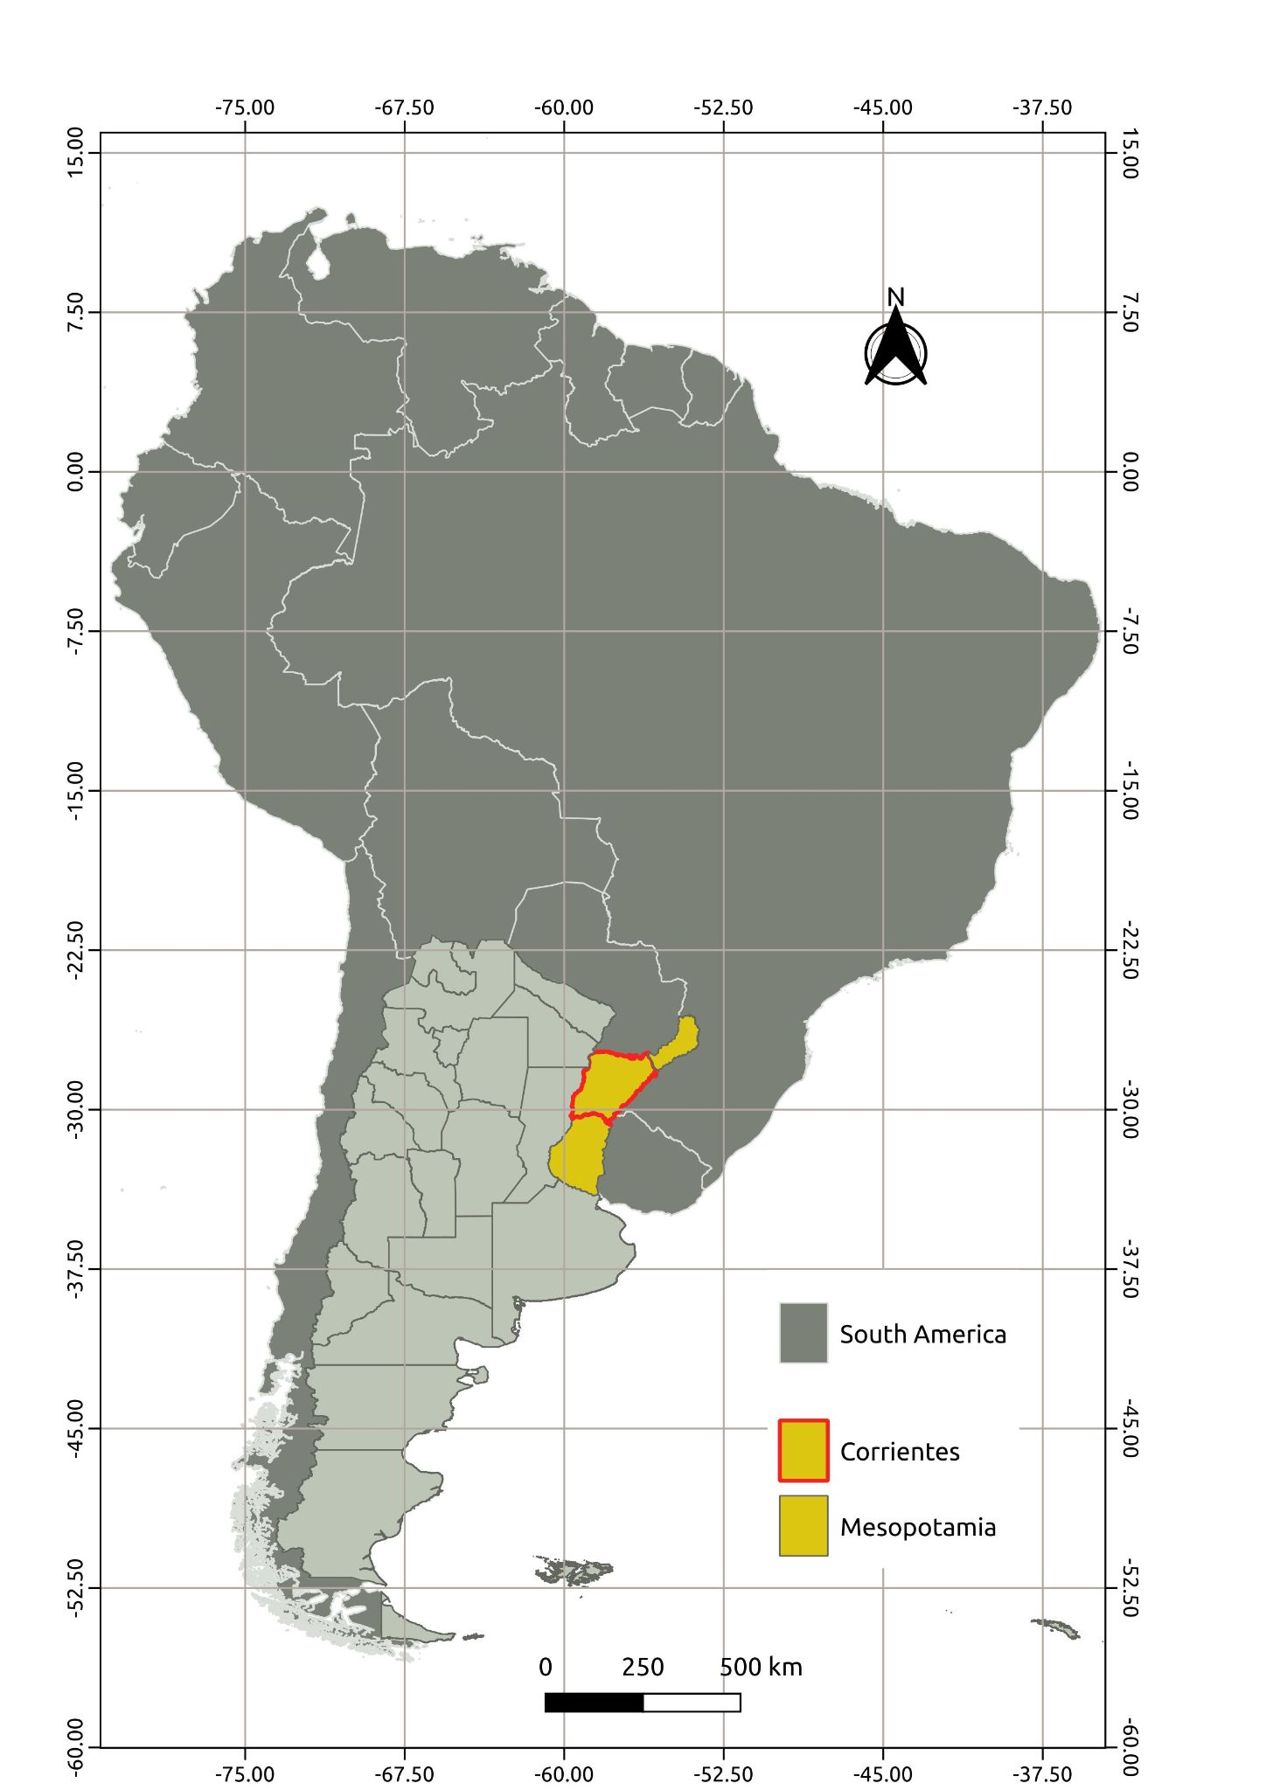
Figure S2. Representation of the canopy mortality map and forest stands. This is a small proportion of the forest stands studied. We have not used the Low mortality data because their identification had a high level of uncertainty compared to the level of high mortality.
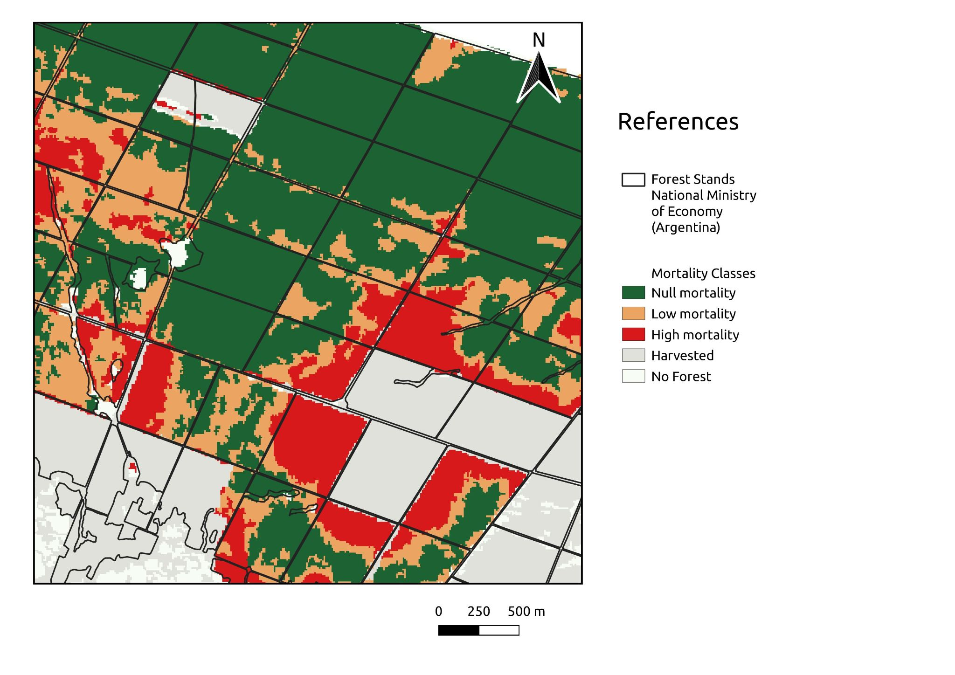

Table S4. Analysis of Deviance of the best model reported in the main text (Table 1). We used Wald tests to evaluate the significance of fixed factors.

Fixed Factors | χ² value | Df | p value
Time | 1855.07 | 2 | <0.0001
Site Quality | 65.005 | 6 | <0.0001
Time x Site Quality | 131.31 | 12 | <0.0001
Random Factors | Variance | Standard Deviation | Corr. coefficient
Time | ID | 6.4 | 2.73
AR1 |  |  | 0.90

Table S5. Type II analysis of deviance to test if the temporal trajectory of the Pine canopy mortality varies among different forestry Site Quality conditions (defined in Table S2) using non-linear mixed models. We fitted the temporal trajectory to a Weibull model, where k is the asymptote (representing maximum accumulated mortality); a is a parameter related to the rate of mortality; and b is a parameter related to the magnitude of the inflection point (high b values indicate abrupt increments in canopy mortality). See the equation in the main text.

Parameter | Predictor | df | F value | P value
k | Intercept | 1 | 4420.76 | < 0.0001
 | Site Quality | 4 | 35.47 | < 0.0001
a | Intercept | 1 | 2986.86 | < 0.0001
 | Site Quality | 4 | 86.18 | < 0.0001
b | Intercept | 1 | 477.29 | < 0.0001
 | Site Quality | 4 | 4.09 | 0.0026

