Appendix E: Model Summary Tables
Habitat Configuration influences mammal populations at a wider spatial extent than habitat composition: a meta-analysis of forest mammal datasets
Landscape Ecology
Nicholas W. Gengler ¹, Miguel A. Acevedo ², and Lyn C. Branch ²
1: University of Florida School of Natural Resources and Environment
2: University of Florida Department of Wildlife Ecology and Conservation
Corresponding author email: genglernick81@gmail.com

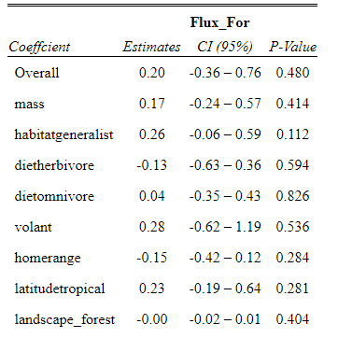
Summary table of the models used to assess the effects of various factors on the magnitude of the difference between the scales of effect of flux and percent forest cover
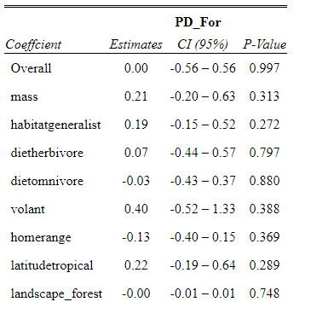
Summary table of the models used to assess the effects of various factors on the magnitude of the difference between the scales of effect of patch density and percent forest cover

