Appendix C: Dataset Global Locations and Citations
Habitat Configuration influences mammal populations at a wider spatial extent than habitat composition: a meta-analysis of forest mammal datasets
Landscape Ecology
Nicholas W. Gengler ¹, Miguel A. Acevedo ², and Lyn C. Branch ²
1: University of Florida School of Natural Resources and Environment
2: University of Florida Department of Wildlife Ecology and Conservation
Corresponding author email: genglernick81@gmail.com

Global Locations
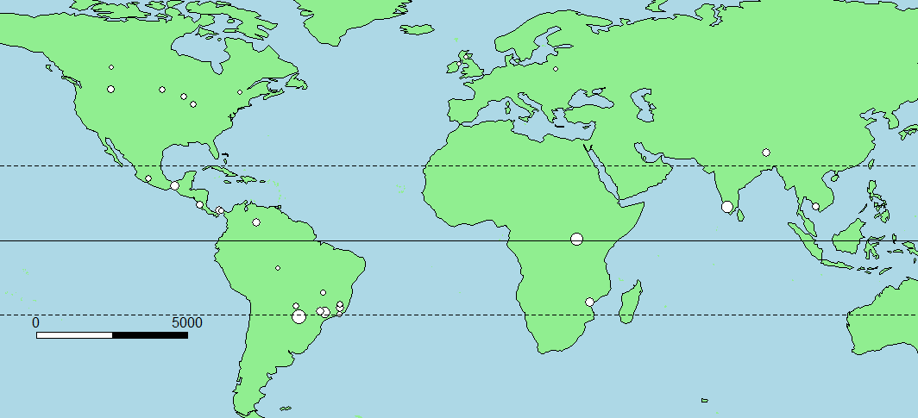
Global locations of the 33 datasets included in this study. Point size is relative to the number of species assessed from each dataset. Dashed lines represent tropical latitudes. Scale bar in kilometers.

Dataset citations
Dryad
Burgar, Joanna M. et al. (2019), Data from: Estimating density for species conservation: comparing camera trap spatial count models to genetic spatial capture-recapture models, Dryad, Dataset, https://doi.org/10.5061/dryad.dh7cd36
Clare, John D.J. et al. (2015), Predicting Bobcat Abundance at a Landscape Scale and Evaluating Occupancy as a Density Index in Central Wisconsin. The Journal of Wildlife Management 79(3):469-480. DOI: 10.1002/jwmg.844 (personal communications)
Farneda, Fábio Z.; Meyer, Christoph F. J.; Grelle, Carlos E. V. (2019), Data from: Effects of land-use change on functional and taxonomic diversity of Neotropical bats, Dryad, Dataset, https://doi.org/10.5061/dryad.sn02v6x0w
Farwig, Nina; Schabo, Dana G.; Albrecht, Jörg (2017), Data from: Trait-associated loss of frugivores in fragmented forest does not affect seed removal rates, Dryad, Dataset, https://doi.org/10.5061/dryad.2784g
Fidino, Mason; Simonis, Juniper L.; Magle, Seth B. (2018), Data from: A multi-state dynamic occupancy model to estimate local colonization-extinction rates and patterns of co-occurrence between two or more interacting species, Dryad, Dataset, https://doi.org/10.5061/dryad.k5mp137
Gallo, Travis; Fidino, Mason; Lehrer, Elizabeth W.; Magle, Seth (2019), Data from: Urbanization alters predator avoidance behaviors, Dryad, Dataset, https://doi.org/10.5061/dryad.2hm27nc
Gaynor, Kaitlyn; Daskin, Joshua; Rich, Lindsey; Brashares, Justin (2020), Data from: Postwar wildlife recovery in an African savanna: Evaluating patterns and drivers of species occupancy and richness, Dryad, Dataset, https://doi.org/10.25349/D9CK5Q
Kays, Roland et al. (2020), An empirical evaluation of camera trap study design: how many, how long, and when?, Dryad, Dataset, https://doi.org/10.5061/dryad.p8cz8w9m2
Kshettry, Aritra; Vaidyanathan, Srinivas; Athreya, Vidya (2018), Data from: Leopard in a tea-cup: a study of leopard habitat-use and human-leopard interactions in north-eastern India, Dryad, Dataset, https://doi.org/10.5061/dryad.pc539
Lintott, Paul R. et al. (2015), Data from: City life makes females fussy: sex differences in habitat use of temperate bats in urban areas, Dryad, Dataset, https://doi.org/10.5061/dryad.5p5dd
Martinez-Fonseca, Jose G.; Chavez-Velasquez, Marlon; Williams-Guillen, Kimberly; Chambers, Carol (2019), Bats use live fences to move between tropical dry forest remnants , Dryad, Dataset, https://doi.org/10.5061/dryad.44j0zpc99
Mills, David et al. (2019), Data from: Competition and specialization in an African forest carnivore community, Dryad, Dataset, https://doi.org/10.5061/dryad.6fq3qv7
Morand, Serge et al. (2015), Data from: Assessing the distribution of disease-bearing rodents in human-modified tropical landscapes, Dryad, Dataset, https://doi.org/10.5061/dryad.m0s63
Mudappa, Divya; Raman, T. R. Shankar (2020), Data from: A conservation status survey of hornbills (Bucerotidae) in the Western Ghats, India, Dryad, Dataset, https://doi.org/10.5061/dryad.63s7r
Muylaert, Renata L.; Stevens, Richard D.; Ribeiro, Milton C. (2016), Data from: Threshold effect of habitat loss on bat richness in cerrado-forest landscapes, Dryad, Dataset, https://doi.org/10.5061/dryad.648jt
Regolin, André Luis et al. (2020), Spatial heterogeneity and habitat configuration overcome habitat composition influences on alpha and beta mammal diversity, Dryad, Dataset, https://doi.org/10.5061/dryad.9s4mw6mcd
Ribeiro, Suzy E.; Prevedello, Jayme A.; Delciellos, Ana Cláudia; Vieira, Marcus Vinicius (2016), Data from: Edge effects and geometric constraints: a landscape-level empirical test, Dryad, Dataset, https://doi.org/10.5061/dryad.72c92
Sidhu, Swati; Raman, T. R. Shankar; Mudappa, Divya (2020), Data from: Prey abundance and leopard diet in a plantation and rainforest landscape, Anamalai Hills, Western Ghats, Dryad, Dataset, https://doi.org/10.5061/dryad.4b8gtht90
Sultaire, Sean M. et al. (2016), Data from: Climate change surpasses land use change in the contracting range boundary of a winter-adapted mammal, Dryad, Dataset, https://doi.org/10.5061/dryad.nc637
Tardy, Olivia; Massé, Ariane; Pelletier, Fanie; Fortin, Daniel (2016), Data from: Resampling method for applying density-dependent habitat selection theory to wildlife surveys, Dryad, Dataset, https://doi.org/10.5061/dryad.1771t
Trubitt, Rebecca T.; Hovick, Torre J.; Gillam, Erin H.; McGranahan, Devan A. (2018), Data from: Habitat associations of bats in a working rangeland landscape, Dryad, Dataset, https://doi.org/10.5061/dryad.r17q65s
Twining, Joshua; Montgomery, Ian; Tosh, David (2020), Declining invasive grey squirrel populations may persist in refugia as native predator recovery reverses squirrel species replacement, Dryad, Dataset, https://doi.org/10.5061/dryad.pzgmsbch7
Wang, Bingxin et al. (2019), Data from: Habitat use of the ocelot (Leopardus pardalis) in Brazilian Amazon, Dryad, Dataset, https://doi.org/10.5061/dryad.p7410jm
Wright, Wilson J; Irvine, Kathryn M; Almberg, Emily S; Litt, Andrea R (2020), Data from: Modelling misclassification in multi-species acoustic data when estimating occupancy and relative activity, Dryad, Dataset, https://doi.org/10.5061/dryad.q83bk3jdg

The Knowledge Network for Biocomplexity
Rodrigo Massara. 2017. Factors Influencing Ocelot Occupancy in Brazilian Atlantic Forest Reserves. Knowledge Network for Biocomplexity. knb.1321.2

Web of Science (dataset only)
Nagy-Reis, M., J. E. F. Oshima, C. Z. Kanda, F. B. L. Palmeira, F. R. de Melo, R. G. Morato,
et al. 2020. NEOTROPICAL CARNIVORES: a data set on carnivore distribution in the Neotropics. Ecology
101(11):e03128. 10.1002/ecy.3128
Specifically:
Alexine Keuroghlian, Bruna da Silva Andrade, Donald P. Eaton, Sean Keuroghlian-Eaton (unpublished)
Hidalgo-Mihart_UJAT_Mexico (unpublished)
Juan L. Pena-Mondragon (unpublished)
Juarez, K, M, 2008, Mamiferos de medio e grande porte nas Unidades de conservacao do Distrito Federal,Universidade de Brasilia
MarcellaPonzio_and_RobertaPaolino_LAEC
Massara_et_al_2018 (unpublished)
Selecao Natural (unpublished)
WCS-Colombia (unpublished)

