Supplemental materials: Second-generation dual-channel visible light optical coherence tomography enables wide-field, full-range, and shot-noise limited retinal imaging
Jingyu Wang^{1, *}, Stephanie Nolen^{2, *}, Weiye Song^{3,4, *}, Wenjun Shao¹, Wei Yi^{3,5}, Amir Kashani¹, Ji Yi^{1,2,*,†}
- Department of Ophthalmology, Johns Hopkins University, Baltimore, MD, USA, 21231,
- Department of Biomedical Engineering, Johns Hopkins University, Baltimore, MD, USA, 21231
- Department of Medicine, Boston University School of Medicine, Boston Medical Center, Boston, MA, USA ,02118
- Current affiliation: Key Laboratory of High Efficiency and Clean Manufacturing, School of Mechanical Engineering, National Demonstration Center for Experimental Mechanical Engineering Education, Shandong University, Jinan, Shandong Province, China, 250061
- Current affiliation: Engineering Training Center, Shandong University, Jinan, Shandong Province, China, 250002
*Authors contributed equally
†Correspondence: jiyi@jhu.edu
- Wide field retinal VIS-OCT imaging

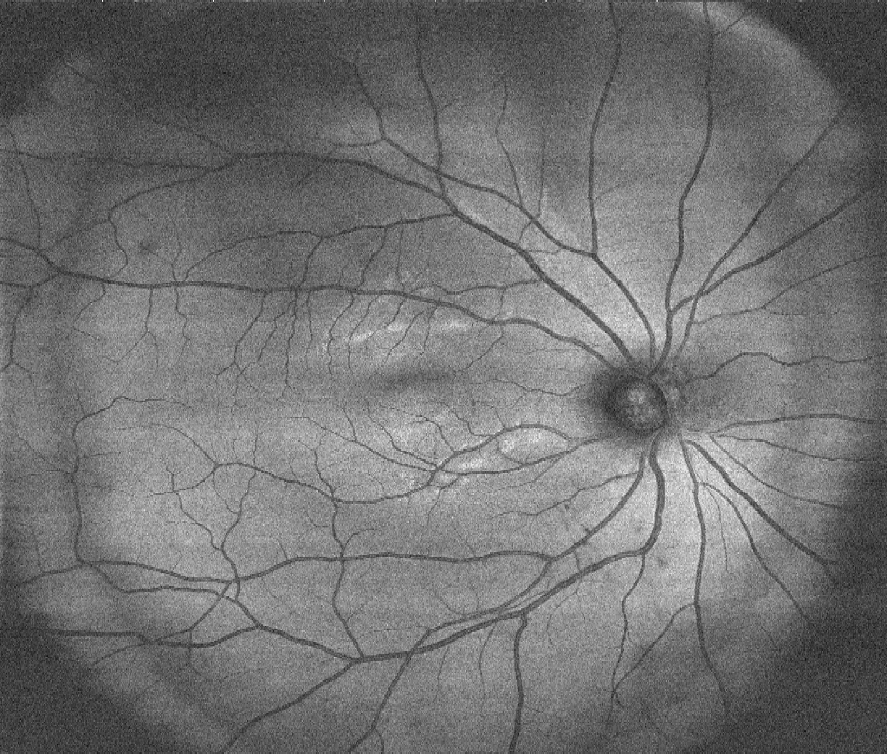

Suppl Fig. 1. En face projection of wide-field VIS-OCT imaging >60° viewing angle. The scanning density is 1024x512 acquired at 100kHz Aline rate.

- Spectrum from visible and near infrared channels.
Suppl Fig 2. The raw spectra in VIS-OCT (a) and NIR-OCT (b) channels.

- Device photograph

Suppl Fig. 3. Photograph of the device from front and side views(a-b). Photograph of custom-made mounting for the retroreflector on a high-torque galvanometer (HTGM) and the fixation target using LED arrays (c-d).

- Scanning protocols

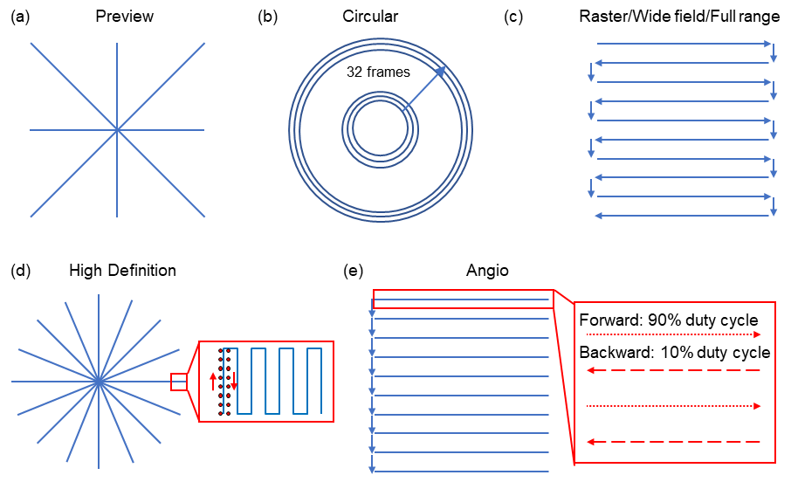
Suppl Fig. 4. Schematic of the scanning path for different protocols encompassed in this paper for the preview (a), circular disc scan (b), raster scan (c), high-definition scan, and (e) angiography scan.

