Supplemental materials

Methods

Additional questionnaires were used to characterize the sample, including: 1) the Sociocultural Adaptation Scale, in which participants rated the difficulty of adapting to various aspects of their host culture (SCAS; 1-7 from very difficult to very easy, M = 4.72, SD = 0.96) (Demes & Geeraert, 2014); 2) the perceived cultural distance scale, in which participants rated how similar their host culture is to their home culture on various items (1-7 from very similar to very different, M = 5.16, SD = 0.73) (Demes & Geeraert, 2014); 3) the Schwartz Culture Value Scale (SVS) (-1-7 from opposite to my values to extremely important) to assess cross-cultural values and beliefs (Schwartz, 1992; M_{achievement} = 1.96, SD_{achievement} = 1.46; M_{tradition} = -0.29, SD_{tradition} = 1.31; M_{conformity} = 1.69, SD_{conformity} = 1.27; M_{self-direction} = 2.23, SD_{self-direction} = 1.32).
Additional Analyses
We were also interested whether time in the US, an objective measure of exposure to the US and potential acculturative influences, was associated with the self-reference effect in memory. When alone in the model, time in the US did not significantly predict the difference in memory performance between self and close other conditions (β = 0.17, t = 1.45, p = 0.15). This continued to be the case with covariates included in the model (p = 0.11).
Supplemental Figure 1. Scatterplot of the Relationship Between SRE and Time in the U.S.
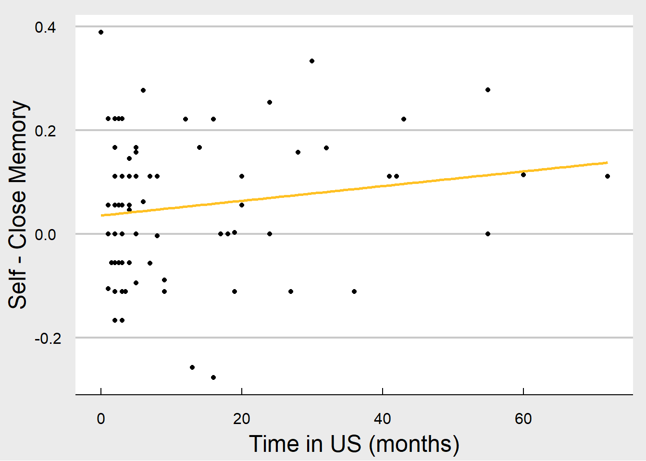
Due to the COVID-19 pandemic, some participants were run in person and some were run online; this also meant that unexpectedly, some participants were tested in the US and some had returned home to China. We tested for the potential influence of COVID-19, current country of residence, and form of data collection, keeping in mind that the three are confounded in this sample. Welch two sample t-tests were run comparing online (n = 53) versus in-person (n = 38) participants in terms of self-versus-close other memory (t(75.70) = 0.25, p = 0.80), close other-versus-farm animal memory (t(87.35) = -0.43, p = 0.67), adjusted host acculturation (t(70.83) = 2.98, p < .01), and adjusted independence (t(66.19) = 1.25, p = 0.21). Only adjusted host acculturation significantly differed between online and in person groups, such that those run in person prior to COVID’s spread were more acculturated to the United States. Welch two sample t-tests were similarly run to examine the difference between participants living in the US and China at time of test in terms of self-versus-close other memory (t(29.66) = -0.06, p = 0.95), close other-versus-farm animal memory (t(17.81) = -0.25, p = 0.80), adjusted host acculturation (t(21.60) = -0.56, p = 0.58), and adjusted independence (t(30.53) = -2.25, p = 0.03). Only adjusted independence significantly differed between US and China residing samples, such that participants residing in China were on average less independent in terms of self-construal.
The exploratory analyses suggest that adjusted host acculturation differed between online (post-COVID) versus in person (pre-COVID) samples. Additionally, adjusted independence differed between participants residing in the US and China in the expected direction, such that participants tested in the US were more independent than those tested in China.

