Supporting Information
Dynamically electrocatalytic CO₂ reduction on Cu-N-C single-atom catalysts
Yanyang Qin¹, Wenshan Zhao¹, Li-Juan Yu², Jianrui Zhang¹, Tiantian Wu^{1, *}, Yaqiong Su^{1, *}
¹ School of Chemistry, Xi'an Key Laboratory of Sustainable Energy Materials Chemistry, State Key Laboratory of Electrical Insulation and Power Equipment, Engineering Research Center of Energy Storage Materials and Devices of Ministry of Education, Xi'an Jiaotong University, Xi'an, 710049, China.
^{2.} Research School of Chemistry, The Australian National University, Canberra, 2601 ACT, Australia.
These authors contributed equally: Yanyang Qin, Wenshan Zhao
*Corresponding Author, Email: tianwu@xjtu.edu.cn, yqsu1989@xjtu.edu.cn

Contents

1. Gibbs free energy calculation method under constant potentials 3
2. Computational method of the free energy of a single dissolved Cu²⁺ ion 3
3. Constant-potential calculation method 4
4. “Slow-growth” approach 5
5. Supplementary figures 7
6. Supplementary tables 13
7. References 14

1. Gibbs free energy calculation method under constant potentials
The Gibbs free energy changes (ΔG) at each ORR reaction step under a constant potential (U) were evaluated by equation (1):
$$\begin{aligned}∆G=∆E(U)+∆ZPE+∆G_{U}^{PCET}+∆G_{pH}+∆\int_{0}^{T}{C_{P}dT}-T∆S\#(1)\end{aligned}$$
In the above equation, E(U) is defined as a grand canonical energy of the system:
$$\begin{aligned}E\left(U\right)=E_{DFT}+∆n^{CPS}∙\left(U-V_{sol}+\frac{Ф_{SHE}}{e}\right)\#\left(2\right)\end{aligned}$$
where E_{DFT} is the energy calculated from DFT, Δn^{CPS} is the number of electrons added or removed from the system, which is determined by the constant-potential method. Φ_{SHE} is the work function of the standard hydrogen electrode, SHE (- 4.6 eV), and V_{sol} is the potential deep in the solution.
And ΔZPE is the zero-point energy change, ΔG_{U}^{PCET} is the free energy contribution of the proton-coupled electron transfer (PCET) at electrode potential U. ΔG_{pH} is the correction of the H⁺ free energy by the concentration, which can be evaluated as ΔG_{pH} = 2.303 × k_{B}T × pH (or 0.06 × pH) eV. Here, the value of pH was initially assumed to be zero. ΔS is the entropy change. C_{P} is the constant-pressure heat capacity and the integration terms are calculated based on the vibrational energies of ORR intermediates. The enthalpies and entropies of free gas-phase molecules were obtained from the NIST-JANAF thermochemical tables(https://janaf.nist.gov/).

2. Computational method of the free energy of a single dissolved Cu²⁺ ion
Determining the free energy of dissolved metal ions and correlating it with DFT values poses a complex challenge, and directly calculating this energy using first principles remains a significant obstacle in the field. To address this, Persson et al. employed a mixed DFT-experimental value as a reference for the aqueous ion energy¹. Experimental data on the free energies of ions relative to bulk metal have been reported for numerous systems ($G_{exp}$)²⁻⁵. These values are taken at standard conditions and referenced to DFT values that are calculated for bulk reference states ($E_{DFT,0 K,M_{bulk}}$) where the free energy is set to 0 eV. For dilute solutions, the ionic activity is assumed to be equivalent to dissolved metal ion concentration, with an activity coefficient of unity. Therefore, by utilizing the Nernst equation, the free energy of dissolved ions can be determined as a function of temperature and dissolved metal ion concentration ($c_{M_{aq}^{x+}}$):
$$\begin{aligned}G_{M_{aq}^{2+}}=E_{DFT,0 K,M_{bulk}}+G_{exp}+k_{B}Tln\left(\frac{c_{M_{aq}^{x+}}}{c^{0}}\right)\#\left(3\right)\end{aligned}$$
where c⁰ is the standard ionic concentration used in the corresponding experiment for determining the G_{exp}. In this study, for Cu²⁺ we adopt a G_{exp} of 0.68 eV according to the experimental data²⁻⁵, the corresponding$E_{DFT,0 K,{Cu}_{bulk}}$ is calculated to be -4.52 eV, therefore, the free energy of a single dissolved Cu²⁺ ion ($G_{M_{aq}^{2+}}$) at $c_{{Cu}_{aq}^{2+}}=1M$ is -3.84 eV.

3. Constant-potential calculation method
The potential-dependent calculation was implemented according to the method and code developed by Duan and co-workers⁶.
In this method, the total number of electrons n, is considered as an additional degree of freedom, which is added on top of the Cartesian coordinates, r. Thus, the corresponding enthalpy landscape on (r, n) can be written as
$$\begin{aligned}H\left(r, n\right)=E\left(r, n\right)-\left(n-n_{0}\right)ϕ\#(4)\end{aligned}$$
where E(r, n) is the internal potential energy, n₀ is the total number of nuclear charges, and ϕ is the effective energy level of the counter electrode.
Taking the SHE with the Fermi level of E_{fS} = − 4.6 eV as the reference electrode, we have
$$\begin{aligned}ϕ=-U+\frac{E_{fS}}{e}\#\left(5\right)\end{aligned}$$
where U is the applied voltage with respect to SHE. As the work function of SHE measurement is scattered from 4.4 through 4.8 eV⁷, the average value of 4.6 eV is taken for our calculations, which is also frequently used in several recent studies^{8, 9}.
The electron chemical potential is then
$$\begin{aligned}μ=\frac{∂E}{∂N}-ϕ=E_{f}-ϕ\#\left(6\right)\end{aligned}$$
where E_{f} is the Fermi level of the working electrode with adsorbates.
Herein, E_{f} is obtained from the output of VASP, and then referenced to vacuum in post-processing by subtracting the surface electrostatic potential. The full gradient of H(r, n) is then (∂H/∂r, ∂H/∂n) = (−f, μ), where f is the atomic force vector. Then, the local optimization can be performed on H(r, n) with the generalized force (f, −μ). This direct optimization approach simultaneously relaxes the atomic positions and the number of electrons. The optimization will stop when the generalized force reached the convergence criteria, which is set as 0.02.

4. “Slow-growth” approach
The "slow-growth" method involves calculating the free energy difference between the initial and final states (IS and FS) through thermodynamic integration¹⁰, as shown below:
$$\begin{aligned}W_{IS→FS}=\int_{ξ_{IS}}^{ξ_{FS}}{dξ}\frac{dW}{dξ}\#\left(7\right)\end{aligned}$$
where $\frac{dW}{dξ}$ is the free energy gradient that can be computed by taking the ensemble-averaged derivative of the Hamiltonian with respect to the variable ξ. In this work, the ξ is chosen as the reaction coordinate (the distance between Cu and N atoms), so that thermodynamic integration can be used to evaluate the reaction and activation energies along the reaction path can be evaluated by varying ξ. The free energy can be considered as the potential of the mean force ($\frac{dW}{dξ}$).
The blue-moon ensemble method is used for evaluating $\frac{dW}{dξ}$ (treated in the form of ${〈\frac{∂H}{∂ξ}〉}_{ξ}$ in this case) by taking a time average over a constrained trajectory of AIMD simulation¹¹, with the ξ fixed at a specified value. In this case, the mean force can be calculated as demonstrated below¹²:
$$\begin{aligned}\frac{dW}{dξ}=\frac{{〈Z^{-\frac{1}{2}}\left(-λ+kTG\right)〉}_{ξ}}{{〈Z^{-\frac{1}{2}}〉}_{ξ}}\#\left(8\right)\end{aligned}$$
where $Z=\sum_{i}{\frac{1}{m_{i}}}{(\frac{∂ξ}{∂r_{i}})}^{2}$ and$G=Z^{-1/2}\sum_{i,j}{\frac{1}{m_{i}m_{j}}}\frac{∂ξ}{∂r_{i}}\frac{∂ξ}{∂r_{i}∂r_{j}}\frac{∂ξ}{∂r_{j}}$, λ is the Lagrange multiplier that can be determined via SHAKE algorithm for constraining the reaction coordinate¹³, modifying the Lagrangian to be:
$$\begin{aligned}L^{*}\left(r,p,ξ\right)=L\left(r,p\right)+λ\left[ξ\left(r\right)-ξ\right]\#\left(9\right)\end{aligned}$$
Here we automated the variation of by imposing an infinitesimally small constant speed $\frac{dξ}{dt}$ of 0.0005 Å/timestep, where the timestep is set to be 1 fs. Eventually, the free energy change can be calculated by¹⁴:
$$\begin{aligned}W_{IS→FS}=\int_{ξ_{IS}}^{ξ_{FS}}{dξ}{〈\frac{∂H}{∂ξ}〉}_{ξ}=\lim_{\frac{dξ}{dt}→0}{\int_{ξ_{IS}}^{ξ_{FS}}{\frac{dξ}{dt}}\frac{∂H}{∂ξ}dt}\#\left(10\right)\end{aligned}$$

5. Supplementary figures
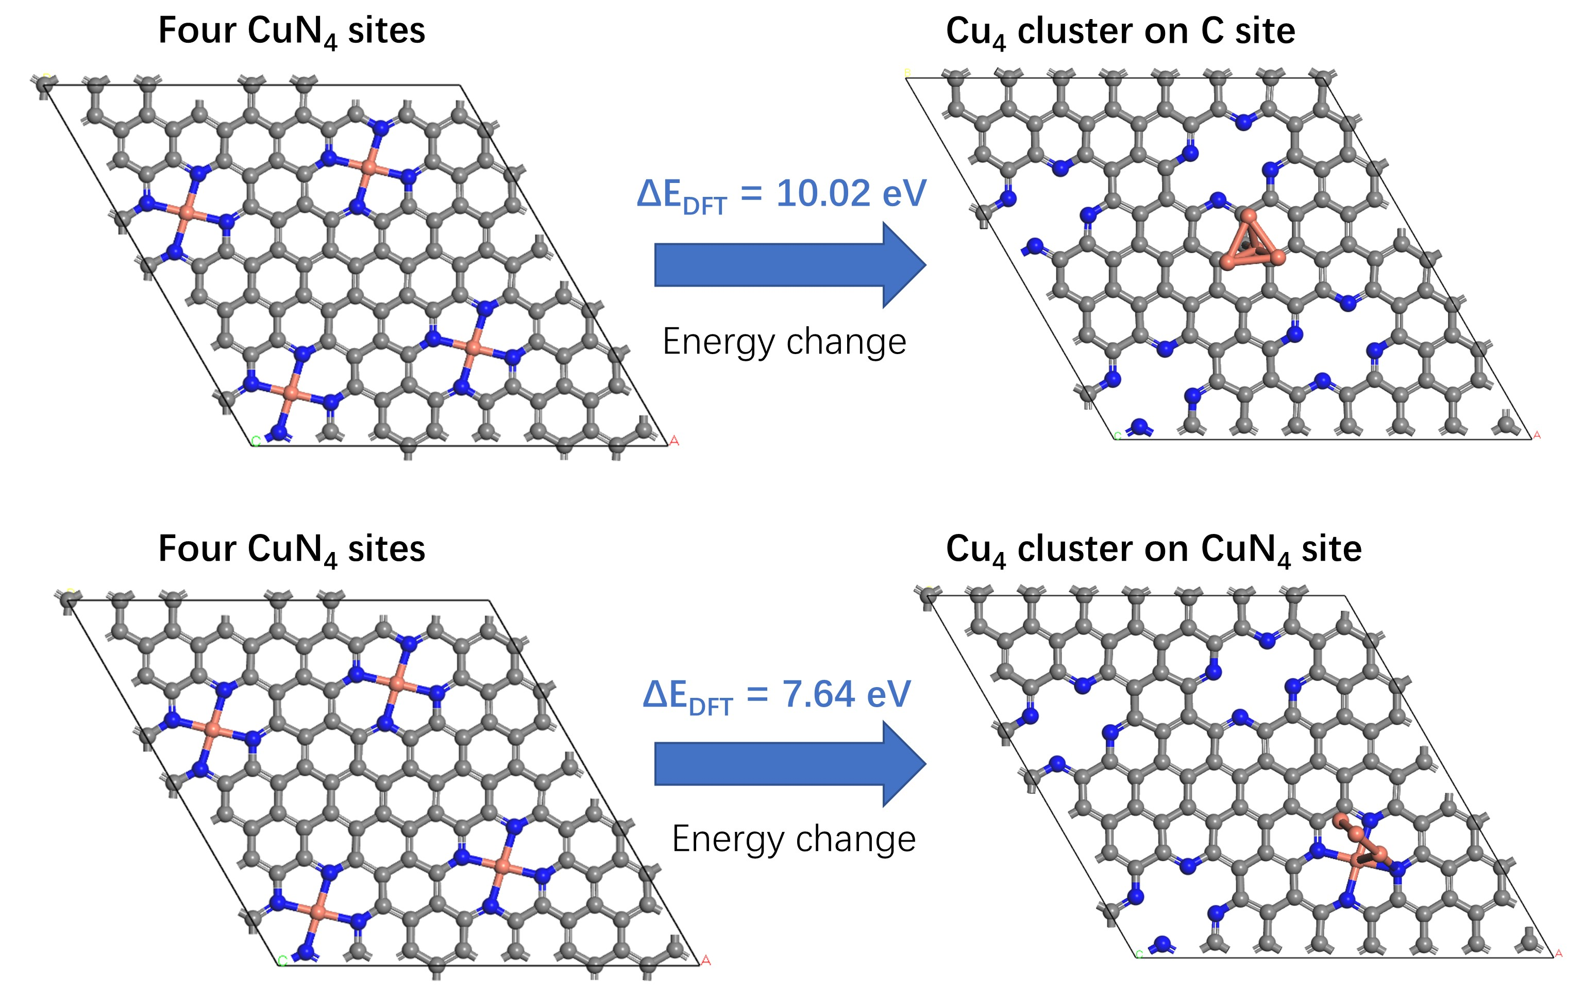
Fig. S1 The binding energies of the Cu₄ cluster on the C site of the graphene substrate and on CuN₄ site, respectively. Cu, N, C, and H atoms are shown in orange, blue, gray, and white, respectively.
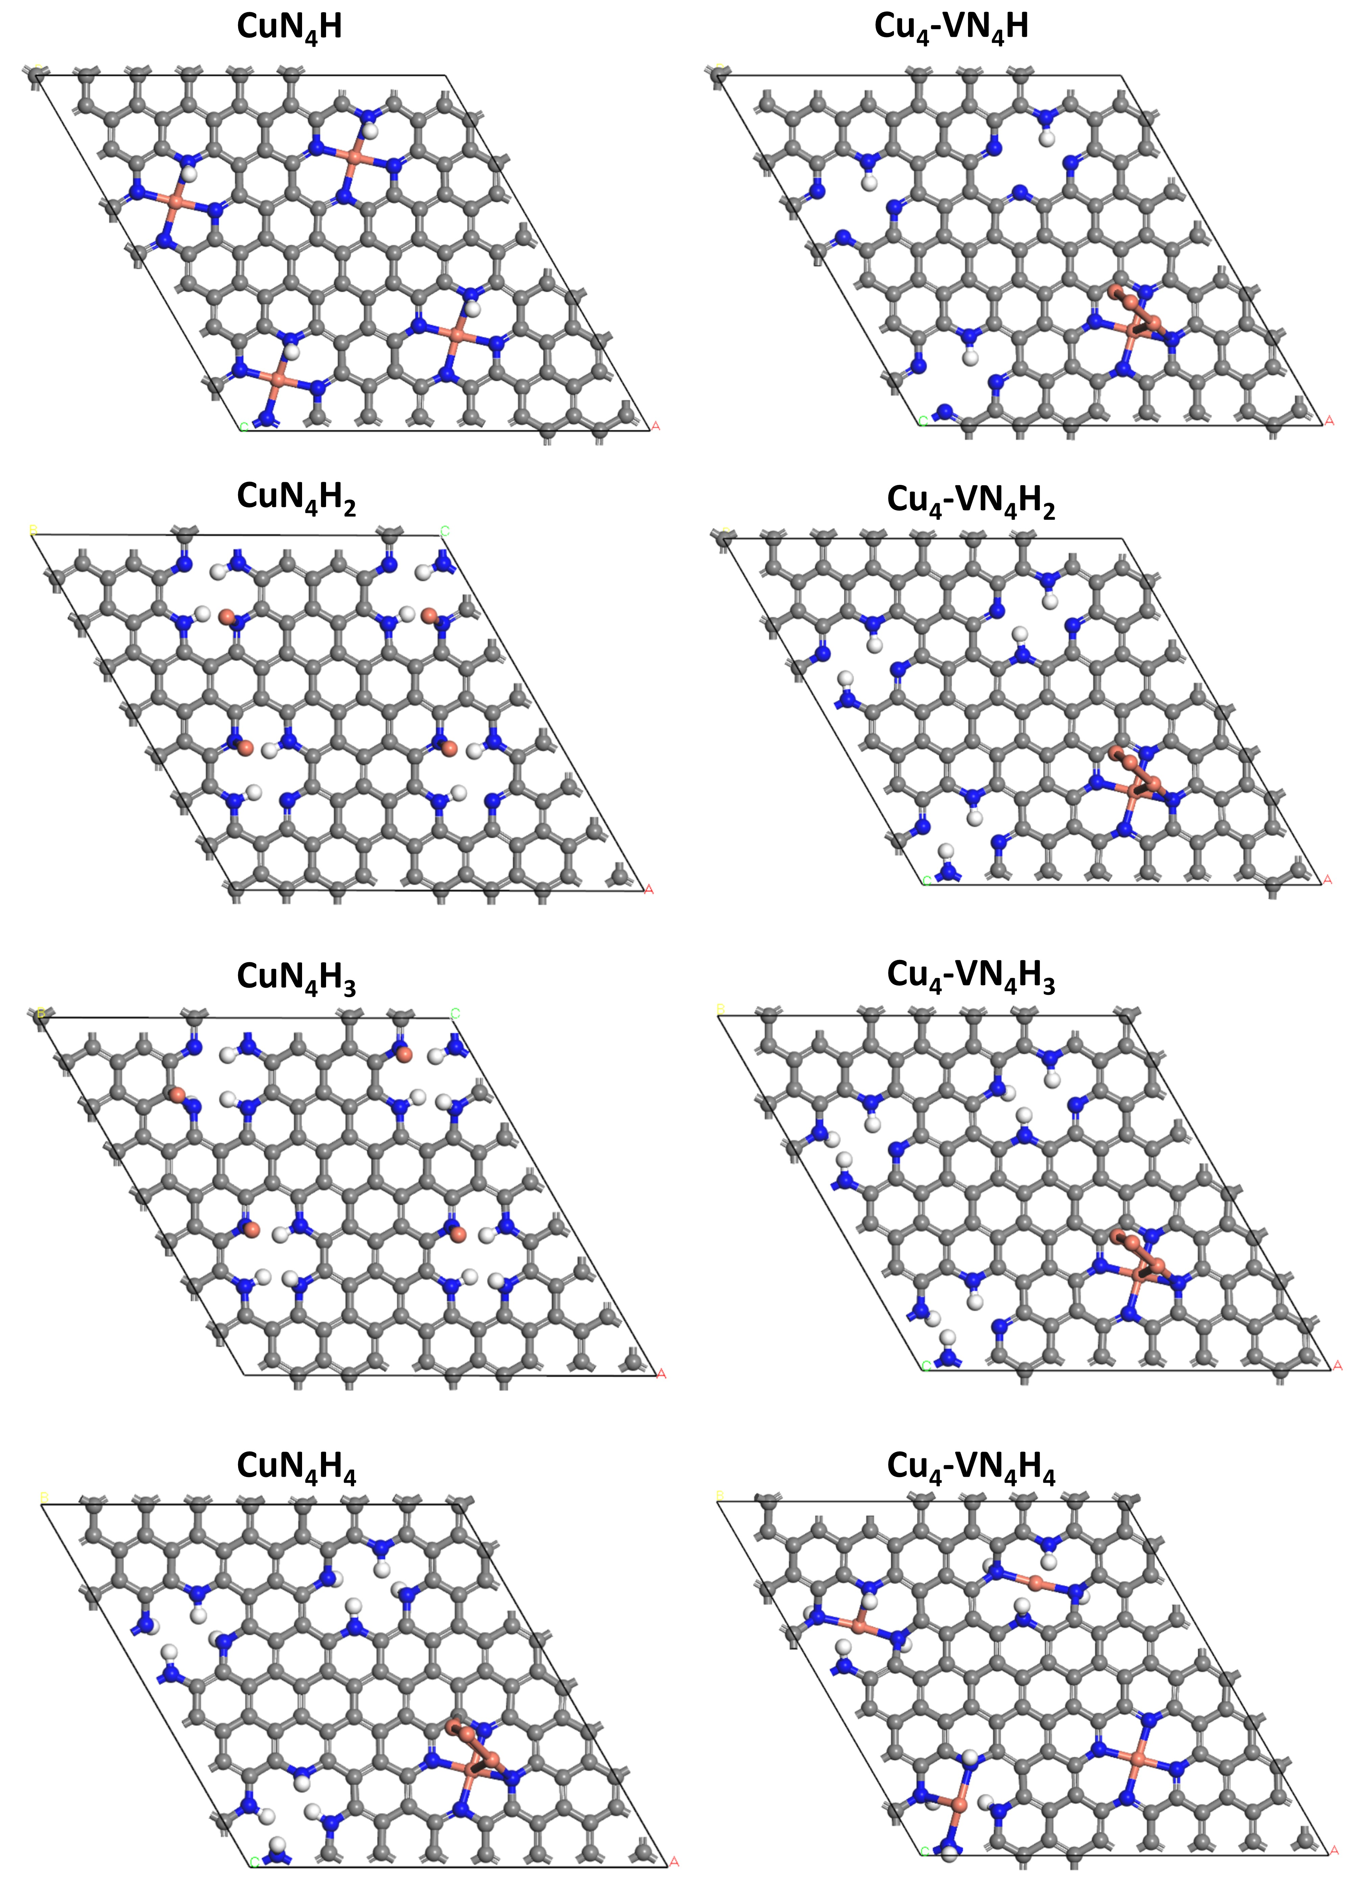
Fig. S2 The optimized structures of the CuN₄ SAC structures with 1-₄ adsorbed H ( CuN₄H, CuN₄H2, CuN₄H3, and CuN₄H₄, respectively), and the corresponding Cu₄ cluster structures (Cu₄-VN₄H, Cu₄-VN₄H₂, Cu₄-VN₄H₃, and Cu₄-VN₄H₄, respectively).
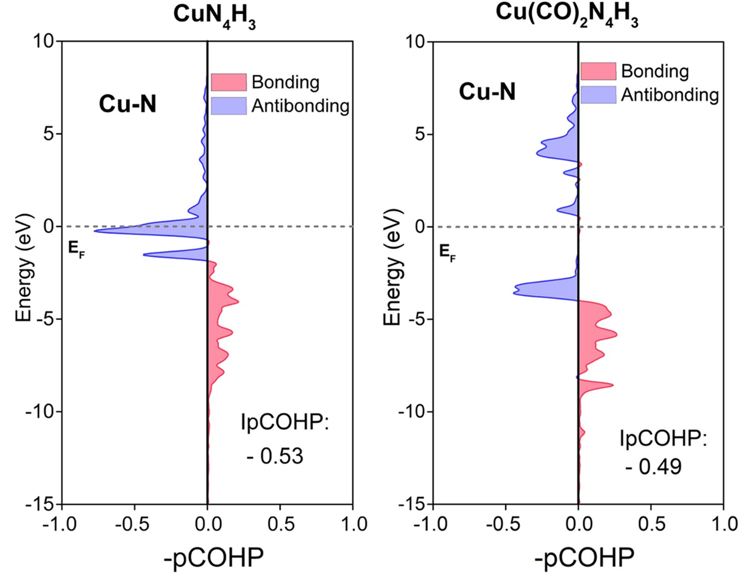
Fig. S3 The calculated projected crystal orbital overlap population (pCOHP) and the integrated-pCOHP (IpCOHP) results of Cu-N bonds for CuH₄N₃ and Cu(CO)₂N₄H₃.
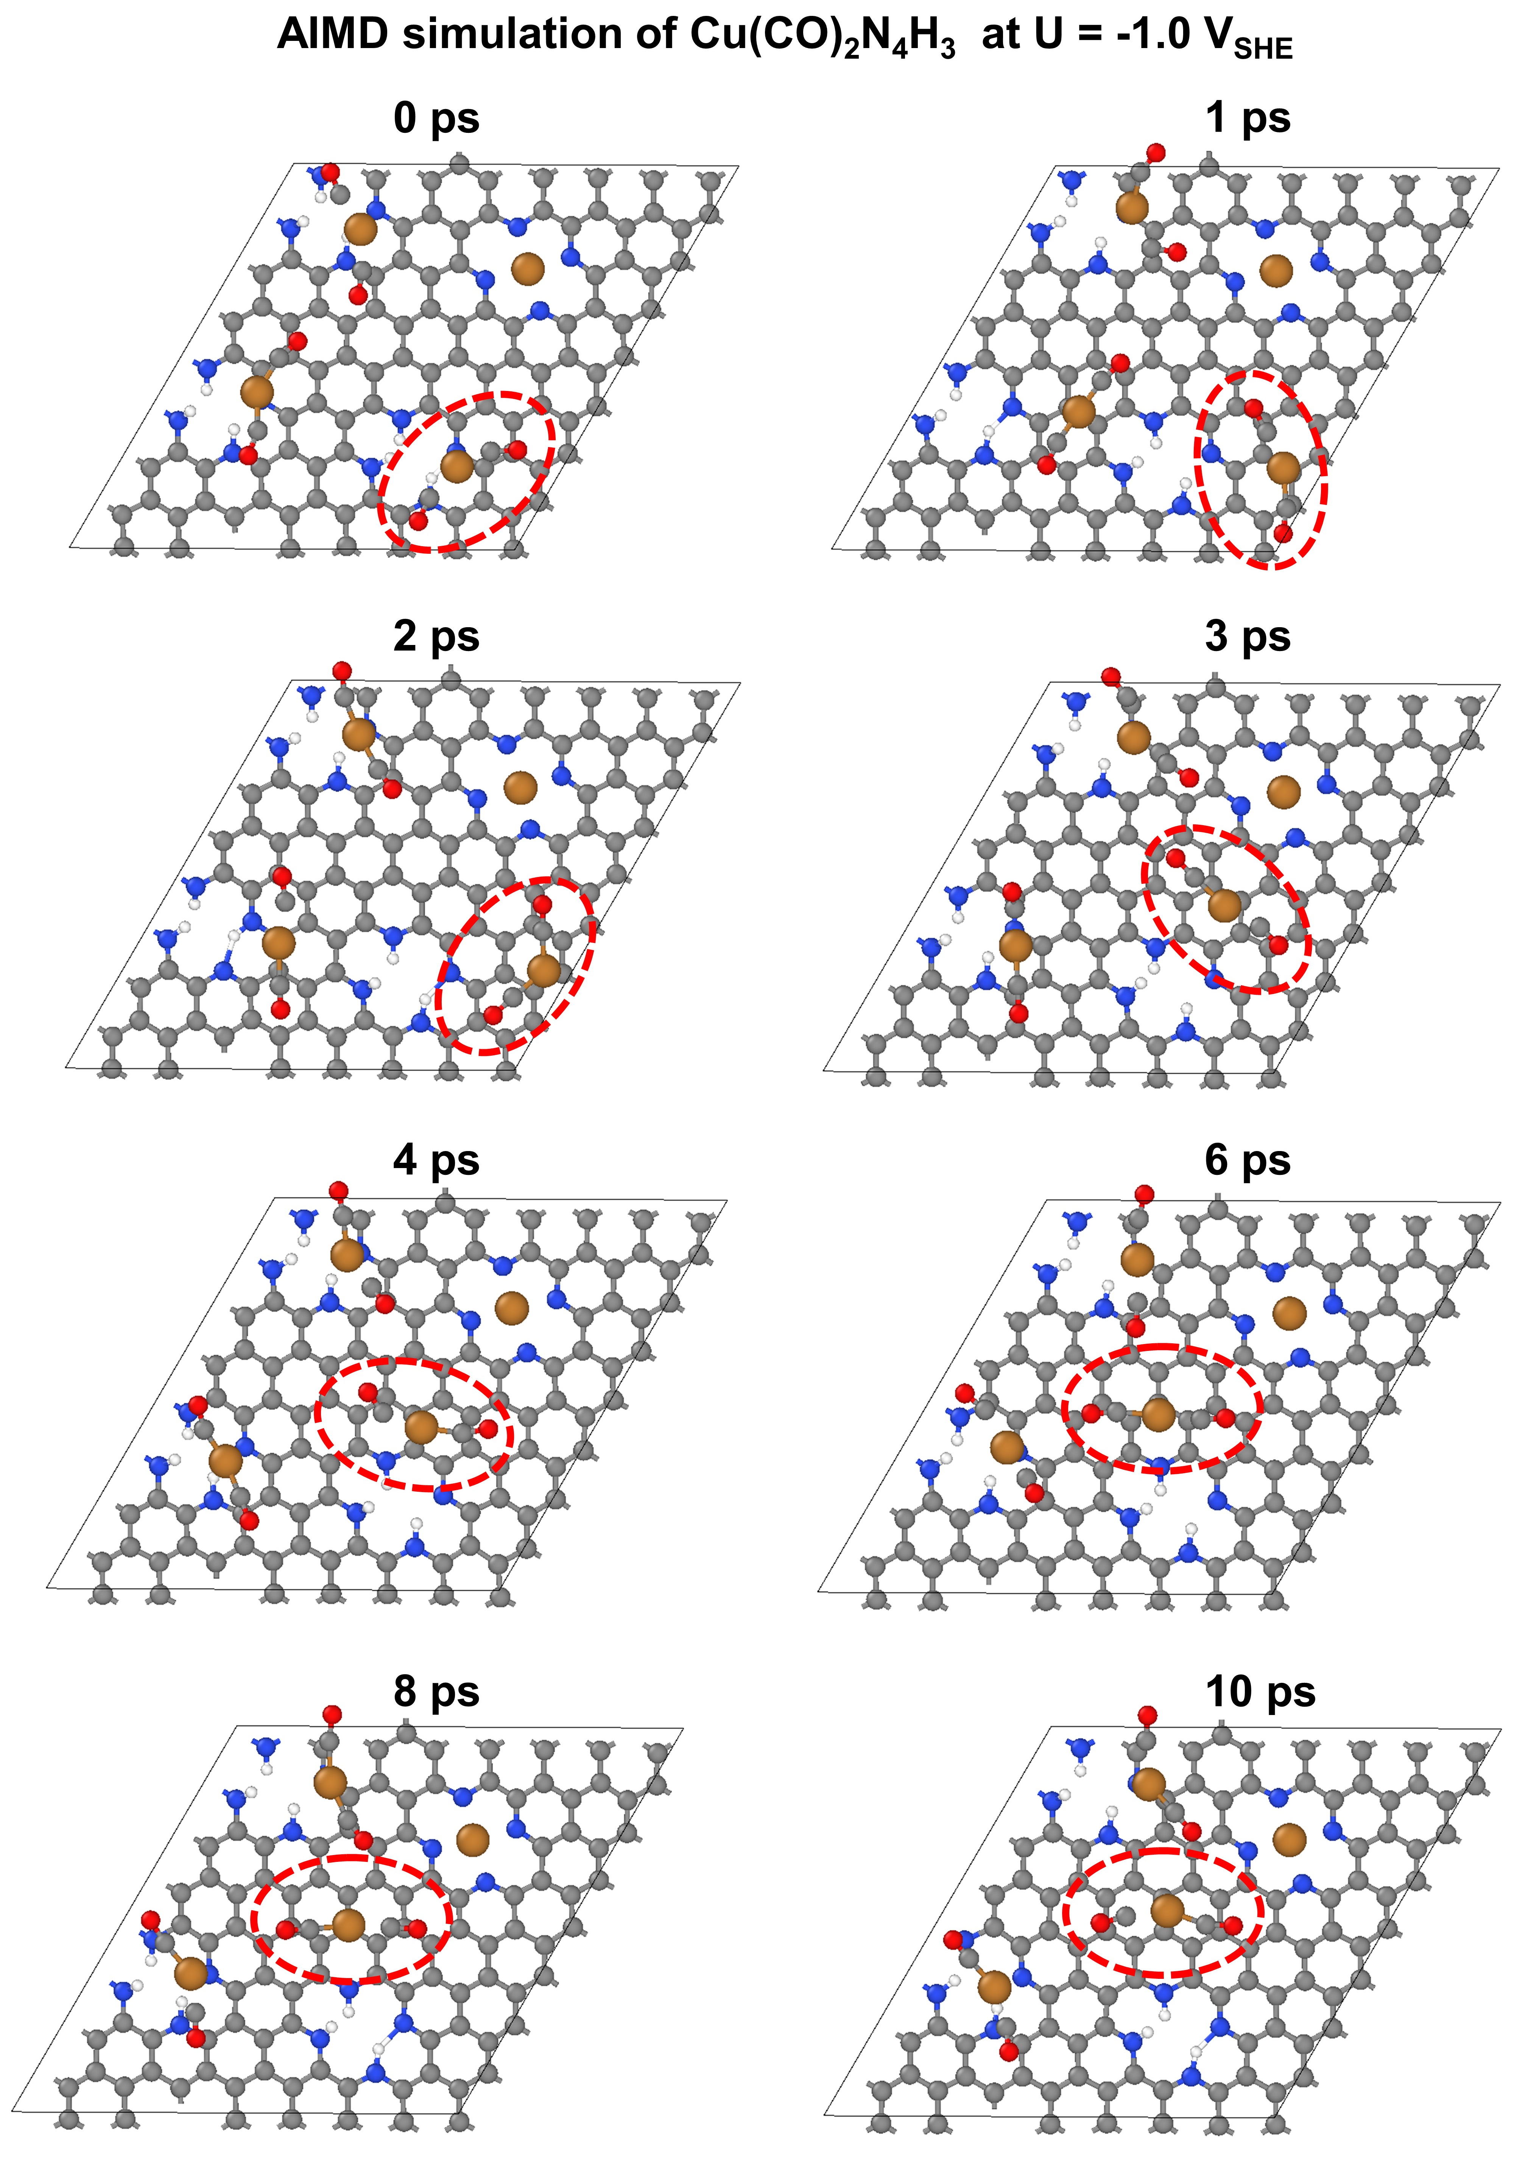
Fig. S4 The representative snapshots of Cu-N bond elongating during the slow growth AIMD (SG-AIMD) simulation. Cu, N, C, and H atoms are shown in orange, blue, gray, and white, respectively. The red dashed circle notes the Cu(CO)₂ moiety.

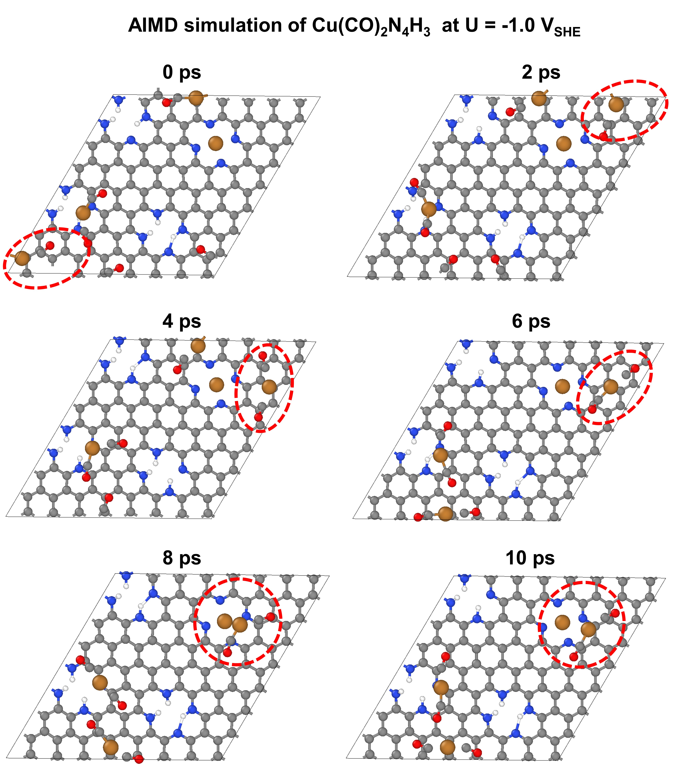
Fig. S5 The representative snapshots of Cu leaching and forming a [Cu^{Ⅰ}(CO)₂]⁺ complex during the AIMD simulation. Cu, N, C, and H atoms are shown in orange, blue, gray, and white, respectively. The red dashed circle notes the Cu(CO)₂ moiety.
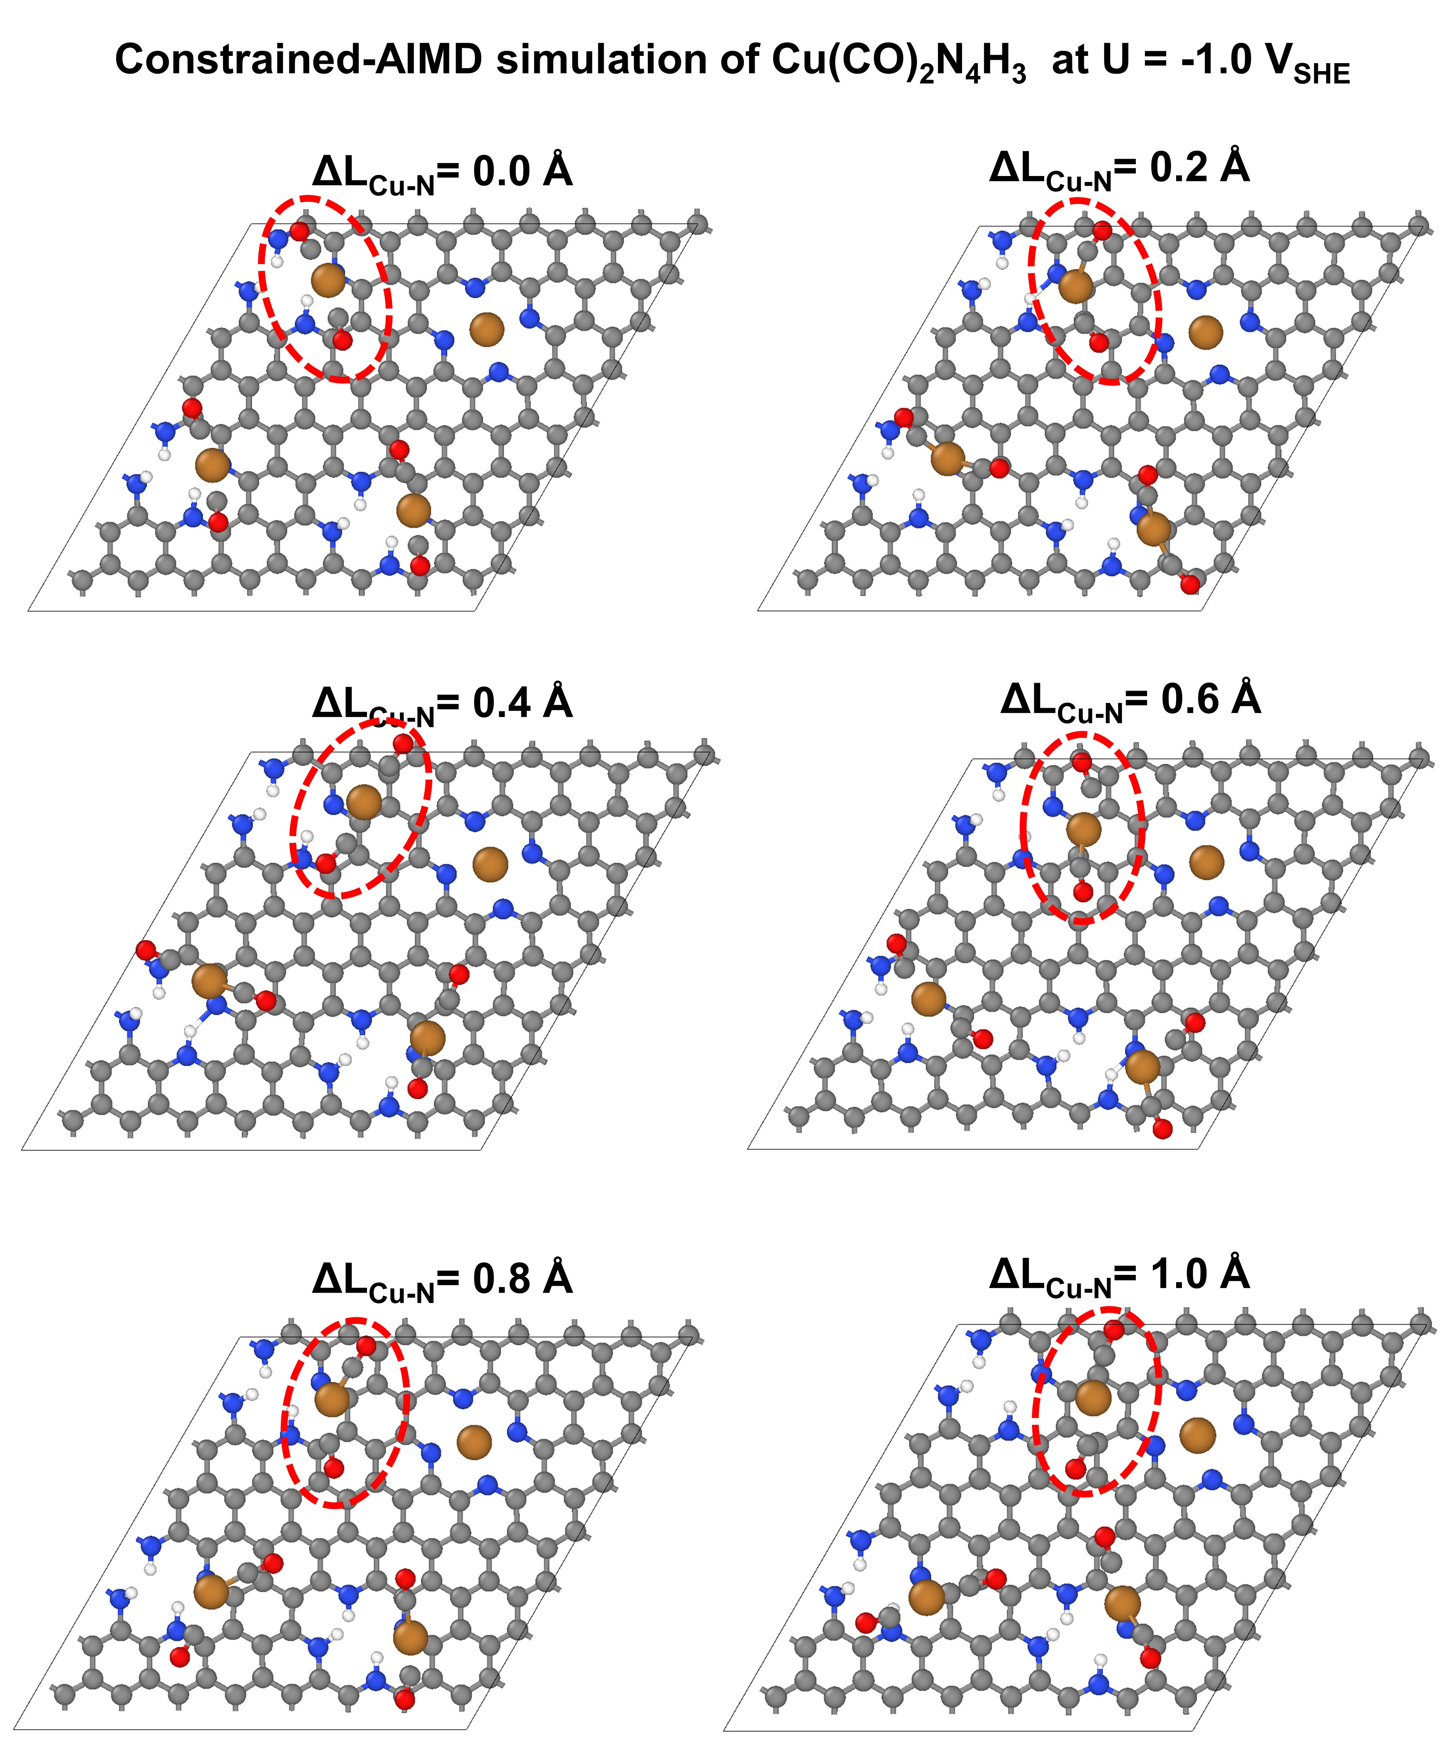
Fig. S6 The representative snapshots of [Cu^{Ⅰ}(CO)₂]⁺ complex migrating and initial sintering on another CuN₄ site during the AIMD simulation.
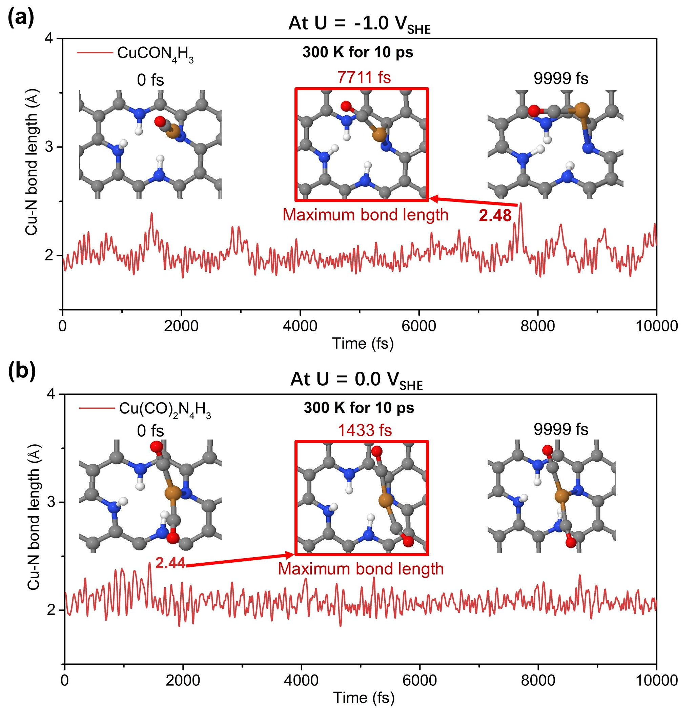
Fig. S7 AIMD simulations (300 K, 10 ps) results for (a) CuN₄H₃ with only one adsorbed CO (denoted as CuCON₄H₃) at U = -1.0 VSHE, and for (b) Cu(CO)₂N₄H₃ at U = 0 VSHE, respectively. The Cu-N bond length is plotted as a function of simulation time, and the representative snapshots are shown in the insets.

6. Supplementary tables
Table S1. Gibbs free energy changes of the CO₂RR intermediates on CuN₄, CuN₄H, CuN₄H₂, CuN₄H₃, CuN₄H₄, and Cu₁₃-CuN₄.
Species | ΔG (eV)
Species | CuN₄ | CuN₄H | CuN₄H₂ | CuN₄H₃ | CuN₄H₄ | Cu₁₃-CuN₄
*(substrate) | / | / | / | / | / | /
*CO2 | 0.2391 | 0.2168 | -0.3950 | -0.2407 | 0.0995 | 0.6063
*COOH | 1.3194 | 0.1699 | -0.4114 | -0.2913 | -1.2119 | 0.1774
*CO | -0.5630 | -0.7540 | 0.0280 | -0.2026 | 0.3570 | -0.3933
*(substrate) | -0.7754 | 0.5874 | 0.9985 | 0.9547 | 0.9755 | -0.1703
SUM | 0.2201 | 0.2201 | 0.2201 | 0.2201 | 0.2201 | 0.2201

7. References
1. Persson, K. A., Waldwick, B., Lazic, P., Ceder, G. Prediction of solid-aqueous equilibria: Scheme to combine first-principles calculations of solids with experimental aqueous states. Phys. Rev. B 85, 235438 (2012).
2. Pourbaix, M. Atlas of electrochemical equilibria in aqueous solutions. NACE, (1966).
3. Bard, A. Standard potentials in aqueous solution. Routledge, 2017.
4. Naumov, G. B., Ryzhenko, B. N., Khodakovskiĭ, I. L. v. Handbook of thermodynamic data, vol. 226. US Geological Survey, Water Resources Division Menlo Park, CA, 1974.
5. Beverskog, B., Puigdomenech, I. Revised pourbaix diagrams for iron at 25–300 c. Corrosion Sci. 38, 2121-2135 (1996).
6. Duan, Z., Xiao, P. Simulation of potential-dependent activation energies in electrocatalysis: Mechanism of O-O bond formation on RuO₂. J. Phys. Chem. C 125, 15243-15250 (2021).
7. Trasatti, S. Structure of the metal/electrolyte solution interface: New data for theory. Electrochim. Acta 36, 1659-1667 (1991).
8. Zhao, X., Liu, Y. Origin of selective production of hydrogen peroxide by electrochemical oxygen reduction. J. Am. Chem. Soc. 143, 9423-9428 (2021).
9. Duan, Z., Henkelman, G. Theoretical resolution of the exceptional oxygen reduction activity of Au(100) in alkaline media. ACS Catal. 9, 5567-5573 (2019).
10. Woo, T. K., Margl, P. M., Blöchl, P. E., Ziegler, T. A combined car−parrinello QM/MM implementation for ab initio molecular dynamics simulations of extended systems: Application to transition metal catalysis. J. Phys. Chem. B 101, 7877-7880 (1997).
11. Carter, E. A., Ciccotti, G., Hynes, J. T., Kapral, R. Constrained reaction coordinate dynamics for the simulation of rare events. Chem. Phys. Lett. 156, 472-477 (1989).
12. Sprik, M., Ciccotti, G. Free energy from constrained molecular dynamics. J. Chem. Phys. 109, 7737-7744 (1998).
13. Ryckaert, J.-P., Ciccotti, G., Berendsen, H. J. C. Numerical integration of the Cartesian equations of motion of a system with constraints: Molecular dynamics of n-alkanes. J. Comput. Phys. 23, 327-341 (1977).
14. Jarzynski, C. Nonequilibrium equality for free energy differences. Phys. Rev. Lett. 78, 2690-2693 (1997).

