Supplementary Information (Supplementary Figures)
Targeting PD-L1 with DNA aptamers and conjugated with gemcitabine as a novel therapeutic strategy for bladder cancer chemotherapy combined with immunotherapy
Xing Hu et al. and Jianye Liu*

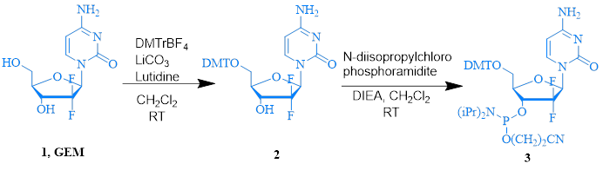
Supplementary Figure 1. The synthesis of GEM phosphoramidite 3.
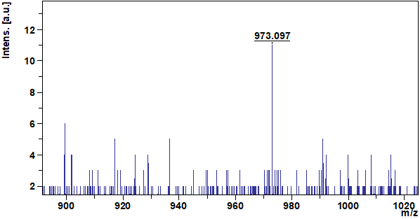
Supplementary Figure 2. The mass spectrum of GEM phosphoramidite 3.
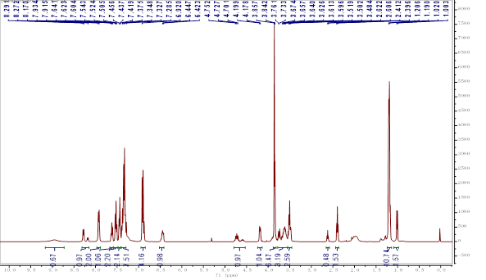
Supplementary Figure 3. The ¹H-NMR spectrum of GEM phosphoramidite 3.
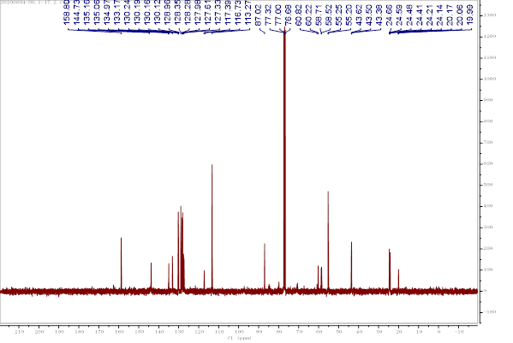
Supplementary Figure 4. The ¹³C-NMR spectrum of GEM phosphoramidite 3.
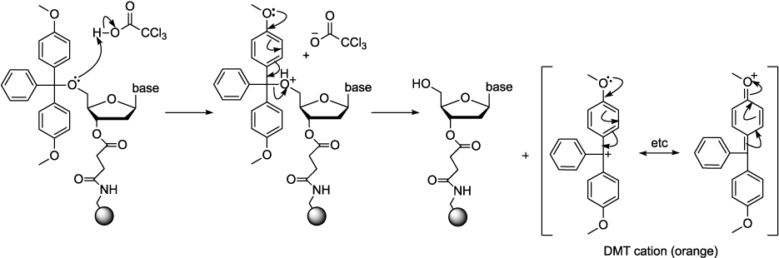
Supplementary Figure 5. Step one of synthesis.
According to the 3 'terminal first base of the oligonucleotide, CPG linked with one of the bases A, G, C and T is selected as the solid carrier. The base 5' OH is protected by the DMT protection group. Before starting synthesis, remove the DMT of the first base with trichloroacetic acid, and expose the active 5 'OH.
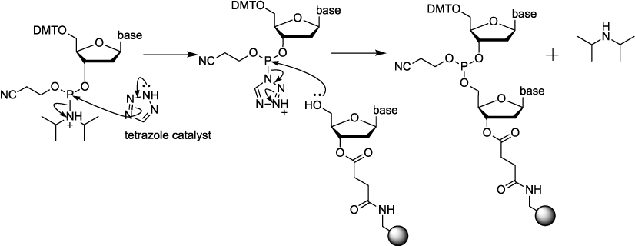
Supplementary Figure 6. Coupling.
After the completion of DMT removal, clean the residual trichloroacetic acid on the solid carrier with anhydrous acetonitrile, add tetrazolium and corresponding phosphorous amide monomer, and the phosphorous amide monomer activated by tetrazolium reacts with 5 'OH on the solid carrier to form phosphorous ester bond.
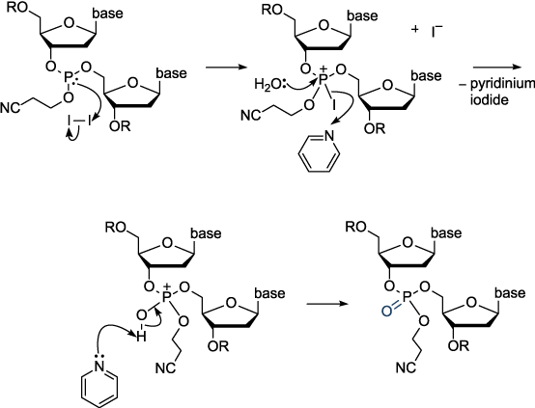
Supplementary Figure 7. Oxidation.
The phosphorous ester bond formed in the coupling step is unstable under acidic conditions. It is necessary to use I2 to oxidize trivalent phosphorus to pentavalent phosphorus to form a stable phosphate diester bond.
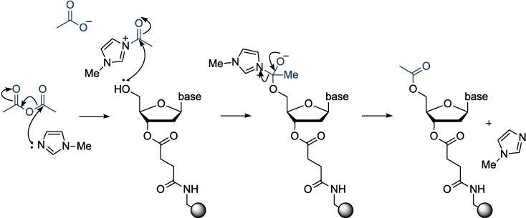
Supplementary Figure 8. Capping.
Use acetyl group to block 5 'OH that is not involved in the reaction to avoid its participation in the next round of reaction.
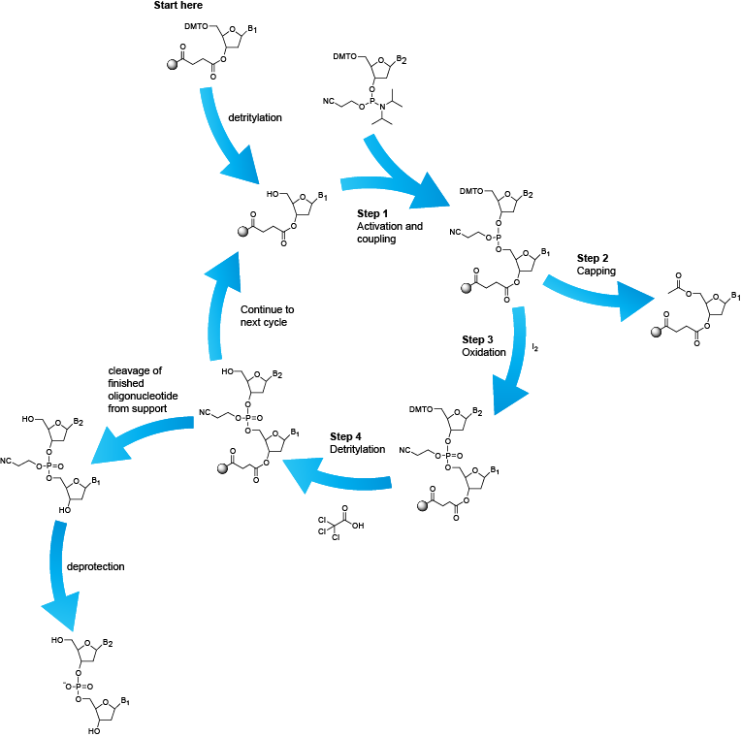
Supplementary Figure 9. The synthesis of PD-L1-GEMs.
Supplementary Figure 10. ESI-MS spectrum of PD-L1 aptamer.
Supplementary Figure 11. ESI-MS spectrum of Control-RS.
Supplementary Figure 12. ESI-MS spectrum of PD-L1-FITC.
Supplementary Figure 13. ESI-MS spectrum of Control-RS-FITC.
Supplementary Figure 14. ESI-MS spectrum of PD-L1-cy5
Supplementary Figure 15. ESI-MS spectrum of Control-RS-cy5.
Supplementary Figure 16. ESI-MS spectrum of PD-L1-GEMs.
Supplementary Figure 17. ESI-MS spectrum of Control-RS-GEMs.
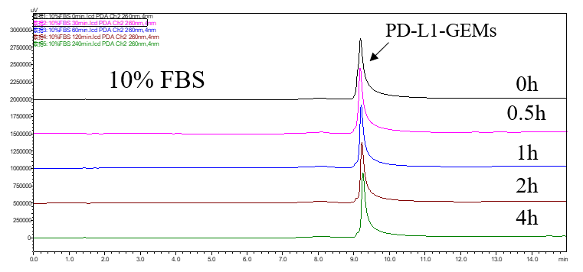
Supplementary Figure 18. The release of GEM from PD-L1-GEMs in 10% FBS buffer.
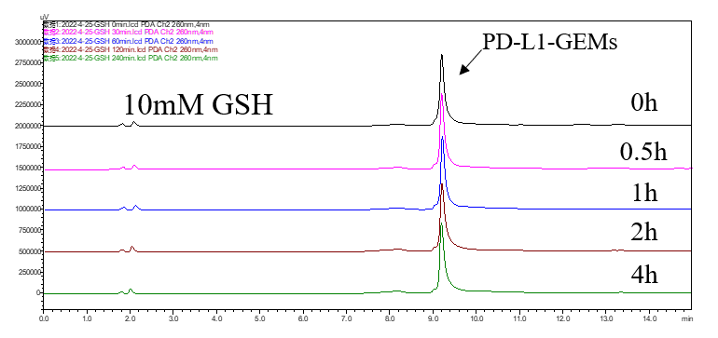
Supplementary Figure 19. The release of GEM from PD-L1-GEMs in 10 mM GSH buffer.
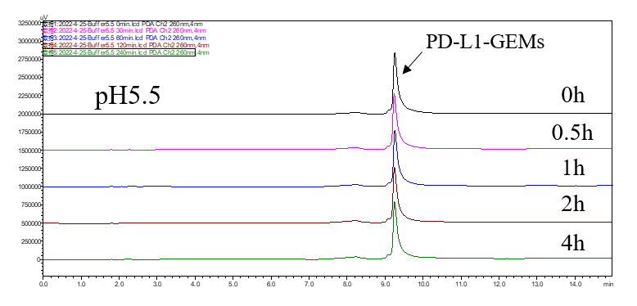
Supplementary Figure 20. The release of GEM from PD-L1-GEMs in pH 5.5 buffer.
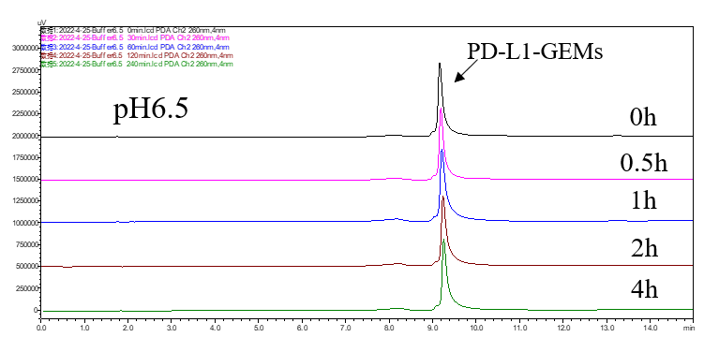
Supplementary Figure 21. The release of GEM from PD-L1-GEMs in pH 6.5 buffer.
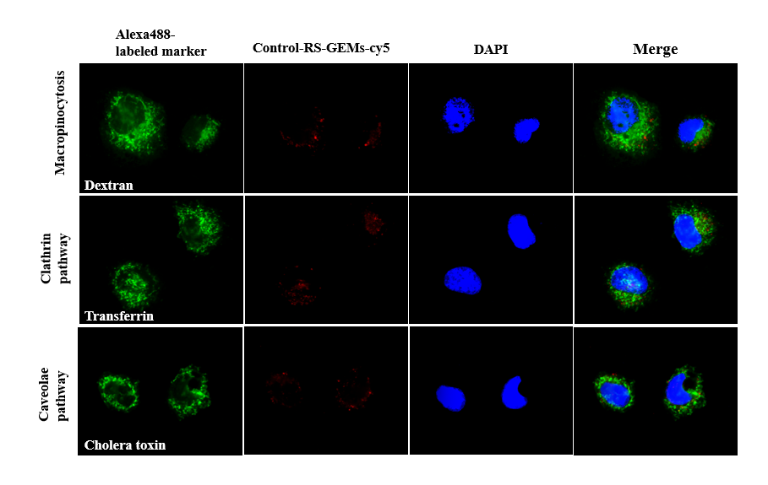
Supplementary Figure 22. Internalization and trafficking of Control-RS-GEMs-cy5 in EJ cells.
Photographs show Control-RS-GEMs-cy5 (red) co-localized with endocytic markers transferrin, cholera toxin, and dextran labeled with Alexa Fluor 488 (green), respectively. The nuclei were counterstained with DAPI (blue).

Supplementary Figure 23. AnnexinV-PE+7-AAD double staining assay was used to detect the cytotoxicity of PD-L1-GEMs by flow cytometry.
Supplementary Figure 24. Biosafety assessment of PD-L1-GEMs in stained tumor sections.
Tumor sections of different groups with (A) Ki67 staining (brown signal), (B) TUNEL staining (brown signal), (C) PD-L1 IHC staining.
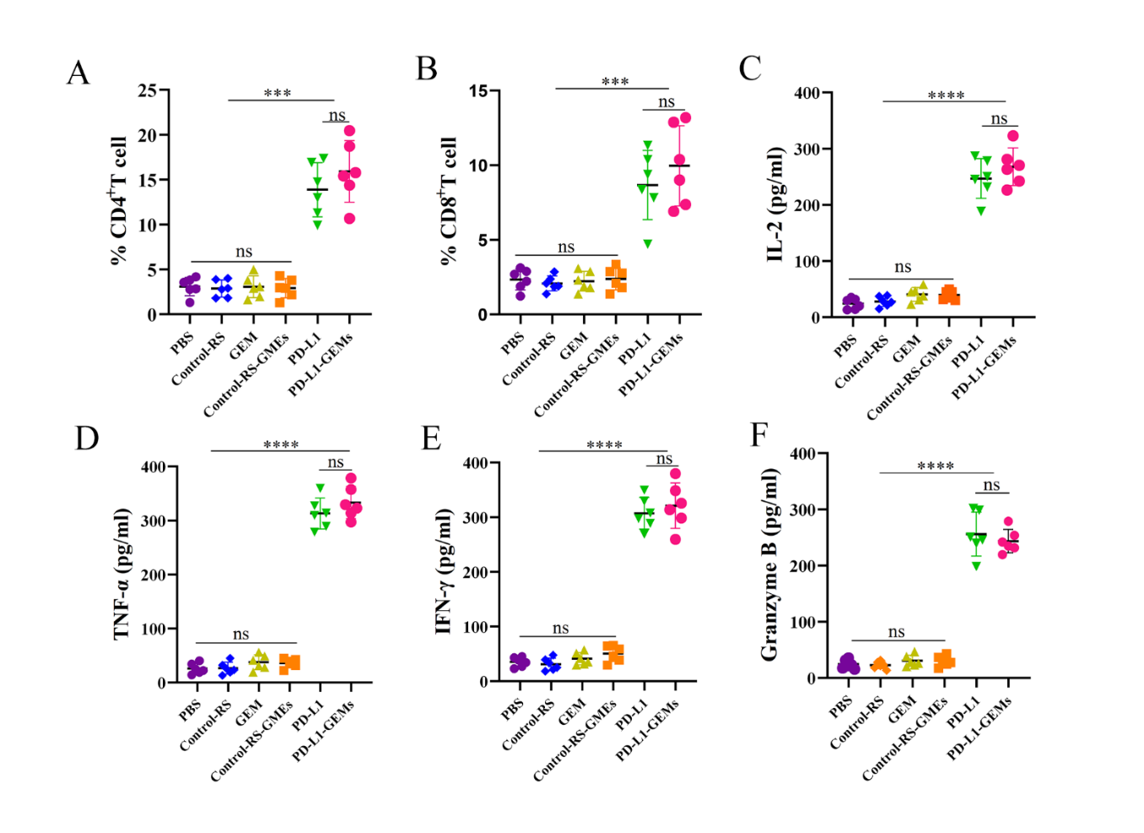
Supplementary Figure 25. Lymphocytes infiltration and cytokines secretion in tumor tissues.
(A-B) The infiltration of CD4⁺ and CD8⁺ T lymphocytes. (C-F) The secretion of IL-2, TNF-α，IFN-γ and Granzyme B. Data shown are the mean ± SD. (n = 6). ns: no significant difference. ***P < 0.001, ****P < 0.0001.
Supplementary Figure 26. The biosafety assessment of PD-L1-GEMs in biochemical assays.
RBCs: red blood cells, WBCs: white blood cells, HGB: hemoglobin, PLTs: platelets. Data are the mean ± SD, n =6. #P < 0.05 vs. the PBS group, * P < 0.05 vs. the PD-L1-GEMs group; ##P < 0.01 vs the PBS group, **P < 0.01 vs. the PD-L1-GEMs group; ***P < 0.001 vs. the PD-L1-GEMs group.
Supplementary Figure 27. The biosafety assessment of PD-L1-GEMs in enzymes assays.
ALT: alanine aminotransferase, AST: aspartate aminotransferase, CREA: creatinine, CK: creatine phosphokinase. Data are the mean ± SD, n = 6; #P < 0.05 vs. the PBS group, *P < 0.05 vs. the PD-L1-GEMs group; ##P < 0.01 vs. the PBS group, ***P < 0.001 vs. the PD-L1-GEMs group; ####P < 0.0001 vs. the PBS group, ****P < 0.0001 vs. the PD-L1-GEMs group.
Supplementary Figure 28. The biosafety assessment of PD-L1-GEMs in the staining of tissue sections.
H&E staining analysis of heart, liver, spleen, lung and kidney tissues in the different groups.

Supplementary Information (Supplementary Tables)
Targeting PD-L1 with DNA aptamers and conjugated with gemcitabine as a novel therapeutic strategy for bladder cancer chemotherapy combined with immunotherapy
Xing Hu et al. and Jianye Liu*
 |  | PD-L1 expression of bladder cancer cells
Characteristic | Number of patients  (n = 148) | Negative (%)  (n = 72) | Positive (%)  (n = 76) | P valueª
Age(years) |  |  |  | 0.052
≤60^{b} | 62 | 36(58.1) | 26(41.9)
＞60 | 86 | 36(41.9) | 50(58.1)
Gender |  |  |  | 0.084
Male | 125 | 57(45.6) | 68(54.4)
Female | 23 | 15(65.2) | 8(34.8)
Tumor size(cm) |  |  |  | 0.964
≤3.8^{c} | 84 | 41(48.8) | 43(51.2)
＞3.8 | 64 | 31(48.4) | 33(51.6)
Tumor multiplicity |  |  |  | 0.716
Unifocal | 39 | 18(46.2) | 21(53.8)
Multifocal | 109 | 54(49.5) | 55(50.5)
Tumor grade |  |  |  | 0.005
Low | 59 | 37(62.7) | 22(37.3)
High | 89 | 35(39.3) | 54(60.7)
pT status |  |  |  | ＜0.001
pT1 | 44 | 38(86.4) | 6(13.6)
pT2 | 52 | 23(44.2) | 29(55.8)
pT3/pT4 | 52 | 11(21.2) | 41(78.8)
pN status |  |  |  | 0.002
pN- | 123 | 67(54.5) | 56(45.5)
pN+ | 25 | 5(20.0) | 20(80.0)
Supplementary Table 1. Relationship between PD-L1 expression and clinicopathologic characteristics in bladder cancer patients. ªChi-square test. ^{b}mean age. ^{c}mean size.

Feature | All cases | HR (95% CI) | P valueª
Age(years) |  |  | 0.39
≤60^{b} | 62 | 1
＞60 | 86 | 1.288 (0.723-2.296)
Gender |  |  | 0.934
Male | 125 | 1
Female | 23 | 0.967 (0.435-2.150)
Tumor size(cm) |  |  | 0.596
≤3.8^{c} | 84 | 1
＞3.8 | 64 | 1.166 (0.661-2.055)
Tumor multiplicity |  |  | 0.998
Unifocal | 39 | 1
Multifocal | 109 | 1.001 (0.545-1.837)
Tumor grade |  |  | ＜0.001
Low | 59 | 1
High | 89 | 4.092 (1.978-8.466)
pT status |  |  | 0.013
pT1 | 44 | 1
pT2 | 52 | 2.029 (0.847-4.860)
pT3/pT4 | 52 | 3.365 (1.454-7.789)
pN status |  |  | ＜0.001
pN- | 123 | 1
pN+ | 25 | 3.878 (2.110-7.127)
PD-L1 expression |  |  | ＜0.001
Negative | 46 | 1
Positive | 102 | 3.983 (2.037-7.789)
Supplementary Table 2. Univariate analysis of PD-L1 and clinical features in bladder cancer patients. ªChi-square test. ^{b}mean age. ^{c}mean size. HR: hazard ratio. CI: confidence interval.

Feature | Hazards ratio | 95% CIª | P value
Tumor grade ( low vs. high) | 2.982 | 1.464-6.074 | 0.003
pT status ( pT1 vs. pT2 vs. pT3/pT4) | 1.179 | 0.751-1.849 | 0.474
pN status ( pN- vs. pN+) | 1.933 | 0.950-3.932 | 0.037
PD-L1 expression (negative vs. positive) | 3.122 | 1.450-6.725 | 0.004
Supplementary Table 3. Multivariate analysis of PD-L1 and clinical features in bladder cancer patients. ªCI: confidence interval.

Name | Sequences and modification (5' to 3')
PD-L1 | TT TAC AGG TTC TGG GGG GTG GGT GGG GAA CCT GTT TT
Control-RS | TT ATT ACC TCT AAA TCA CTG CTC TGT AAC ATG GTC GCG CTA GG TT
PD-L1-FITC | TT TAC AGG TTC TGG GGG GTG GGT GGG GAA CCT GTT TT(FITC)
Control-RS-FITC | TT ATT ACC TCT AAA TCA CTG CTC TGT AAC ATG GTC GCG CTA GG TT(FITC)
PD-L1-cy5 | TT TAC AGG TTC TGG GGG GTG GGT GGG GAA CCT GTT TT (cy5)
Control-RS-cy5 | TT ATT ACC TCT AAA TCA CTG CTC TGT AAC ATG GTC GCG CTA GG TT (cy5)
PD-L1-GEMs | TT TAC AGG TTC TGG GGG GTG GGT GGG GAA CCT GTT MMM TT
Control-RS-GEMs | TT ATT ACC TCT AAA TCA CTG CTC TGT AAC ATG GTC GCG CTA GG MMM TT
Supplementary Table 4. Aptamer sequences used in the study.
Group | No.of rats  sacrificed | Normal (T0) | Cancer in situ or Noninvasive papillary  carcinoma (Tis/Ta) | Subepithelial connective tissue invasive bladder cancer (T1) | Muscle invasive bladder cancer (≥T2)
PBS control | 10 | 0 | 1 | 1 | 8
PD-L1 | 10 | 0 | 2 | 3 | 5
Control-RS | 10 | 0 | 1 | 2 | 7
GEM | 10 | 1 | 4 | 2 | 3
Control-RS-GEMs | 10 | 2 | 3 | 2 | 3
PD-L1-GEMs | 10 | 5 | 3 | 2 | 0
Supplementary Table 5. Tumor suppression effect of different treatment on bladder histopathologic changes in SD rat bladders of different groups.
Group | PBS | Control-RS | PD-L1 | Control-RS-GEMs | GEM | PD-L1-GEMs
RBC (10⁹/L) | 8.9 ± 0.5 | 9.4 ± 0.8 | 7.36 ± 2.8 | 8.1 ± 2.1 | 9.1 ± 0.46 | 9.1 ± 2.8
WBC (10¹²/L) | 5.7 ± 1.9 | 5.4 ± 1.3 | 3.7 ± 1.5 | 2.7 ± 1.1 | 1.95 ± 0.7 | 4.7 ± 1.1
PLTs (10⁹/L) | 874.4 ± 69.9 | 801.4 ± 165.7 | 781.2 ± 186 | 701.1 ± 217.0 | 644.4 ± 86.5 | 784.4 ± 154.5
HGB(g/L) | 132.8 ± 5.1 | 140.6 ± 9.35 | 130.2 ± 20.3 | 139.8 ± 5.1 | 130.3 ± 86.5 | 139.3 ± 4.39
ALT (U/L) | 37.1 ± 1.6 | 35.7 ± 2.3 | 35.1 ± 2.1 | 49.6 ± 2.0 | 55.02 ± 3.9 | 39.6 ± 4.1
AST (U/L) | 140.5 ± 9.4 | 126.1 ± 7.5 | 124.5 ± 9.6 | 168.0 ± 15.1 | 194.5 ± 9.0 | 146.6 ± 8.1
CREA (umol/L) | 18.6 ± 2.1 | 20.1 ± 2.8 | 15.0 ± 1.4 | 17.2 ± 0.4 | 15.0 ± 1.4 | 21.4 ± 1.6
UREA (mmol/L) | 7.7 ± 0.6 | 6.6 ± 1.0 | 6.3 ± 0.4 | 6.5 ± 0.3 | 6.23 ± 0.4 | 6.7 ± 0.6
CK (U/L) | 495.4 ± 156.9 | 667.9 ± 126.0 | 350.1 ± 11.9 | 457.0 ± 98.2 | 350.1 ± 116.2 | 516.4 ± 185.7
Supplementary Table 6. Hematological values and serum biochemical values of treated mice (Mean ± SD). RBC: red blood cell, WBC: white blood cells, PLT: platelet, HGB: hemoglobin, ALT: alanine aminotransferase, AST: aspartate aminotransferase, CREA: creatinine, and CK: creatine phosphokinase.

Supplementary Methods
Targeting PD-L1 with DNA aptamers and conjugated with gemcitabine as a novel therapeutic strategy for bladder cancer chemotherapy combined with immunotherapy
Xing Hu et al. and Jianye Liu*

Oligonucleotide synthesis and purification
As shown in Supplementary Figure 1¹, 1350 mg of Lutidine and 900 mg of Li₂CO₃, suspended in 100 ml of anhydrous CH₂Cl₂, were added to compound 1 (269 mg of gemcitabine, approximately 1.0 mmol, 97% pure). Next, we added 460 mg (1.12. mol) of 4,4'-dimethoxytrityl tetrafluoroborate salt (DMTBF₄) and 150 ml of CH₂Cl₂, and the precipitate was washed using saturated NaCl and dried in the presence of anhydrous Na₂SO₄. The solvent was removed, and a flash column was used to purify the residue to provide compound 2 (approximately 400 mg, M+H⁺ = 543.3, yield = 73%). Then, CH₂Cl₂ was used to resuspend 246 mg (approximately 0.5mmol) of compound 2, 650 mg (5 mmol) of N, N-Diisopropylethylamine (DIEA) was added, and the mixture was cooled at 0 ℃. Next, we added 596 g (2.44 mmol)) of N-diisopropylchlorophosphoramidite and then monitored the reaction using thin-layer chromatography (TLC). When all the starting material had dissolved, CH₂Cl₂ (~100 ml) was used to dilute the reaction solution, followed by washing with saturated NaCl and saturated NaHCO₃. The products were dried over anhydrous Na₂SO₄, concentrated, and a flash column was used to purify the residue, giving approximately 380 mg of GEM phosphoramidite 3 as a white powder at a yield of 80% (MW calculated for 950.03; M+Na⁺ = 973.09). Compared with the calculated structure, the MS, ¹H-NMR, and ¹³C-NMR of the product were consistent (Fig. S2-S4)².
After the synthesis of the PD-L1-GEMs sequence, a DNA synthesizer (PolyGen GmbH, Langen, Germany) was used to carry out the next procedure in auto-synthesis mode, following the supplier's protocol. Previously reported standards were used to treat the primary products. To cleave the CpG of dinucleotides, the primary products were reacted with approximately 400 μl of 28% ammonium hydroxide for 30 min at 65 ℃. One ml of ice-cold ethanol together with 40 µl of 3 M NaCl were mixed with the cleaved DNA, followed by incubation －20 ℃ for 1 h. The reaction was then centrifuged at 12,000 rpm and 4 ℃ for 20 min and the supernatant was discarded. The pellet was suspended in 1 ml of ice-cold ethanol and 40 µl of 3 M NaCl, left to stand for 1 h at －20 ℃ to allow the oligonucleotides to precipitate, followed by repeated centrifugation to obtain the pellet. Triethylamine acetate (TEAA; 400 µl, 0.1 M) was used to dissolve the pellet, which was then purified using HPLC. After lyophilization, the oligonucleotides were dissolved using sterilized ultrapure water and subjected to desalting via a desalt mini column. Next, fluorescein isothiocyanate (FITC) and cyanine 5 (cy5) labeling of the strands was carried out, followed by further purification. After quantification, the oligonucleotides in sterilized water were stored for subsequent experiments.

References
1. Wang R, et al. Automated modular synthesis of aptamer-drug conjugates for targeted drug delivery. J Am Chem Soc 136, 2731-2734 (2014).

2. Xiang W, et al. Targeting treatment of bladder cancer using PTK7 aptamer-gemcitabine conjugate. Biomater Res 26, 74 (2022).

