Supplementary Information

Title: Microbial life-history strategies in soils under long-term fertilizations

Authors: Xiu Wang^{1, 2}, Zhongmin Dai^{1, 2, 3}*, Jiahui Lin^{1, 2}, Kankan Zhao^{1, 2}, Philip C. Brookes^{1, 2}, Albert Barberán⁴, Yakov Kuzyakov^{5, 6}, Jianming Xu^{1, 2, 3}

Affiliations:
¹ Institute of Soil and Water Resources and Environmental Science, College of Environmental and Resource Sciences, Zhejiang University, 866 Yuhangtang Road, Hangzhou 310058, China
² Zhejiang Provincial Key Laboratory of Agricultural Resources and Environment, Zhejiang University, 866 Yuhangtang Road, Hangzhou 310058, China
³ The Rural Development Academy at Zhejiang University, Zhejiang University, Hangzhou 310058, China
⁴ Department of Environmental Science, University of Arizona, Tucson, AZ 85721, USA
⁵ Department of Agricultural Soil Science, University of Gottingen, 37077 Gottingen, Germany
⁶ Peoples Friendship University of Russia (RUDN University), 117198 Moscow, Institute of Environmental Sciences, Kazan Federal University, 420049 Kazan, Russia

*Corresponding author.
E-mail: zmdai@zju.edu.cn

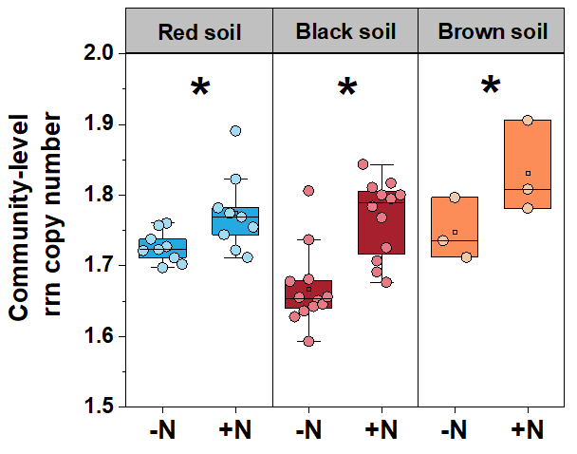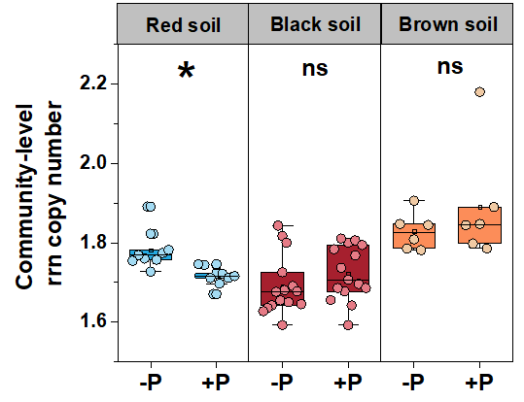

Fig. S1. The community-level rrn copy number under long-term N and P fertilizations revealed by an alternative pipeline of dada2 generating ASVs. This method shows the same trend of microbial strategy responses to long-term N and P fertilizations.

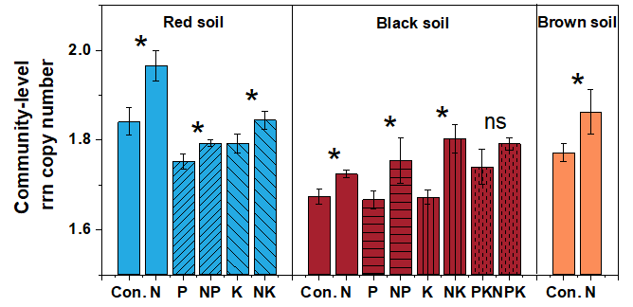

Fig. S2. Effects of long-term N fertilization on soil community-level average rrn copy number in each pairwise comparison (i.e. the soils with and without N fertilization) across all treatments by one-way ANOVA.

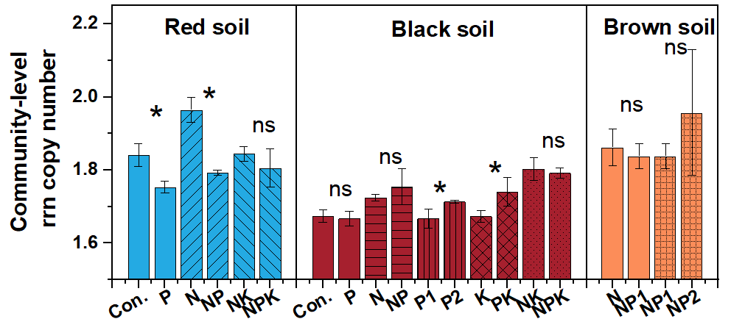

Fig. S3. Effects of long-term P fertilization on soil community-level average rrn copy number in each pairwise comparison (i.e. the soils with and without P fertilization) across all treatments by one-way ANOVA.

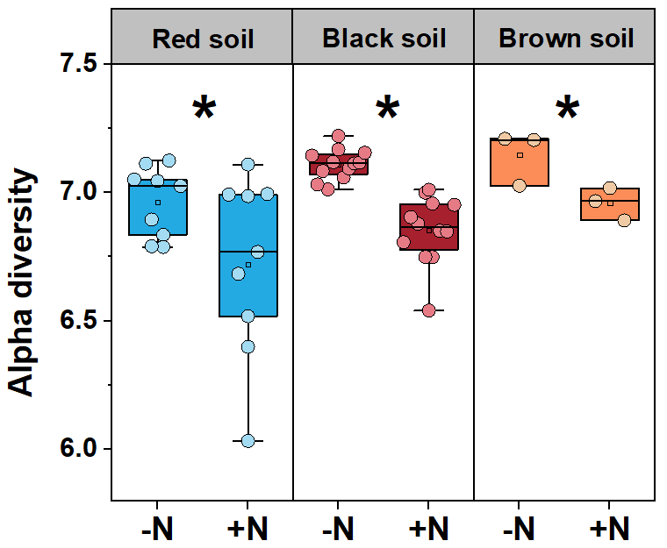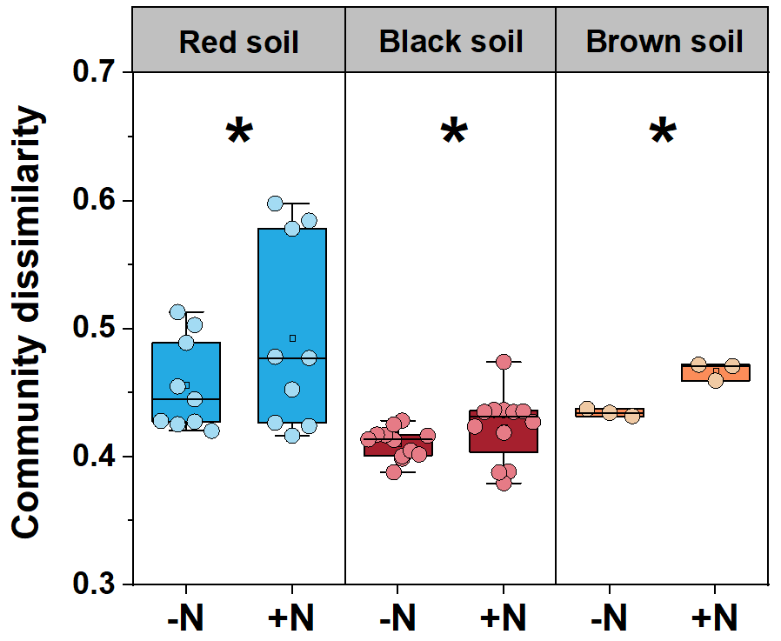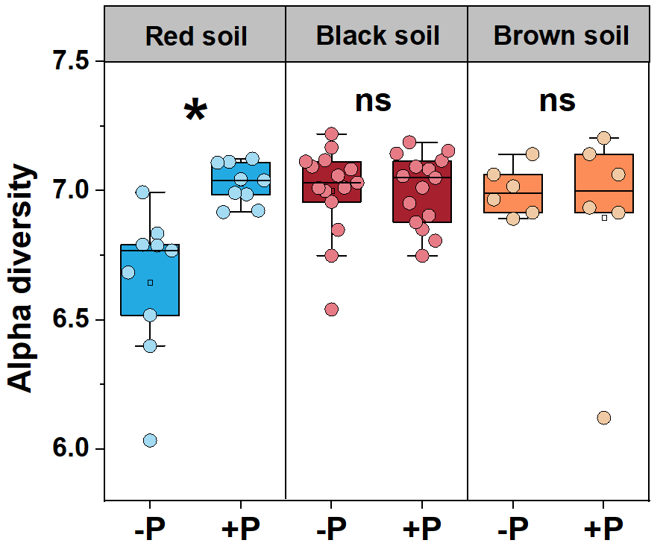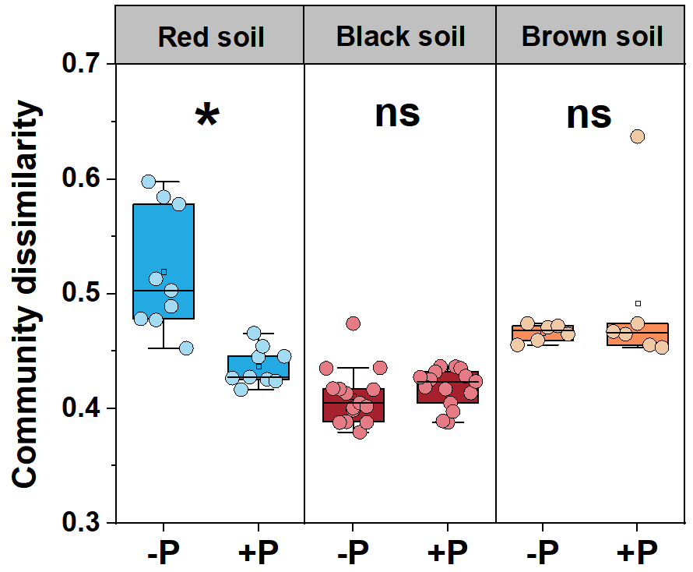

Fig. S4. Microbial alpha diversity and community dissimilarity under fertilizations in soils of the three long-term field sites. The differences in the soil microbial alpha diversity and community dissimilarity between -N and +N, and -P and +P groups in each site were revealed by two-way ANOVA.

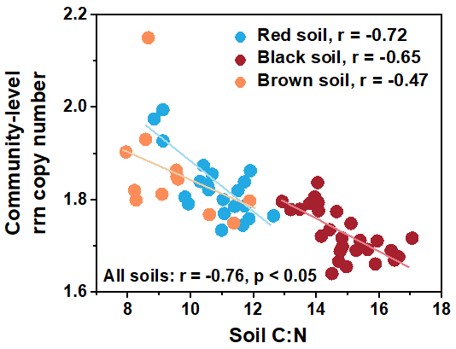
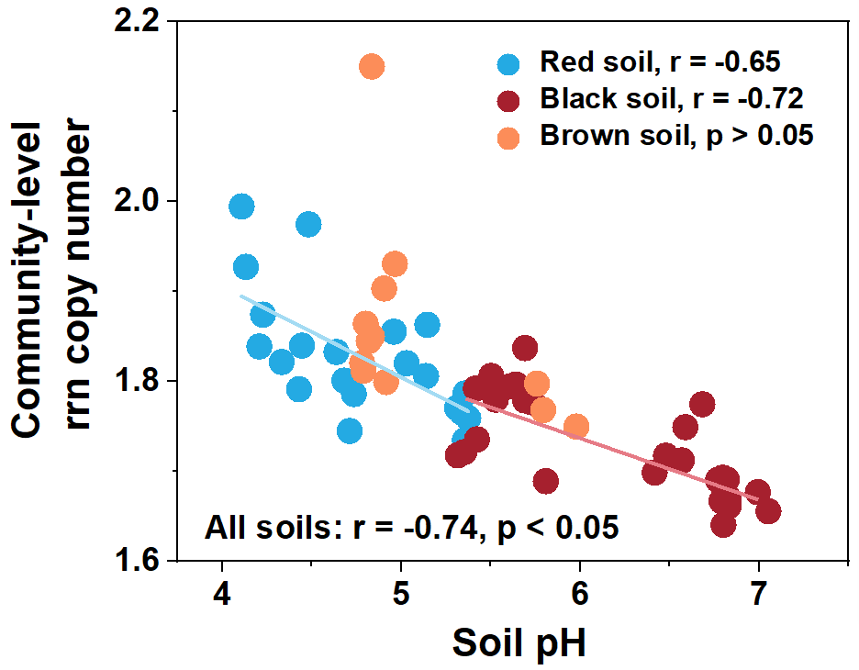

Fig. S5. The relationship between soil C:N ratio, C:P ratio and community-level rrn copy number revealed by Pearson Correlation.

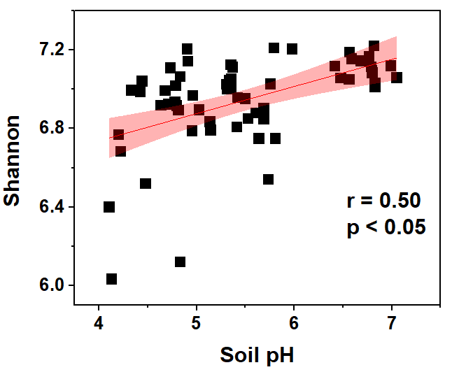

Fig. S6. Relationships between soil pH and microbial alpha diversity in long-term field trials revealed by Pearson Correlation.

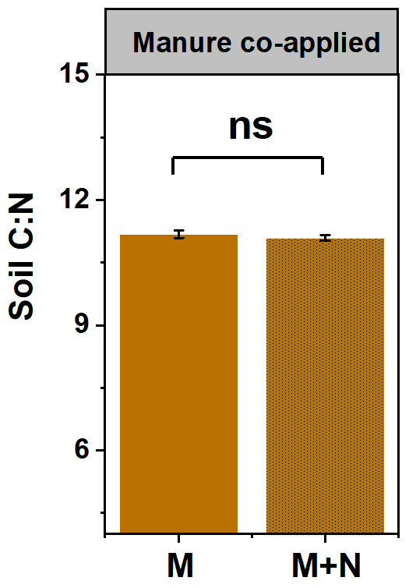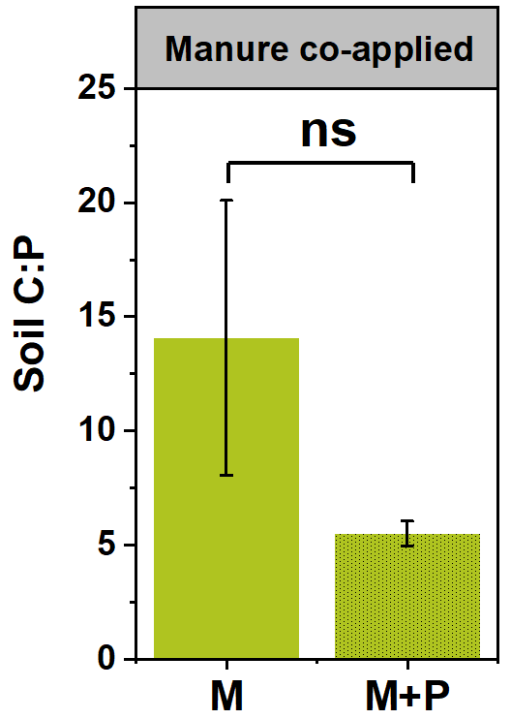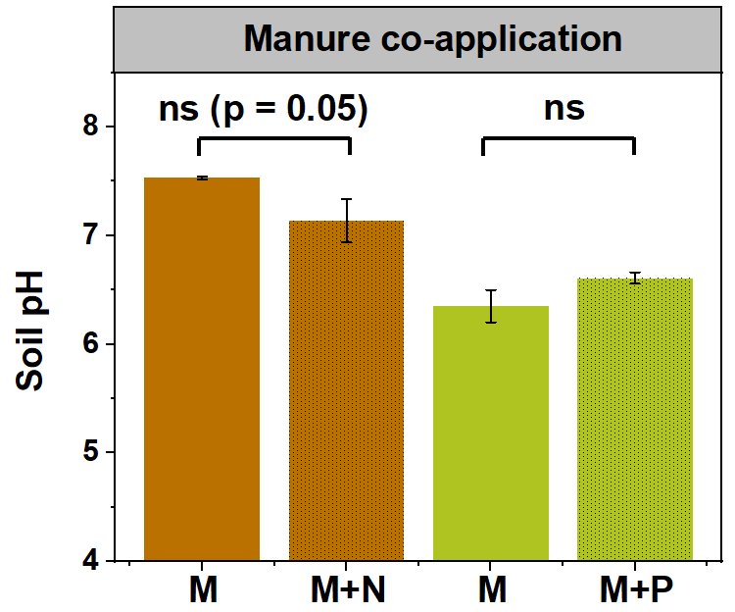

Fig. S7. Effects of long-term N and P fertilizations on soil C:N ratio, C:P ratio and soil pH of the initial soils with long-term manure application.

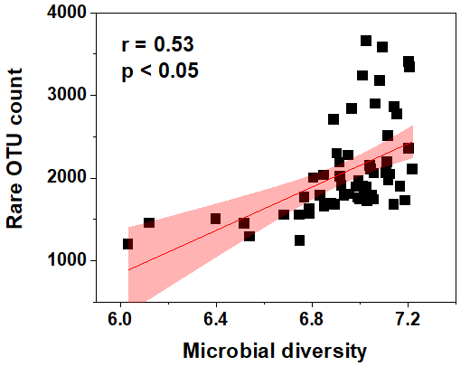

Fig. S8. Relationships between microbial alpha diversity and rare OTU count in long-term field trials revealed by Pearson Correlation.

Table S1. Site information, crop type, fertilization regime and experimental period for three long-term experimental sites receiving N, P and K nutrient inputs.
Site location | Longitude | Latitude | Soil type | Crop type | Fertilization regime | Fertilizer type | Experimental period (years)
Jiangxi province  (JX) | 116º20’E | 28º15’N | Red soil | Maize | (1) No nutrient (CK)  (2) N input (N)  (3) P input (P)  (4) K input (K)  (5) N + P inputs (NP)  (6) N + K inputs (NK)  (7) N + P + K inputs (NPK) | N: urea (120 kg N ha⁻¹)  P: calcium magnesium phosphate (26.2 kg P ha⁻¹)  K: potassium chloride (99.6 kg K ha⁻¹) | 31
Heilongjiang province  (HLJ) | 126°35′E | 45°40′N | Black soil | Maize-soybean-  wheat rotation | (1) No nutrient (CK)  (2) N input (N)  (3) P input (P)  (4) Double P input (2P)  (5) K input (K)  (6) N + P inputs (NP)  (7) N + K inputs (NK)  (8) P + K inputs (PK)  (9) N + P + K inputs (NPK) | N: urea (375 kg N ha⁻¹)  P: calcium superphosphate + diammonium phosphate (131 kg P ha⁻¹)  K: potassium chloride (62.3 kg K ha⁻¹) | 39
Liaoning province  (LN) | 123º34’E | 41 º49’N | Brown soil | Maize | (1) No nutrient (CK)  (2) N input (N)  (3) N + P input (NP)  (4) N + double P input (N2P) | N: urea (150 kg N ha⁻¹)  P: ammonium dihydrogen phosphate (29.5 kg P ha⁻¹)  K: potassium chloride (124.5 kg K ha⁻¹) | 30

Table S2. Treatments used for two-way ANOVA to test the N and P effects on community-level rrn copy number in each long-term field site.
Experimental Site | -N  (treatments without N input) | +N  (treatments with N input) | -P  (treatments without P input) | +P  (treatments with P input)
Jiangxi site | JX ª -CK ^{b} | JX-N | JX-CK | JX-P
 | JX-P | JX-NP | JX-N | JX-NP
 | JX-K | JX-NK | JX-NK | JX-NPK
Heilongjiang site | HLJ-CK | HLJ-N | HLJ-CK | HLJ-P
 | HLJ-P | HLJ-NP | HLJ-N | HLJ-NP
 | HLJ-K | HLJ-NK | HLJ-P | HLJ-2P
 | HLJ-PK | HLJ-NPK | HLJ-K | HLJ-PK
 |  |  | HLJ-NK | HLJ-NPK
Liaoning site | LN-CK | LN-N | LN-N | LN-NP
 |  |  | LN-NP | LN-N2P

a The name of each site.
b The name of the nutrient input treatment.

Table S3. Site information, crop type and experimental period for the long-term experimental sites receiving N, P and NPK nutrient inputs with manure application.
Site location | Longitude | Latitude | Soil type | Crop type | Fertilization regime | Treatment comparison | Fertilizer type | Experimental period (years)
Guangdong  province  (GD) | 113º26’E | 23º23’N | Red soil | Cabbage-  cabbage-  eggplant rotation | (1) P + K + Manure inputs (NK+M)  (2) N + P + K + Manure inputs (NPK+M)  (3) N + K + Manure inputs (NK+M)  (4) N + K + 2P + Manure inputs (N2PK+M) | N effect under manure co-application:  (1) vs (2)  P effect under manure co-application:  (3) vs (4) | N: urea (720 kg N ha⁻¹)  P: calcium superphosphate (160.6 kg P ha⁻¹)  K: potassium chloride (431.6 kg K ha⁻¹)  Manure: (360 kg N ha⁻¹; 290.4 kg P ha⁻¹; 505.4 kg K ha⁻¹) | 7

