Supporting Information
Construction of Quantum Well surface from an Nb Surface doped Core-shell La-SrTiO₃ Nanocubes for Photocatalytic Hydrogen Production

Yuqi Fan. Guoliang Zhang. Huiming Zhou. Yang Qiu. Weiliang Wang*. Feng Dang*.

*Corresponding author
dangfeng@sdu.edu.cn
sdqcsdnu@163.com
Index
EXPERIMENTAL SECTION…………………………………………………………………………03
Table 1 The information of experimental materials and chemical reagents ……………02
Characterization ……………………………………………………………………………………04
METHODS ……………………………………………………………………………………………04
Synthesis of QW-SrTiO₃ nanopraticles …………………………………………………………04
Fbrication of QW-SrTiO₃/GR hybrid composite ………………………………………………05
Photocatalytic hydrogen production activity……………………………………………………05
Photoelectrochemical measurements……………………………………………………………06
Calculation detail ……………………………………………………………………………………07
Supporting Figure (Figure S1-S16) ………………………………………………………….…10
Table S1 ………………………………………………………………………………………………27
References (S1 ) ……………………………………………………………………………………28

EXPERIMENTAL SECTION

Table 1. Information of experimental materials and chemical reagents
Name | Chemical formula | Purity | Source
bis(ammonium lactate) titanium dihydroxide (TALH) | C₆H₁₈N₂O₈Ti | AR | Sigma Chemical Co. (St. Louis, MO, USA)
Oleic acid (OLA) | C₁₈H₃₄O₂ | 65% | Wako Pure Chemical Industries, Ltd
tert-Butylamine | C₄H₁₁N | 99.5% | Sigma Chemical Co. (St. Louis, MO, USA)
Strontium hydroxide | Sr(OH)₂·8H₂O | 99.5% | Aladdin reagent (Shanghai) Co., Ltd.
Lanthanum hydroxide | La(OH)₃ | 99% | National drug group chemical reagents Co., Ltd.
Niobium chloride | NbCl₅ | 99% | Aladdin reagent (Shanghai) Co., Ltd.
Sodium hydroxide | NaOH | 98% | Sigma Chemical Co. (St. Louis, MO, USA)
Graphene | - | - | Qingdao Hua Gao Mo Polytron Technologies Inc
Liquid nitrogen | - | - | Ji'nan De Yang Special Gas Co., Ltd.
Characterization
The crystal phases of the synthesized powders were characterized by X-ray diffraction (XRD, Rigaku D/Max r B). The morphological structure of QW-SrTiO₃ nanoparticles and QW-SrTiO₃/GR composites were analyzed by transmission electron microscopy (TEM) and high-resolution transmission electron microscopy (HRTEM, JEM-2100F). The morphologies of pure GR and QW-SrTiO₃/GR composites were observed by field-emission scanning microscope (FESEM, SU70). The functional groups and chemical bonds of samples were recorded by Fourier transform infrared spectroscopy (FTIR, FT/IR-600). The absorption spectra and band gap were measured by UV-vis spectroscopy. The photoluminescence (PL) emission spectrum was performed on fluorescence spectrophotometer. The direct visualization of nanoscale structural and compositional information were achieved by integrating energy-dispersive X-ray spectroscopy (EDX) with the spherical aberration corrected scanning transmission electron microscopy (Cs-STEM, Titan G3 50-300 PICO) techniques, including acquiring Bright-field (BF), high-angle annular dark-field (HAADF) images.

METHODS
Synthesis of QW-SrTiO₃ nanopraticles
A typical synthesis process consists of two steps. Firstly, bis(ammonium lactate) titanium dihydroxide (TALH) (0.05 mol/L, Sr:Ti = 1:1) was added into an aqueous solution of Sr(OH)₂ and La(OH)₃ (24 mL, 1.0 mol/L) under mechanical stirring. Then, a 5 mol/L aqueous NaOH solution was added to the reaction mixture to produce a NaOH concentration of 1 mol/L. The reaction mixture was transferred to a 50 mL autoclave, and then tert-Butylamine and oleic acid (OLA) (Sr: OLA: tert-Butylamine = 1:8:8) were added into the solution. The sealed autoclave was heated at 220 °C for 16 h and then cooled down to room temperature to obtain the intermediate composed of nanocubes and unreacted Ti-based hydrous gel.
For the surface doping of Nb on La-SrTiO₃ nanoparticles, alcohol solution containing NbCl₅ as the Nb source (5.0 mol%) with a concentration of 0.05 mol/L was added in above precursor. Then the suspension was heated to 220 ºC for another 24 h under hydrothermal conditions. Under hydrothermal condition, Nb ion can be dissolved into the mixed solution and Sr species break the Ti-O bond of Ti-O-Ti cross-linked network to form SrTiO₃ crystal structure. In this process, Nb ion can enter the SrTiO₃ crystal structure and Nb doped layer was be obtained on the surface of SrTiO₃ nanoparticles. After the synthesis, the quantum well particles were centrifugally separated and washed twice by ethanol.
Fabrication of QW-SrTiO₃/GR hybrid composite
The graphene (GR) was dispersed in distilled water through ultrasonic irradiation for 2h with a concentration of 1mg/mL. 0.5 g QW-SrTiO₃ nanocubes were dispersed in 100 mL distilled water under ultrosonic irradiation for 30 min, and then the dispersion of GR was added with different volume. The mixture was mechinically stirred for 1 h, and then frozen by liquid nitrogen and subsequently freeze-dried until the water was evaporated.
Photocatalytic hydrogen production activity
The photocatalytic H₂ generation was performed in a closed quartz flask at room temperature. A 500 W xenon arc lamp used as the light sources, which was located 10 cm away from the photocatalytic reactor. In a typical process, 0.05 g of the photocatalyst was dispersed in the mixed solution containing distilled water (80-95 mL) and methanol (5-20 mL) as the sacrificial agent. Prior to irradiation, nitrogen (N₂) was bubbled though the reactor for 30 min to remove the air in the system. The amount of produced hydrogen were monitored by an online gas chromatograph (GC-2060F, LuNan Analytical Instruments, LTD, China). A Gas chromatography (GC, Agilent 7890B) was used at intervals to identify the intermediates in the water/methanol suspension for the explanation of the photocatalytic pathway.
The apparent quantum yield (AQY) measurement of photocatalytic hydrogen production and wavelength experiments:
To measure the apparent quantum yield (AQY) of the reaction system, the monochromatic LED lamps with band pass filter of 420 ± 4.2 nm were used as the light source. The amount of H₂ evolution was calculated under the light irradiation (λ = 420 nm) for 1 h. The photocatalytic reactions were conducted on the same experimental setup and optimized reaction conditions. The intensity of incident monochromatic illumination was measured by an ILT 950 spectroradiometer. The irradiated area for the reaction was controlled at 1.0×1.0 cm². Depending on the amount of H₂ produced by the photocatalytic reaction in an average of one hour, and the AQY was calculated as follow:

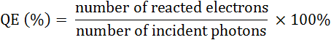

= 2×[n_{H2} ·N_{A}·ħ·c)] ×100%/(I·S·t·λ)

Where, NA is Avogadro constant (6.022×1023/mol), ħ the Planck constant (6.626×10-34 J∙s), c the speed of light (3×108 m/s), S the irradiation area (cm²), I the intensity of irradiation light (W/cm²), t the photoreaction time (s), λ the wavelength of the monochromatic light (m).
Photoelectrochemical measurements
Photocurrents were measured using a three-electrode configuration with the as-prepared photocatalysts, Ag/AgCl electrode, and Pt wire as the working electrode, reference electrode and counter electrode, respectively. 5 mol/L Na₂SO₄ solution was used as the electrolyte, and a 500 W Xe lamp was used as the light source of reaction. For working electrode, 5 mg of photocatalyst powders was grounded with 1 mL mixed solvents (water/ethanol) and 50 μL Nafion solution (~5%) to prepare the slurry, and then kept under ultrasonication for 20 min. Afterward the as-prepared solution was doped on glassy carbon electrode with diameter of 5 mm.

Calculation detail
Density functional theory (DFT) calculations were performed with Vienna Ab Initio Simulation Package (VASP) ^{[1]} using the GGA-PBE electron exchange-correlation functional.^{[2]} The projector augmented-wave (PAW) method was employed to represent the interaction between the ion cores and the valence electrons.^{[3]} The kinetic energy cutoff was set as 400 eV and electronic energies were converged within10⁻⁴ eV. All structures were relaxed until the forces acting over each atom were smaller than 0.05 eV/Å. In order to understand the surface activity of the SrTiO₃-based catalyst towards water splitting, we initially prepared an undoped 2 × 2 SrTiO₃ (100) slab consisting of five atomic layers. While the bottom two layers were fixed in the corresponding bulk position, the upper three layers were fully relaxed. The vacuum between slabs was 12 Å, in which a Gamma centered k-point mesh of 4×3×1 was included. Here, we mainly considered the TiO₂-terminated surface rather than the SrO-terminated surface because the TiO₂-terminated surface is thought to be more catalytically active than its SrO-terminated counterpart. ^{[4]} For different doped cases, the electronic structures of doped systems are mainly associated with the radius of cationic dopants as well as the electronegativity of elements.^{[5, 6]} The radius of cations of La³⁺ is 1.03 Å, which is close to that of Sr²⁺ (1.18 Å). The electronegativity of La is 1.10, which is close to that of Sr (0.95). Similarly, the radius of cations Nb⁵⁺ (0.64 Å) is close to that of Ti⁴⁺ (0.61 Å), and the electronegativity of Nb (1.60) is close to that of Ti (1.54). For La-SrTiO₃ and Nb-SrTiO₃ stuctures, Sr²⁺ or Ti⁴⁺ cation near the surface region of the undoped SrTiO₃ (100) slab is preferred to be replaced with La³⁺ or Nb⁵⁺, respectively. TiO₂-terminated SrTiO₃ (100) surface with two atomic layers is used to represent 2D-SrTiO₃, in which one Ti atom on the surface is substituted by the Nb atom to form 2D-Nb-SrTiO₃ structure.
The adsorption energy of surface species is calculated by
E_{ad}(x) = E(sur) + E(x) – E(x + sur)
where E_{ad}(x) is the adsorption energy per x relative to the energy of the clean surface E(sur) and the energy of E(x); E(x + sur) is the energy of the surface covered by x.

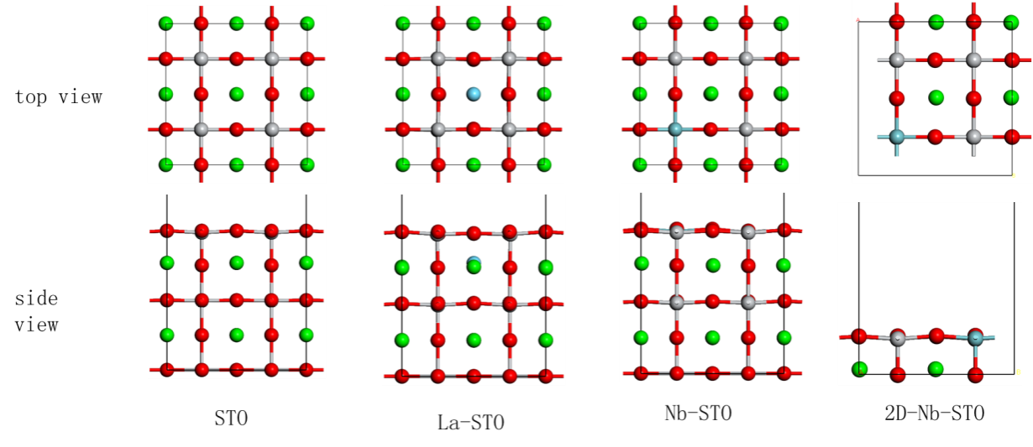

Reference
[1] Fuchs M, Scheffler M (1999) Ab initio pseudopotentials for electronic structure calculations of poly-atomic systems using density-functional theory. Comput Phys Commun 19: 67-98.
[2] Li G, Dang C, Hou Y, Dang F, Fan Y, Guo Z (2020) Experimental and Theoretical Characteristic of Single Atom Co-N-C Catalyst for Li-O₂ Batteries. Eng Sci 10, 85-94.
[3] Kresse G, Joubert D, Condens. Kresse G, Joubert D (1999) From ultrasoft pseudopotentials to the projector augmented-wave method. Phys Rev B 59: 1758.
[4] Lim S, Choi J, Suh D, S K, Ham H, Ha J, M J (2019) Combined experimental and density functional theory (DFT) studies on the catalyst design for the oxidative coupling of methane. J Catal. 375: 478-492.
[5] Liu H, Xiang H, Wang Y, Li Z, Qian L, Li P, Ma Y, Zhou H, Huang W (2019) A Flexible Multimodal Sensor That Detects Strain, Humidity, Temperature, and Pressure with Carbon Black and Reduced Graphene Oxide Hierarchical Composite on Paper. ACS Appl Mater interfaces 11: 40613-40619.
[6] Wang Y, Zhang C, Liu Y, Zhang M, Min F (2019) Efficient Visible‐Light‐Induced Photocatalytic Activity of SrTiO₃ Co-Doped With Os and N: A GGA ⁺ U Investigation. Phys Status Solidi B 256: 1800574.
7. Henkelman G, Uberuaga Blas P, Jónsson H (2000) A climbing image nudged elastic band method for finding saddle points and minimum energy paths. J Chem Phys 113: 9901-9904.

Supporting Figures

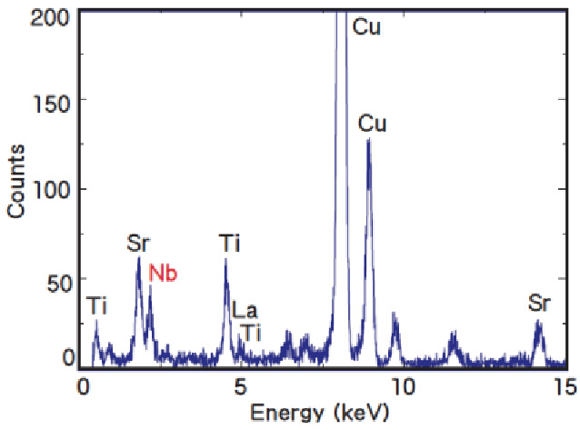
Fig. S1 EDS analysis of QW-STO with 5% La doping and 5% Nb surface doping.

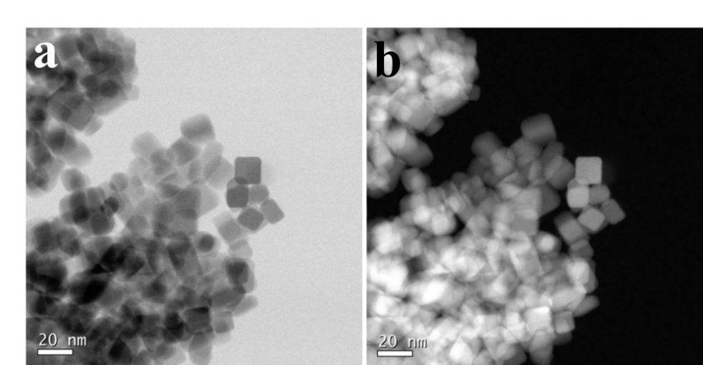
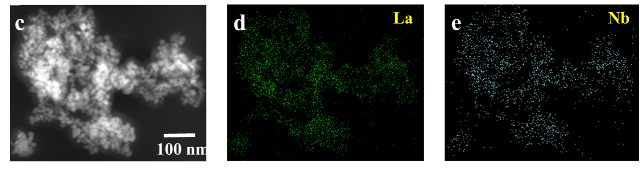
Fig. S2 BF-STEM(a), HAADF-STEM(b) images of QW-STO and (c-e) the La and Nb element mapping of QW-STO nanoparticles containing over 100 particles

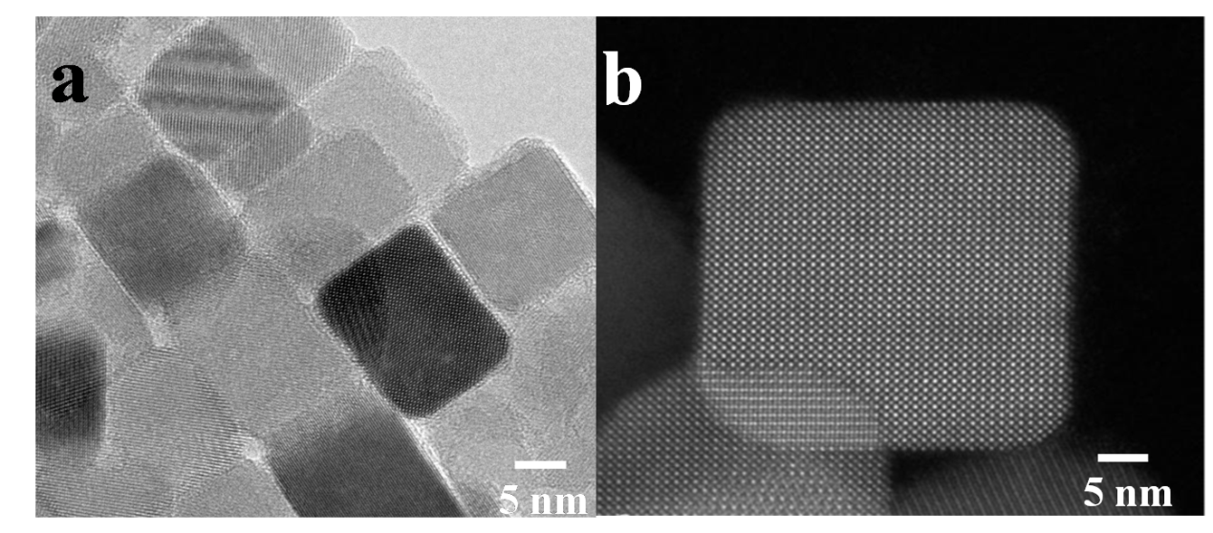
Fig. S3 HRTEM(a) and HAADF-STEM(b) images of QW-STO.

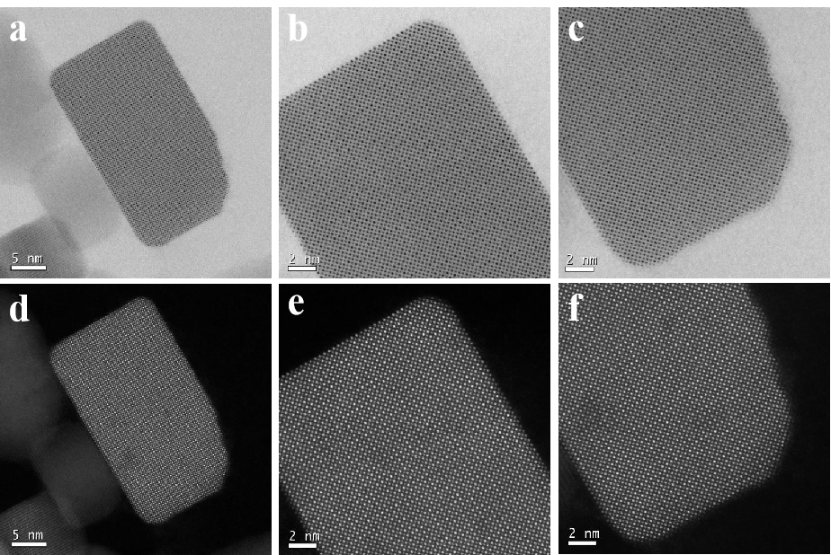
Fig. S4 BF-STEM (a-c) and HAADF-STEM (d-f) images of STO nanocubes.

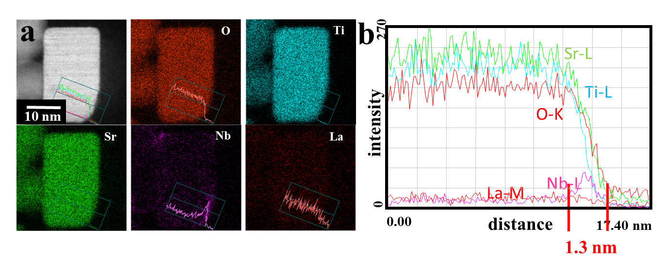
Fig. S5 Results of EDX intensity analysis of STO nanocubes (a and b).

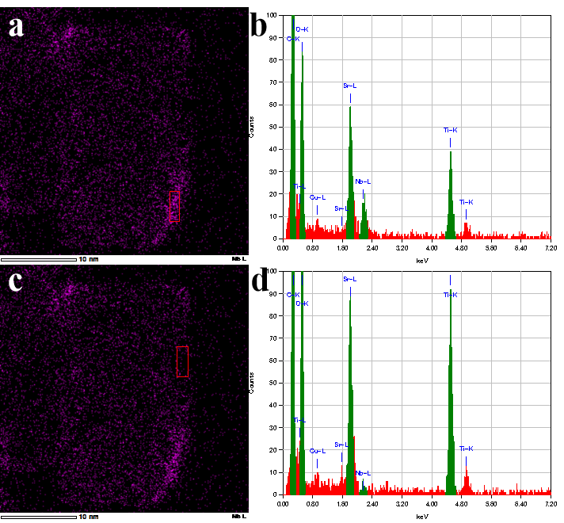
Fig. S6 EDX spectrum acquisition region of Nb layer in QW-STO (a and b) and corresponding diffraction results (b and d).

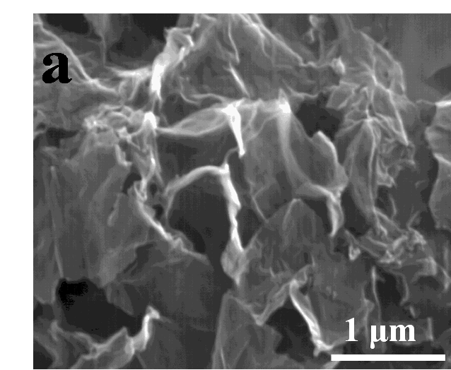
Fig. S7 SEM image of GR.

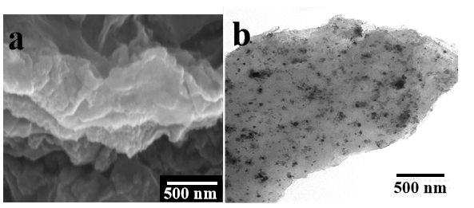
Fig. S8 (a) SEM image and (b) TEM image of QW-STO/GR (1.0 wt%).
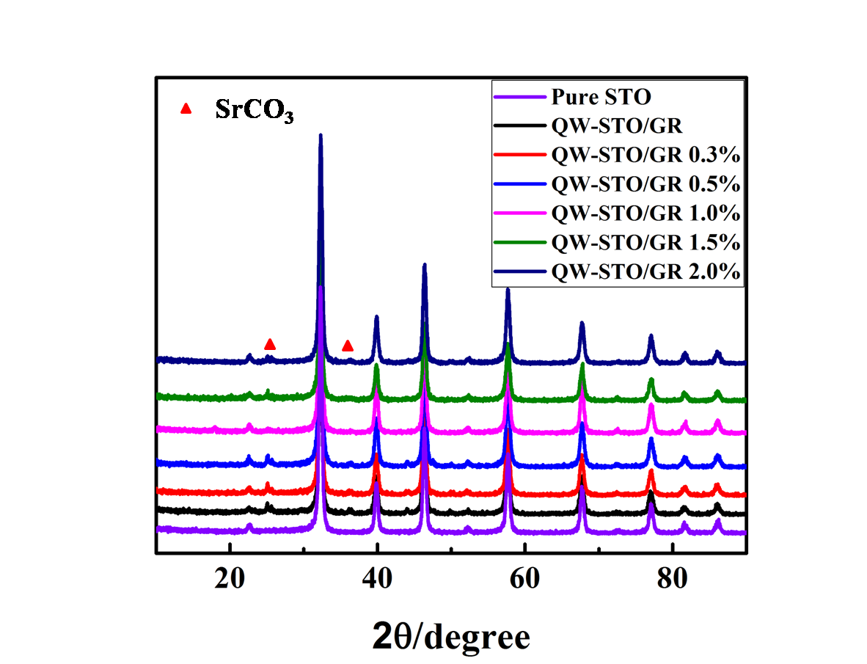

Fig. S9 XRD patterns of QW-STO and QW-STO/GR with different content of GR.
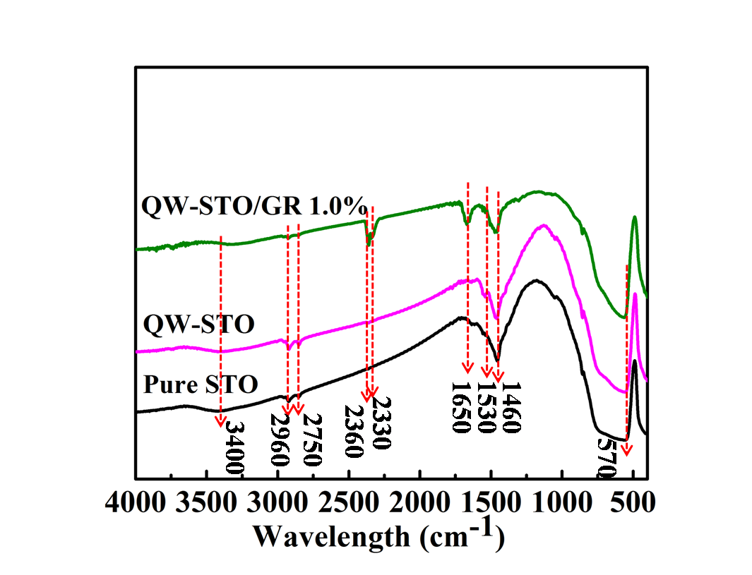
Fig. S10 FT-IR spectra of pure STO, QW-STO and QW-STO/GR (1.0%).

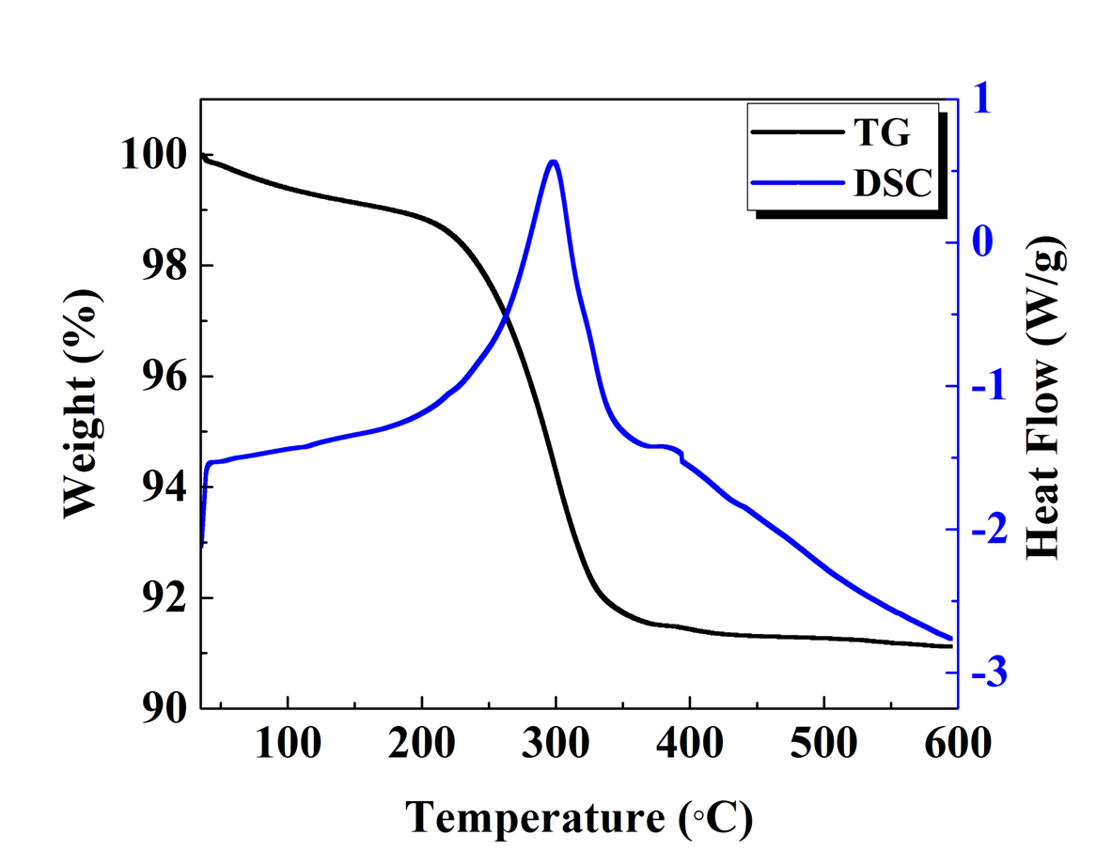
Fig. S11 TG-DSC curve of QW-STO with 5% La doping and 5% Nb surface doping.

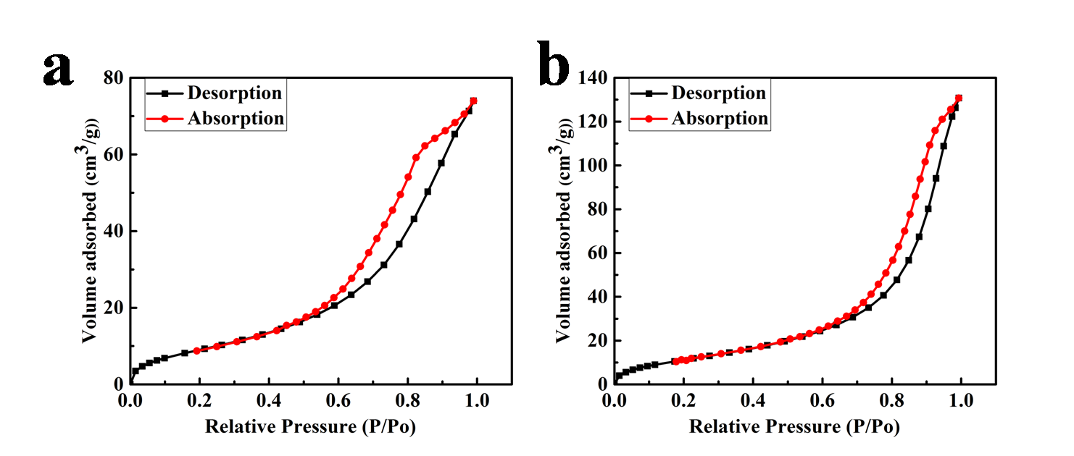

Fig. S12 Nitrogen adsorption-desorption isotherm of different samples and the corresponding pore distribution (a) pure SrTiO₃; (b) QW-STO/GR (1.0%).

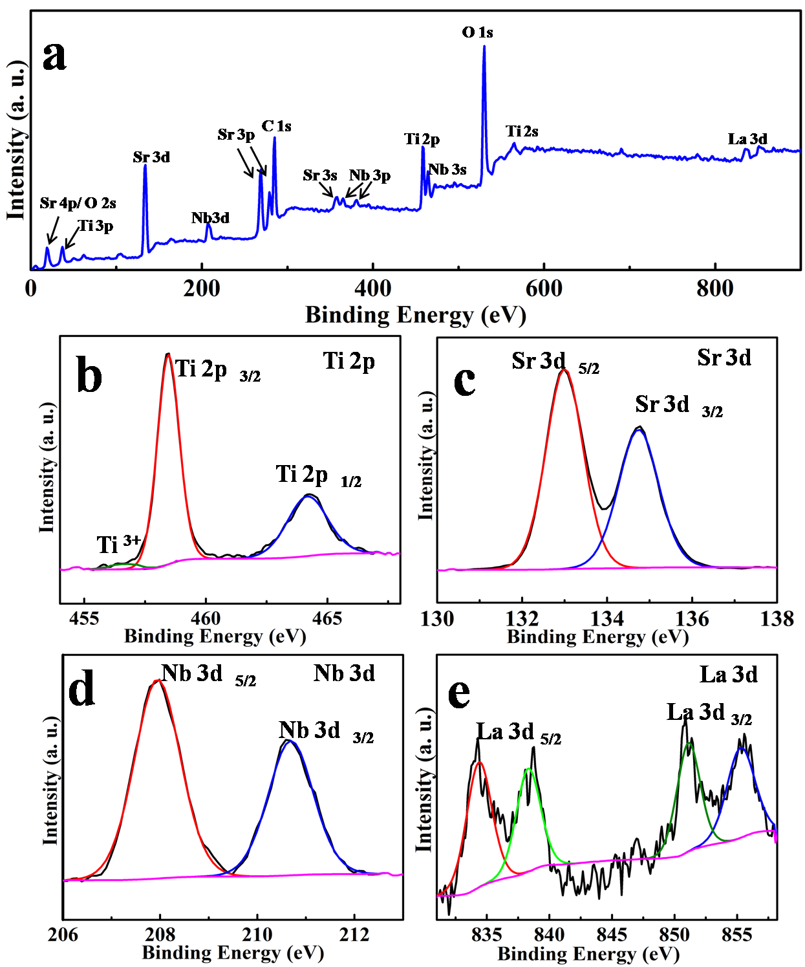

Fig. S13 XPS spectra for quantum well SrTiO₃ with 5% La doping and 5% Nb surfacing doping. (a) overall spectrum and (b-e) elemental spectra of Ti, Sr, Nb and La.

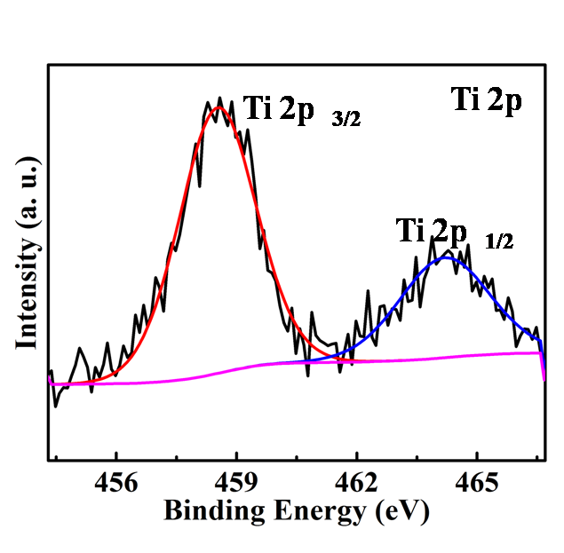

Fig. S14XPS spectra of Nb 2p for quantum well SrTiO₃ with 5% La doping and 5% Nb surfacing doping.

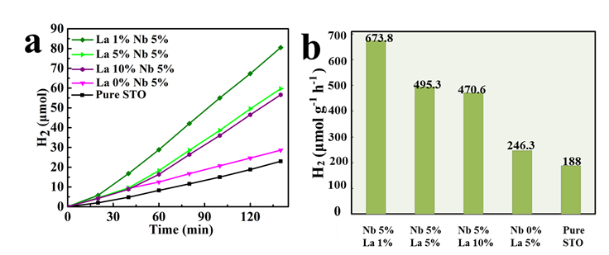
Fig. S15 (a) The efficiencies of H₂ evolution over QW-STO doped with different amounts of La; (b) Rate of H₂ evolution from the corresponding photocatalyst over 140 min.

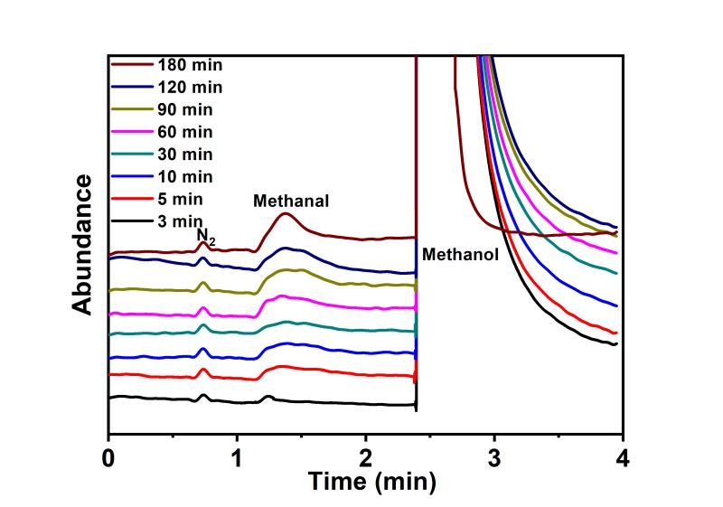
Fig. S16 HPLC results of the intermediates and products at intervals from the water/methanol mixture (volume ratio = 9:1) in the suspension containing the QW-STO under irradiation of light (Xe lamp, 500 W).

Table S1 The adsorption energy of different adsorbates adsorbate on SrTiO₃, La-SrTiO₃, 2D Nb- SrTiO₃, respectively
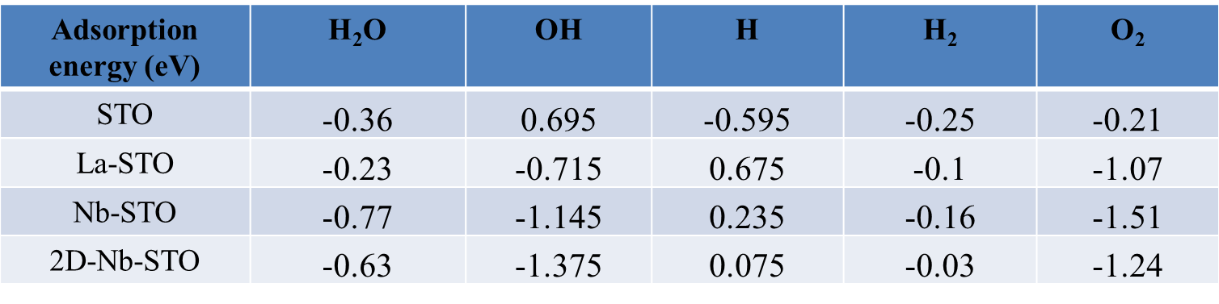

References
(S1) Xiang Q , Yu J, Mietek (2011) Jaroniec Enhanced photocatalytic H₂-production activity of graphene-modified titania nanosheets. Nanoscale 3: 3670-3678.

