Supplementary Figures
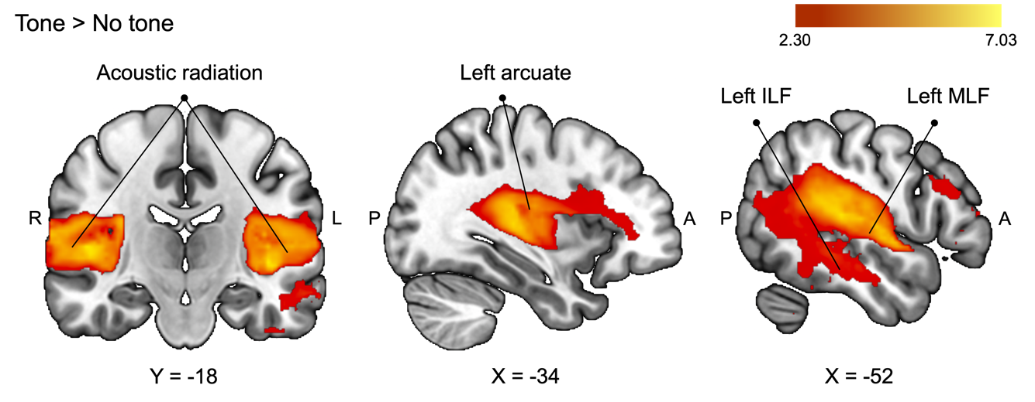
Supplementary Figure 1. Additional brain sections showing activations and white matter involvement obtained in the contrast Tone > No tone for the alerting task at a statistical Z-threshold of >2.3 and a corrected cluster significance threshold of p = 0.05. The color bar denotes Z-values. ILF, inferior longitudinal fasciculus; MLF, middle longitudinal fasciculus.

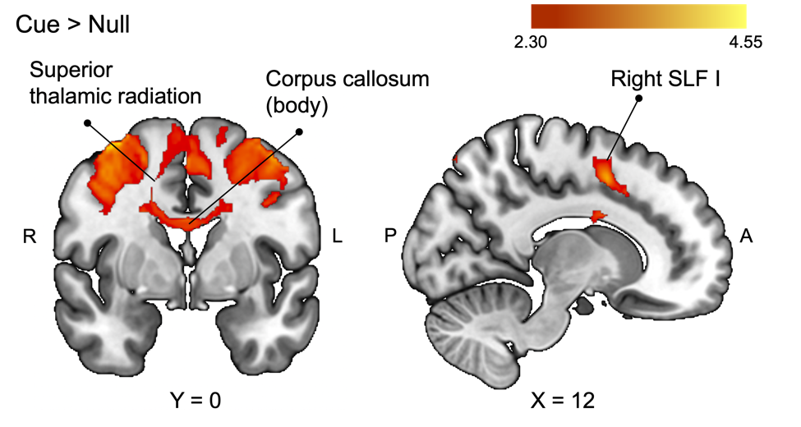
Supplementary Figure 2. Additional brain sections showing activations and white matter involvement obtained in the contrast Cue > Null for the orienting task at a statistical Z-threshold of >2.3 and a corrected cluster significance threshold of p = 0.05. The color bar denotes Z-values. SLF, superior longitudinal fasciculus.

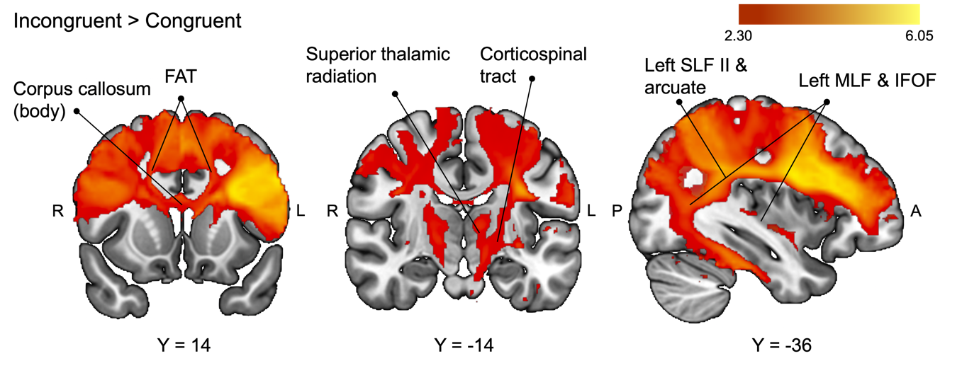
Supplementary Figure 3. Additional brain sections showing activations and white matter involvement obtained in the contrast Incongruent > Congruent for the executive attention task at a statistical Z-threshold of >2.3 and a corrected cluster significance threshold of p = 0.05. The color bar denotes Z-values. FAT, frontal aslant tract; IFOF, inferior frontal-occipital fasciculus; MLF, middle longitudinal fasciculus; SLF, superior longitudinal fasciculus.

