Supporting Information

Preparation of a multifunctional and ultrasensitive Au@AgNPs-Van/PDMS film SERS substrate for rapid detection of foodborne pathogens in beef
Yaodi Zhu ^{ab#}, Shijie Liu^{ab#}, Lijun Zhao^{ab*}, Na Wangª, Mengya^{ab} Li, Dong Liangª, Gaiming Zhao^{ab}, Weijia Liu^{ab}, Lingxia Sun^{ab}, Lina Xuª, Miaoyun Li^{ab**}
ª College of Food Science and Technology, International Joint Laboratory of Meat
Processing and Safety in Henan province, Henan Agricultural University, No.63
Wenhua Rd, Zhengzhou, 450002, P.R. China
^{b} International Joint Laboratory of Meat Processing and Safety in Henan province,
Henan Agricultural University, No.63 Wenhua Rd, Zhengzhou, 450002, P.R. China
# These authors contributed equally to this study
Corresponding Author:
zhaolj2014@126.com (Lijun Zhao); limy7476@126.com (Miaoyun Li)

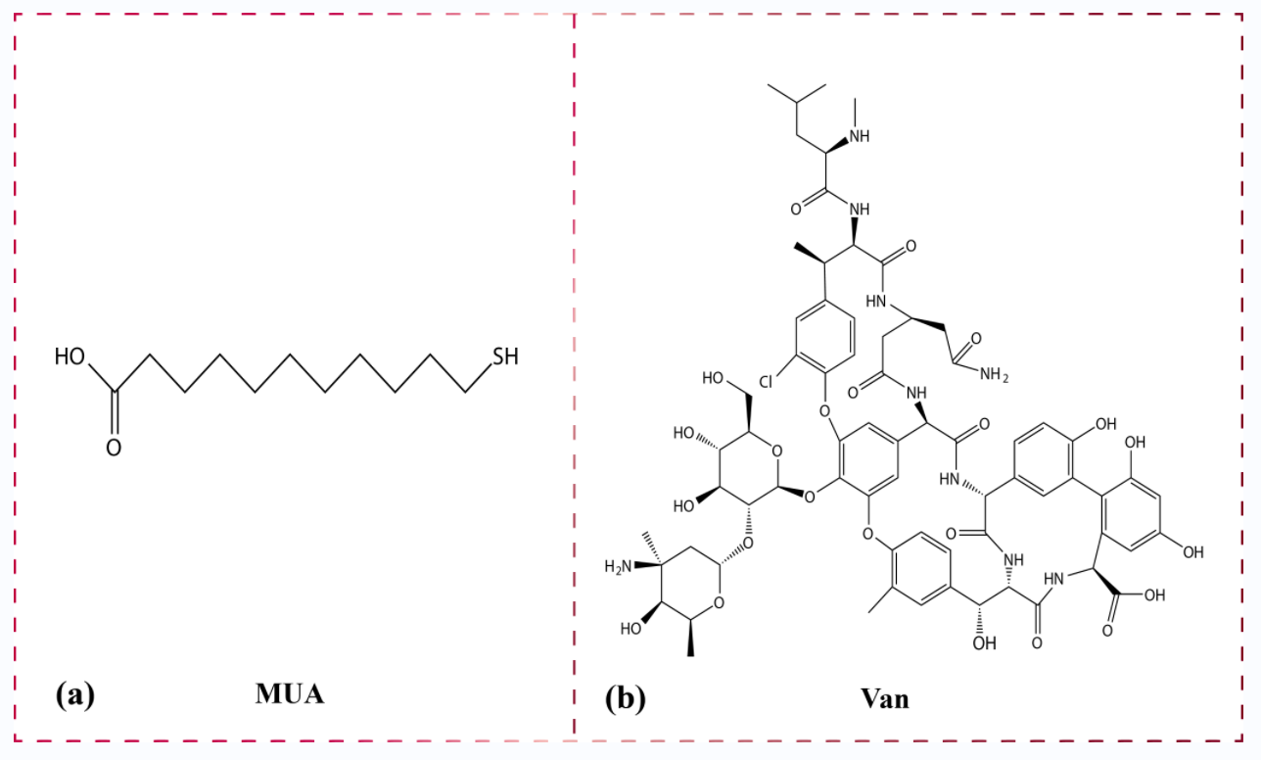
Figure S1. The chemical structure formulae of MUA (a) and Van (b), respectively.

Figure S2. Schematic diagram of Au@AgNPs/Van synthesis. MUA was commonly used as a multifunctional modification chain with a sulfhydryl group at one end that can be firmly bound to the Ag shell surface via an Ag-S bond and a carboxyl group at the other end that can provide a site for coupling vancomycin. At the same time, the carbon chain of MUA can extend the arm, effectively reducing the steric hindrance between vancomycin and bacteria. EDC activation could facilitate and stably promote the chemical coupling between Van and MUA.
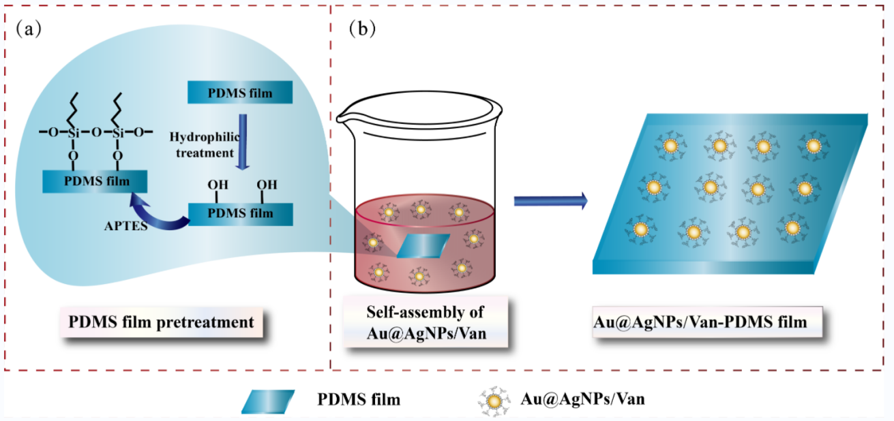
Figure S3 Schematic diagram of preparation process of Au@AgNPs/Van-PDMS film SERS substrate

Figure S4. SERS detection performance for the three foodborne pathogens pathogens based on Au@AgNPs/Van-PDMS film. (a)-(d) Raman spectra for blank Au@AgNPs/Van-PDMS film SERS substrate, pure C. perfringens, pure B. subtilis, and pure S. aureus, respectively. (e)-(g) Enhancement spectra for C. perfringens, B. subtilis, and S. aureus on Au@AgNPs/Van-PDMS film, respectively. Data analysis range: 400-1800 cm⁻¹.
Table S1 Calculation of AEF for Au@AgNPs/Van-PDMS film
Target | SERS substrate | Raman shift (cm⁻¹) | I_{RS} (a.u.) | I_{SERS} (a.u.) | AEF
C. perfringens | Au@AgNPs/Van-PDMS film | 1318 | 297.96 | 145278.59 | 4.88×10⁴
B. subtilis | Au@AgNPs/Van-PDMS film | 749 | 138.29 | 127679.58 | 9.23×10⁴
S. aureus | Au@AgNPs/Van-PDMS film | 1524 | 205.47 | 223935.31 | 1.09×10⁵
Combine Figure 4 and Table 1 to explain the calculation process of AEF:
The analytical enhancement factor (AEF) can be calculated by targeting the intensity of the intensities of the strongest characteristic peaks as follows.
$AEF=\frac{I_{SERS}/C_{SERS}}{I_{RS}/C_{RS}}$ (1)
where I_{RS} and I_{SERS} represent the normal Raman intensity and SERS intensity of C. perfringens, B. subtilis and S. aureus at 1318 cm⁻¹, 749 cm⁻¹ and 1524 cm⁻¹, respectively. C_{RS} and C_{SERS} are the corresponding concentrations of foodborne pathogens measured in non-SERS conditions and SERS detection conditions, respectively, under identical experimental conditions (laser wavelength, laser power or microscope objective, etc.). In order to obtain better Raman spectra of pure biological samples and highlight the enhancement effect of Au@AgNPs/Van-PDMS film, the concentration of pure foodborne pathogens was selected to be 100 times that of SERS measurement (C_{RS} = 100×C_{SERS}).

