Supplementary Materials

Supplementary material 1: TRIPOD Checklist: Prediction Model Development and Validation

Section/Topic | Item |  | Checklist Item | Page
Title and abstract
Title | 1 | D;V | Identify the study as developing and/or validating a multivariable prediction model, the target population, and the outcome to be predicted. | 1
Abstract | 2 | D;V | Provide a summary of objectives, study design, setting, participants, sample size, predictors, outcome, statistical analysis, results, and conclusions. | 2
Introduction
Background and objectives | 3a | D;V | Explain the medical context (including whether diagnostic or prognostic) and rationale for developing or validating the multivariable prediction model, including references to existing models. | 3
Background and objectives | 3b | D;V | Specify the objectives, including whether the study describes the development or validation of the model or both. | 4
Methods
Source of data | 4a | D;V | Describe the study design or source of data (e.g., randomized trial, cohort, or registry data), separately for the development and validation data sets, if applicable. | 4
Source of data | 4b | D;V | Specify the key study dates, including start of accrual; end of accrual; and, if applicable, end of follow-up. | 4
Participants | 5a | D;V | Specify key elements of the study setting (e.g., primary care, secondary care, general population) including number and location of centres. | 4
Participants | 5b | D;V | Describe eligibility criteria for participants. | 5
Participants | 5c | D;V | Give details of treatments received, if relevant. | N/A
Outcome | 6a | D;V | Clearly define the outcome that is predicted by the prediction model, including how and when assessed. | 5
Outcome | 6b | D;V | Report any actions to blind assessment of the outcome to be predicted. | N/A
Predictors | 7a | D;V | Clearly define all predictors used in developing or validating the multivariable prediction model, including how and when they were measured. | 5
Predictors | 7b | D;V | Report any actions to blind assessment of predictors for the outcome and other predictors. | N/A
Sample size | 8 | D;V | Explain how the study size was arrived at. | 9
Missing data | 9 | D;V | Describe how missing data were handled (e.g., complete-case analysis, single imputation, multiple imputation) with details of any imputation method. | 6
Statistical analysis methods | 10a | D | Describe how predictors were handled in the analyses. | 6
Statistical analysis methods | 10b | D | Specify type of model, all model-building procedures (including any predictor selection), and method for internal validation. | 6
Statistical analysis methods | 10c | V | For validation, describe how the predictions were calculated. | 6
Statistical analysis methods | 10d | D;V | Specify all measures used to assess model performance and, if relevant, to compare multiple models. | 6
Statistical analysis methods | 10e | V | Describe any model updating (e.g., recalibration) arising from the validation, if done. | N/A
Risk groups | 11 | D;V | Provide details on how risk groups were created, if done. | N/A
Development vs. validation | 12 | V | For validation, identify any differences from the development data in setting, eligibility criteria, outcome, and predictors. | 12,13
Results
Participants | 13a | D;V | Describe the flow of participants through the study, including the number of participants with and without the outcome and, if applicable, a summary of the follow-up time. A diagram may be helpful. | 8
Participants | 13b | D;V | Describe the characteristics of the participants (basic demographics, clinical features, available predictors), including the number of participants with missing data for predictors and outcome. | 13
Participants | 13c | V | For validation, show a comparison with the development data of the distribution of important variables (demographics, predictors and outcome). | 13
Model development | 14a | D | Specify the number of participants and outcome events in each analysis. | 8
Model development | 14b | D | If done, report the unadjusted association between each candidate predictor and outcome. | N/A
Model specification | 15a | D | Present the full prediction model to allow predictions for individuals (i.e., all regression coefficients, and model intercept or baseline survival at a given time point). | 13
Model specification | 15b | D | Explain how to the use the prediction model. | 5
Model performance | 16 | D;V | Report performance measures (with CIs) for the prediction model. | 7
Model-updating | 17 | V | If done, report the results from any model updating (i.e., model specification, model performance). | N/A
Discussion
Limitations | 18 | D;V | Discuss any limitations of the study (such as nonrepresentative sample, few events per predictor, missing data). | 16
Interpretation | 19a | V | For validation, discuss the results with reference to performance in the development data, and any other validation data. | 15
Interpretation | 19b | D;V | Give an overall interpretation of the results, considering objectives, limitations, results from similar studies, and other relevant evidence. | 17
Implications | 20 | D;V | Discuss the potential clinical use of the model and implications for future research. | 17
Other information
Supplementary information | 21 | D;V | Provide information about the availability of supplementary resources, such as study protocol, Web calculator, and data sets. | included
Funding | 22 | D;V | Give the source of funding and the role of the funders for the present study. | 17
D: development of a prediction model, V: validation of a prediction model, D;V: development and validation of a prediction model, N/A: Not Applicable

Supplementary Material 2: Candidate predictors of this study for ML development

Data source | Variable | Unit | ICD codes 9-10
Demographics | Age at admission | year
Demographics | Gender-N(%)  Female  Male | - | -
Demographics | Ethnicity-N(%)  White  African-American  Hispanic-Latino  Asian  Other | - | -
Labs | Prothrombin time | second | -
Labs | Anion gap max | mEq/L | -
Labs | Anion gap min | mEq/L | -
Labs | Bicarbonate max | mEq/L | -
Labs | Bicarbonate min | mEq/L | -
Labs | Blood urine nitrogen min | mg/dL | -
Labs | Calcium max | mg/dL | -
Labs | Calcium min | mg/dL | -
Labs | Chloride max | mEq/L | -
Labs | Creatinine max | mg/dL | -
Labs | Creatinine min | mg/dL | -
Labs | Diastolic blood pressure max | mmHg | -
Labs | eGFR | ml/min/1.73 m2 | -
Labs | Heart rate max | bpm | -
Labs | Hematocrit min | % | -
Labs | Hemoglobin min | g/dL | -
Labs | Hemoglobin max | g/dL | -
Labs | Oxygen saturation (Spo2) max | % | -
Labs | Oxygen saturation (Spo2) min | % | -
Labs | Platelets min | K/uL | -
Labs | Potassium max | mEq/L | -
Labs | Respiratory rate max | inspirations/min | -
Labs | Sodium max | mEq/L | -
Labs | Systolic blood pressure max | mmHg | -
Labs | Temperature max | Celsius | -
Labs | Urine output | ml | -
Labs | Weight max | kg | -
Labs | White blood count max | K/uL | -
Labs | White blood count min | K/uL | -
Comobidities | Obesity | - | ICD9:27801,V778  ICD10: E66
Comobidities | Mild liver disease | - | ICD9:570,571,0706,0709,5733,5734,5738,5739,V427,07022,07023,07032,07033,07044,07054
Comobidities | Mild liver disease | - | ICD10:B18,K73,K74,K700,K701,K702,K703,K709,K713,K714,K715,K717,K760,K762,K763,K764,K768,K769,Z944
Comobidities | Severe liver disease | - | ICD9: 4560,4561,4562,5722, 5723, 5724, 5725, 5726, 5727,5728
Comobidities | Severe liver disease | - | ICD10:I850,I859,I864,I982,K704,K711,K721,K729,K765,K766,K767
Comobidities | Supplemental Oxygen | - | -
Comobidities | Sepsis | - | ICD9: 99591,99592
Comobidities | Sepsis | - | ICD10: A41,R652
Comobidities | Peripheral vascular disease | - | ICD9:440,441,0930,4373,4471,5571,5579,V434,4431, 4431, 4432, 4433, 4434, 4435, 4436,4437, 4438, 4439
Comobidities | Peripheral vascular disease | - | ICD10:I70,I71,I731,I738,I739,I771,I790,I792,K551,K558,K559,Z958,Z959
Comobidities | Chronic heart failure | - | ICD9:40401,40403,40411,40413,40491,40493,42820,42822,42830,42832,42840,42842 4249,4281
Comobidities | Chronic heart failure | - | ICD10:I50,I509,I502,I503,I504,I508,I5020,I5030,I5032,I5040,I5042,I5081,I5082,I5083,I5084,I5089,I50810,I50812,I50814
Comobidities | Chronic kidney disease | - | ICD9:582,585,586,V56,5880,V420,V451,40301,40311,40391,40402,40403,40412,40413,40492,40493
Comobidities | Chronic kidney disease | - | ICD10:N18,N19,I120,I131,N032,N033,N034,N035,N036,N037,N052,N053,N054,N055,N056,N057,N250,Z490,Z491,Z492,Z940,Z992
Comobidities | kidney transplant | - | ICD9: V45, V4511, V420
Comobidities | kidney transplant | - | ICD10: Z992, Z94
Comobidities | Cyclosporine | - | -
Comobidities | Hypertension | - | ICD9:4010,4011,4019,2507,40501,40509,40511,40519,40591,40599,64200,64201,64202,64203,64204,64220,64221,64222,64223,64224,64270,64271,64272,64273,64274
Comobidities | Hypertension | - | ICD10:I10,I15,O10,O11,O12,I150,I158,I159,O100,O104,O109
Comobidities | Myocardial infarction | - | ICD9:410,412
Comobidities | Myocardial infarction | - | ICD10:I21,I22,I252
Comobidities | Tracheostomy | - | -
Comobidities | Congestive heart failure | - | ICD9:428,39891,40201,40211,40291,40401,40403,40411,40413,40491,40493,4254,4259
Comobidities | Congestive heart failure | - | ICD10:I43,I50,I099,I110,I130,I132,I255,I420,I425,I426,I427,I428,I429,P290
Comobidities | Invasive ventilation | - | -
Comobidities | Diabetes Type2 | - | ICD9: 2500,2501,2502,2503,2508,2509, 2504,2505,2506,2507
Comobidities | Diabetes Type2 | - | ICD10:E100,E10l,E106,E108,E109,E110,E111,E116,E118,E119,E120,E121,E126,E128,E129,E130,E131,E136,E138,E139,E140,E141,E146,E148,E149,E102,E103,E104,E105,E107,E112,E113,E114,E115,E117,E122,E123,E124,E125,E127,E132,E133,E134,E135,E137,E142,E143,E144,E145,E147
Comobidities | Chronic pulmonary disease | - | ICD9:490,505,4168,4169,5064,5081,5088
Comobidities | Chronic pulmonary disease | - | ICD10:J40, J41, J42, J43, J44, J45, J46, J47,J60, J61, J62, J63, J64, J65, J66, J67, I278,I279,J684,J701,J703

Supplementary Material 3: The missingness counts of the input variables (n=*****)

Variable |  | No of Missingness(%)
Age |  | 0(0.0)
Female |  | 0(0.0)
Ethnicity |  | 7,520(16.93)
Chronic kidney disease |  | 0(0.0)
Kidney transplant |  | 0(0.0)
Congestive heart failure |  | 0(0.0)
Diabetes Type2 |  | 0(0.0)
Hypertension |  | 0(0.0)
Obesity |  | 0(0.0)
Peripheral vascular disease |  | 0(0.0)
Mild liver diseases |  | 0(0.0)
Severe liver diseases |  | 0(0.0)
Myocardial infarction |  | 0(0.0)
Chronic pulmonary disease |  | 0(0.0)
Chronic heart failure |  | 0(0.0)
Sepsis |  | 0(0.0)
Hematocrit min |  | 63(0.14)
Hemoglobin min |  | 82(0.18)
Hemoglobin max |  | 82(0.18)
Platelets min |  | 876(1.97)
White blood count min |  | 268(0.6)
White blood count max |  | 268(0.6)
Albumin min |  | 27,699(62.37)
Albumin max |  | 27,699(62.37)
Globulin min |  | 43,829(98.69)
Globulin max |  | 43,829(98.69)
Total protein min |  | 43,401(97.73)
Total protein max |  | 43,401(97.73)
Anion gap min |  | 105(0.24)
Anion gap max |  | 105(0.24)
Bicarbonate min |  | 53(0.12)
Bicarbonate max |  | 53(0.12)
Blood urine nitrogen min |  | 30(0.07)
Calcium min |  | 4,066(9.16)
Calcium max |  | 4,066(9.16)
Chloride max |  | 52(0.12)
Creatinine min |  | 0(0.0)
Creatinine max |  | 0(0.0)
Sodium max |  | 57(0.13)
Potassium max |  | 86(0.19)
Prothrombin time |  | 3,869(8.71)
Thrombin min |  | 44,333(99.83)
Thrombin max |  | 44,333(99.83)
Bilirubin min |  | 22,581(50.85)
Bilirubin max |  | 22,581(50.85)
eGFR |  | 0(0.0)
Heart rate max |  | 78(0.18)
Systolic blood pressure max |  | 198(0.45)
Diastolic blood pressure max |  | 199(0.45)
Respiratory rate max |  | 115(0.26)
Temperature max |  | 1,468(3.31)
Oxygen saturation min |  | 89(0.2)
Oxygen saturation max |  | 89(0.2)
Cyclosporine |  | 0(0.0)
BMI |  | 21,352(48.08)
Urine output |  | 641(1.44)
Supplemental Oxygen |  | 0(0.0)
Invasive ventilation |  | 0(0.0)
Tracheostomy |  | 0(0.0)
Weight max |  | 438(0.99)

Supplementary Material 4: The performance of ML models along with the selected classification thresholds

Selected baseline SCr | Model | Classification  Threshold | Precision | Recall | f1 | AUC
Baseline SCr 1 | LR | 0.63 | 0.45 | 0.46 | 0.45 | 0.74
Baseline SCr 1 | ANN | 0.67 | 0.44 | 0.46 | 0.45 | 0.74
Baseline SCr 1 | RF | 0.59 | 0.42 | 0.43 | 0.43 | 0.72
Baseline SCr 1 | XGB | 0.60 | 0.43 | 0.45 | 0.44 | 0.74
Baseline SCr 2 | LR | 0.65 | 0.40 | 0.41 | 0.41 | 0.72
Baseline SCr 2 | ANN | 0.80 | 0.37 | 0.47 | 0.41 | 0.71
Baseline SCr 2 | RF | 0.59 | 0.38 | 0.42 | 0.40 | 0.72
Baseline SCr 2 | XGB | 0.60 | 0.38 | 0.40 | 0.39 | 0.73
Baseline SCr 3 | LR | 0.66 | 0.40 | 0.41 | 0.41 | 0.74
Baseline SCr 3 | ANN | 0.69 | 0.39 | 0.45 | 0.42 | 0.74
Baseline SCr 3 | RF | 0.59 | 0.38 | 0.42 | 0.40 | 0.74
Baseline SCr 3 | XGB | 0.65 | 0.42 | 0.47 | 0.45 | 0.77
Baseline SCr 3 mod. 1 | XGB | 0.64 | 0.42 | 0.45 | 0.43 | 0.76
Baseline SCr 3 mod. 2 | XGB | 0.645 | 0.44 | 0.45 | 0.44 | 0.77
Baseline SCr 3 mod. 3 | XGB | 0.63 | 0.56 | 0.61 | 0.58 | 0.86
ANN: Artificial Neural Networks, LR: Logistic Regression, RF: Random, RRT: Renal Replacement Therapy, Forest, SCr: Serum Creatinine, XGB: Extreme Gradient Boosting

Supplementary Material 5: The break down and SHAP plots using the Dalex package for 10 random prediction instances in the false positive group

SCr max (mg/dL) | Baseline SCr (mg/dL) | Break down plot | SHAP plot
1.6 | 1.47 | 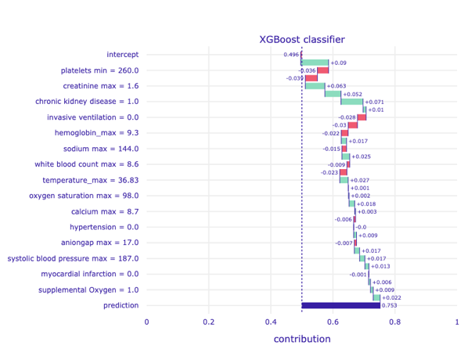 | 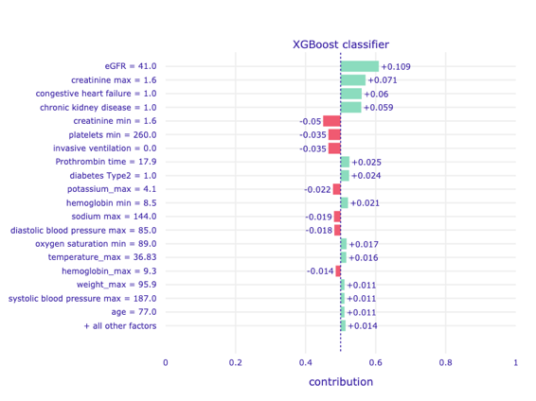
1.1 | 0.9 | 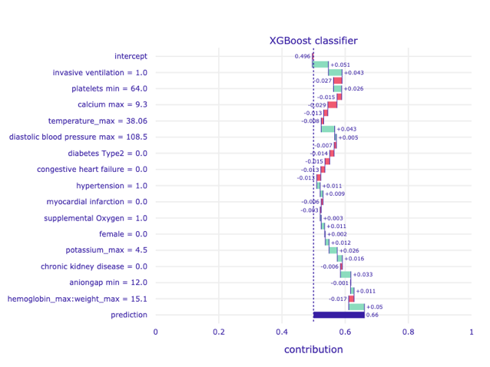 | 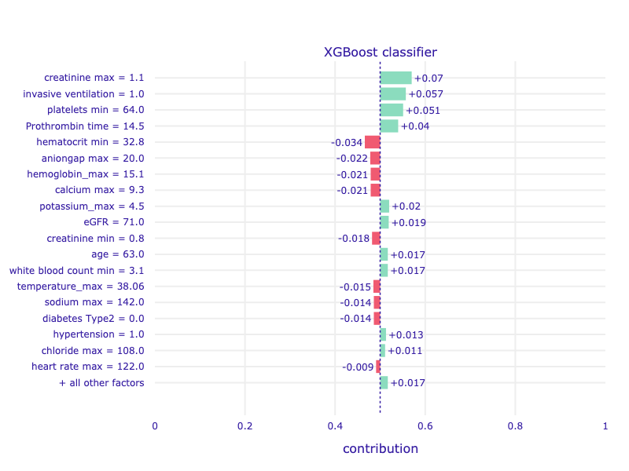
1.2 | 1.025 | 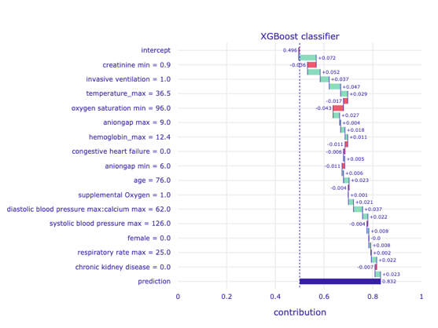 | 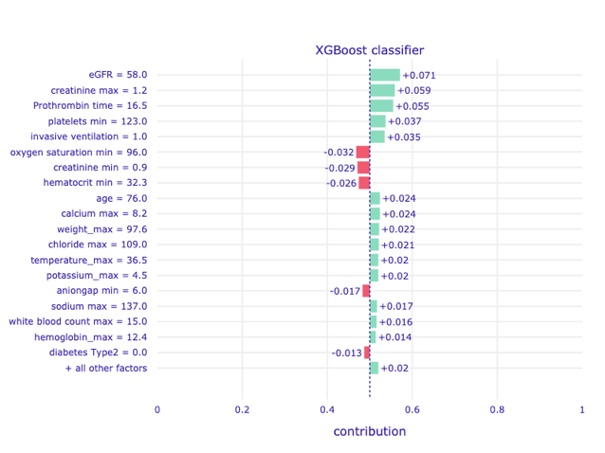
1.1 | 1.05 | 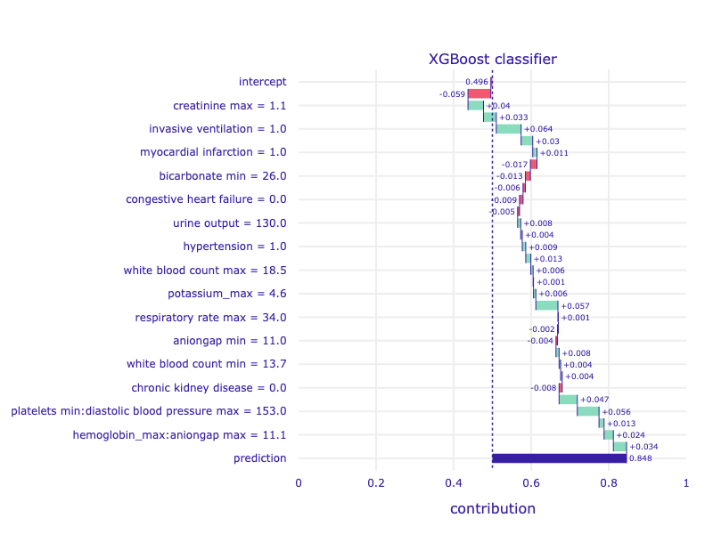 | 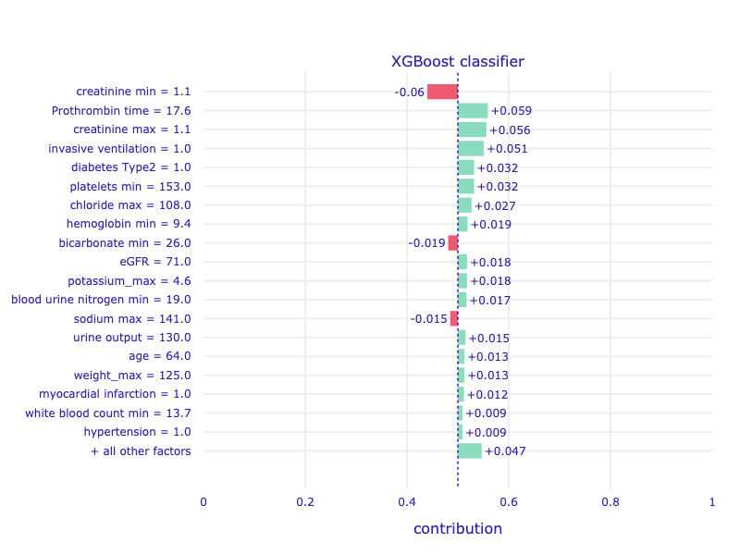
1.1 | 0.83 | 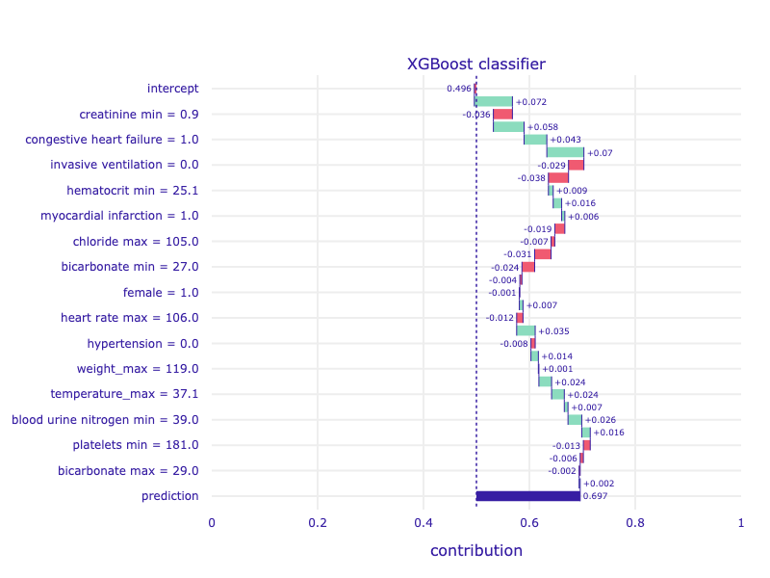 | 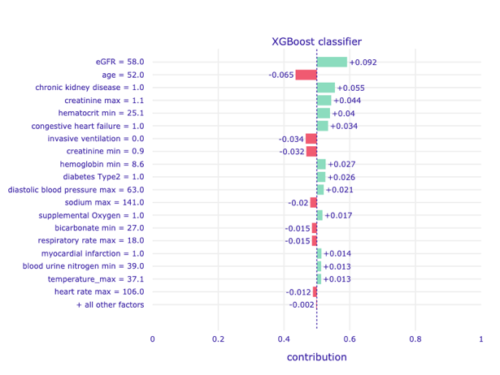
1.1 | 1.04 | 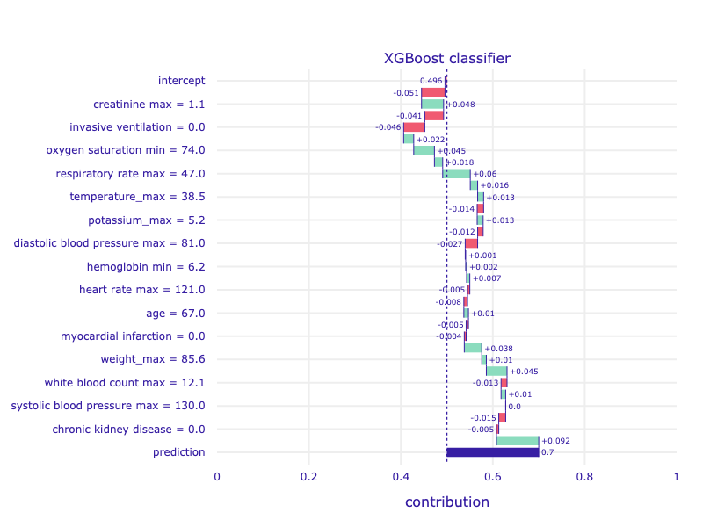 | 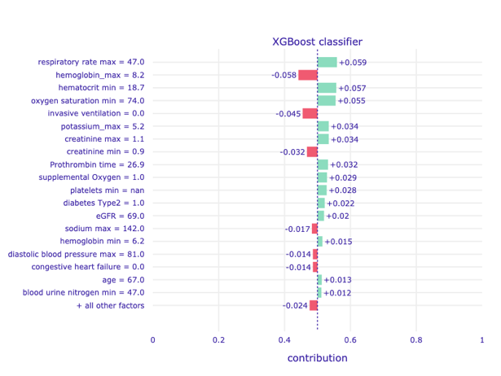
1.1 | 1.02 | 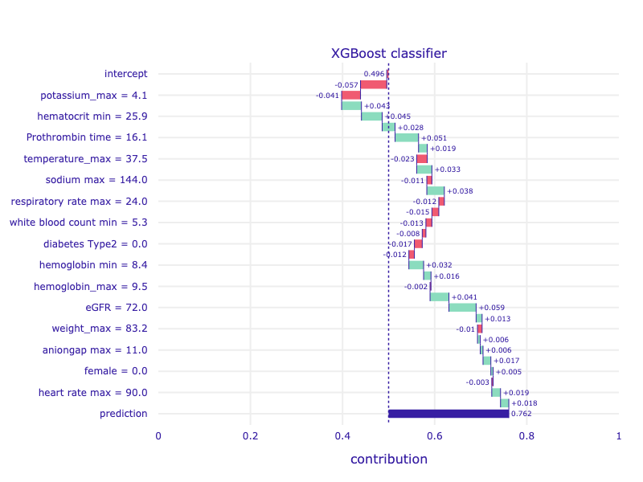 | 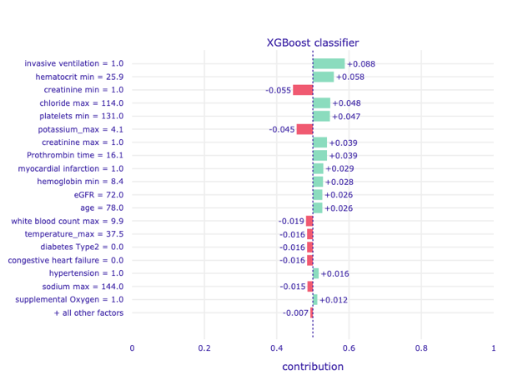
1.2 | 1.09 | 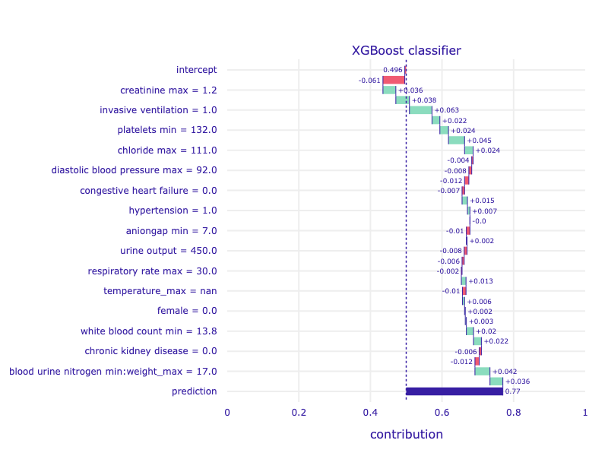 | 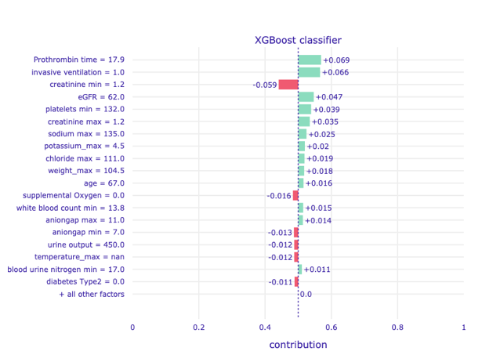
2.8 | 2.7 | 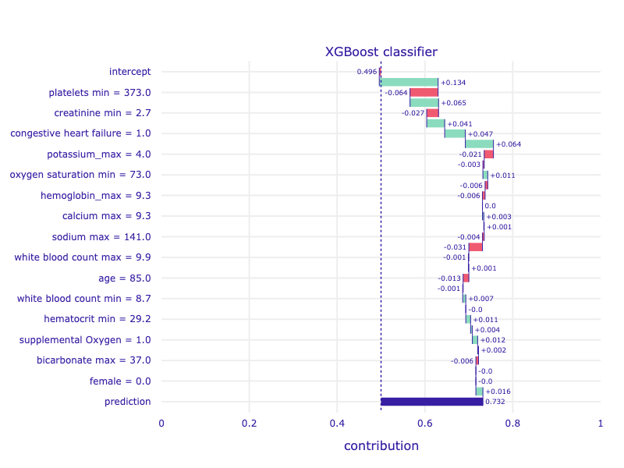 | 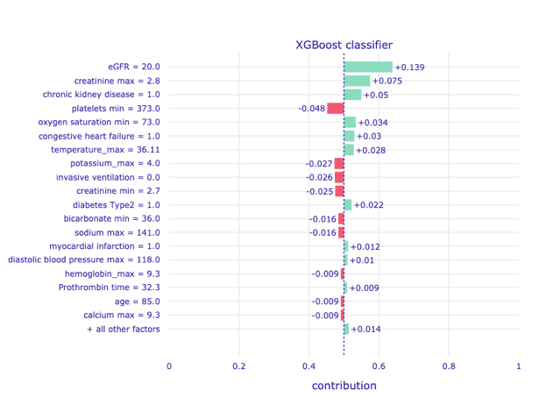
1.0 | 0.77 | 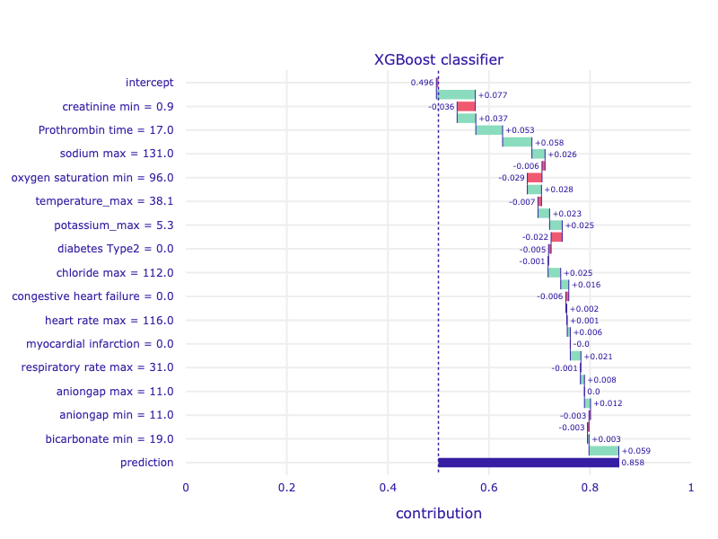 | 