Supplementary Figures
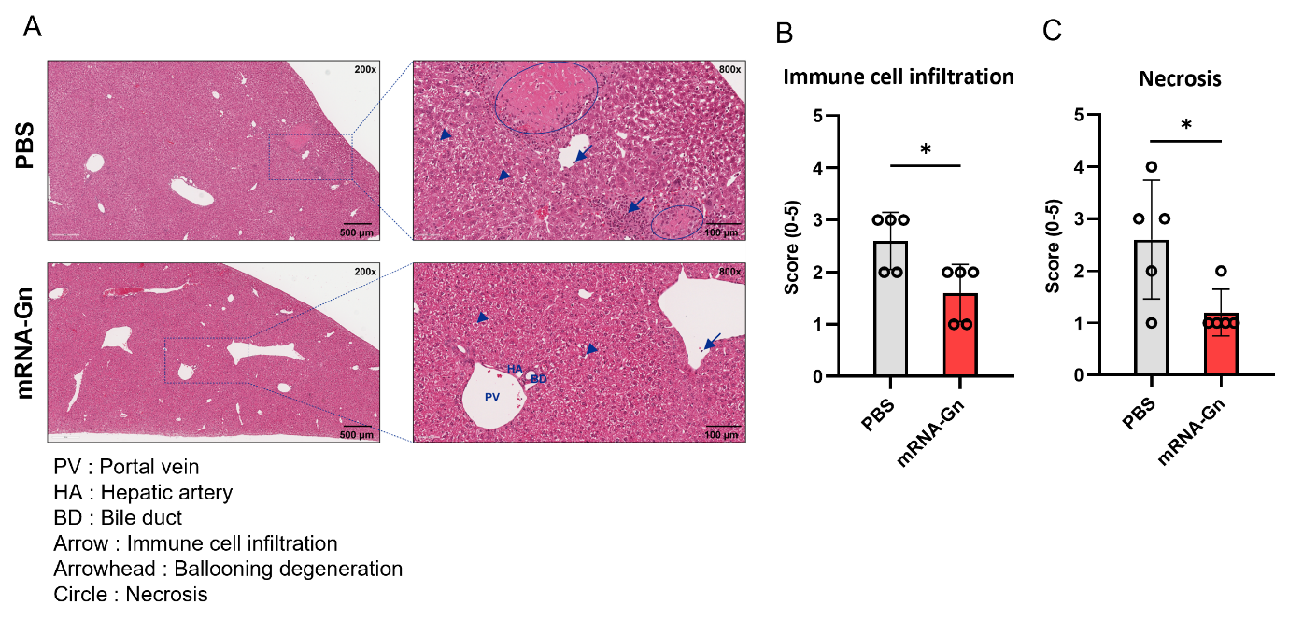

Supplementary figure 1. Pathological findings for the liver after virus challenge. (A) Pathology image of liver. (B, C) Scoring graphs. The bars represent mean ± SD. Statistical analysis was performed using the Mann–Whitney U test. (*p < 0.05, **p < 0.01, ***p < 0.001, ****p < 0.001)

(a)
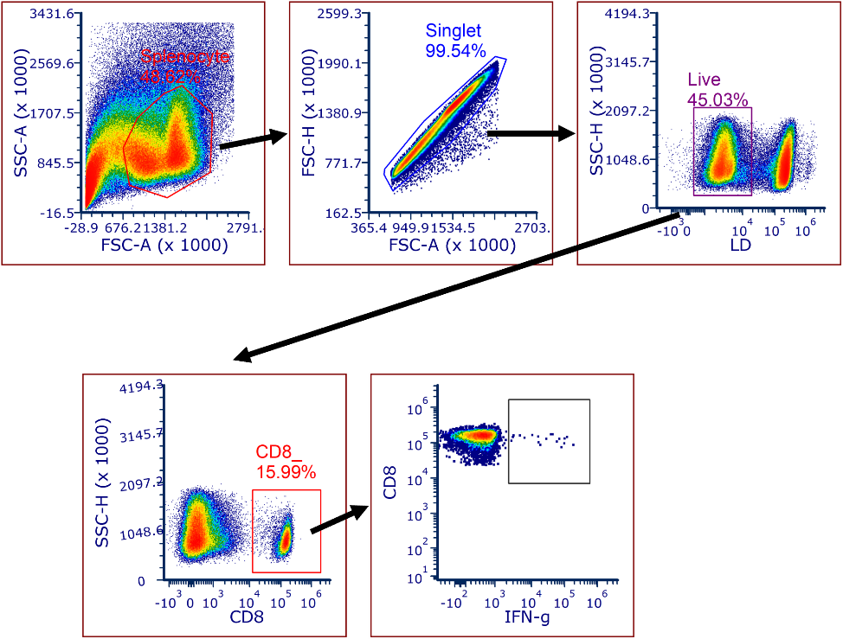

(b)
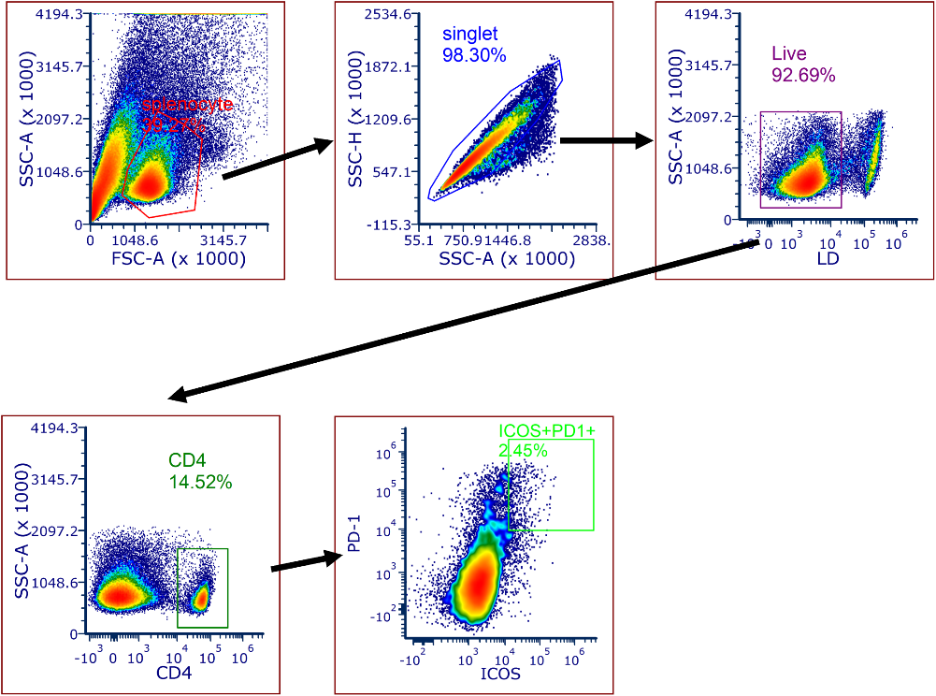

(c)
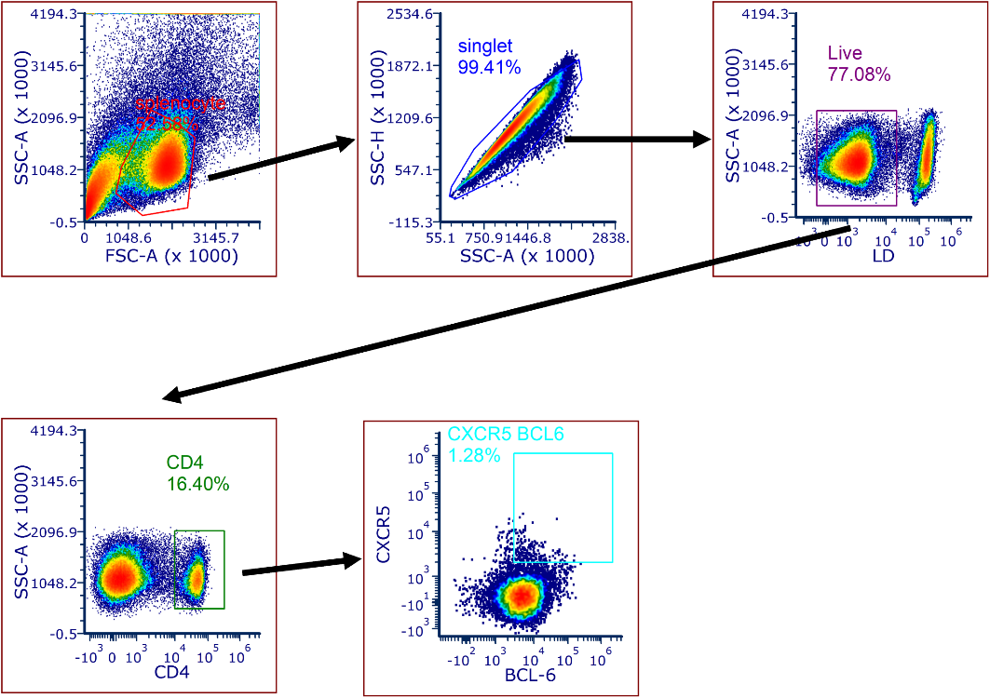

(d)
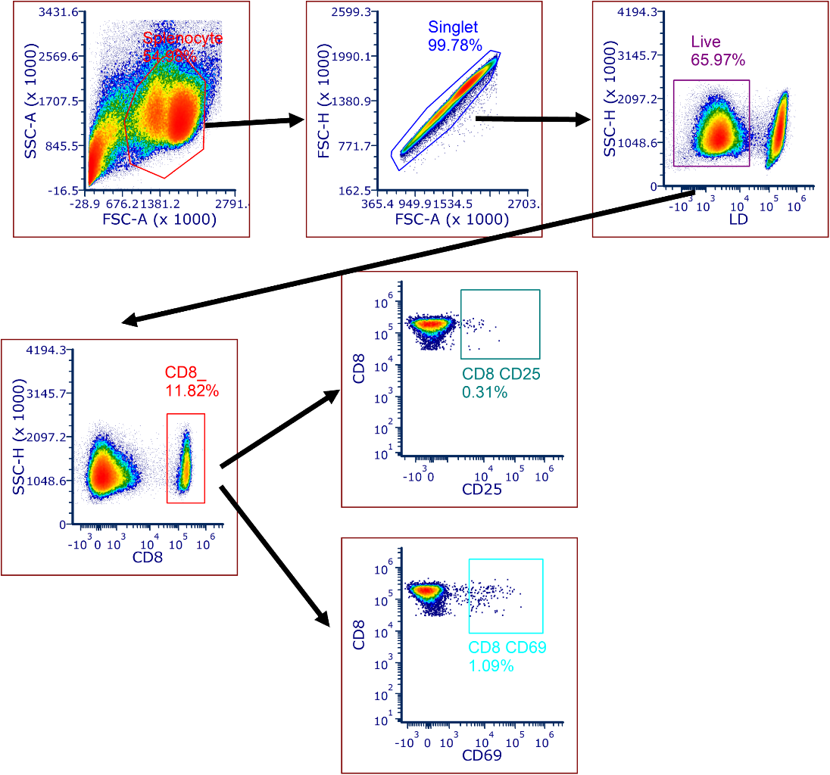
Supplementary Figure 2. Flow cytometry gating strategy. (a) IFN-gamma secreting CD8⁺ T cells, (b) ICOS⁺ PD-1⁺ double positive in CD4⁺ T cells, (c) CXCR5⁺ BCL-6⁺ double positive in CD4⁺ T cells and (d) CD25⁺ or CD69⁺ in CD8⁺ T cells.

