Polyhydrido Copper Nanocluster [Cu₁₄H₁₀(PPh₃)₈(SPhMe₂)₃]⁺ : Symmetry-Breaking by Thiolate Ligands to form Racemic Pairs of Chiral Clusters in Solid-State
Shuhuan Zeng¹, Xin Ge¹, Hongwen Deng², Shuwei Hao¹, Zhiye Zhang¹, Boon K. Teo^{2*}, Cunfa Sun^{1*}
¹College of Materials Science and Engineering, Huaqiao University, Xiamen 361021, China
²State Key Laboratory for Physical Chemistry of Solid Surfaces, Collaborative Innovation Center of Chemistry for Energy Materials,National & Local Joint Engineering Research Center of Preparation Technology of Nanomaterials, College of Chemistry andChemical Engineering, Xiamen University, Xiamen 361005, China

Experimental details
Reagents. Copper(II) acetate monohydrate [Cu(CH₃COO)₂·H₂O, purity 99%], sodium borohydride (NaBH₄, purity 98%), sodium borodeuteride (NaBD₄, purity 99%), dichloromethane (CH₂Cl₂, A.R.), and methanol (CH₃OH, A.R.) were purchased from Sinopharm Chemical Reagent Co. Ltd. (Shanghai, China). Tetraphenylphosphonium tetraphenylborate (TPPTPB, purity 99%), 2,4-dimethylbenzenethiol (HSPhMe₂, purity 99%), were purchased from Alfa Aesar Chemical Reagent Co. Ltd. (Tianjin, China). The water used in all experiments was ultrapure. All reagents were used as received without further purification.
Synthetic process. In a typical synthesis, 100 mg of Cu(OAc)₂•H₂O and 32 mg TPPTPB were dissolved in a mixed solvent of 2 mL methanol and 4ml CH₂Cl₂, followed by the addition of 100 mg of PPh₃ and 30 μL of HSPhMe₂ under the vigorous stirring. After 20 min, 3 mL of an aqueous solution of NaBH₄ (30 mg/mL) were added dropwise to the reaction mixture. After aged for 3 h at 25 °C, then the aqueous phase and precipitate were removed, while the organic phase was concentrated and washed with MeOH/H₂O (4:1 by volume) several times, and then dissolved in CH₂Cl₂ for further analysis. By the diffusion with hexane at 4 °C for one week, bright-yellow single crystals suitable for X-ray diffraction study were obtained with ~12% yield based on copper. With the same procedures, instead of NaBH₄, NaBD₄ was used to synthesize the deuterium analog (1_{D}).
Single Crystal Analysis: The diffraction data of all compounds were collected on an Agilent Technologies SuperNova system. X-ray single crystal diffractometer with Cu Kα radiation (λ = 1.54184 Å) at 100 K. The data were processed using CrysAlis^{Pro}.^{[1]} All structures were solved and refined using Full-matrix least-squares based on F² with program ShelXT and ShelXLwithin Olex2.^{[2-4]}
Measurements of Optical Properties. Pure crystals were dissolved in Spectro Grade CH₂Cl₂ for spectrum measurements. UV/Vis absorption spectra were recorded on a Varian Carry 5000 spectrophotometer using a quartz cuvette of 1 mm path length. The signal of the blank solvent was subtracted. For each spectrum, eight scans at a scanning speed 100 nm/min with a data pitch of 0.1 nm were averaged. The spectra were recorded at room temperature.
Measurements of NMR. ²H-NMR spectrum was recorded on an AVANCE III 850 MHz spectrometer in dichloromethane. Chemical shifts are reported in ppm with the internal TMS signal at 0.0 ppm as a standard.

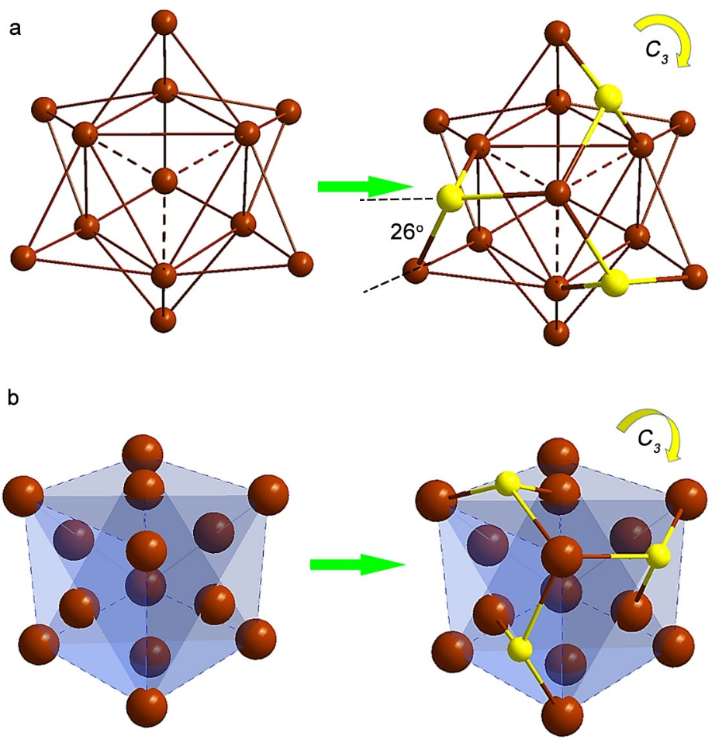
Figure S1 The cubic skeleton breaks into C₃ symmetry, a) top view of the copper frame; b) side view of the copper cube and the thiolation. Color labels: brown = Cu, yellow = S.
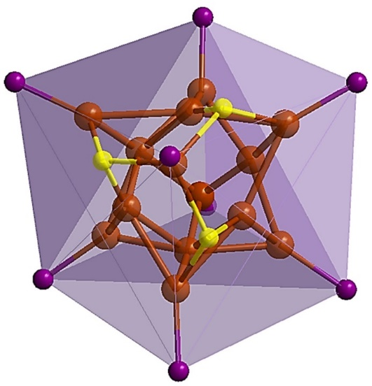
Figure S2 Side view of the phosphorus frame. Color labels: brown = Cu, yellow = S, pink = P.

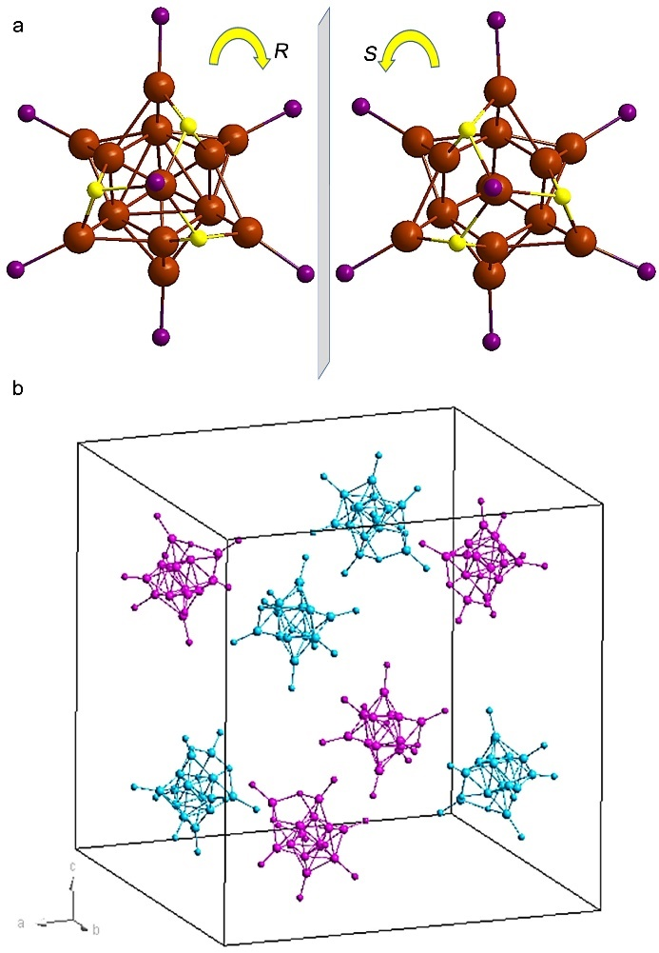
Figure S3 a): Chirality caused by the chiral orientation of the thiolate ligands in 2; b): The unit cell diagram of 2, the unit cell contains four pair of enantiomers (two different colors). All hydrogen and carbon atoms and solvents are omitted for clarity. Color labels: brown = Cu, yellow = S, pink = P.
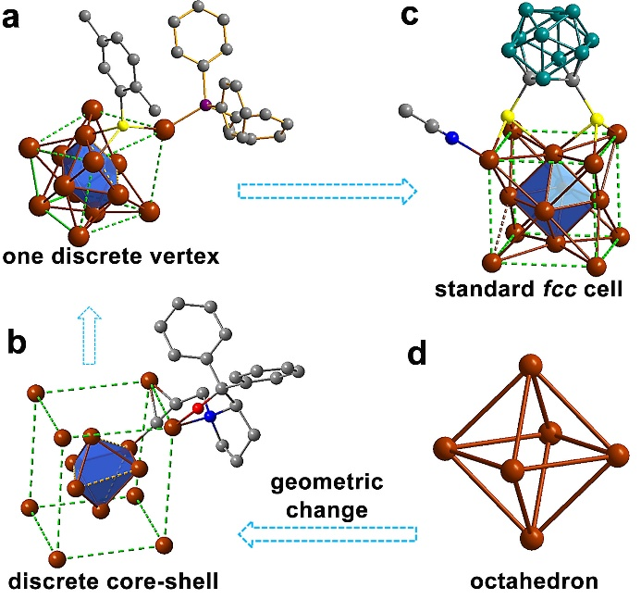
Figure S4 Geometric change of the fcc unit gradually form inner octahedron to standard fcc cell. Skeleton of a): cluster 2, b): S. Q. Zang’s work, alkynyl copper cluster with quasi-fcc 14-Cu skeleton^{[5]}, c): S. Q. Zang’s dithiolated Cu₁₄ cluster with regular fcc skeleton[^{6]} d): [CuHPPh₃]₆ cluster^{[7]}. All the H and part of ligands are omitted for clarity. Color labels: brown = Cu, yellow = S, pink = P, gray = C, teal = B, red = O.

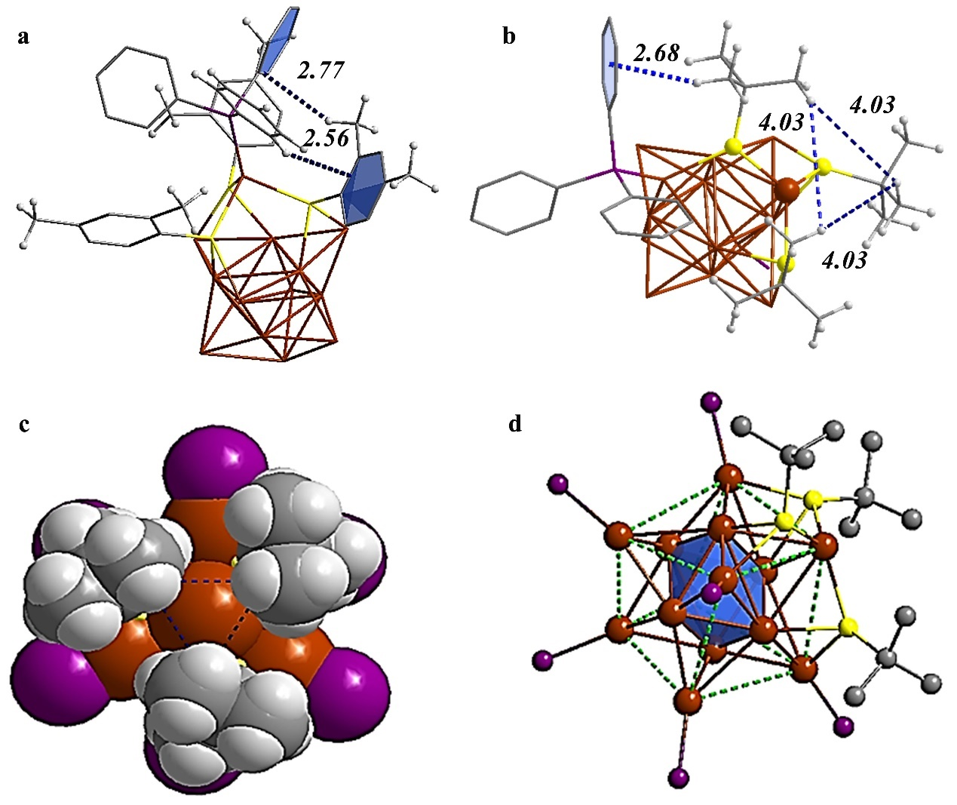
Figure S5 The presence of intracluster weak interactions on the surface. a): cluster 2; b): cluster 1. c): space-filling model of cluster 1, viewed along the C₃ axis. d): cubic 14-Cu in cluster 1. In cluster 2, the hydrogen atoms of thiolate ligands bind with a phenyl group of the PPh₃ ligand tightly via intracluster C−H…π interactions (2.72 Å), particularly with the protruded vertex. Furthermore, the phenyl groups of the PPh₃ on the protruded vertex interact with nearby thiolates through C−H…π interactions (2.64 Å). While in cluster 1, the steric thiolate ligands also interact with copper atoms through intracluster C−H…π interactions (2.68 Å), but the thiolate further interact with the vertex copper atom via weak C−H…Cu interaction ^{[8]}. In cluster 1, the three ^{t}BuS are more packed, severe steric hindrance occurred with short C-H…H-C distances leaving no space for 8th PPh₃ added (the distances between the ligands are 4.03 Å), which leads the vertex to be a bare copper atom other than Cu-PPh₃ as in cluster 2. Thus, cluster 2 shows a protrude vertex, while cluster 1 possesses a standard fcc cell. Color labels: brown = Cu, yellow = S, pink = P, gray = C, light with gray = H.

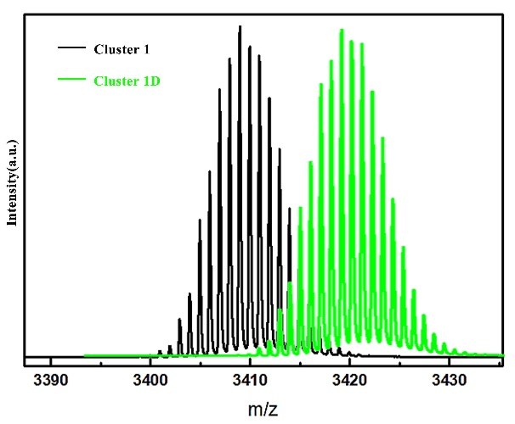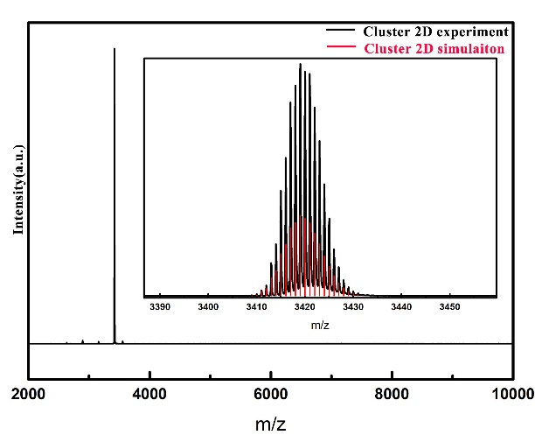
Figure S6 ESI-MS: comparison of cluster 2 and 2D (left); full scale and analysis of 2D (right).
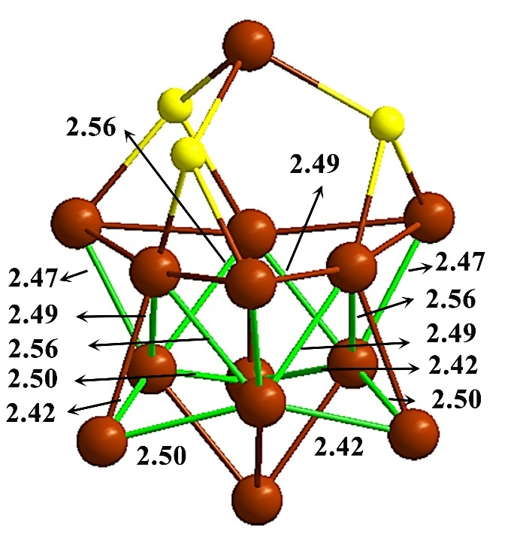
Figure S7 Shorter bonds in the skeleton, as obtained from experimental crystallographic data. Color labels: brown = Cu, yellow = S.

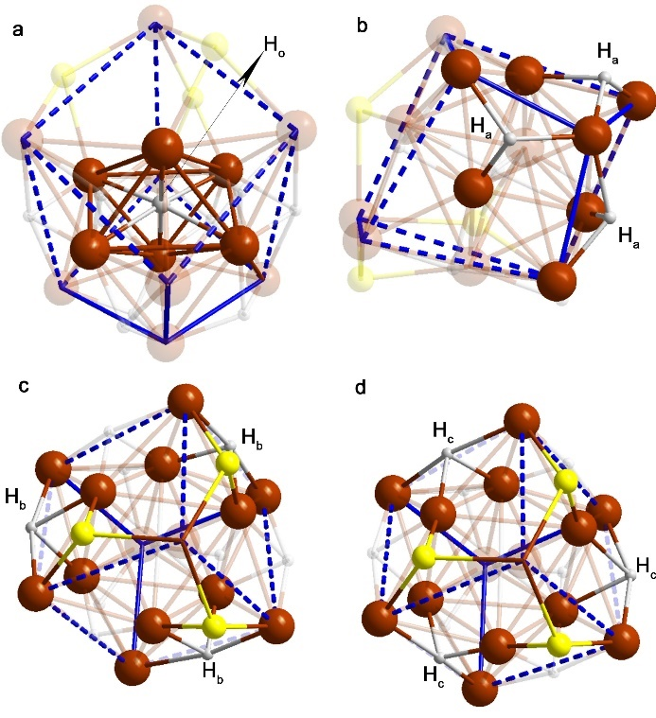
Figure S8 Four groups caused by the symmetry and thiolates’ coordination: a) the μ₆- H_{o}; b) three facial μ₃- H_{a}; c) three edged μ₄- H_{b} sharing two Cu with thiolate; d) three edged μ₄- H_{c} sharing one Cu with thiolate. Color labels: brown = Cu, yellow = S, white = H.

Table S1. Cluster 2: Cu-Cu bonds and Cu···Cu distances
Atom1- Atom1 | Range /Å | Average/Å | Atom1- Atom1 | Range /Å | Average/Å
Cu_{a}···Cu_{e} | 3.68 | 3.68 | Cu_{f}···Cu_{f} | 3.03 | 3.03
Cu_{b}-Cu_{e} | 2.63-2.70 | 2.67 | Cu_{c}-Cu_{f} | 2.42-2.50 | 2.46
Cu_{e}···Cu_{e} | 2.95 | 2.95 | Cu_{d}-Cu_{f} | 2.56 | 2.56
Cu_{e}-Cu_{c} | 2.67 | 2.67 | Cu_{a}···Cu_{b} | 4.29 | 4.29
Cu_{e}-Cu_{f} | 2.49-2.56 | 2.52 | Cu_{b}···Cu_{c} | 3.92-4.04 | 3.98
Cu_{f}-Cu_{d} | 2.97 | 2.97 | Cu_{d}-Cu_{c} | 2.97 | 2.97

Table S2. Cluster 2: Cu-H and Cu-S bonds
Atom1- Atom2 | Distance（±0.01）/Å |  |  |  |  |  |  |  |  |  |  |  | Average（±0.01）/Å
Ha-Cu | 1.80 | 1.90 | 2.05 | 1.80 | 1.90 | 2.05 | 1.80 | 1.90 | 2.05 |  |  |  | 1.92
Hb-Cu | 1.90 | 1.97 | 2.02 | 2.04 | 1.90 | 1.97 | 2.02 | 2.04 | 1.90 | 1.97 | 2.02 | 2.04 | 1.98
Hc-Cu | 1.89 | 1.94 | 2.09 | 2.10 | 1.89 | 1.94 | 2.09 | 2.10 | 1.89 | 1.94 | 2.09 | 2.10 | 2.00
Ho-Cu | 1.84 | 2.09 | 1.84 | 2.09 | 1.84 | 2.09 |  |  |  |  |  |  | 1.96
S-Cua | 2.42 | 2.42 | 2.42 |  |  |  |  |  |  |  |  |  | 2.42
S-Cub | 2.31 | 2.31 | 2.31 |  |  |  |  |  |  |  |  |  | 2.31
S-Cue | 2.28 | 2.28 | 2.28 |  |  |  |  |  |  |  |  |  | 2.28

References
[1] CrysAlisPro Version 1.171.35.19. Agilent Technologies Inc. Santa Clara C, USA. 2011.
[2] Sheldrick GM. Shelxt - integrated space-group and crystal-structure determination. Acta Crystallogr Sect A: Found Adv, 2015, 71(Pt 1): 3-8
[3] Dolomanov OV, Bourhis LJ, Gildea RJ, et al. Olex2: A complete structure solution, refinement and analysis program. J Appl Crystallogr, 2009, 42(2): 339-341
[4] Sheldrick GM. A short history of shelx. Acta Crystallogr A, 2008, 64(Pt 1): 112-122
[5] M.M. Zhang, X.Y. Dong, Z.Y. Wang, H.Y. Li, S.J. Li, X. Zhao, S.Q. Zang, Angew. Chem. Int. Ed., 2020, 59, 10052-10058.
[6] Y.L. Li, J. Wang, P. Luo, X.H. Ma, X.Y. Dong, Z.Y. Wang, C.X. Du, S.Q. Zang, T.C.W. Mak, Adv. Sci., 2019, 6, 1900833-1900839.
[7] R.C. Stevens, M.R. McLean, R. Bau, T.F. Koetzle, J. Am. Chem. Soc., 1989, 111, 3472–3473;
[8] L. Wang, X. Yan, G. Tian, Z. Xie, S. Shi, Y. Zhang, S. Li, X. Sun, J. Sun, J. He and H. Shen, Dalton Trans, 2023, 52, 3371-3377.

