Supplementary Material
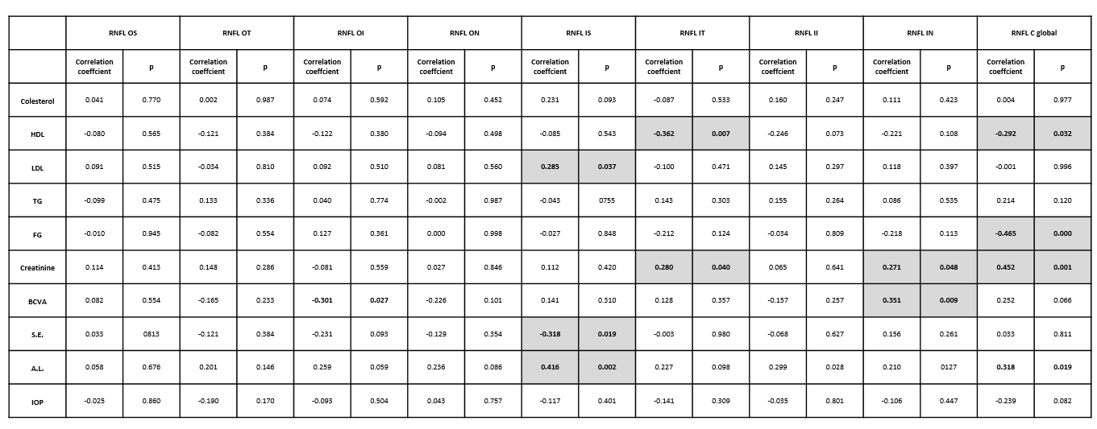

Suppl. Table 1: Correlations between clinical variables (HDL, high-density lipoprotein; LDL, low-density lipoprotein; TG, triglycerides; FR, filtrate rate; BCVA, best-corrected visual acuity; SE, spherical equivalent; AL, axial length; IOP, intraocular pressure) in DM2 patients and RNFL thickness by OCT in the nine areas of the early treatment diabetic retinopathy study (ETDRS) grid (OS, Outer Superior; OT, Outer Temporal; OI, Outer Inferior; ON, Outer Nasal; IS, Inner Superior; IT, Inner Temporal; II, Inner Inferior, IN: Inner Nasal; C, Central; and where temporal quadrants are represented left and nasal quadrants are represented right). The values that reached statistical significance (p<0.05) are shown in bold with a grey background.

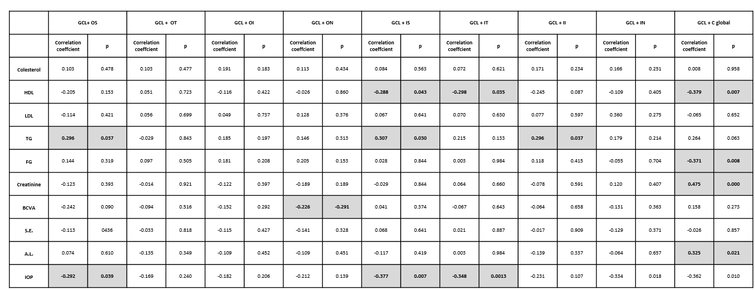

Suppl. Table 2: Correlations between clinical variables (HDL, high-density lipoprotein; LDL, low-density lipoprotein; TG, triglycerides; FR, filtrate rate; BCVA, best-corrected visual acuity; SE, spherical equivalent; AL, axial length; IOP, intraocular pressure) in DM2 patients and GCL+ (GC-IPL) thickness by OCT in the nine areas of the early treatment diabetic retinopathy study (ETDRS) grid (OS, Outer Superior; OT, Outer Temporal; OI, Outer Inferior; ON, Outer Nasal; IS, Inner Superior; IT, Inner Temporal; II, Inner Inferior, IN: Inner Nasal; C, Central; and where temporal quadrants are represented left and nasal quadrants are represented right). The values that reached statistical significance (p<0.05) are shown in bold with a grey background.

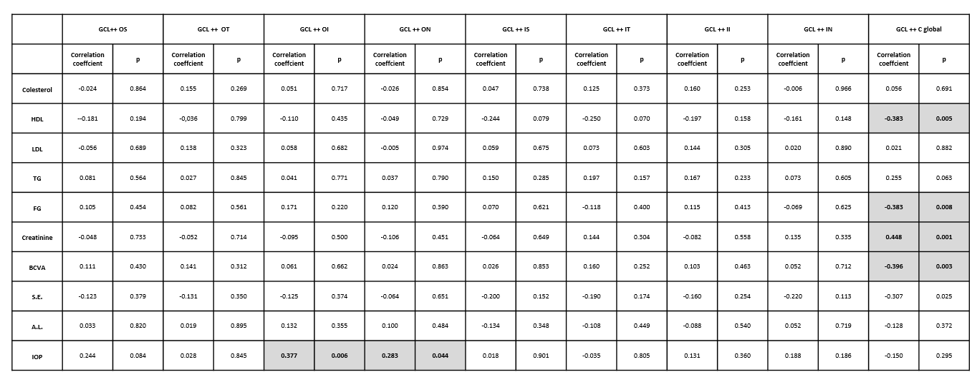

Suppl. Table 3: Correlations between clinical variables (HDL, high-density lipoprotein; LDL, low-density lipoprotein; TG, triglycerides; FR, filtrate rate; BCVA, best-corrected visual acuity; SE, spherical equivalent; AL, axial length; IOP, intraocular pressure) in DM2 patients and GCL ++ (ILM - IPL/INL [GCC]) thickness by OCT in the nine areas of the early treatment diabetic retinopathy study (ETDRS) grid (OS, Outer Superior; OT, Outer Temporal; OI, Outer Inferior; ON, Outer Nasal; IS, Inner Superior; IT, Inner Temporal; II, Inner Inferior, IN: Inner Nasal; C, Central; and where temporal quadrants are represented left and nasal quadrants are represented right). The values that reached statistical significance (p<0.05) are shown in bold with a grey background.

