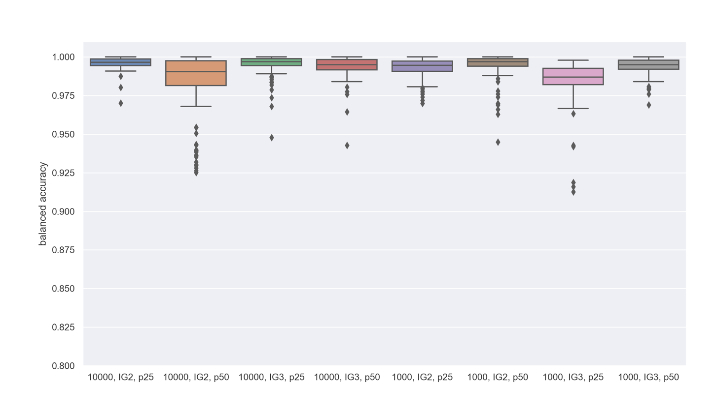
Figure S1. Distribution of balanced accuracy of Random Forest prediction for population of HIBACHI experiments. Experiments are indicated with population size (1000 or 10000), interaction complexity (IG2 or IG3) and proportion of cases and controls (p25 or p50)

