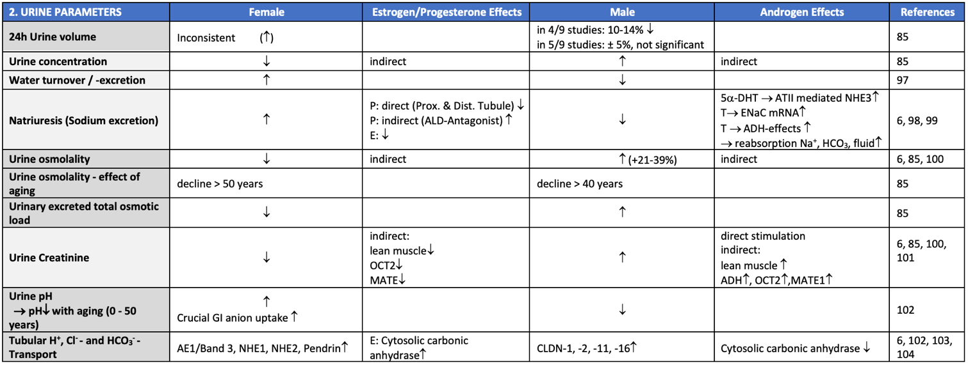

Supplementary Table 2: Physiological sex differences and influence of sex hormones on basic urinary parameters.

