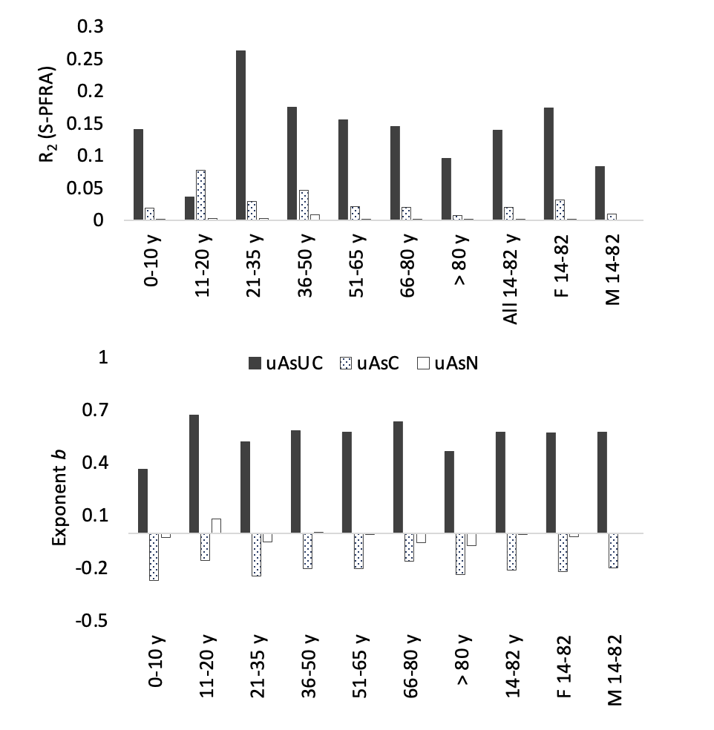

Supplementary Figure 4: Sex- and age-differentiated efficacy of standardization in trimmed data sets.
S-PFRA was performed in the age/sex subsets of Fig 3 following the exclusion of outliers. R² and b values are compared between uAs_{UC},uAs_{C}, and uAs_{N}. Outliers were defined as all values above the upper fences (UF) in boxplots with
UF = 3. Quartile + 1.5 × IQR.

