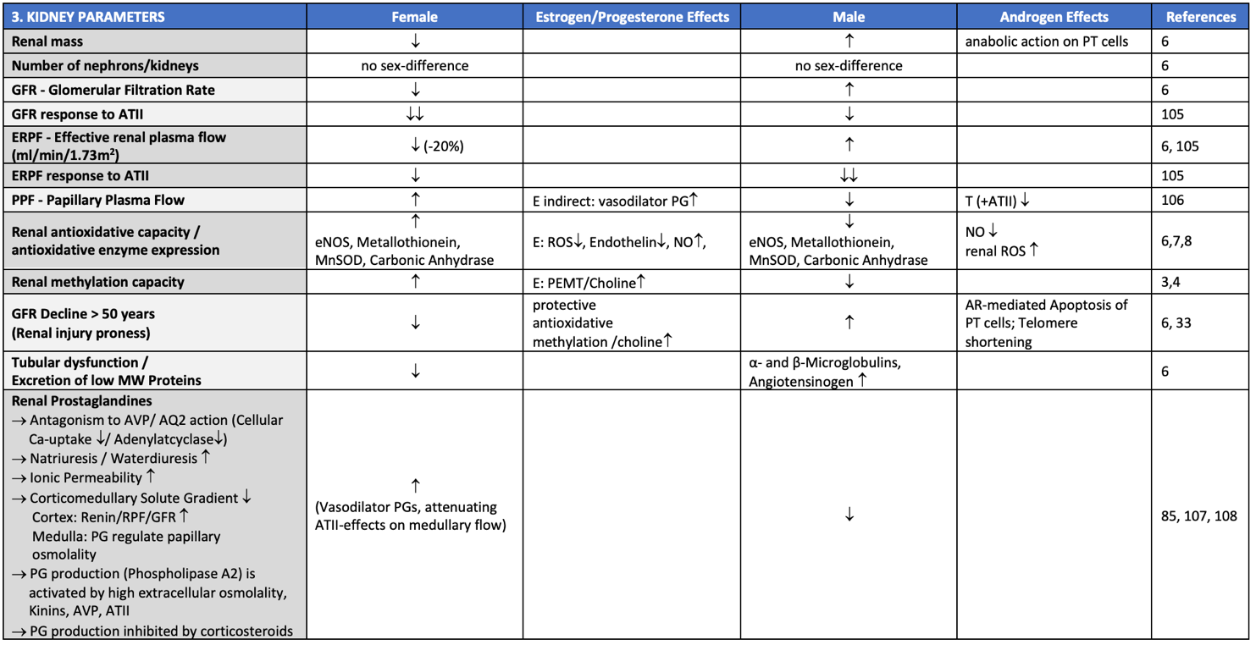

Supplementary Table 3: Physiological sex differences and influence of sex hormones on basic renal parameters.

