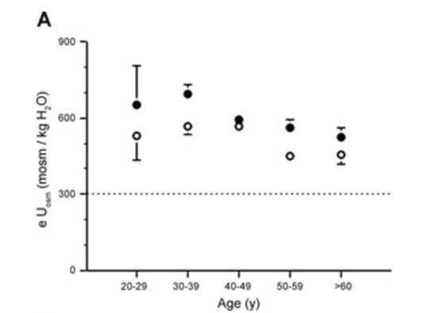

"U_{osm} in men and women in the different age categories in subjects of study D during the run-in period. B: U_{osm} in men and women in study S according to the different classes of CKD (I to V). Means ± SE for men (•) and women (○). Dashed lines indicate isoosmolality to plasma. Relatively large SEs in the first age and CKD classes are probably due to the small number of subjects of each sex in these classes. When SEs are not visible, they are smaller than the symbols. Comparison by two-way ANOVA (sex and CKD, or sex and age). The sex difference was significant in both cases." ⁸⁵

Supplementary Figure 5: Effect of age on sex-differentiated urine osmolality (Perucca J et al., 2006).
Reproduction of original Figure 2 A of "Sex difference in urine concentration across differing ages, sodium intake, and level of kidney disease," Perucca J, et al. (2006).⁸⁵

