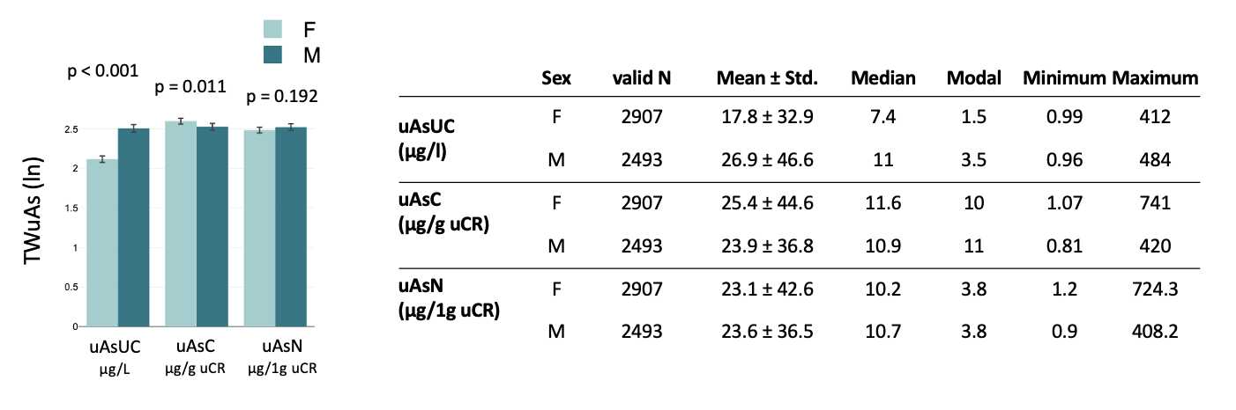

Supplementary Figure 2: Quantitative sex differences of TWuAs within uAs_{UC,} uAs_{C}, and uAs_{N}.
All n=5400 samples (2493 males, 2907 females) were in the age band 14-82 years, < 500 μg/L uAs_{UC,} and uCR < 4.5 g/L. Bars/Error bars: means/SE of log-transformed, sex-differentiated TWuAs data. The significance (p) of sex differences within each log-transformed TWuAs dataset was established by the Mann-Whitney U test. In addition, linear statistical data are given in the table.

