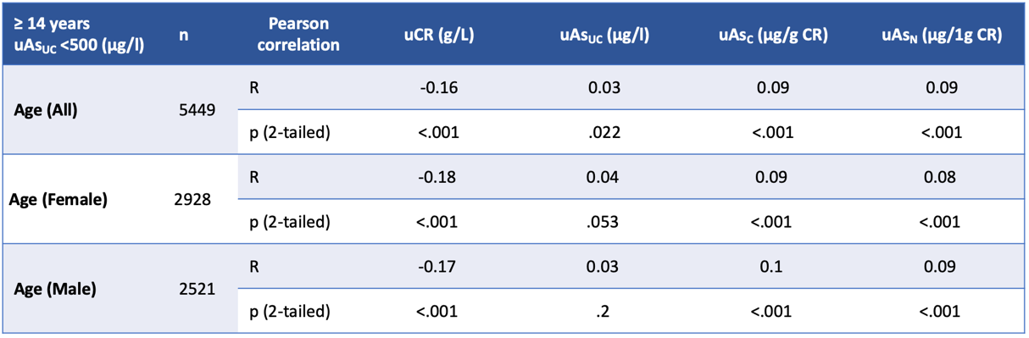

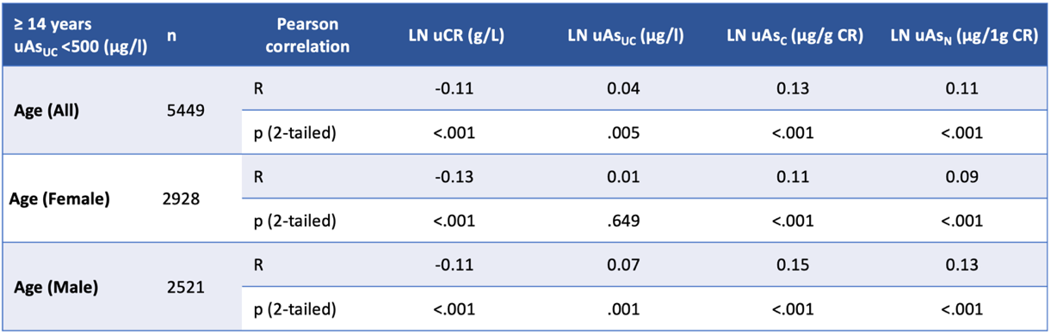

Supplementary Table 5: Pearson correlation of age with uCR and TWuAs.
Pearson correlation coefficients (R) and significance (p) are given for linear data (upper table) and log data closer to the normal distribution (lower table).

