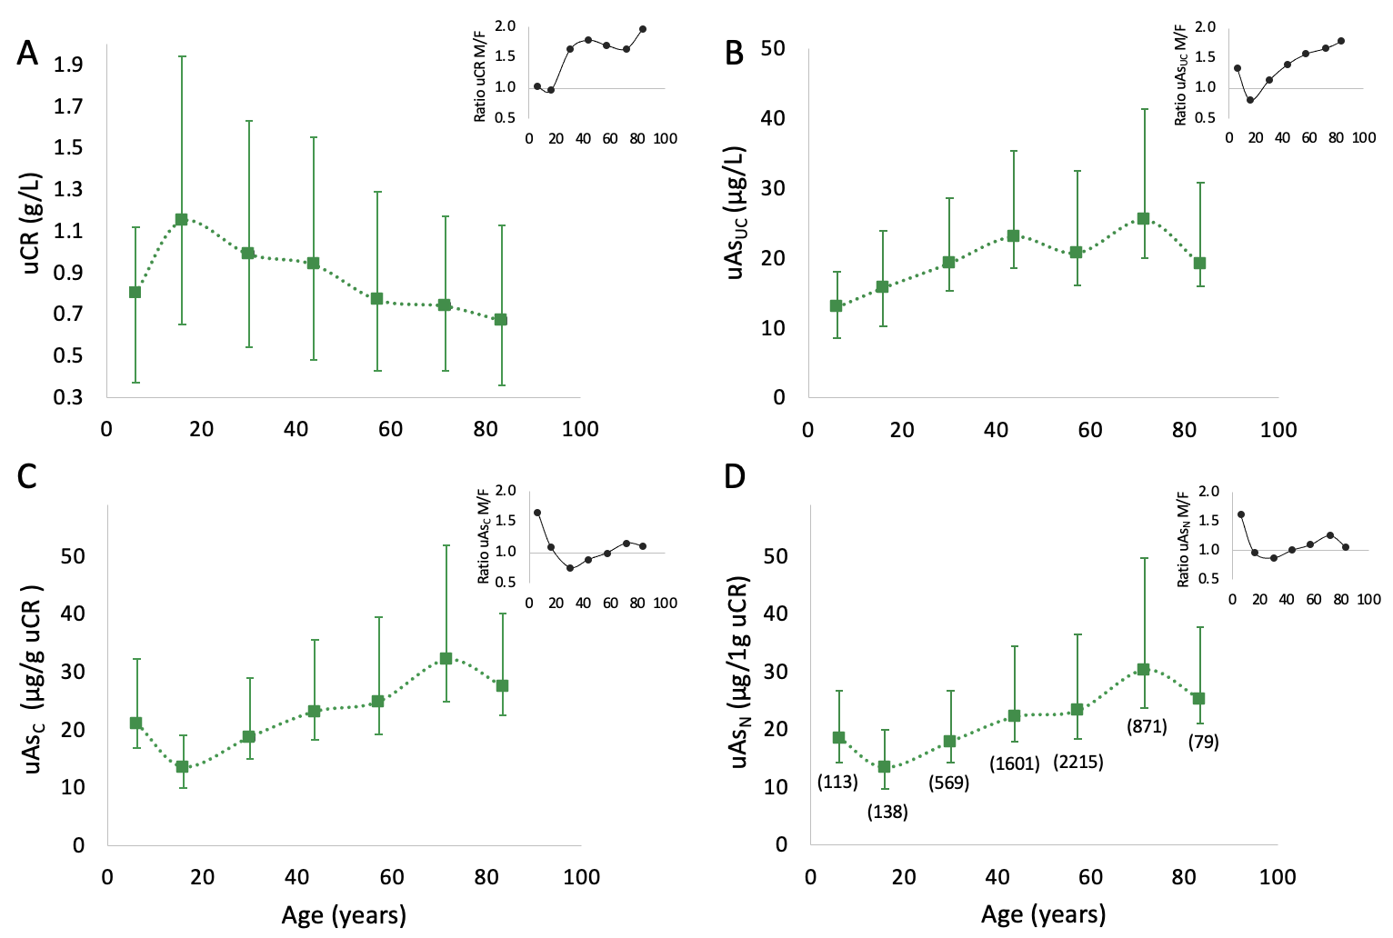

Supplementary Figure 1: Influence of age on medians and ICRs of uCR and TWuAs.
All samples with age indication, uAs_{UC} ≤ 500 μg/L, and uCR < 4.5 g/L (n=5585, females n= 2967, males n = 2618) were classified into seven identical age groups as in Fig 1 (0-10 y, 11-20 y, 21-35 y, 36-50 y, 51-65 y, 66-80 y, >80 y). The supplementary Excel file gives detailed descriptive statistics for each age group. Medians (squares) ± ICRs (vertical error bars) were calculated for uCR (A), uAs_{UC} (B), uAs_{C} (C), and uAs_{N} (D) in sex-aggregate data. Horizontal age error bars were omitted as age SEs in individual age bands ranged from 0.09 to 0.53 years and thus were too small for visual delimitation from measurement points. Sex ratios of mean values are illustrated in the inlays of Figures A-D. The sample sizes of the individual subgroups are shown in parentheses next to the data points in (D).

