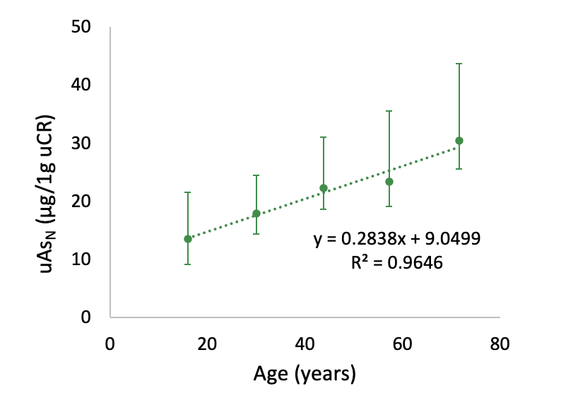
Supplementary Figure 3: Increase in As_{N} with age between the end of puberty and the seventh decade of life.
Medians and ICR of 5 age bands are shown. Linear regression revealed an average annual increase of 0.28 µg/1 g uCR uAs_{N}. However, the rule of continuous increment of uAs_{N} with age illustrated here does not seem to hold at both ends of life since infants had higher uAsN than adolescents, and there is a drop in uAsN among the very elderly compared to younger seniors (Fig 1).

