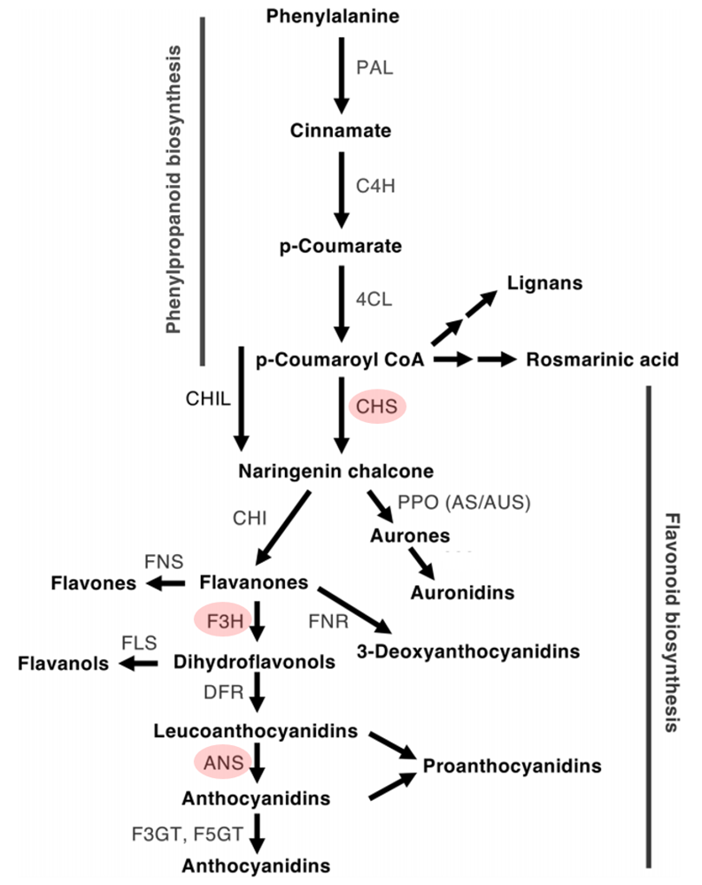
Supplementary Fig. S2: Simplified schematic representation of a section of the phenylpropanoid pathway directing to the production of flavonoid compounds. Pathway enzymes are indicated in abbreviations as follows: PAL: phenylalanine ammonia-lyase; C4H, cinnamate 4-hyd hydroxylase; 4CL, 4-coumarate:CoA ligase; CHS, chalcone synthase; CHI, chalcone isomerase; CHIL, chalcone isomerase-like; F3H, flavanone 3-hydroxylase; DFR, dihydroflavonol 4-reductase; FNR, flavanone reductase; ANS, anthocyanidin synthase; F3GT, flavonoid 3-O-glucosyltransferase; A5GT, anthocyanidin 5-O-lucosyltransferase; AUS/AS, aureusidin/aurone synthase; FNS, flavone synthase; FLS, flavonol synthase.
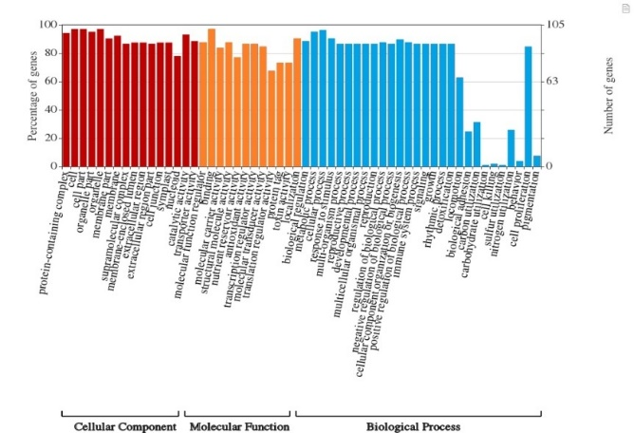
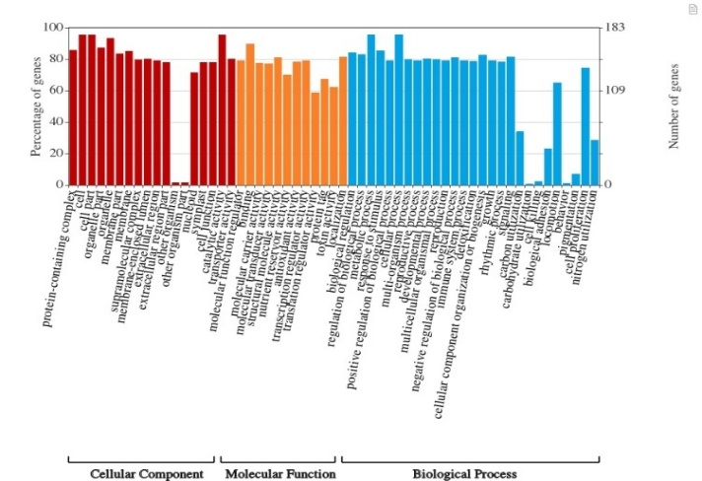
(a)
(b)

(c)
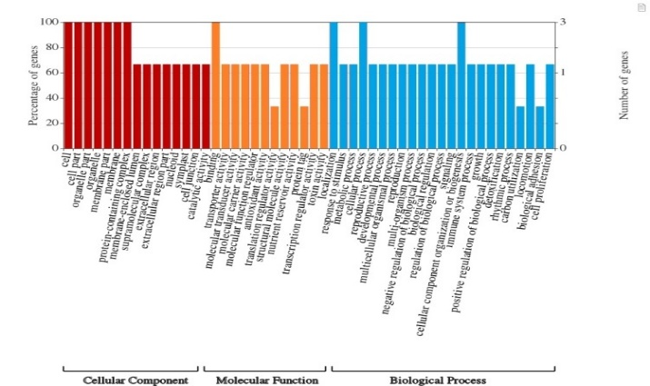
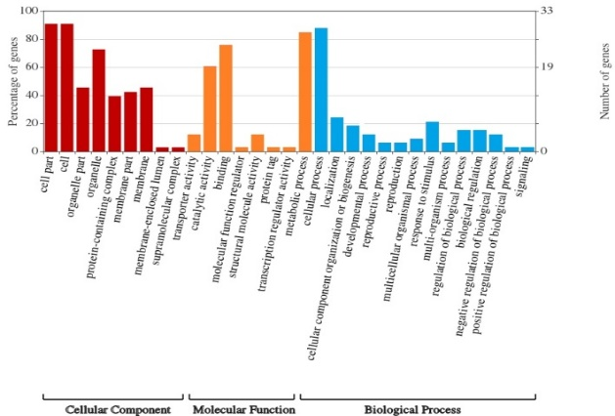
(d)
Supplementary Fig. S1: Functional assignment of the filtered contigs from different SAGE libraries based on GO categorization. Summarizing according to their molecular functions, cellular processes and biological processes of filtered (a) SAGE 1, (b) SAGE 2, (c) SAGE 3 and (d) SAGE 4 library.

Supplementary Table S1: List of identified flavonoid glycoconjugates in wheat NILs (HD2329 and HD2329+Lr28) at 0, 72 and 168 hpi
Time points | Sl.  No. | Proposed compound | R_{t}  (min) | MW | Molecular formula | [M+H]⁺  m/z | Polyphenol Class | References | Present in  HD2329 | Present in HD2329+Lr28
0 hpi | 1. | Quercetagenin 3,6,7,3'-tetramethyl ether (Chrysosplenetin) | 5.13 | 374.34 | C₁₉H₁₈O₈ | 375.0 | Flavonoids | ChEBI ID: 3689  PhytoHub
0 hpi | 2. | 5,5'-Dihydroferulic acid | 5.55 | 390.38 | C₂₀H₂₂O₈ | 391.09 | Phenolic acids | PhytoHub,  Phenol Explorer
0 hpi | 3. | Chrysoeriol- O-deoxyhexoside- C-hexoside | 7.04 | 608.54 | C₂₈H₃₂O₁₅ | 609.14 | Flavonoids | Wojakowska et al., 2013 |  | -
0 hpi | 4. | Tricin 7- O-hexoside | 7.98 | 492.4 | C₂₃H₂₄O₁₂ | 493.16 | Flavonoids | CHEBI ID:75349  Ioset et al., 2007  Wojakowska et al., 2013 | -
0 hpi | 5. | 5,3',4'-Trihydroxy-3-methoxy-6:7-methylenedioxyflavone 4'-O-glucuronide | 10.06 | 520.39 | C₂₃H₂₀O₁₄ | 521.34 | Flavonoids | PhytoHub, Phenol Explorer |  | -
72 hpi | 6. | Luteolin 6-C- hexoside O-hexoside | 6.12 | 610.11 | C₂₇H₃₀O₁₆ | 611.05 | Flavonoids | Wojakowska et al., 2013
72 hpi | 7. | Chrysoeriol O- hexoside C- hexoside | 6.83 | 624.16 | C₂₈H₃₂O₁₆ | 625.04 | Flavonoids | Wojakowska et al., 2013 |  | -
72 hpi & 168 hpi | 8. | Tricin 7- O- hexoside malonylated | 6.95 | 578.16 | C₂₆H₂₆O₁₅ | 579.06 | Flavonoids | Wojakowska et al., 2013
0 hpi, 72 hpi & 168 hpi | 9. | Apigenin C-hexoside C-pentoside | 5.95 | 564.49 | C₂₆H₂₈O₁₄ | 565.19 | Flavonoids | Ioset et al., 2007; Wojakowska et al., 2013 |  | -
0 hpi, 72 hpi & 168 hpi | 10. | Luteolin 6-C- glucoside | 6.14 | 448.37 | C₂₁H₂₀O₁₁ | 449.10 | Flavonoids | ChEBI ID:17965  Ioset et al., 2007; Wojakowska et al., 2013 |  | -
0 hpi, 72 hpi & 168 hpi | 11. | Luteolin -C- deoxyhexosyl-O-hexoside/ Luteolin 7-O-rutinoside | 6.49 | 594.51 | C₂₇H₃₀O₁₅ | 595.12 | Flavonoids | ChEBI ID: 31788  Wojakowska et al., 2013 | -
0 hpi, 72 hpi & 168 hpi | 12. | Apigenin 6-C-glucoside | 6.94 | 432.38 | C₂₁H₂₀O₁₀ | 433.20 | Flavonoids | ChEBI ID: 18330  Wojakowska et al., 2013
0 hpi, 72 hpi & 168 hpi | 13. | Chrysoeriol 6-C- glucoside | 7.2 | 462.40 | C₂₂H₂₂O₁₁ | 463.14 | Flavonoids | Ioset et al., 2007  Wojakowska et al., 2013 |  | -
hpi, hours post inoculation; MW, Molecular Weight; ChEBI ID, Chemical Entities of Biological Interest database (https://www.ebi.ac.uk/chebi/); Phenol Explorer; Phenol Explorer Database (http://phenol-explorer.eu/compounds/classification)

Supplementary Table S2: List of filtered contigs from all the four SAGE libraries.
Sl. No. | SAGE 1 |  | SAGE 2 |  | SAGE 3 |  | SAGE 4
 | Contigs | KO specific genes | Contigs | KO specific genes | Contigs | KO specific genes | Contigs | KO specific genes
1 | contig_147 | K07198 | contig_4 | K01209 | contig_69 | K03627 | contig_108 | K21198
2 | contig_204 | K06630 | contig_75 | K15633 | contig_205 | K01900 | contig_341 | K18635
3 | contig_224 | K01304 | contig_170 | K22733 | contig_238 | K08081 | contig_411 | K02980
4 | contig_352 | K18151 | contig_193 | K15296 | contig_326 | K01358 | contig_500 | K15633
5 | contig_368 | K13800 | contig_208 | K10589 | contig_393 | K20547 | contig_762 | K21889
6 | contig_480 | K00844 | contig_334 | K12828 | contig_402 | K00344 | contig_934 | K17796
7 | contig_633 | K01900 | contig_347 | K08232 | contig_456 | K02872 | contig_1001 | K08901
8 | contig_692 | K13484 | contig_514 | K01205 | contig_480 | K00827 | contig_1102 | K07305
9 | contig_731 | K12857 | contig_672 | K13448 | contig_491 | K01427 | contig_1204 | K12158
10 | contig_777 | K01733 | contig_707 | K12741 | contig_509 | K13412 | contig_1270 | K11099
11 | contig_884 | K04035 | contig_745 | K05283 | contig_554 | K15891 | contig_1324 | K07305
12 | contig_918 | K08762 | contig_759 | K05016 | contig_591 | K06185 | contig_1367 | K14085
13 | contig_924 | K18469 | contig_782 | K15275 | contig_672 | K03264 | contig_1419 | K15115
14 | contig_957 | K13103 | contig_795 | K17422 | contig_770 | K02971 | contig_1483 | K01969
15 | contig_1015 | K13071 | contig_812 | K12158 | contig_793 | K14004 | contig_1679 | K08247
16 | contig_1019 | K01188 | contig_858 | K03035 | contig_800 | K17260 | contig_1712 | K06630
17 | contig_1054 | K11886 | contig_939 | K15216 | contig_814 | K03671 | contig_1717 | K12947
18 | contig_1107 | K12840 | contig_969 | K07767 | contig_975 | K22047 | contig_2236 | K01267
19 | contig_1112 | K14497 | contig_1067 | K09496 | contig_984 | K18453 | contig_2289 | K01735
20 | contig_1286 | K15171 | contig_1116 | K15397 | contig_999 | K10704 | contig_2327 | K12827
21 | contig_1311 | K02701 | contig_1307 | K04564 | contig_1030 | K01520 | contig_2502 | K12869
22 | contig_1368 | K13064 | contig_1325 | K00901 | contig_1111 | K10775 | contig_2558 | K00850
23 | contig_1370 | K19658 | contig_1359 | K00573 | contig_1142 | K04649 | contig_2781 | K19045
24 | contig_1384 | K02888 | contig_1498 | K11649 | contig_1185 | K02888 | contig_2909 | K15223
25 | contig_1401 | K03238 | contig_1535 | K17892 | contig_1407 | K05391 | contig_2959 | K02964
26 | contig_1450 | K19269 | contig_1621 | K17260 | contig_1422 | K18159 | contig_3023 | K12396
27 | contig_1463 | K02891 | contig_1692 | K10258 | contig_1445 | K15275 | contig_3049 | K01358
28 | contig_1522 | K07305 | contig_1758 | K00654 | contig_1526 | K11866 | contig_3084 | K06689
29 | contig_1539 | K02698 | contig_1774 | K01079 | contig_1558 | K04382 | contig_3172 | K08869
30 | contig_1553 | K03036 | contig_1857 | K17098 | contig_1613 | K01641 | contig_3229 | K05955
31 | contig_1561 | K15028 | contig_1859 | K17824 | contig_1630 | K17824 | contig_3230 | K19765
32 | contig_1611 | K14207 | contig_1990 | K02874 | contig_1635 | K12823 | contig_3330 | K00864
33 | contig_1622 | K00949 | contig_2059 | K05391 | contig_1794 | K00951 | contig_3362 | K00939
34 | contig_1626 | K03626 | contig_2119 | K13280 | contig_1829 | K06691 | contig_3375 | K14271
35 | contig_1635 | K01783 | contig_2255 | K01641 | contig_1845 | K18204
36 | contig_1684 | K16055 | contig_2322 | K03046 | contig_1853 | K12856
37 | contig_1693 | K10782 | contig_2326 | K13421 | contig_1901 | K02147
38 | contig_1715 | K02145 | contig_2343 | K09487 | contig_1960 | K20553
39 | contig_1721 | K01363 | contig_2533 | K14332 | contig_2018 | K17268
40 | contig_1750 | K10047 | contig_2573 | K17637 | contig_2038 | K13993
41 | contig_1763 | K20726 | contig_2585 | K02964 | contig_2047 | K01885
42 | contig_1820 | K00499 | contig_2642 | K05917 | contig_2066 | K02183
43 | contig_1827 | K19984 | contig_2741 | K03146 | contig_2225 | K03178
44 | contig_1841 | K03868 | contig_2770 | K01897 | contig_2236 | K00142
45 | contig_1852 | K00232 | contig_2786 | K10523 | contig_2271 | K20456
46 | contig_1854 | K18655 | contig_2802 | K01601 | contig_2319 | K15135
47 | contig_1862 | K17757 | contig_3024 | K02266 | contig_2399 | K02154
48 | contig_1902 | K08341 | contig_3241 | K21777 | contig_2435 | K10728
49 | contig_1944 | K22748 | contig_3247 | K03100 | contig_248 | K14297
50 | contig_1998 | K03950 | contig_3387 | K05546 | contig_2497 | K14299
51 | contig_2005 | K22596 | contig_3391 | K21867 | contig_2588 | K01369
52 | contig_2024 | K02109 | contig_3396 | K15891 | contig_2594 | K07195
53 | contig_2028 | K01057 | contig_3402 | K05293 | contig_2718 | K01079
54 | contig_2039 | K18204 | contig_3500 | K07277 | contig_2720 | K05841
55 | contig_2097 | K13161 | contig_3504 | K17790 | contig_2765 | K13113
56 | contig_2181 | K01922 | contig_3517 | K20791 | contig_2785 | K00384
57 | contig_2271 | K11324 | contig_3575 | K02146 | contig_2819 | K00327
58 | contig_2357 | K01373 | contig_3596 | K00799 | contig_2849 | K10624
59 | contig_2424 | K03687 | contig_3692 | K13091 | contig_2905 | K01870
60 | contig_2477 | K01673 | contig_3701 | K15498 | contig_2967 | K15283
61 | contig_2481 | K05756 | contig_3726 | K11099 | contig_2986 | K01805
62 | contig_2505 | K00927 | contig_3759 | K13431 | contig_3032 | K01623
63 | contig_2538 | K12893 | contig_3761 | K08081 | contig_3047 | K22804
64 | contig_2565 | K03798 | contig_3791 | K00430 | contig_3088 | K01267
65 | contig_2585 | K08288 | contig_3822 | K00162 | contig_3091 | K15029
66 | contig_2592 | K02910 | contig_3823 | K14484 | contig_3108 | K01231
67 | contig_2629 | K00951 | contig_3843 | K22827 | contig_3123 | K13519
68 | contig_2643 | K21888 | contig_3845 | K04392 | contig_3125 | K01689
69 | contig_2666 | K09286 | contig_3916 | K00083 | contig_3156 | K12948
70 | contig_2676 | K03231 | contig_3920 | K10875 | contig_3204 | K00799
71 | contig_2684 | K14861 | contig_4076 | K06276 | contig_3293 | K01802
72 | contig_2704 | K17302 | contig_4096 | K22068 | contig_3328 | K20280
73 | contig_2716 | K00801 | contig_4199 | K01469 | contig_3335 | K14861
74 | contig_2753 | K02893 | contig_4227 | K11253 | contig_3354 | K20367
75 | contig_2795 | K01823 | contig_4265 | K01802 | contig_3449 | K03100
76 | contig_2857 | K15015 | contig_4287 | K01265 | contig_3495 | K15200
77 | contig_2915 | K00284 | contig_4338 | K06890 | contig_3647 | K12194
78 | contig_2975 | K12183 | contig_4425 | K10755 | contig_3674 | K00981
79 | contig_3005 | K12119 | contig_4466 | K02875 | contig_3698 | K00514
80 | contig_3047 | K14498 | contig_4479 | K07759 | contig_3771 | K02937
81 | contig_3049 | K01369 | contig_4517 | K00142 | contig_3772 | K02997
82 | contig_3112 | K06269 | contig_4553 | K02265 | contig_3858 | K05759
83 | contig_3119 | K12129 | contig_4579 | K00627 | contig_3905 | K17408
84 | contig_3165 | K18883 | contig_4580 | K01209 | contig_3915 | K09873
85 | contig_3175 | K14948 | contig_4582 | K02113 | contig_3928 | K02731
86 | contig_3176 | K01602 | contig_4613 | K22804 | contig_4037 | K11420
87 | contig_3180 | K12373 | contig_4756 | K12856 | contig_4128 | K13412
88 | contig_3182 | K15919 | contig_4839 | K08901 | contig_4133 | K14157
89 | contig_3194 | K22530 | contig_4844 | K05841 | contig_4149 | K13811
90 | contig_3262 | K12898 | contig_4880 | K17600 | contig_4161 | K08286
91 | contig_3320 | K12502 | contig_4903 | K01100 | contig_4174 | K10255
92 | contig_3327 | K00465 | contig_4958 | K21374 | contig_4175 | K02993
93 | contig_3368 | K00234 | contig_4982 | K03549 | contig_4283 | K06130
94 | contig_3372 | K09562 | contig_5305 | K10624 | contig_4302 | K03263
95 | contig_3424 | K01530 | contig_5355 | K14565 | contig_4307 | K12492
96 | contig_3436 | K12668 | contig_5358 | K22825 | contig_4318 | K01517
97 | contig_3496 | K07195 | contig_5458 | K18442 | contig_4325 | K20660
98 | contig_3566 | K03965 | contig_5581 | K03768 | contig_4376 | K01647
99 | contig_3594 | K02971 | contig_5596 | K14379 | contig_4405 | K13091
100 | contig_3621 | K04382 | contig_5646 | K02865 | contig_4427 | K10775
101 | contig_3667 | K00344 | contig_5654 | K22736 | contig_4454 | K18442
102 | contig_3731 | K09550 | contig_5666 | K00811 | contig_4474 | K00344
103 | contig_3740 | K02706 | contig_5678 | K21198 | contig_4489 | K07573
104 | contig_3769 | K16833 | contig_5705 | K02927 | contig_4567 | K12446
105 | contig_3902 | K10581 | contig_5716 | K15378 | contig_4570 | K02961
106 | contig_3931 | K22366 | contig_5727 | K19658
107 | contig_3989 | K21480 | contig_5740 | K02932
108 | contig_4052 | K13448 | contig_5750 | K07874
109 | contig_4057 | K08247 | contig_5805 | K04565
110 | contig_4146 | K06664 | contig_5834 | K15683
111 | contig_4234 | K14402 | contig_5842 | K20547
112 | contig_4236 | K19995 | contig_5846 | K17972
113 | contig_4249 | K21866 | contig_5854 | K02974
114 | contig_4289 | K14777 | contig_5873 | K11252
115 | contig_4292 | K00383 | contig_5894 | K13519
116 | contig_4337 | K10999 | contig_5938 | K12592
117 | contig_4417 | K02735 | contig_5999 | K09553
118 | contig_4457 | K15283 | contig_6008 | K00028
119 | contig_4476 | K02731 | contig_6041 | K12600
120 | contig_4517 | K11097 | contig_6063 | K22857
121 | contig_4563 | K15378 | contig_6096 | K11252
122 | contig_4654 | K11842 | contig_6101 | K18065
123 | contig_4703 | K02899 | contig_6118 | K01517
124 | contig_4706 | K01069 | contig_6205 | K09013
125 | contig_4715 | K20456
126 | contig_4731 | K15287
127 | contig_4745 | K16297
128 | contig_4768 | K01444
129 | contig_4802 | K15451
130 | contig_4814 | K00799
131 | contig_4839 | K12863
132 | contig_4931 | K00761
133 | contig_4946 | K21444
134 | contig_5035 | K17602
135 | contig_5038 | K03283
136 | contig_5118 | K01647
137 | contig_5134 | K03236
138 | contig_5182 | K19995
139 | contig_5270 | K17525
140 | contig_5296 | K00921
141 | contig_5334 | K01476
142 | contig_5382 | K22063
143 | contig_5429 | K11855
144 | contig_5496 | K01188
145 | contig_5565 | K13412
146 | contig_5620 | K06689
147 | contig_5652 | K02723
148 | contig_5688 | K12863
149 | contig_5702 | K09680
150 | contig_5729 | K15200
151 | contig_5738 | K19367
152 | contig_5748 | K10768
153 | contig_5758 | K07901
154 | contig_5770 | K15201
155 | contig_5823 | K08852
156 | contig_5844 | K13126
157 | contig_5909 | K03030
158 | contig_5960 | K07019
159 | contig_5992 | K09422
160 | contig_6002 | K10580
161 | contig_6048 | K15455
162 | contig_6090 | K01814
163 | contig_6096 | K03031
164 | contig_6110 | K10807
165 | contig_6125 | K03514
166 | contig_6126 | K07466
167 | contig_6128 | K17966
168 | contig_6143 | K14802
169 | contig_6144 | K08835
170 | contig_6154 | K07374
171 | contig_6163 | K08272
172 | contig_6237 | K02734
173 | contig_6244 | K20553
174 | contig_6273 | K01679
175 | contig_6300 | K01011
176 | contig_6309 | K02728
177 | contig_6398 | K00888
178 | contig_6425 | K05955
179 | contig_6480 | K00344
180 | contig_6485 | K21866
181 | contig_6493 | K02894
182 | contig_6507 | K09503
183 | contig_6567 | K22390
184 | contig_6585 | K22139
185 | contig_6586 | K15191
186 | contig_6629 | K01760
187 | contig_6644 | K12449
188 | contig_6655 | K03007
189 | contig_6657 | K15095
190 | contig_6681 | K12863
191 | contig_6756 | K08955
192 | contig_6812 | K07199
193 | contig_6815 | K02901
194 | contig_6826 | K02995
195 | contig_6877 | K07573
196 | contig_6888 | K01358
197 | contig_6891 | K10640
198 | contig_6932 | K22138
199 | contig_6937 | K21843
200 | contig_6997 | K04424

Supplementary Table S3: List of enzymes selected from Flavonoid Biosynthetic pathway
Sl. No. | EC number | Name of the enzyme | Reaction catalysed | Description
1. | 2.3.1.74 | Chalcone synthase | 3 malonyl-CoA + 4-coumaroyl-CoA 4 CoA + naringenin chalcone + 3 CO₍₂₎ | - The enzyme catalyzes the first committed step in the biosynthesis of flavonoids.  - It can also act on dihydro-4-coumaroyl-CoA, forming phloretin.
2. | 1.14.11.9 | Flavanone 3-dioxygenase | A (2S)-flavan-4-one + 2-oxoglutarate + O₍₂₎ a (2R, 3R)-dihydroflavonol + succinate + CO₍₂₎ | - This plant enzyme catalyzes an early step in the flavonoid biosynthesis pathway, leading to the production of flavanols and anthocyanins.
3. | 1.14.20.4 | Anthocyanidin synthase | A (2R, 3S, 4S)-leucoanthocyanidin + 2-oxoglutarate + O₍₂₎ an anthocyanidin + succinate + CO₍₂₎ + 2H₍₂₎O | - Is involved in the pathway by which many flowering plants make anthocyanin flower pigments (glycosylated anthocyandins).  - When assayed in vitro, non-enzymic epimerization of the product can lead to formation of dihydroflavanols. Thus when the substrate is leucocyanidin, a mixture of (+)-taxifolin and (+)-epitaxifolin are formed. The enzyme can also oxidize the formed (+)-taxifolin to quercetin.

Supplementary Table S4: Physico chemical properties of the identified proteins
Sl. No. | Sequence ID | Residue length | Mol Wt. | pI | Aliphatic index | Gravy
1. | TaCHS1 | 417 | 46084.48 | 11.75 | 50.26 | -0.566
2. | TaCHS2 | 416 | 45813.72 | 10.78 | 56.37 | -0.924
3. | TaCHS3 | 448 | 49320.22 | 11.4 | 52.81 | -0.527
4. | TaCHS4 | 1696 | 194877.62 | 9.83 | 82.29 | -0.322
5. | TaCHS5 | 394 | 43197.79 | 6.02 | 87.39 | -0.099
6. | TaCHS6 | 1690 | 189867.09 | 10.05 | 84.48 | -0.145
7. | TaF3H1 | 481 | 51010.56 | 11.69 | 58.34 | -1.006
8. | TaF3H2 | 378 | 42134.94 | 5.76 | 81.56 | -0.371
9. | TaF3H3 | 1471 | 56321.87 | 7.43 | 74.63 | -0.452
10. | TaF3H4 | 253 | 47325.14 | 5.98 | 57.82 | -0.287
11. | TaF3H5 | 1498 | 167724.38 | 11.54 | 52.74 | -0.743
12. | TaF3H6 | 245 | 45291.74 | 8.52 | 84.14 | -0.437
13. | TaF3H7 | 378 | 53385.81 | 6.11 | 57.00 | -0.148
14. | TaANS1 | 1567 | 176153.68 | 10.40 | 73.85 | -0.279
15. | TaANS2 | 1020 | 114766.45 | 11.67 | 57.31 | -0.687
16. | TaANS3 | 778 | 87399.08 | 12.04 | 51.90 | -0.733
17. | TaANS4 | 1067 | 120232.24 | 10.09 | 81.00 | -0.349
18. | TaANS5 | 1140 | 125156.35 | 11.57 | 64.47 | -0.788

Supplementary Table S5: Depiction of stretches of protein tags for nuclear localization signals.
Sl. No. | Sequence ID | NLS
1. | TaCHS1
2. | TaCHS2
3. | TaCHS3 | 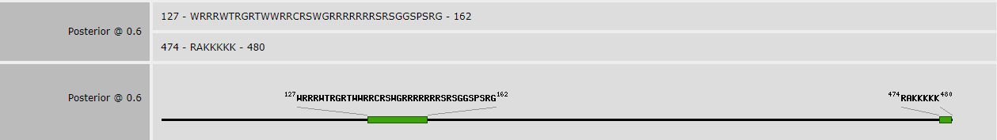
4. | TaCHS4
5. | TaCHS5
6. | TaF3H1
7. | TaF3H2
8. | TaF3H3
9. | TaF3H4
10. | TaF3H5
11. | TaF3H6
12. | TaF3H7
13. | TaANS1
14. | TaANS2
15. | TaANS3
16. | TaANS4
17. | TaANS5
18. | TaANS6 | 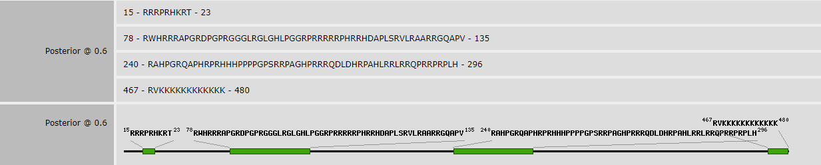

Supplementary Table S6: CHS, ANS and F3H genes targeted by miRNAs with maximum expectation as zero and the energy required to unpair target (UPE) as 25.0 as discerened using psRNA tool.

Sl. No. | miRNA Acc.No. | Target | Expected | UPE | Alignment | Target Description
1. | tae-miR9781 | TaF3H-1 | 0.0 | 19.726 |  | Triticum aestivum F3H-A1 gene for flavanone 3-hydroxylase, complete cds
2. | tae-miR9773 | TaANS-5 | 3.5 | 13.363 |  | Triticum aestivum TaANS-A1 gene for anthocyanidin synthase, complete cds
3. | tae-miR1130a | TaCHS-5 | 4.0 | 15.004 |  | Triticum aestivum chalcone synthase (CHS) gene, complete cds
4. | tae-miR9670-3p | TaANS-3 | 4.0 | 14.342 |  | Triticum aestivum TaANS-B1 gene for anthocyanidin synthase, complete cds
5. | tae-miR531 | TaANS-1 | 4.5 | 24.736 |  | Triticum aestivum TaANS-D1 gene for anthocyanidin synthase, complete cds
6. | tae-miR1121 | TaCHS-2 | 5.0 | 22.383 |  | Triticum aestivum cultivar Gy115 MITE 81 chalcone synthase (CHS7BL) gene, complete cds
7. | tae-miR1121 | TaCHS-1 | 5.0 | 20.302 |  | Triticum aestivum cultivar Opata MITE 81 chalcone synthase (CHS7BL) gene, complete cds
8. | tae-miR1121 | TaANS-2 | 5.0 | 17.143 |  | Triticum aestivum TaANS-B2 gene for anthocyanidin synthase, complete cds
9. | tae-miR1128 | TaANS-5 | 5.0 | 22.305 |  | Triticum aestivum TaANS-A1 gene for anthocyanidin synthase, complete cds
10. | tae-miR1130b-3p | TaCHS-5 | 5.0 | 19.502 |  | Triticum aestivum chalcone synthase (CHS) gene, complete cds
11. | tae-miR1135 | TaCHS-1 | 5.0 | 17.745 |  | Triticum aestivum cultivar Opata MITE 81 chalcone synthase (CHS7BL) gene, complete cds
12. | tae-miR1135 | TaCHS-2 | 5.0 | 17.745 |  | Triticum aestivum cultivar Gy115 MITE 81 chalcone synthase (CHS7BL) gene, complete cds
13. | tae-miR1847-5p | TaANS-2 | 5.0 | 20.532 |  | Triticum aestivum TaANS-B2 gene for anthocyanidin synthase, complete cds
14. | tae-miR397-5p | TaANS-2 | 5.0 | 18.089 |  | Triticum aestivum TaANS-B2 gene for anthocyanidin synthase, complete cds
15. | tae-miR408 | TaF3H-6 | 5.0 | 20.789 |  | Triticum aestivum F3H-B1 gene for flavanone 3-hydroxylase, complete cds
16. | tae-miR5086 | TaF3H-6 | 5.0 | 11.509 |  | Triticum aestivum F3H-B1 gene for flavanone 3-hydroxylase, complete cds
17. | tae-miR9659-3p | TaCHS-1 | 5.0 | 22.269 |  | Triticum aestivum cultivar Opata MITE 81 chalcone synthase (CHS7BL) gene, complete cds
18. | tae-miR9659-3p | TaCHS-2 | 5.0 | 22.434 |  | Triticum aestivum cultivar Gy115 MITE 81 chalcone synthase (CHS7BL) gene, complete cds
19. | tae-miR9670-3p | TaF3H-3 | 5.0 | 20.445 |  | Triticum aestivum flavanone 3-hydroxylase (F3h-B2) gene, complete cds
20. | tae-miR9677a | TaF3H-3 | 5.0 | 17.886 |  | Triticum aestivum flavanone 3-hydroxylase (F3h-B2) gene, complete cds
21. | tae-miR9773 | TaANS-1 | 5.0 | 15.752 |  | Triticum aestivum TaANS-D1 gene for anthocyanidin synthase, complete cds
22. | tae-miR9775 | TaF3H-3 | 5.0 | 17.141 |  | Triticum aestivum flavanone 3-hydroxylase (F3h-B2) gene, complete cds
23. | tae-miR9776 | TaCHS-1 | 5.0 | 15.893 |  | Triticum aestivum cultivar Opata MITE 81 chalcone synthase (CHS7BL) gene, complete cds
24. | tae-miR9776 | TaCHS-2 | 5.0 | 15.893 |  | Triticum aestivum cultivar Gy115 MITE 81 chalcone synthase (CHS7BL) gene, complete cds
25. | tae-miR9779 | TaF3H-3 | 5.0 | 12.538 |  | Triticum aestivum flavanone 3-hydroxylase (F3h-B2) gene, complete cds
26. | tae-miR9781 | TaANS-2 | 5.0 | 22.103 |  | Triticum aestivum TaANS-B2 gene for anthocyanidin synthase, complete cds

Supplementary Table S8: Determination of Ka (non-synonymous substitutions), Ks (synonymous substitutions), Ka/Ks ratio and divergence time of eighteen orthologous genes.
Sl. No. | Flavonoid biosynthesis genes | Ka | Ks | Ka/Ks | Time of divergence (Mya)
1. | TaCHS1 | 0.038 | 5.7841 | 0.0065 | 317.807
2. | TaCHS2 | 0.0172 | 3.2441 | 0.0053 | 178.247
3. | TaCHS3 | 0.0409 | 3.1878 | 0.0128 | 175.153
4. | TaCHS4 | 0.0458 | 5.2837 | 0.0086 | 290.313
5. | TaCHS5 | 0.0238 | 3.1147 | 0.0076 | 171.137
6. | TaCHS6 | 0.047 | 4.3427 | 0.0108 | 238.609
7. | TaF3H1 | 0.2174 | 41.7543 | 0.0052 | 2294.192
8. | TaF3H2 | 0.0143 | 34.5728 | 0.0042 | 1899.604
9. | TaF3H3 | 0.1783 | 30.3752 | 0.0058 | 1668.967
10. | TaF3H4 | 0.1824 | 28.7484 | 0.0063 | 1579.583
11. | TaF3H5 | 0.1739 | 22.7319 | 0.0076 | 1249.005
12. | TaF3H6 | 0.1572 | 38.7752 | 0.0041 | 2130.505
13. | TaF3H7 | 0.2673 | 31.8374 | 0.0083 | 1749.307
14. | TaANS1 | 0.1978 | 56.8200 | 0.0035 | 3121.98
15. | TaANS2 | 0.2439 | 93.4183 | 0.0026 | 5132.873
16. | TaANS3 | 0.2055 | 56.4922 | 0.0036 | 3103.967
17. | TaANS4 | 0.2156 | 44.9860 | 0.0048 | 2471.758
18. | TaANS5 | 0.1992 | 50.8176 | 0.0039 | 2792.175

Supplementary Table S9: List of primers used for quantitative Real Time PCR studies.
Sl. No. | Primer Name | Sequence (5’-3’) |  | Size (bp)
1. | Chalcone synthase (CHS) | Fwd | CTACCGTCTCCCATCAGATAGA | 22
1. | Chalcone synthase (CHS) | Rev | GTTATCTTCAGGGCCACTACAC | 22
2. | Flavanone 3- dioxygenase (F3H) | Fwd | CCACCAAGTCTCTCAACGAA | 20
2. | Flavanone 3- dioxygenase (F3H) | Rev | CTGCTACACACGTACGGATAC | 21
3. | Anthocyanidin synthase (ANS) | Fwd | TGGAGTTGGACGATAGCATAGC | 22
3. | Anthocyanidin synthase (ANS) | Rev | CTCCATCTTTCCATCACACGC | 21

