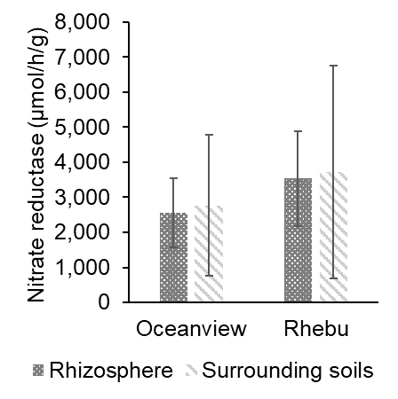
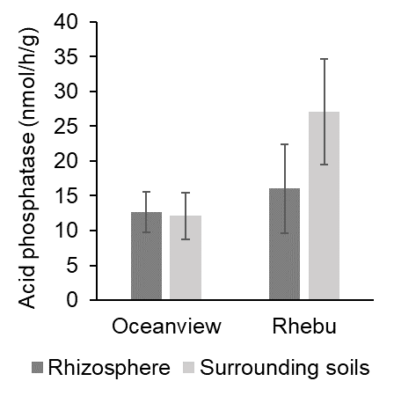
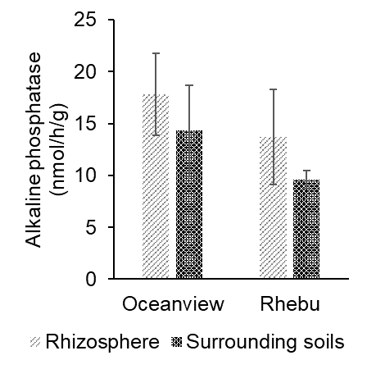
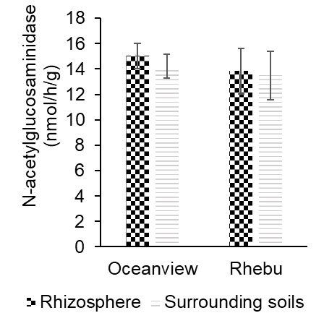
B
A
D
C
a
a
a
a
a
a
a
a
a
a
a
a
a
a
a
a
Figure S1: Soil extracellular enzyme activities in E. villosus rhizosphere and non-rhizosphere soils collected in Rhebu and Oceanview, Eastern Cape. In each graph, different letters denote significant differences in the enzyme activity of soil samples within study sites (independent samples t-test, p≤0.05, means±SE, n=30).

