Supplementary Information of the manuscript:
Nitrogen addition affects biomass allocation and functional traits of two dominated tree species in North China
Qinze Zhang ª, Jiyou Zhu ª, Jiaan Liang ª, Meiyang Li ª, Shuo Huang ª, Hongyuan Li ^{a, *}
ª College of Environmental Science & Engineering, Nankai University, Tianjin 300350, China
*Corresponding author: eialee@nankai.edu.cn (Hongyuan Li)

Table S1 List of plant functional traits selected
Trait | Unit | Description | Characteristic | Function
Aboveground traits
SLA | cm²/g | Specific leaf area | Morphology | Assimilate utilization, Light interception, Palatability, Space niche in canopy (Wilson et al., 1999; Rowe et al., 2012)
LA | cm² | Leaf area | Morphology | Light interception (Wilson et al., 1999; Maire et al., 2012)
LT | cm | Leaf thickness | Morphology | Water storage, Palatability (Garnier et al., 2004; Rowe et al., 2012)
LDMC | % | Leaf dry matter content | Morphology | Assimilate utilization, Palatability, Decomposability (Maire et al., 2012)
LTD | g/cm³ | Leaf tissue density | Morphology | Assimilate utilization, Decomposability, Resource storage (Maire et al., 2012)
LNC | % | Leaf N content | Chemical composition | Photosynthetic capacity, Palatability (Yang et al., 2009; Ordoñez et al., 2009)
LCC | % | Leaf C content | Chemical composition | Assimilate utilization, Leaf architecture (Bryant et al., 1983; Maire et al., 2012)
LCC/LNC | % | Leaf C/N ratio | Chemical composition | Leaf growth resource limitation (Wilson, 1988; Wang et al., 2016)
PL | cm | Plant height | Morphology | Light interception, Avoidance (Walburg et al., 1982; Yin et al., 2011)
Belowground traits
SRL | cm/g | Specific root length | Morphology | Assimilate utilization, Nutrient uptake, Space niche in soil, Forage efficiency (Li et al., 2016; Ding et al., 2020)
SRA | cm²/g | Specific root area | Morphology | Assimilate utilization, Nutrient uptake, Space niche in soil (Li et al., 2016)
RL | cm | Root length | Morphology | Space niche in soil, Nutrient acquisition strategy (Maire et al., 2012)
RA | cm² | Root area per soil volume | Morphology | Space niche in soil, Nutrient acquisition strategy (Maire et al., 2012)
RNC | % | Root N content | Chemical composition | Efficiency of nitrogen transport and utilization (Nadelhoffer et al., 1999; Bauer et al., 2004)
RCC | % | Root C content | Chemical composition | Efficiency of carbon transport and utilization, Root architecture (Bryant et al., 1983; Maire et al., 2012)
RCC/RNC | % | Root C/N ratio | Chemical composition | Root growth resource limitation, Soil nutrient resource limitation (Wilson, 1988; Wang et al., 2016)
RTD | g/cm³ | Root tissue density | Morphology | Assimilate utilization, Water transport, Resource storage (Maire et al., 2012)
BRI | cm⁻¹ | Branching intensity | Morphology | Fungal colonization (Ding et al., 2020)
RD | cm | Average root diameter | Morphology | Growth time strategy, Life span (Ding et al., 2020)

Table S2 Effects of N addition on biomass (aboveground, belowground and total biomass) and root-shoot ratio of Pinus tabuliformis and Fraxinus chinensis. Asterisks were added to P values at the levels of “***” for P < 0.001, “**” for P < 0.01, and “*” for P < 0.05.
Variable | Pinus tabuliformis |  | Fraxinus chinensis
Variable | F value | P value | F value | P value
Aboveground biomass | 4.781 | 0.025* | 1.865 | 0.189
Belowground biomass | 4.809 | 0.024* | 15.791 | <0.001***
Total biomass | 5.048 | 0.021* | 6.136 | 0.011*
Root-Shoot ratio | 3.793 | 0.046* | 33.305 | <0.001***

Table S3 Effects of N addition on aboveground traits including leaf area (LA), specific leaf area (SLA), leaf thickness (LT), plant height (PL), leaf dry matter content (LDMC), and leaf tissue density (LTD) of Pinus tabuliformis and Fraxinus chinensis. Asterisks were added to P values at the levels of “***” for P < 0.001, “**” for P < 0.01, and “*” for P < 0.05.
Variable | Pinus tabuliformis |  | Fraxinus chinensis
Variable | F value | P value | F value | P value
LA | 0.441 | 0.441 | 1.343 | 0.291
SLA | 15.281 | <0.001*** | 2.173 | 0.148
LT | 0.769 | 0.481 | 0.769 | 0.481
PL | 5.485 | 0.016* | 0.282 | 0.758
LDMC | 4.462 | 0.030* | 3.639 | 0.049*
LTD | 0.667 | 0.528 | 4.693 | 0.026*

Table S4 Effects of N addition on belowground traits including root length (RL), specific root length (SRL), root area (RA), specific root area (SRA), average root diameter (RD), root tissue density (RTD) and branching intensity (BRI) of Pinus tabuliformis and Fraxinus chinensis. Asterisks were added to P values at the levels of “***” for P < 0.001, “**” for P < 0.01, and “*” for P < 0.05.
Variable | Pinus tabuliformis |  | Fraxinus chinensis
Variable | F value | P value | F value | P value
RL | 1.584 | 0.238 | 7.363 | 0.006**
SRL | 66.983 | <0.001*** | 6.057 | 0.012*
RA | 3.675 | 0.049* | 4.553 | 0.028*
SRA | 48.243 | <0.001*** | 4.667 | 0.027*
RD | 1.617 | 0.231 | 6.604 | 0.009**
RTD | 15.306 | <0.001*** | 0.611 | 0.556
BRI | 1.344 | 0.291 | 1.154 | 0.342

Table S5 Effects of N addition on nutrient traits including leaf carbon content (LCC), leaf nitrogen content (LNC), root carbon content (RCC), root nitrogen content (RNC), LCC/LNC, and RCC/RNC of Pinus tabuliformis and Fraxinus chinensis. Asterisks were added to P values at the levels of “***” for P < 0.001, “**” for P < 0.01, and “*” for P < 0.05.
Variable | Pinus tabuliformis |  | Fraxinus chinensis
Variable | F value | P value | F value | P value
LCC | 3.159 | 0.072 | 2.755 | 0.096
LNC | 9.317 | 0.002** | 18.341 | <0.001***
RCC | 4.38 | 0.032* | 1.056 | 0.372
RNC | 16.463 | <0.001*** | 15.969 | <0.001***
LCC/LNC | 4.282 | 0.034* | 33.766 | <0.001***
RCC/RNC | 6.468 | 0.009** | 5.642 | 0.015*

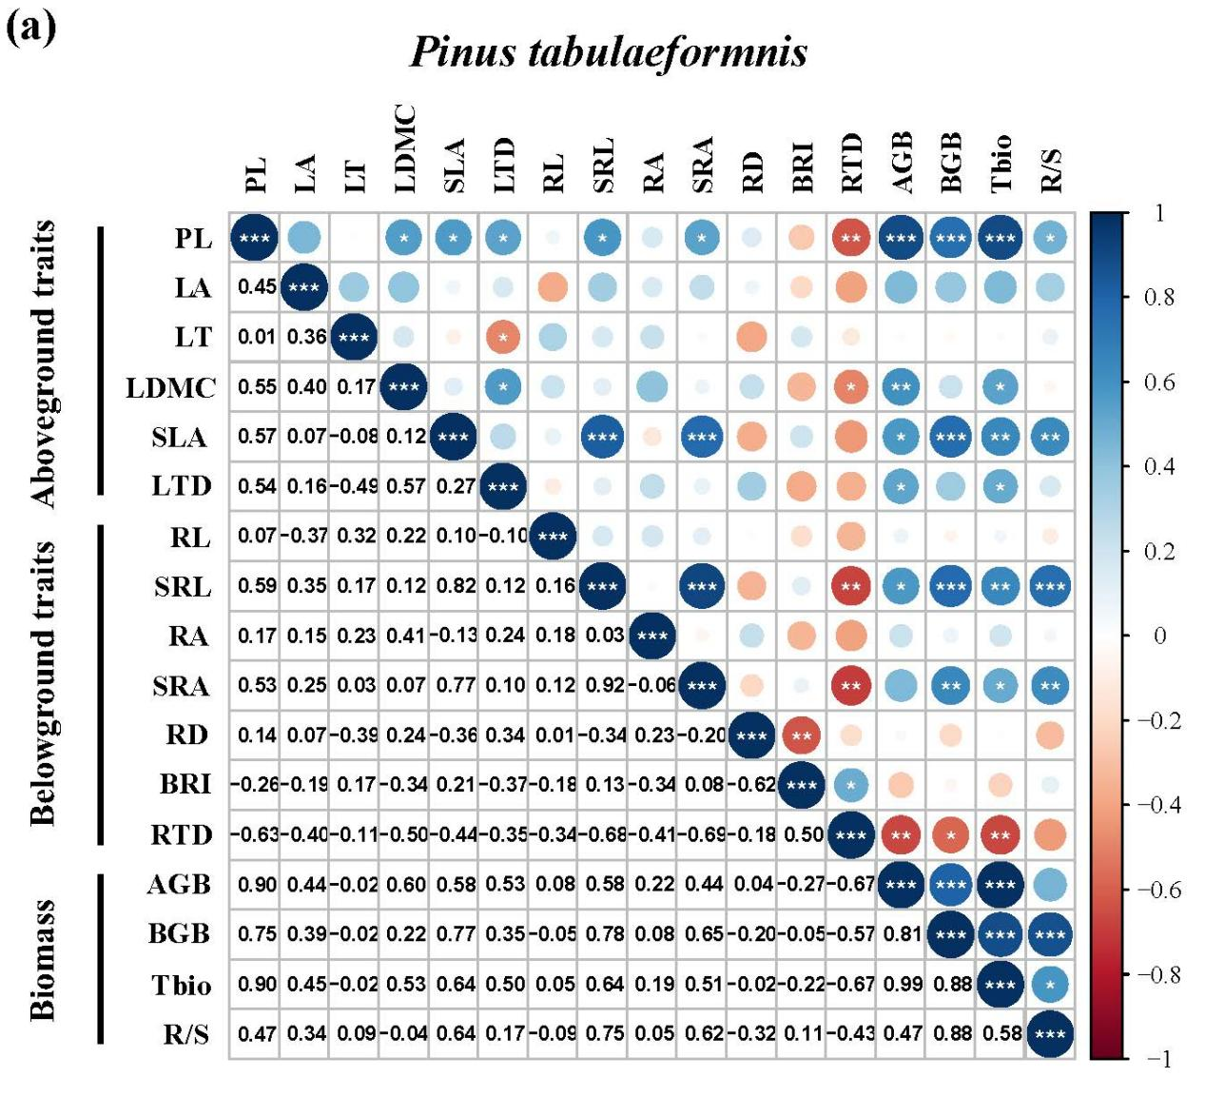
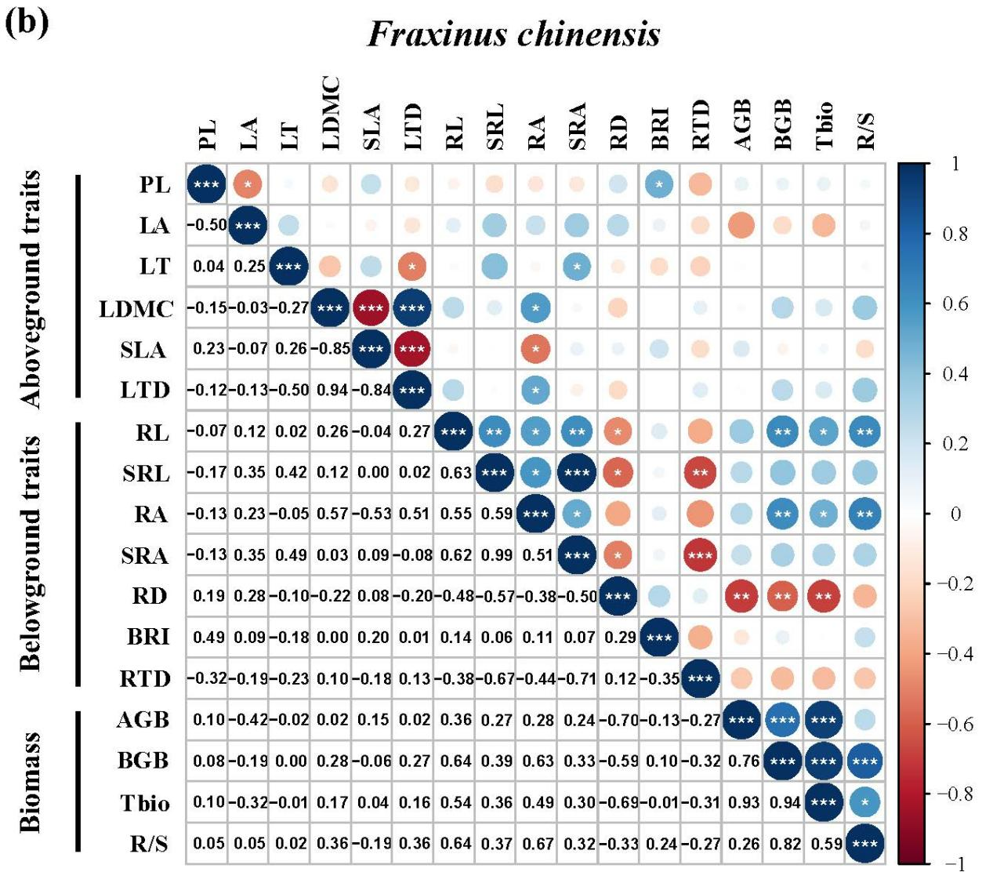
Fig. S1 Correlation matrix of plant functional traits and biomass of Pinus tabuliformis and Fraxinus chinensis. In total, 17 trait indexes are used in this analysis: aboveground traits include plant height (PL), leaf area (LA), leaf thickness (LT), leaf dry matter content (LDMC), specific leaf area (SLA), and leaf tissue density (LTD); belowground traits include root length (RL), specific root length (SRL), root area (RA), specific root area (SRA), average root diameter (RD), branching intensity (BRI), and root tissue density (RTD); biomass traits include aboveground biomass (AGB), belowground biomass (BGB), total biomass (Tbio) and root-shoot biomass ratio (R/S). The lower triangle shows Pearson correlation coefficients, which are illustrated by the color in the upper triangle. The size of the circle in the upper triangle indicates the P value of the correlation, with asterisks were added to significant results for P values at the levels of “***” for P < 0.001, “**” for P < 0.01, and “*” for P < 0.05.

References
Bauera, G.A., Bazzaza, F.A., Minochab, R., Longb, S., Magillc, A., Aberc, J., Berntsonc, G.M., 2004. Effects of chronic N additions on tissue chemistry, photosynthetic capacity, and carbon sequestration potential of a red pine (Pinus resinosa Ait.) stand in the NE United States. Forest Ecol. Manag. 196, 173-186.
Bryant, J.P., Chapin, F.S., Klein, D.R., 1983. Carbon/nutrient balance of boreal plants in relation to vertebrate herbivory. Oikos 40, 357.
Ding, J., Kong, D., Zhang, Z., Cai, Q., Xiao, J., Liu, Q., Yin, H., 2020. Climate and soil nutrients differentially drive multidimensional fine root traits in ectomycorrhizal‐dominated alpine coniferous forests. J. Ecol. 108, 2544-2556.
Garnier, E., Cortez, J., Billès, G., Navas, M., Roumet, C., Debussche, M., Laurent, G., Blanchard, A., Aubry, D., Bellmann, A., Neill, C., Toussaint, J., 2004. Plant functional markers capture ecosystem properties during secondary succession. Ecology 85, 2630-2637.
Li, Y., Niu, S., Yu, G., 2015. Aggravated phosphorus limitation on biomass production under increasing nitrogen loading: a meta-analysis. Glob. Change Boil. 222, 934-943.
Maire, V., Gross, N., Börger, L., Proulx, R., Wirth, C., Pontes, L.D., Soussana, J., Louault, F., 2012. Habitat filtering and niche differentiation jointly explain species relative abundance within grassland communities along fertility and disturbance gradients. New Phytol. 1962, 497-509.
Nadelhoffer, K.J., Emmett, B.A., Gundersen, P., Kjønaas, O.J., Koopmans, C.J., Schleppi, P., Tietema, A., Wright, R.F., 1999. Nitrogen deposition makes a minor contribution to carbon sequestration in temperate forests. Nature 398, 145-148.
Ordoñez, J.C., Bodegom, P.M., Witte, J.P.M., Wright, I.J., Reich, P.B., Aerts, R., 2009. A global study of relationships between leaf traits, climate and soil measures of nutrient fertility. Glob. Ecol. Biogeogr. 18, 137–149.
Rowe, D.B., Getter, K.L., Durhman, A.K., 2012. Effect of green roof media depth on Crassulacean plant succession over seven years. Landscape Urban Plan. 104, 310–319.
Walburg, G., Bauer, M. E., Daughtry, C. S., Housley, T. L., 1982. Effects of nitrogen nutrition on the growth, yield, and reflectance characteristics of corn canopies 1. Agron. J. 74, 677-688.
Wang, L., Wang, J., Liu, W. W., Gan, Y., Wu, Y., 2016. Biomass allocation, compensatory growth and internal C/N balance of Lolium perenne in response to defoliation and light treatments. Pol. J. Ecol. 64, 485-499.
Wilson, J. B., 1988. A review of evidence on the control of shoot: root ratio. Ann. Bot. 61, 433-449.
Yang, Y. H., Fang, J. Y., Ji, C. J., Han, W. X., 2009. Above- and belowground biomass allocation in Tibetan grasslands. J. Veg. Sci. 20, 177–184.
Yin, X., McClure, M. A., Jaja, N., Tyler, D. D., Hayes, R. M., 2011. In-season prediction of corn yield using plant height under major production systems. Agron. J. 103, 923-929.

