Scale-selective identification and assessment of global eddies from satellite data

Yikai Yang¹, Lili Zeng^{1,2*}, Qiang Wang¹
1. State Key Laboratory of Tropical Oceanography (LTO), South China Sea Institute of Oceanology, Chinese Academy of Sciences, Guangzhou, 510301, China
2. Southern Marine Science and Engineering Guangdong Laboratory (Guangzhou), Guangzhou, China

Corresponding Author:
Dr. Lili Zeng
State Key Laboratory of Tropical Oceanography, South China Sea Institute of Oceanology, Chinese Academy of Sciences, Guangzhou, China
Tel: (86) 20-8902-4304; Fax: (86) 20-8902-4304
Email: zenglili@scsio.ac.cn

Supplementary materials
The approximate grid points of the eddy boundary are initially calculated as $\text{P=}\frac{2πL}{(R_{lon}+R_{lat})/2}$ by considering eddies as quasicircles without the index c. A regional sensitivity experiment is carried out for eddy detection and tracking over the course of a year in a random sea area to evaluate the accuracy of this estimation method. According to a total of 6743 calculations for 842 eddies, there are approximately 0.0028 more grid points at the actual eddy boundary than what was determined by the estimation approach. The difference is unrelated to the actual number of eddy grid points (Fig. S1). The index c is added as an error-compensating correction with a value of 1 given the mean error of 0.0028.
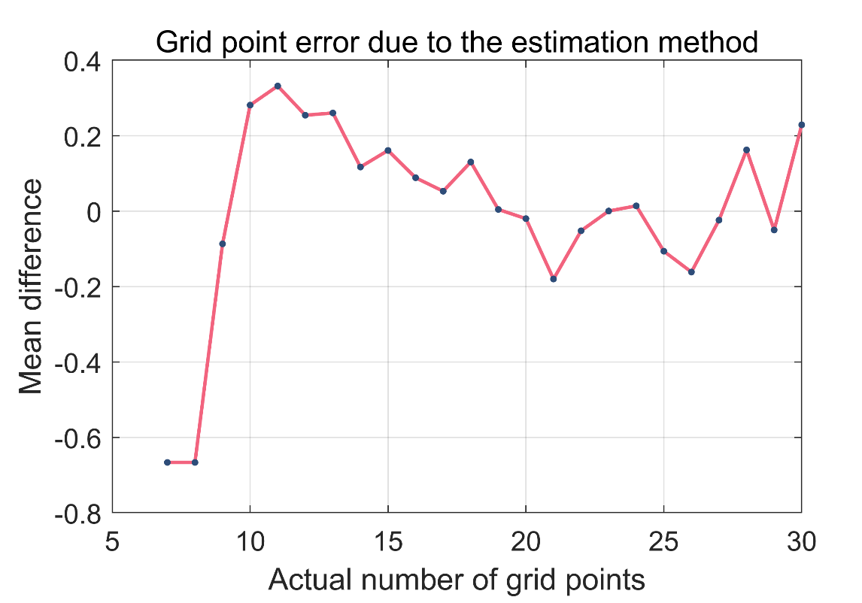
Figure S1. Grid point error of the eddy boundary due to the estimation method $\text{P=}\frac{2πL}{(R_{lon}+R_{lat})/2}$.

With the quasicircular assumption, the grid points of the eddy boundary can be estimated as $\text{P=}\frac{2πL}{(R_{lon}+R_{lat})/2}\text{+c}$, where the $(R_{lon}+R_{lat})/2$ is the approximate length (in km) based on the meridional ($R_{lon}=\frac{2πR_{E}}{360}∙rslt$) and zonal ($R_{lat}=\frac{2πR_{E}cos⁡(lat)}{360}∙rslt$) lengths of the resolution grid for each region. The values of $P_{max-lat}$ for various values of L are determined with an Earth radius $R_{E}$ of 6371 km and a data resolution rslt of 0.25°, as shown in Figure S2.
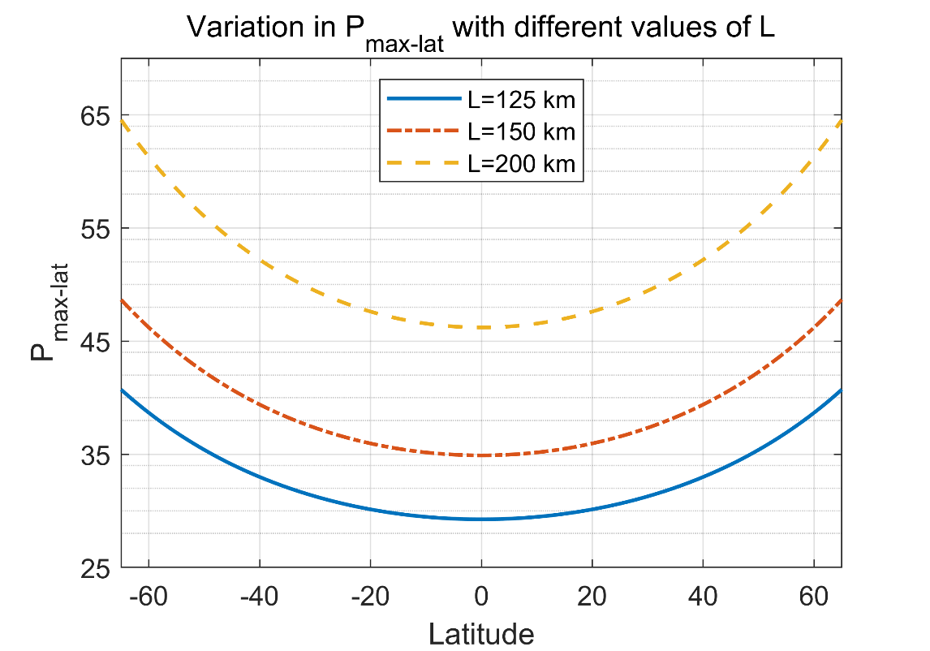
Figure S2. Variation in $P_{max-lat}$ with different values of L as a function of latitude.

Figure S3. Duration-radius plots of the multiyear mean results of the SEIA in the (a) Pacific, (b) Atlantic and (c) Indian Oceans. Colors represent certain ratios between the duration and radius; increasingly blue or red colors indicate lower or higher ratios, respectively. The green line is a quadratic fitting curve.

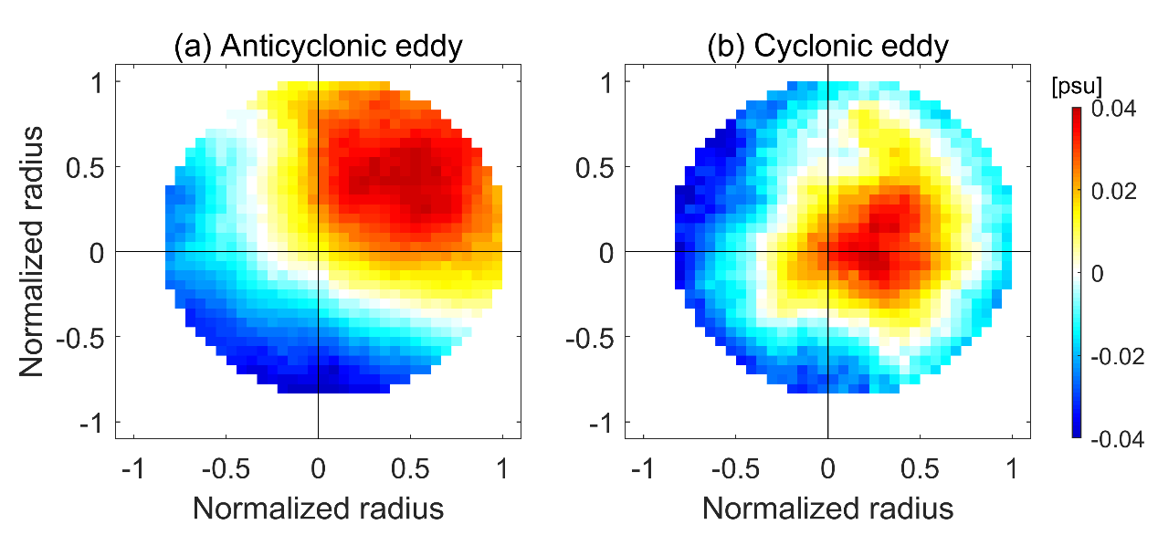
Figure S4. Composite averages of SSS (unit: psu) anomalies of (a) anticyclonic and (b) cyclonic eddies in the south Indian Ocean (30°S–20°S, 60°E–100°E).

