Table S1. Search Strategy(performed at 04/23/2022)
No. | Database | Search Terms | Number of Items found
1 | PubMed | #1 ((Air filters[MeSH Terms]) OR (Air filter[MeSH Terms]) OR (Filter, Air[MeSH Terms]) OR (Filters, Air[MeSH Terms]) OR (Air Purifiers[MeSH Terms]) OR (Purifier, Air[MeSH Terms]) OR (Purifiers, Air[MeSH Terms]) OR (Air Purifier[MeSH Terms]) OR (Air filtration[MeSH Terms]))  #2((Air filters[Title/Abstract]) OR (Air filter[Title/Abstract]) OR (Filter, Air[Title/Abstract]) OR (Filters, Air[Title/Abstract]) OR (Air Purifiers[Title/Abstract]) OR (Purifier, Air[Title/Abstract]) OR (Purifiers, Air[Title/Abstract]) OR (Air Purifier[Title/Abstract]) OR (Air clear[Title/Abstract]) OR (Air clean[Title/Abstract]) OR (Air filtration[Title/Abstract]) OR (ULPA[Title/Abstract]) OR (HEPA[Title/Abstract]))  #3((C-Reactive Protein[MeSH Terms]) OR (C Reactive Protein[MeSH Terms]) OR (Interleukin[MeSH Terms]) OR (Interleukin-6[MeSH Terms]) OR (Interleukin 6[MeSH Terms]) OR (IL-6[MeSH Terms]) OR (tumor necrosis factor[MeSH Terms]) OR (Tumor Necrosis Factor-alpha[MeSH Terms]) OR (TNF-alpha[MeSH Terms]) OR (TNF alpha[MeSH Terms]) OR (tumor necrosis factor-α[MeSH Terms]) OR (TNF-α[MeSH Terms]))  #4((C-Reactive Protein[Title/Abstract]) OR (C Reactive Protein[Title/Abstract]) OR (CRP[Title/Abstract]) OR (Interleukin[Title/Abstract]) OR (Interleukin-6[Title/Abstract]) OR (Interleukin 6[Title/Abstract]) OR (IL-6[Title/Abstract]) OR (IL6[Title/Abstract]) OR (tumor necrosis factor[Title/Abstract]) OR (Tumor Necrosis Factor-alpha[Title/Abstract]) OR (TNF-alpha[Title/Abstract]) OR (TNF alpha[Title/Abstract]) OR (TNF[Title/Abstract]) OR (tumor necrosis factor-α[Title/Abstract]) OR (TNF-α[Title/Abstract]))  #5((Malondialdehyde[MeSH Terms]) OR (deoxyguanosine[MeSH Terms]) OR (8-hydroxy-2'-deoxyguanosine[MeSH Terms]) OR (8-hydroxy-2-deoxyguanosine[MeSH Terms]) OR (8'-hydroxy-2'-deoxyguanosine[MeSH Terms]) OR (8-hydroxy-deoxyguanosine[MeSH Terms]) OR (8-hydroxydeoxyguanosine[MeSH Terms]) OR (8OHdG[MeSH Terms]) OR (8-OH-dG[MeSH Terms]) OR (8-OHdG[MeSH Terms]) OR (2'-deoxy-8-hydroxyguanosine[MeSH Terms]) OR (8-oxo-2-deoxyguanosine[MeSH Terms]) OR (8-oxodG[MeSH Terms]) OR (8-oxo-dG[MeSH Terms]) OR (8-oxodGuo[MeSH Terms]) OR (7,8-dihydro-8-oxo-2'-deoxyguanosine[MeSH Terms]) OR (8-oxo-7,8-dihydro-2'-deoxyguanosine[MeSH Terms]) OR (Isoprostanes[MeSH Terms]) OR (Isoprostane[MeSH Terms]) OR (F2 isoprostane[MeSH Terms]) OR (F2 isoprostanes[MeSH Terms]) OR (F2 IsoPs[MeSH Terms]) OR (PGF2[MeSH Terms]) OR (PGF2alpha[MeSH Terms]) OR (Prostaglandin F2[MeSH Terms]) OR (Prostaglandin F2alpha[MeSH Terms]) OR (Prostaglandin F2 alpha[MeSH Terms]) OR (F2alpha Prostaglandin[MeSH Terms]) OR (F2 alpha Prostaglandin[MeSH Terms]))  #6((Malondialdehyde[Title/Abstract]) OR (MDA[Title/Abstract]) OR (deoxyguanosine[Title/Abstract]) OR (8-hydroxy-2'-deoxyguanosine[Title/Abstract]) OR (8-hydroxy-2-deoxyguanosine[Title/Abstract]) OR (8'-hydroxy-2'-deoxyguanosine[Title/Abstract]) OR (8-hydroxy-deoxyguanosine[Title/Abstract]) OR (8-hydroxydeoxyguanosine[Title/Abstract]) OR (8-oxo-7,8-dihydrodeoxyguanine[Title/Abstract]) OR (8OHdG[Title/Abstract]) OR (8-OH-dG[Title/Abstract]) OR (8-OHdG[Title/Abstract]) OR (8-oxo-2-deoxyguanosine[Title/Abstract]) OR (oxo8dG[Title/Abstract]) OR (8-oxodG[Title/Abstract]) OR (8-oxo-dG[Title/Abstract]) OR (8-oxodGuo[Title/Abstract]) OR (7,8-dihydro-8-oxo-2'-deoxyguanosine[Title/Abstract]) OR (8-oxo-7,8-dihydro-2'-deoxyguanosine[Title/Abstract]) OR (8-OHGua[Title/Abstract]) OR (8-oxoGua[Title/Abstract]) OR (8-Oxo-guanine[Title/Abstract]) OR (8-oxoG[Title/Abstract]) OR (8-hydroxyguanine[Title/Abstract]) OR (8-OHG[Title/Abstract]) OR (8-hydroxy-2’-guanosine[Title/Abstract]) OR (8-hydroxyguanosine[Title/Abstract]) OR (Isoprostanes[Title/Abstract]) OR (8-epi-prostaglandin F2alpha[Title/Abstract]) OR (Isoprostane[Title/Abstract]) OR (F2 isoprostane[Title/Abstract]) OR (F2 isoprostanes[Title/Abstract]) OR (F2 IsoP[Title/Abstract]) OR (F2 IsoPs[Title/Abstract]) OR (8-isoprostane[Title/Abstract]) OR (8-iso-PGF[Title/Abstract]) OR (8-iso-PGF2a[Title/Abstract]) OR (8-iso-PGF 2a[Title/Abstract]) OR (8-iso-PGF2alpha[Title/Abstract]) OR (8-iso-PGF 2alpha[Title/Abstract]) OR (8-iso-prostaglandin F2alpha[Title/Abstract]) OR (8-isoprostaglandin F2alpha[Title/Abstract]) OR (8-epiprostaglandin F2alpha[Title/Abstract]) OR (8-epi-PGF2alpha[Title/Abstract]) OR (8-epi-PGF2 alpha[Title/Abstract]) OR (PGF2[Title/Abstract]) OR (PGF2alpha[Title/Abstract]) OR (Prostaglandin F2[Title/Abstract]) OR (Prostaglandin F2alpha[Title/Abstract]) OR (Prostaglandin F2 alpha[Title/Abstract]) OR (F2alpha Prostaglandin[Title/Abstract]) OR (F2 alpha Prostaglandin[Title/Abstract]))  (#1 OR #2) AND (#3 OR #4 OR #5 OR #6) | 217
2 | Web of Science | TS=(Air filters OR Air filter OR Filter, Air OR Filters, Air OR Air Purifiers OR Purifier, Air OR Purifiers, Air OR Air Purifier OR Air clear OR Air clean OR Air filtration OR ULPA OR HEPA) AND TS=(C-Reactive Protein OR C Reactive Protein OR CRP OR Interleukin OR Interleukin-6 OR Interleukin 6 OR IL-6 OR IL6 OR tumor necrosis factor OR Tumor Necrosis Factor-alpha OR TNF-alpha OR TNF alpha OR TNF OR tumor necrosis factor-α OR TNF-α OR Malondialdehyde OR MDA OR deoxyguanosine OR 8-hydroxy-2'-deoxyguanosine OR 8-hydroxy-2-deoxyguanosine OR 8'-hydroxy-2'-deoxyguanosine OR 8-hydroxy-deoxyguanosine OR 8-hydroxydeoxyguanosine OR 8-oxo-7,8-dihydrodeoxyguanine OR 80hdg OR 8-OH-dG OR 8-OHdG OR 2'-deoxy-8-hydroxyguanosine OR 8-oxo-2-deoxyguanosine OR oxodg OR 8-oxodG OR 8-oxo-dG OR 8-oxodGuo OR 7,8-dihydro-8-oxo-2'-deoxyguanosine OR 8-oxo-7,8-dihydro-2'-deoxyguanosine OR 8-OHGua OR 8-oxoGua OR 8-Oxo-guanine OR 8-oxoG OR 8-hydroxyguanine OR 8-OHG OR 8-hydroxy-2’-guanosine OR 8-hydroxyguanosine OR isoprostane OR 8-epi-prostaglandin F2alpha OR Isoprostane OR F2 isoprostane OR F2 isoprostane OR F2 IsoP OR F2 isopr OR 8-isoprostane OR 8-iso-PGF OR 8-iso-PGF2a OR 8-iso-PGF 2a OR 8-iso-PGF2alpha OR 8-iso-PGF 2alpha OR 8-iso-prostaglandin F2alpha OR 8-isoprostaglandin F2alpha OR 8-epiprostaglandin F2alpha OR 8-epi-PGF2alpha OR 8-epi-PGF2 alpha OR PGF2 OR PGF2alpha OR Prostaglandin F2 OR Prostaglandin F2alpha OR Prostaglandin F2 alpha OR F2alpha Prostaglandin OR F2 alpha Prostaglandin) AND TS= (clinical trials OR randomized controlled trials OR controlled clinical trials OR double blind method OR single blind method OR intervention studies OR cross-over studies OR placebo OR assignment OR random allocation) | 68
3 | Embase | ('air filters':ab,ti OR 'air filter':ab,ti OR 'filter, air':ab,ti OR 'filters, air':ab,ti OR 'air purifiers':ab,ti OR 'purifier, air':ab,ti OR 'purifiers, air':ab,ti OR 'air purifier':ab,ti OR 'air clear':ab,ti OR 'air clean':ab,ti OR 'air filtration':ab,ti OR hepa:ab,ti) AND ('c-reactive protein':ab,ti OR 'c reactive protein':ab,ti OR crp:ab,ti OR interleukin:ab,ti OR 'interleukin 6':ab,ti OR 'il 6':ab,ti OR il6:ab,ti OR 'tumor necrosis factor':ab,ti OR 'tumor necrosis factor-alpha':ab,ti OR 'tnf alpha':ab,ti OR tnf:ab,ti OR 'tumor necrosis factor-α':ab,ti OR 'tnf α':ab,ti OR malondialdehyde:ab,ti OR mda:ab,ti OR deoxyguanosine:ab,ti OR '8 hydroxy 2 deoxyguanosine':ab,ti OR '8 hydroxy deoxyguanosine':ab,ti OR '8 hydroxydeoxyguanosine':ab,ti OR '8 oxo 7,8 dihydrodeoxyguanine':ab,ti OR 8ohdg:ab,ti OR '8 oh dg':ab,ti OR '8 ohdg':ab,ti OR '2 deoxy 8 hydroxyguanosine':ab,ti OR '8 oxo 2 deoxyguanosine':ab,ti OR oxo8dg:ab,ti OR '8 oxodgtpase':ab,ti OR '8 oxo dg':ab,ti OR '8 oxodguo':ab,ti OR '7,8 dihydro 8 oxo 2 deoxyguanosine':ab,ti OR '8 oxo 7,8 dihydro 2 deoxyguanosine':ab,ti OR '8 ohgua':ab,ti OR '8 oxogua':ab,ti OR '8 oxo guanine':ab,ti OR '8 oxog':ab,ti OR '8 hydroxyguanine':ab,ti OR '8 ohg':ab,ti OR '8 hydroxyguanosine':ab,ti OR isoprostanes:ab,ti OR '8 epi prostaglandin f2alpha':ab,ti OR isoprostane:ab,ti OR 'f2 isoprostane':ab,ti OR 'f2 isoprostanes':ab,ti OR 'f2 isop':ab,ti OR 'f2 isops':ab,ti OR '8 isoprostane':ab,ti OR '8 iso pgf':ab,ti OR '8 iso pgf2a':ab,ti OR '8-iso-pgf 2a':ab,ti OR '8 iso pgf2alpha':ab,ti OR '8-iso-pgf 2alpha':ab,ti OR '8-isoprostaglandin f2alpha':ab,ti OR 'prostaglandin f2':ab,ti OR 'f2alpha prostaglandin':ab,ti) | 156
4 | Scopus | ( TITLE-ABS-KEY ( air AND filters ) OR TITLE-ABS-KEY ( air AND filter ) OR TITLE-ABS-KEY ( filter, AND air ) OR TITLE-ABS-KEY ( filters, AND air ) OR TITLE-ABS-KEY ( air AND purifiers ) OR TITLE-ABS-KEY ( purifier, AND air ) OR TITLE-ABS-KEY ( purifiers, AND air ) OR TITLE-ABS-KEY ( air AND purifier ) OR TITLE-ABS-KEY ( air AND clear ) OR TITLE-ABS-KEY ( air AND clean ) OR TITLE-ABS-KEY ( air AND filtration ) OR TITLE-ABS-KEY ( hepa ) ) AND ( ( TITLE-ABS-KEY ( c-reactive AND protein ) OR TITLE-ABS-KEY ( c AND reactive AND protein ) OR TITLE-ABS-KEY ( crp ) OR TITLE-ABS-KEY ( interleukin ) OR TITLE-ABS-KEY ( interleukin-6 ) OR TITLE-ABS-KEY ( interleukin AND 6 ) OR TITLE-ABS-KEY ( il-6 ) OR TITLE-ABS-KEY ( il6 ) OR TITLE-ABS-KEY ( tumor AND necrosis AND factor ) OR TITLE-ABS-KEY ( tumor AND necrosis AND factor-alpha ) OR TITLE-ABS-KEY ( tnf-alpha ) OR TITLE-ABS-KEY ( tnf AND alpha ) OR TITLE-ABS-KEY ( tnf ) OR TITLE-ABS-KEY ( tumor AND necrosis AND factor-α ) OR TITLE-ABS-KEY ( tnf-α ) ) OR ( TITLE-ABS-KEY ( malondialdehyde ) OR TITLE-ABS-KEY ( mda ) OR TITLE-ABS-KEY ( deoxyguanosine ) OR TITLE-ABS-KEY ( 8-hydroxy-2'-deoxyguanosine ) OR TITLE-ABS-KEY ( 8-hydroxy-2-deoxyguanosine ) OR TITLE-ABS-KEY ( 8'-hydroxy-2'-deoxyguanosine ) OR TITLE-ABS-KEY ( 8-hydroxy-deoxyguanosine ) OR TITLE-ABS-KEY ( 8-hydroxydeoxyguanosine ) OR TITLE-ABS-KEY ( 8-oxo-7,8-dihydrodeoxyguanine ) ( TITLE-ABS-KEY ( c-reactive AND protein ) OR TITLE-ABS-KEY ( c AND reactive AND protein ) OR TITLE-ABS-KEY ( crp ) OR TITLE-ABS-KEY ( interleukin ) OR TITLE-ABS-KEY ( interleukin-6 ) OR TITLE-ABS-KEY ( interleukin AND 6 ) OR TITLE-ABS-KEY ( il-6 ) OR TITLE-ABS-KEY ( il6 ) OR TITLE-ABS-KEY ( tumor AND necrosis AND factor ) OR TITLE-ABS-KEY ( tumor AND necrosis AND factor-alpha ) OR TITLE-ABS-KEY ( tnf-alpha ) OR TITLE-ABS-KEY ( tnf AND alpha ) OR TITLE-ABS-KEY ( tnf ) OR TITLE-ABS-KEY ( tumor AND necrosis AND factor-α ) OR TITLE-ABS-KEY ( tnf-α ) ) OR TITLE-ABS-KEY ( 8ohdg ) OR TITLE-ABS-KEY ( 8-oh-dg ) OR TITLE-ABS-KEY ( 8-ohdg ) OR TITLE-ABS-KEY ( 2'-deoxy-8-hydroxyguanosine ) OR TITLE-ABS-KEY ( 8-oxo-2-deoxyguanosine ) OR TITLE-ABS-KEY ( oxo8dg ) OR TITLE-ABS-KEY ( 8-oxodg ) OR TITLE-ABS-KEY ( 8-oxo-dg ) OR TITLE-ABS-KEY ( 8-oxodguo ) OR TITLE-ABS-KEY ( 7,8-dihydro-8-oxo-2'-deoxyguanosine ) OR TITLE-ABS-KEY ( 8-oxo-7,8-dihydro-2'-deoxyguanosine ) OR TITLE-ABS-KEY ( 8-ohgua ) OR TITLE-ABS-KEY ( 8-oxogua ) OR TITLE-ABS-KEY ( 8-oxo-guanine ) OR TITLE-ABS-KEY ( 8-oxog ) OR TITLE-ABS-KEY ( 8-hydroxyguanine ) OR TITLE-ABS-KEY ( 8-ohg ) OR TITLE-ABS-KEY ( 8-hydroxy-2'-guanosine ) OR TITLE-ABS-KEY ( 8-hydroxyguanosine ) OR TITLE-ABS-KEY ( isoprostanes ) OR TITLE-ABS-KEY ( 8-epi-prostaglandin AND f2alpha ) OR TITLE-ABS-KEY ( isoprostane ) OR TITLE-ABS-KEY ( f2 AND isoprostane ) OR TITLE-ABS-KEY ( f2 AND isoprostanes ) OR TITLE-ABS-KEY ( f2 AND isop ) OR TITLE-ABS-KEY ( f2 AND isops ) OR TITLE-ABS-KEY ( 8-isoprostane ) OR TITLE-ABS-KEY ( 8-iso-pgf ) OR TITLE-ABS-KEY ( 8-iso-pgf2a ) OR TITLE-ABS-KEY ( 8-iso-pgf AND 2a ) OR TITLE-ABS-KEY ( 8-iso-pgf2alpha ) OR TITLE-ABS-KEY ( 8-iso-pgf AND 2alpha ) OR TITLE-ABS-KEY ( 8-iso-prostaglandin AND f2alpha ) OR TITLE-ABS-KEY ( 8-isoprostaglandin AND f2alpha ) OR TITLE-ABS-KEY ( 8-epiprostaglandin AND f2alpha ) OR TITLE-ABS-KEY ( 8-epi-pgf2alpha ) OR TITLE-ABS-KEY ( 8-epi-pgf2 AND alpha ) OR TITLE-ABS-KEY ( pgf2 ) OR TITLE-ABS-KEY ( pgf2alpha ) OR TITLE-ABS-KEY ( prostaglandin AND f2 ) OR TITLE-ABS-KEY ( prostaglandin AND f2alpha ) OR TITLE-ABS-KEY ( f2alpha AND prostaglandin ) ) ) AND ( TITLE-ABS-KEY ( clinical AND trials ) OR TITLE-ABS-KEY ( randomized AND controlled AND trials ) OR TITLE-ABS-KEY ( controlled AND clinical AND trials ) OR TITLE-ABS-KEY ( double AND blind AND method ) OR TITLE-ABS-KEY ( single AND blind AND method ) OR TITLE-ABS-KEY ( intervention AND studies ) OR TITLE-ABS-KEY ( cross-over AND studies ) OR TITLE-ABS-KEY ( random AND allocation ) ) | 86
5 | the Cochrane Library | #1Air filters OR Air filter OR Filter, Air OR Filters, Air OR Air Purifiers OR Purifier, Air OR Purifiers, Air OR Air Purifier OR Air clear OR Air clean OR Air filtration OR HEPA #2 C-Reactive Protein OR C Reactive Protein OR CRP OR Interleukin OR Interleukin-6 OR Interleukin 6 OR IL-6 OR IL6 OR tumor necrosis factor OR Tumor Necrosis Factor-alpha OR TNF-alpha OR TNF alpha OR TNF OR tumor necrosis factor-α OR TNF-α OR Malondialdehyde OR MDA OR deoxyguanosine OR ("8-hydroxy-2'-deoxyguanosine") OR ("8-hydroxy-2-deoxyguanosine") OR ("8'-hydroxy-2'-deoxyguanosine") OR ("8-hydroxy-deoxyguanosine") OR ("8-hydroxydeoxyguanosine") OR ("8-oxo-7,8-dihydrodeoxyguanine") OR 8OHdG OR ("8-OH-dG") OR ("8-OHdG") OR ("2'-deoxy-8-hydroxyguanosine") OR ("8-oxo-2-deoxyguanosine") OR oxo8dG OR ("8-oxodG") OR ("8-oxo-dG") OR ("8-oxodGuo") OR ("7,8-dihydro-8-oxo-2'-deoxyguanosine") OR ("8-oxo-7,8-dihydro-2'-deoxyguanosine") OR ("8-OHGua") OR ("8-oxoGua") OR ("8-Oxo-guanine") OR ("8-oxoG") OR ("8-hydroxyguanine") OR ("8-OHG") OR ("8-hydroxy-2’-guanosine") OR ("8-hydroxyguanosine") OR Isoprostanes OR ("8-epi-prostaglandin F2alpha") OR Isoprostane OR F2 isoprostane OR F2 isoprostanes OR F2 IsoP OR F2 IsoPs OR ("8-isoprostane") OR ("8-iso-PGF") OR ("8-iso-PGF2a") OR ("8-iso-PGF 2a") OR ("8-iso-PGF2alpha") OR ("8-iso-PGF 2alpha") OR ("8-iso-prostaglandin F2alpha") OR ("8-isoprostaglandin F2alpha") OR ("8-epiprostaglandin F2alpha") OR ("8-epi-PGF2alpha") OR ("8-epi-PGF2 alpha") OR PGF2 OR PGF2alpha OR Prostaglandin F2 OR Prostaglandin F2alpha OR Prostaglandin F2 alpha OR F2alpha Prostaglandin OR F2 alpha Prostaglandin | 150
Total number of documents |  |  | 677

Figure S1. Sensitivity analysis of air filtration on IL-6 (A), CRP (B), TNF-α (C), MDA (D), 8-OHdG (E) and 8-isoPGF2α (F).

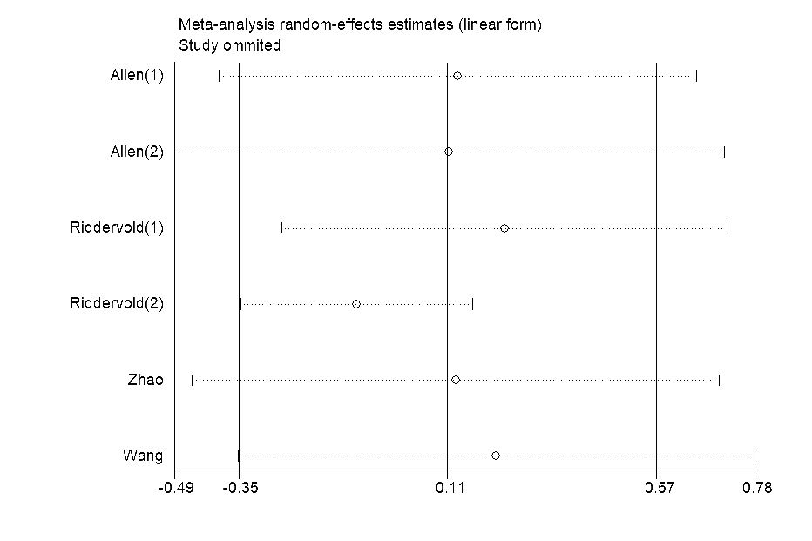
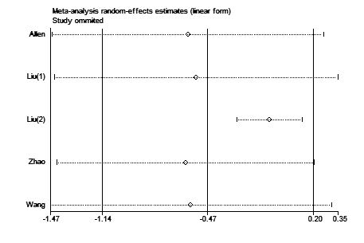
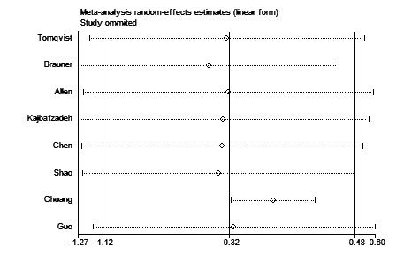
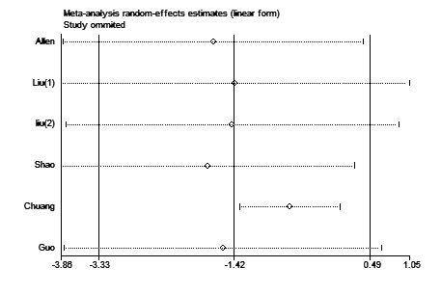
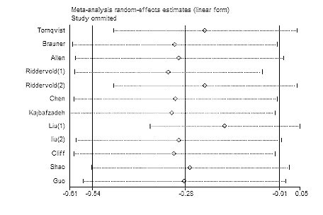
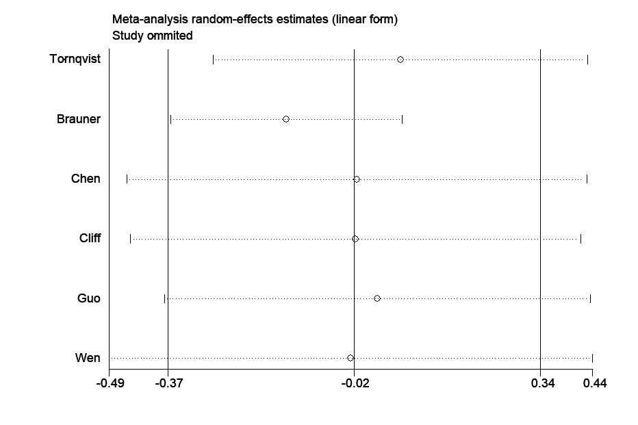
A
D
B
C
E
F

Figure S2. Funnel plot of the effect of air filtration on IL-6 (A), CRP (B), TNF-α (C), MDA (D), 8-OHdG (E) and 8-isoPGF2α (F).
A
B
C
D
E
F

