Supplementary Materials
Space-confined synthesis of CoSe₂-NC nanoclusters anchored on honeycomb-like carbon framework towards high-performance lithium sulfur battery
Sun Xinxing¹, Gao Hongjing¹ *, Liu Shuangke, Sun Weiwei, Li Yujie, Wang Danqin, Guo Qingpeng, Hong Xiaobin, Xu Jing, Zheng Chunman*
College of Aerospace Science and Engineering, National University of Defense Technology, Changsha, 410073, China
Abstract：Lithium-sulfur (Li-S) battery has been considered to be one of the next generation high energy density rechargeable battery systems due to the high theoretical energy density, low cost and environmental friendliness. However, the commercial application of Li-S battery still faces problems such as sluggish redox kinetics and infamous shuttle effect of sulfur cathode, which result in low sulfur utilization, poor cycle life and unsatisfied rate performance. Herein, we proposed a CoSe₂-NC nanoclusters anchored honeycomb-like carbon framework (CoSe₂-NC @HCF) as sulfur hosts aiming to accelerate sulfur conversion and inhibit polysulfide shuttle in Li-S electrochemistry via space-confined growth and in-situ selenization. The obtained CoSe₂-NC@HCF provides strong chemical adsorption capability and massive polar cobalt active sites as well as abundant and continuous hierarchy pores supplying adequate sulfur storage space and physical confinement. The S/CoSe₂-NC @HCF cathode with sulfur content of 83.24 wt% delivershigh sulfur utilization with initial discharge capacity of 1212.9 mAhg⁻¹ at 0.1 C, excellent rate performance with 1094.7 mAh·g^{–1} at 1C rate, and good cylability with low capacity decay rate of 0.12% up to 600 cycles.
Keywords: lithium-sulfur battery; Composite sulfur cathode; Honeycomb-like carbon; Three-dimension network structure; Ion transport
1 These authors contributed equally.
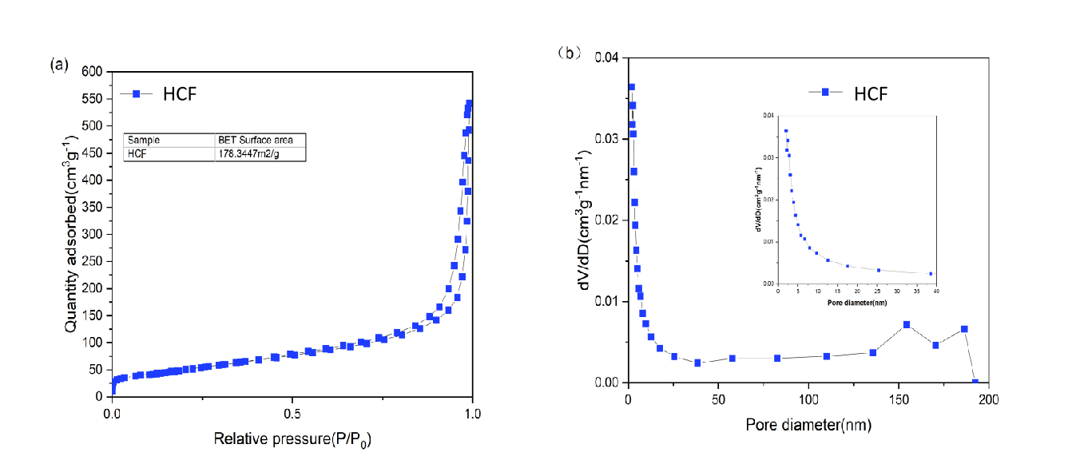
Figure S1. (a) The HCF adsorption–desorption isotherms, (b) the pore size distribution curves of HCF

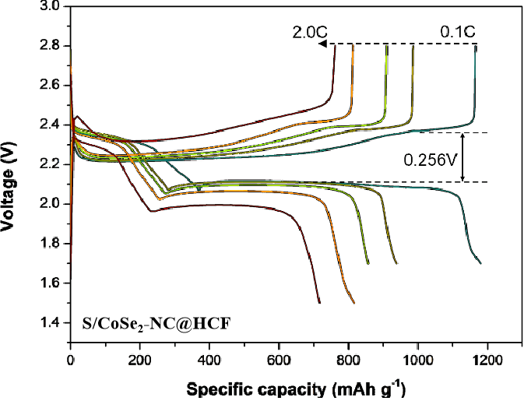
Figure S2. Discharge/charge profiles of the S/HCF electrode at a rate range of 0.1C-2C.

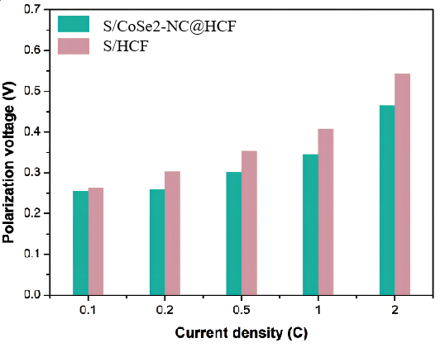
Figure S3. Corresponding polarization voltage comparison between S/CoSe₂-NC@HCF and S/HCF electrodes at a rate range of 0.1C-2C.
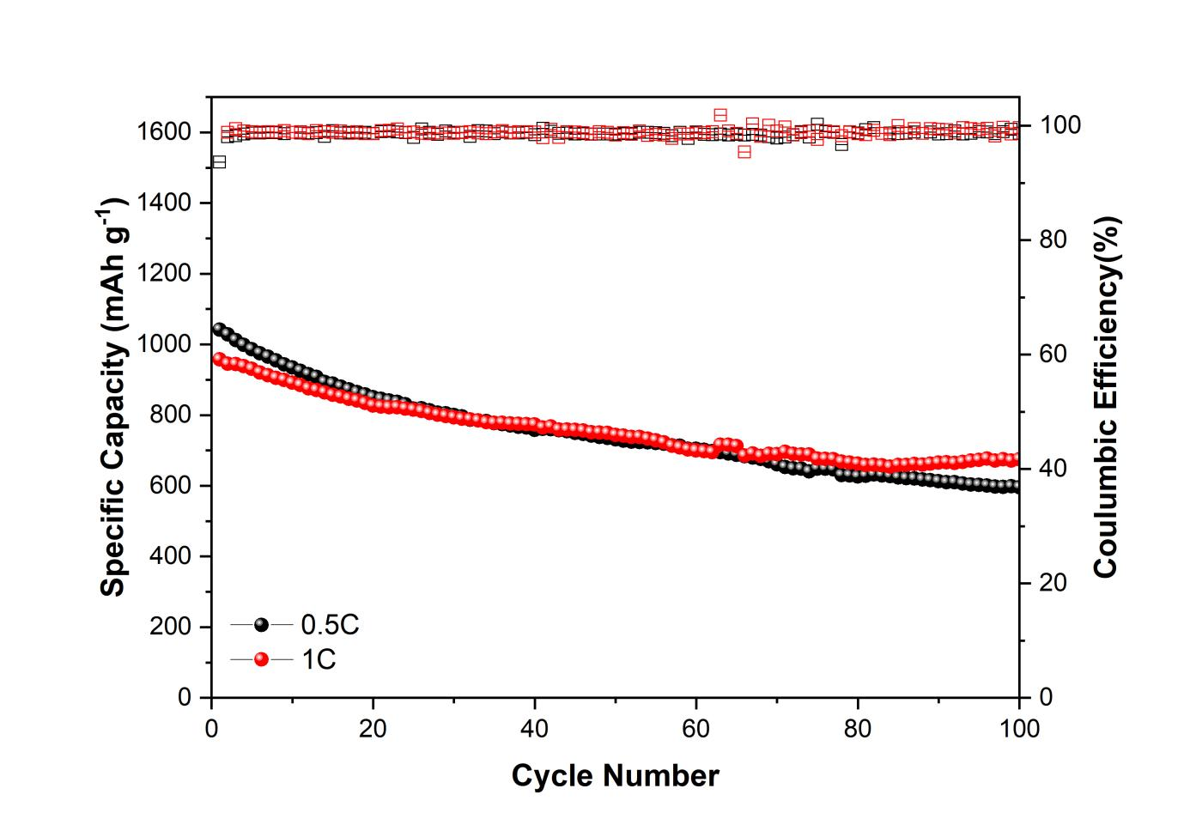
Figure S4. Cycling performance of the HCF electrode at 0.5C and 1C for 100 cycles.

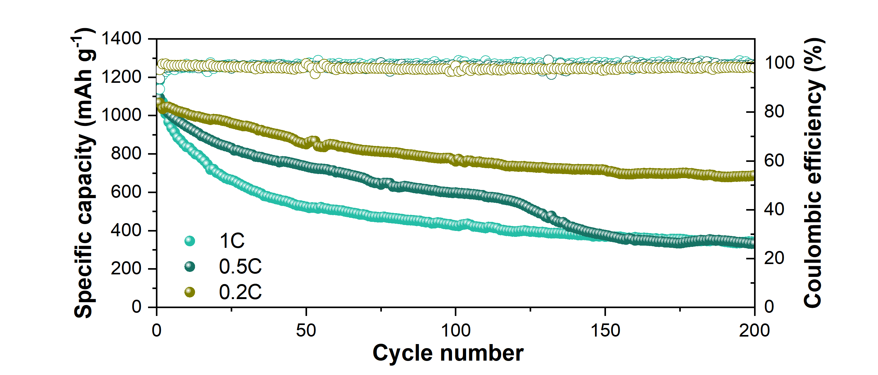
Figure S5. Cycling performance of the CoSe₂-NC@HCF electrode at 0.2C, 0.5C and 1C for 200 cycles.
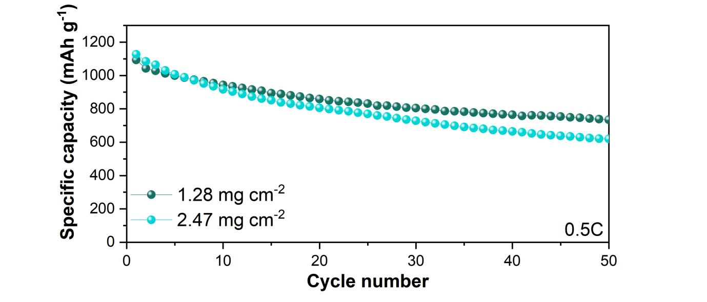
Figure S6. Cycling performance of the S/CoSe₂-NC@HCF composite sulfur cathodes with high sulfur areal density of 1.28 mg cm⁻² and 2.47 mg cm⁻² at 0.5C for 50 cycles.

Table S1. Comparison of the electrochemical performances among this work and other previously reported similar works.
Cathode Materials | Sulfur Content  wt% | Rate | Initial Capacity  mAh g⁻¹ | Cycle Number | Decay rate Per Cycle | Ref.
CoSe₂-NC@HC | 80.83% | 1.0 C | 957.3 | 600 | 0.12% | This work
Co@NHCRs | 60% | 0.5 C | 971 | 100 | 0.27% | S1^{[1]}
S-DHCS@CNTs | 73% | 0.2 C | 1709 | 48 | 1.19% | S2^{[2]}
HCSs/S-LBL | 65% | 0.6 C | 850 | 200 | 0.16% | S3^{[3]}
S@Co-N-GC | 70% | 0.2 C | 1440 | 200 | 0.198% | S4^{[4]}
COM-MPC@S | 59.4% | 1.0 C | 1221.8 | 50 | 1.0% | S5^{[5]}
FeS₂-C | 61.7% | 0.5 C | 877.6 | 350 | 0.03% | S6^{[6]}
rGO/VO₂/S | 70% | 1.0 C | 718.6 | 400 | 0.07% | S7^{[7]}
Fe-PNC/S | 70% | 0.1 C | 1138.6 | 300 | 0.2 | S8^{[8]}
MF-1.1-20/S | 67.7% | 1.0 C | 755 | 300 | 0.09% | S9^{[9]}
S@RGO/PANI | 67% | 1.0 C | 685 | 500 | 0.05% | S10^{[10]}

References
[1] M. Zhang, C. Yu, C. Zhao, X. Song, X. Han, S. Liu, C. Hao, J. Qiu, Cobalt-embedded nitrogen-dopedhollowcarbonnanorods for synergisticallyimmobilizingthedischargeproducts in lithium-sulfur battery, Energy Storage Mater., 5 (2016) 223-229.
[2] Walle M D, Liu Y-N. Confine sulfur in double-hollow carbon sphere integrated with carbon nanotubes for advanced lithium-sulfur batteries [J]. Materials for Renewable and Sustainable Energy, 2021, 10 (1): 1.
[3] Wu F, Li J, Su Y, et al. Layer-by-layer assembled architecture of polyelectrolyte multilayers and graphene sheets on hollow carbon spheres/sulfur composite for high-performance lithium-sulfur batteries [J]. Nano Letters, 2016, 16 (9): 5488-5494.
[4] Li Y-J, Fan J-M, Zheng M-S, et al. A novel synergistic composite with multi-functional effects for high-performance Li-S batteries [J]. Energy & Environmental Science, 2016, 9 (6): 1998-2004.
[5] Ji X, Li Q, Yu H, et al. Three-dimensional ordered macroporous ZIF-8 nanoparticle-derived nitrogen-doped hierarchical porous carbons for high-performance lithium-sulfur batteries [J]. RSC Advances, 2020, 10 (69): 41983-41992.
[6] Xie D, Mei S, Xu Y, et al. Efficient sulfur host based on yolk-shell iron oxide/sulfide-carbon nanospindles for lithium-sulfur batteries [J]. Chemsuschem, 2021, 14 (5): 1404-1413.
[7] Song Z, Lu X, Hu Q, et al. Construction of reduced graphene oxide wrapped yolk-shell vanadium dioxide sphere hybrid host for high-performance lithium-sulfur batteries [J]. Dalton Transactions, 2020, 49 (42): 14921-14930.
[8] Liu Z Z, Zhou L, Ge Q, et al. Atomic iron catalysis of polysulfide conversion in lithium-sulfur batteries [J]. Acs Applied Materials & Interfaces, 2018, 10 (23): 19311-19317.
[9] Cheng J, Zhang X, Miao X, et al. Interconnected hollow carbon spheres with tunable wall-thickness for improving the high-rate performance of energy storage devices [J]. Electrochimica Acta, 2019, 312: 358-368.
[10] Man J-z, Yang X, Li Z-h, et al. Synthesis of polyaniline nanowires wrapped yolk-shell structured S@rGO composite material and its improved lithium-storage performance [J]. Ionics, 2021, 27 (6): 2455-2464.

