Supplementary file

Long-term environmental enrichment prevents schizophrenia-like abnormalities and promotes hippocampal Slc6a4 gene demethylation in mice submitted to a two-hit model

Greicy Coelho Arraes^{1,2}, Francisco Stefânio Barreto^{1,3}, Germana Silva Vasconcelos¹, Camila Nayane de Carvalho Lima^{1,4}, Francisco Eliclécio Rodrigues da Silva¹, Francisca Cléa Florenço de Sousa¹, Cristiana Libardi Miranda Furtado^{3,5}, Danielle S. Macêdo^{1,6*}

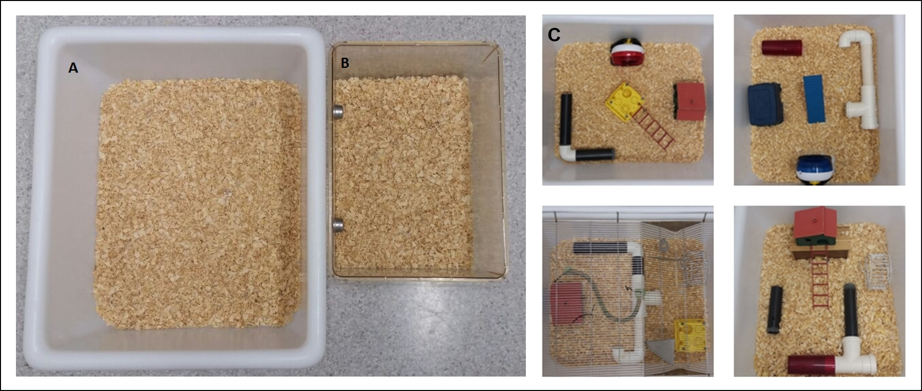
Figure S1 - Comparison between cages used to keep animals in enriched houses (2A) and standard environments (2B). Environmental enrichment consisted of cognitive, physical, and social stimulations by supplementing the animal’s environment with running wheels, tunnels, igloos, huts, retreats, wood toys, a maze, and nesting material (2C). These materials provide a different stimulus to promote change in mice behavior, such as increased locomotor activity, exploration capacity, and work memory.

Table S1 – Summary of the data present in the study results section
Fig. # | Mean | S.E.M | N | Statistical method used
Fig. 2A (%PPI)
PP70 |  |  |  | Repated measures 2way ANOVA  Tukey's Test for Post hoc Analysis
Zero-hit+SE (control) | 72.3 | 3.6 | 9
Zero-hit+EE | 64.0 | 5.0 | 9
Two-hit+SE | 12.6 | 9.2 | 7
Two-hit+EE | 73.4 | 2.6 | 13
PP75
Zero-hit+SE (control) | 75.6 | 2.2 | 9
Zero-hit+EE | 68.7 | 4.5 | 9
Two-hit+SE | 18.5 | 10.2 | 7
Two-hit+EE | 76.5 | 2.7 | 13
PP80
Zero-hit+SE (control) | 79.5 | 2.2 | 9
Zero-hit+EE | 72.1 | 3.4 | 9
Two-hit+SE | 18.7 | 5.7 | 7
Two-hit+EE | 79.5 | 2.5 | 13
Fig. 2B (Mean %PPI) |  |  |  | Regular 2way ANOVA  Šídák's multiple comparisons test
Zero-hit+SE (control) | 75.8 | 2.4 | 9 | Regular 2way ANOVA  Šídák's multiple comparisons test
Zero-hit+EE | 68.3 | 3.9 | 9 | Regular 2way ANOVA  Šídák's multiple comparisons test
Two-hit+SE | 16.6 | 7.8 | 7 | Regular 2way ANOVA  Šídák's multiple comparisons test
Two-hit+EE | 76.5 | 2.4 | 13 | Regular 2way ANOVA  Šídák's multiple comparisons test
Fig. 3 A (Travelled distance)
Zero-hit+SE (control) | 1253.5 | 21.6 | 9 | Regular 2way ANOVA  Šídák's multiple comparisons test
Zero-hit+EE | 1607.0 | 67.9 | 9 | Regular 2way ANOVA  Šídák's multiple comparisons test
Two-hit+SE | 1277.3 | 110.7 | 7 | Regular 2way ANOVA  Šídák's multiple comparisons test
Two-hit+EE | 1616.2 | 84.3 | 13 | Regular 2way ANOVA  Šídák's multiple comparisons test
Fig. 3C (Spontaneous alternations)
Zero-hit+SE (control) | 72.4 | 3.4 | 8 | Regular 2way ANOVA  Šídák's multiple comparisons test
Zero-hit+EE | 75.3 | 0.6 | 10 | Regular 2way ANOVA  Šídák's multiple comparisons test
Two-hit+SE | 58.1 | 3.0 | 11 | Regular 2way ANOVA  Šídák's multiple comparisons test
Two-hit+EE | 73.8 | 3.0 | 8 | Regular 2way ANOVA  Šídák's multiple comparisons test

Table S1 continued
Fig. # | Mean | S.E.M | N | Statistical method used
Fig. 3D (Social Preference Index)
Zero-hit+SE (control) | 0.7 | 0.05 | 8 | Regular 2way ANOVA  Šídák's multiple comparisons test
Zero-hit+EE | 0.5 | 0.05 | 6 | Regular 2way ANOVA  Šídák's multiple comparisons test
Two-hit+SE | 0.8 | 0.03 | 6 | Regular 2way ANOVA  Šídák's multiple comparisons test
Two-hit+EE | 0.7 | 0.08 | 6 | Regular 2way ANOVA  Šídák's multiple comparisons test
Fig. 4A (IBA-1 protein expression)
Zero-hit+SE (control) | 2.6 | 0.3 | 10 | Dunn's multiple comparisons test
Zero-hit+EE | 1.5 | 0.2 | 10 | Dunn's multiple comparisons test
Two-hit+SE | 6.0 | 0.6 | 8 | Dunn's multiple comparisons test
Two-hit+EE | 2.3 | 0.4 | 8 | Dunn's multiple comparisons test
Fig. 4B (DCX protein expression)
Zero-hit+SE (control) | 2.7 | 0.3 | 7 | Bonferroni's multiple comparisons test
Zero-hit+EE | 4.1 | 0.5 | 8 | Bonferroni's multiple comparisons test
Two-hit+SE | 1.7 | 0.3 | 7 | Bonferroni's multiple comparisons test
Two-hit+EE | 4.1 | 0.5 | 6 | Bonferroni's multiple comparisons test

