Supplementary Information

Multiomics analysis to explore blood metabolite biomarkers in an Alzheimer’s Disease Neuroimaging Initiative cohort

Takaki Oka¹, Yuki Matsuzawa¹, Momoka Tsuneyoshi², Yoshitaka Nakamura², Ken Aoshima^{3,4}, Hiroshi Tsugawa^{1,5,6,7} for the Alzheimer’s Disease Metabolomics Consortium**

- Department of Biotechnology and Life Science, Tokyo University of Agriculture and Technology, Tokyo, Japan
- Human Biology Integration Foundation, Eisai Co., Ltd., Ibaraki, Japan
- Microbes & Host Defense Domain, Eisai Co., Ltd., Ibaraki, Japan
- School of Integrative and Global Majors, University of Tsukuba, Ibaraki, Japan
- RIKEN Center for Sustainable Resource Science, Yokohama, Japan
- RIKEN Center for Integrative Medical Sciences, Yokohama, Japan
- Graduate School of Medical Life Science, Yokohama City University, Yokohama, Japan
**Data used in preparation of this article were generated by the Alzheimer’s Disease Metabolomics Consortium

Corresponding authors
Hiroshi Tsugawa: htsugawa@go.tuat.ac.jp

Contents:
Supplementary Figures 1-2

Supplementary Figures
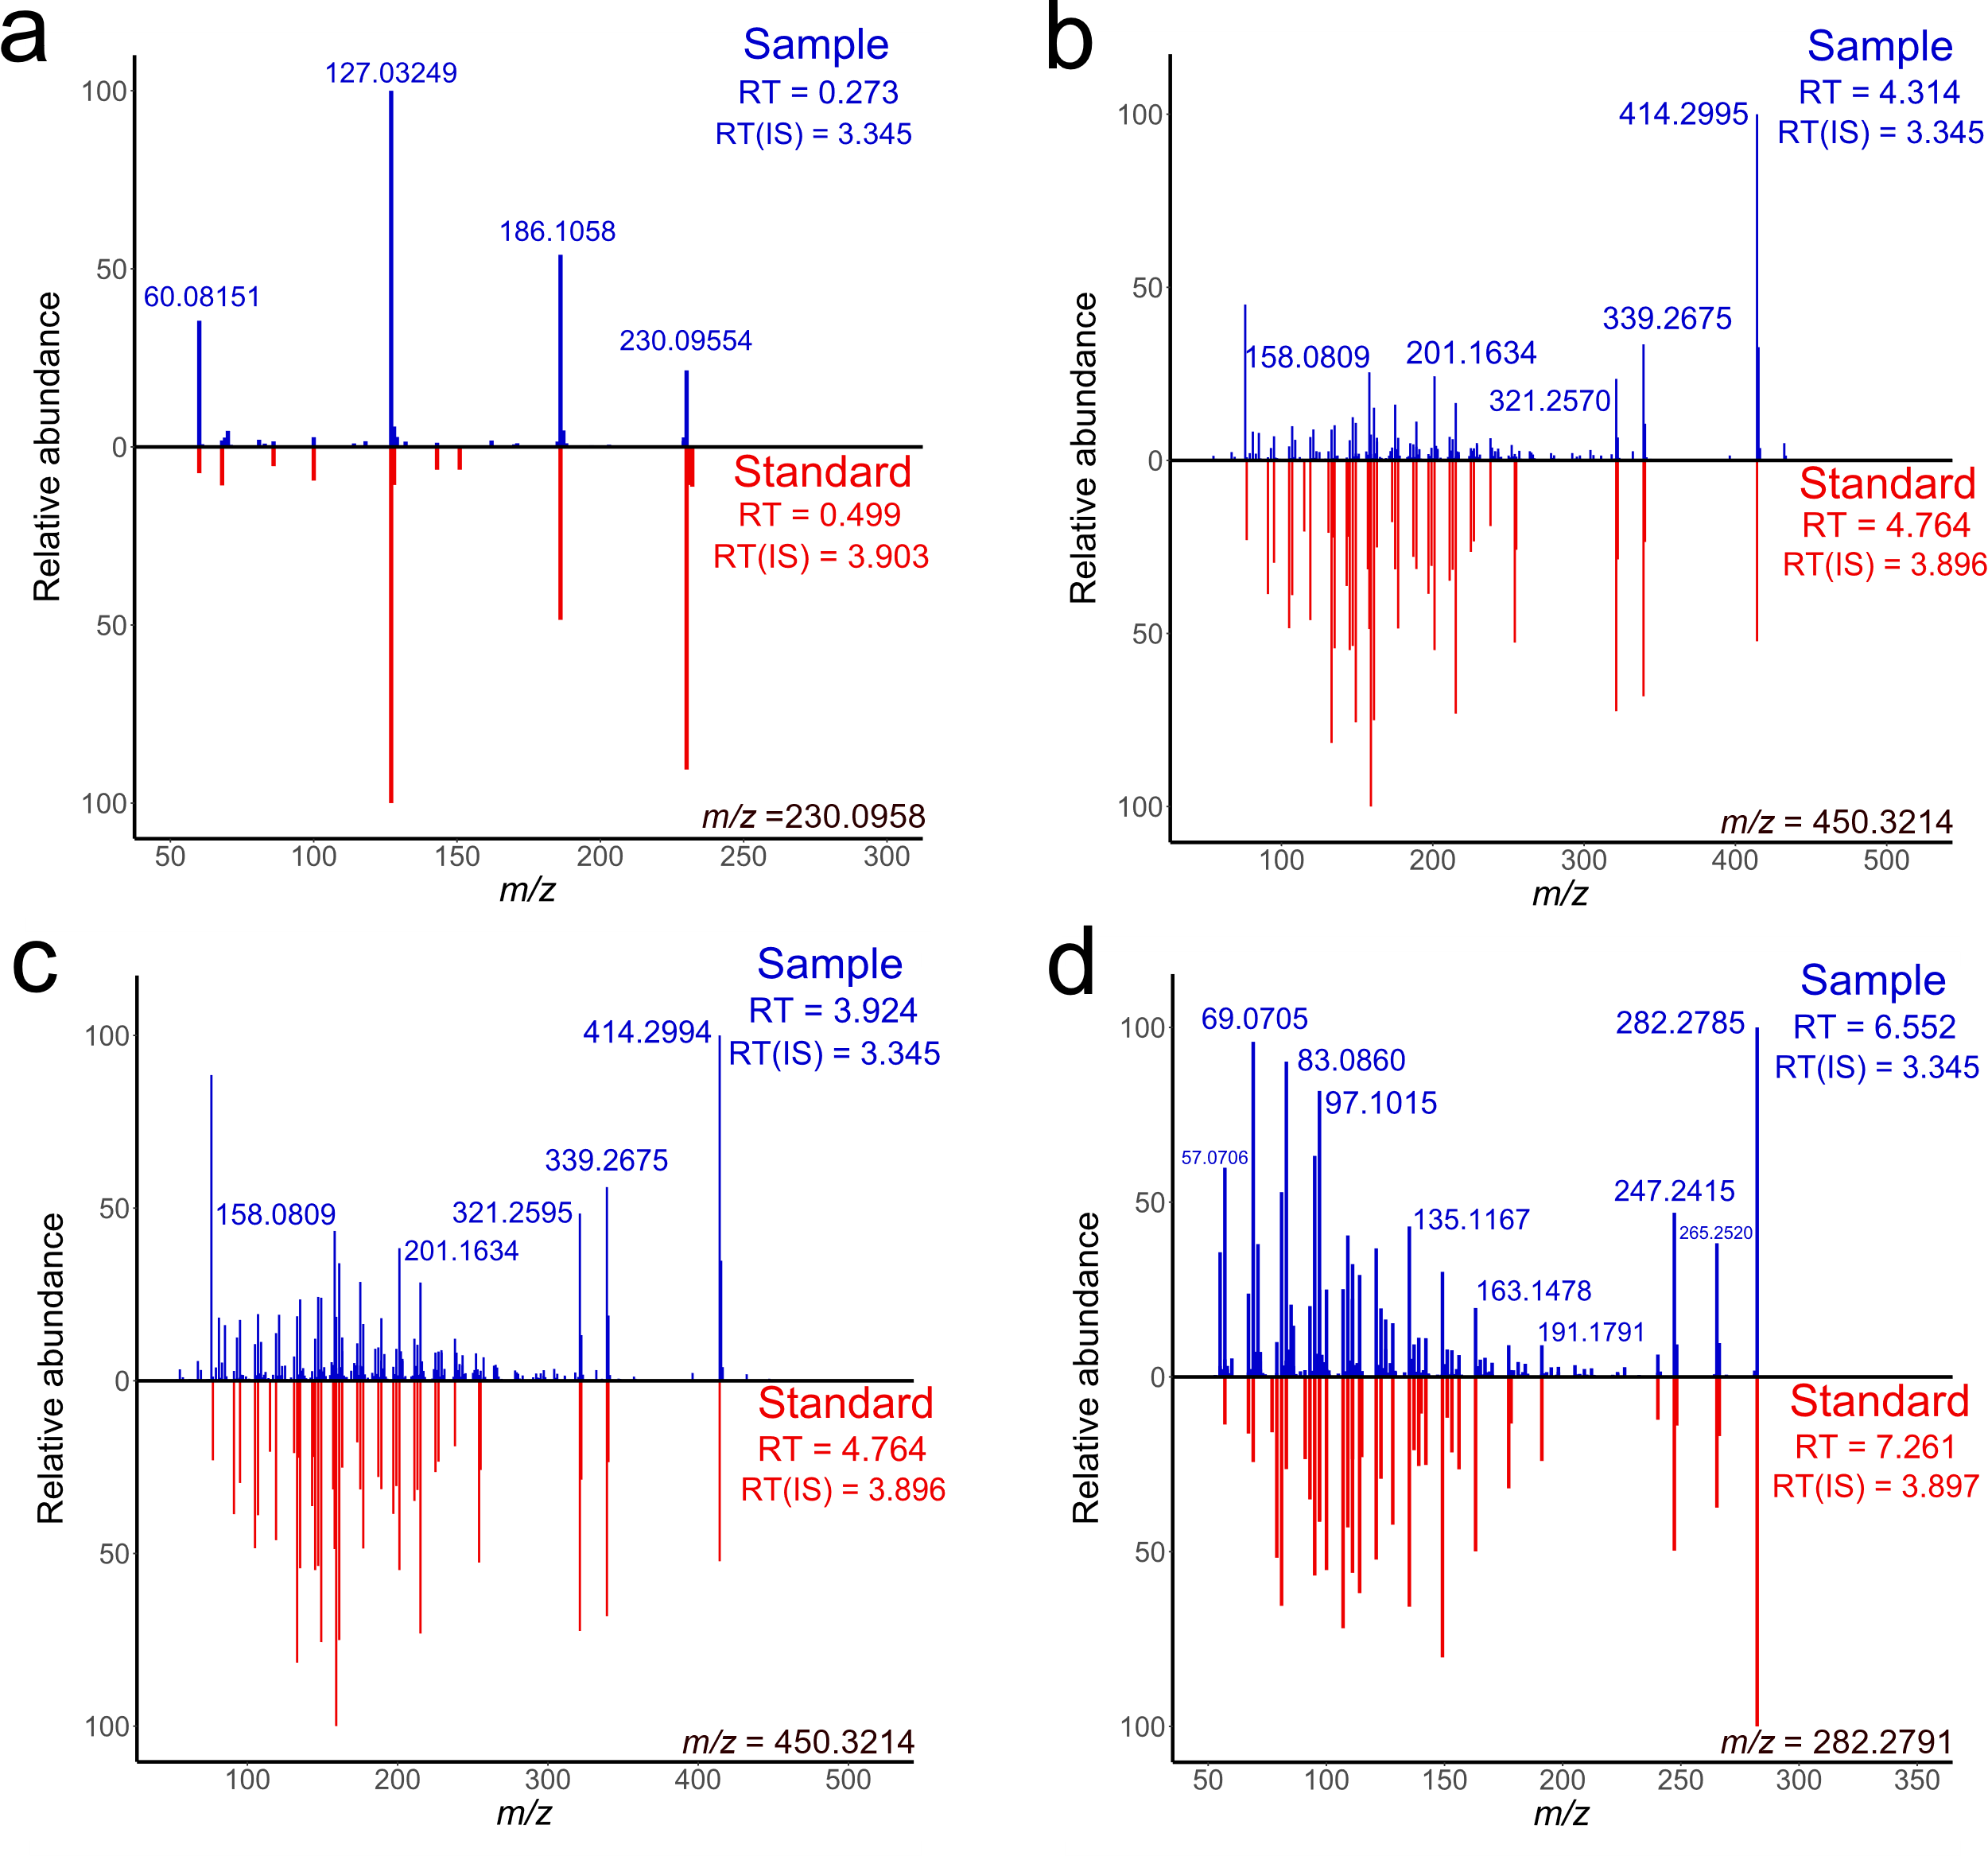
Supplementary Figure 1. Comparison of MS/MS spectra from ADNI samples and authentic standards. The ADNI’s experimental and standard spectra for (a) ergothioneine, (b) glycochenodeoxycholic acid-A, (c) glycochenodeoxycholic acid-B, and (d) oleamide were described in the upper (blue) and lower (red) panels. The retention time (RT) of analytes and the RT value of sulfamethoxine, RT (IS) used as the internal standard in the ADNI study were described. The precursor m/z of standards was shown at the right-bottom area of each figure.

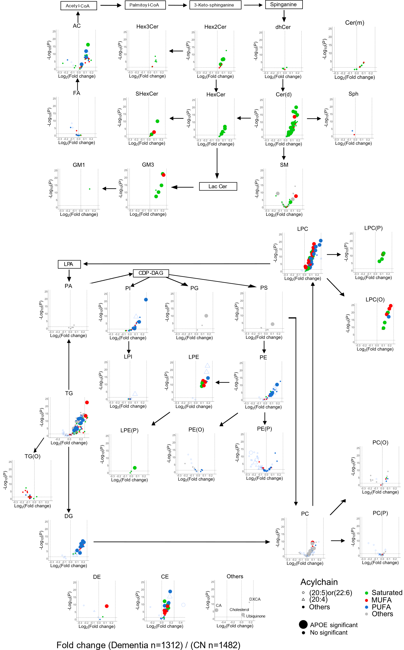Supplementary Figure 2. Comparison of lipids between AD and CN. The healthy control (CN) was set to the base of the fold change calculation. P-values were calculated using the Mann-Whitney U test. The false discovery rate (FDR) correction was used to adjust the p-values. The x- and y-axes show the log₂ fold change- and -log₁₀ p-value. The horizontal dot line indicates the value of P=0.05. The fatty acid composition in complex lipids was described by the different plot shape. The lipids containing docosahexaenoic acid (22:6) or eicosapentaenoic acid (20:5), arachidonic acid (20:4), and others were described by no-filled circle, triangle, and filled circle, respectively. The lipid containing saturated-, mono unsaturated (MUFA), and polyunsaturated fatty acids (PUFA) were distinguished by the plot colors of green, red, and blue, respectively. The significantly changed metabolites in APOE4/4 patients when compared to the genotypes were described by the larger circle symbol.

