SUPPLEMENTAL METHODS
Evaluation of Hypersensitivity: Mapping participant’s affected extremity for areas of spontaneous pain and thermal hypo/hypersensitivity was done by exposing the area to a 20°C cold stimulus, 40°C warm stimulus (Thermal Roller, Somedic, Sweden), brush (SENSELab Brush-05, Somedic, Sweden), and pinprick (Von Frey filament #6.10, applied pressure 980mN)¹.
Quantitative Sensory Testing (QST) was performed at baseline using an abbreviated version of the German Research Network on Neuropathic Pain (DFNS) protocol to determine differential sensory profiles of each participant’s affected (most painful) and unaffected (non-painful) regions^{2,3}. This was used to assess warm and cold detection (WDT and CDT) thresholds, heat and cold pain thresholds (HPT and CPT), mechanical detection and pain thresholds (MDT and MPT), presence of wind-up (enhanced temporal summation) to pinprick, vibration detection thresholds (VDT), and pressure pain threshold (PPT), and conditioned pain modulation (CPM). The Thermal Sensory Analyzer (TSA-II or PATHWAY platform; Medoc, Ramat Yishai, Israel) was used to determine WDT, CDT, HPT, and CP ^{4,5}. A set of standardized Semmes-Weinstein monofilaments (0.25, 0.5, 1, 2, 4, 8, 16, 32, 64, 128, and 256mN; North Coast, USA) was used to assess MDT for each participant’s affected and unaffected area. A set of calibrated blunt metal probes with applied force 8-512mN (MRC systems, Germany) was used to determine the MPT. Wind-up ratio (WUR) was assessed using a #6.10 von Frey filament (. 980mN) and calculated as the ratio between pain intensity elicited by a train of ten 1Hz stimuli versus a single stimulus value was calculated⁶. Each participant’s frequency of vibration detection threshold was determined using a clinical tuning fork (64Hz, 8/8 scale)^{7,8}. A handheld algometer (Wagner Instruments) was used to determine each participant’s PPT following continuous pressure application at a 0.5kg/sec rate. The test sites used for affected and control sites were along the same muscle. A cold-water bath and the Thermal Sensory Analyzer were used to assess each participant’s CPM. CPM was evaluated by determining the change in elicited thermal pain rating before versus during exposure to a conditioning stimulus (cold water bath maintained at 12°C). The test stimulus was determined as the probe temperature, which elicited a pain intensity of 50 on a 0-100 NRS in each participant. First, the Pain-50 stimulus was applied, and the subject-reported pain intensity (NRS) evoked by the stimulus was documented. This procedure was repeated twice. Next, the Pain-50 stimulus was applied during the last 30 seconds of a 60-second contralateral cold conditioning, and the participant was asked to report the pain intensity elicited by the thermal probe. This was repeated twice. The difference between the reported pain intensity of the stimulus before and during conditioning was the CPM magnitude. A CPM <0 implies efficient descending pain modulation.
Description of Pre-Screening Session (Task-Specific θ Modulation): To train subjects to control a BCI using frontal-θ power, a task was provided to initiate modulation of this pattern. We collected EEG during a serial subtraction mental arithmetic task to assess each participant's characteristic θ modulation profile. It has been previously shown that mental arithmetic, calculations, and mental tasks increase frontal midline θ activity. We used this observation to pre-screen participants for task-specific modulation ^{9–11}. This strategy was used for all participants to induce initial θ modulation, which could be used to exert BCI control. Baseline EEG data were collected for five minutes before the experiment. The task design consisted of two 25-trial blocks. Before assessment recording, the subjects were given randomly generated three-digit multiple of 50. This number would be used for the serial subtraction task. Each trial consisted of a five-second task period where participants were asked to engage in serial subtraction and a five-second baseline period where subjects were asked to fix their gaze on a fixation cross presented at the center of the display without performing any mental tasks. During the task period, a pseudorandom prime number between 3 and 19 was selected and presented to the participant in the middle of the screen. The participants were asked to serially subtract that prime number from the three-digit multiple of 50 until that number disappeared and the baseline fixation cross was presented. Offline analysis was conducted to quantify the degree of θ modulation and quantify the spectral properties of their activity modulation.

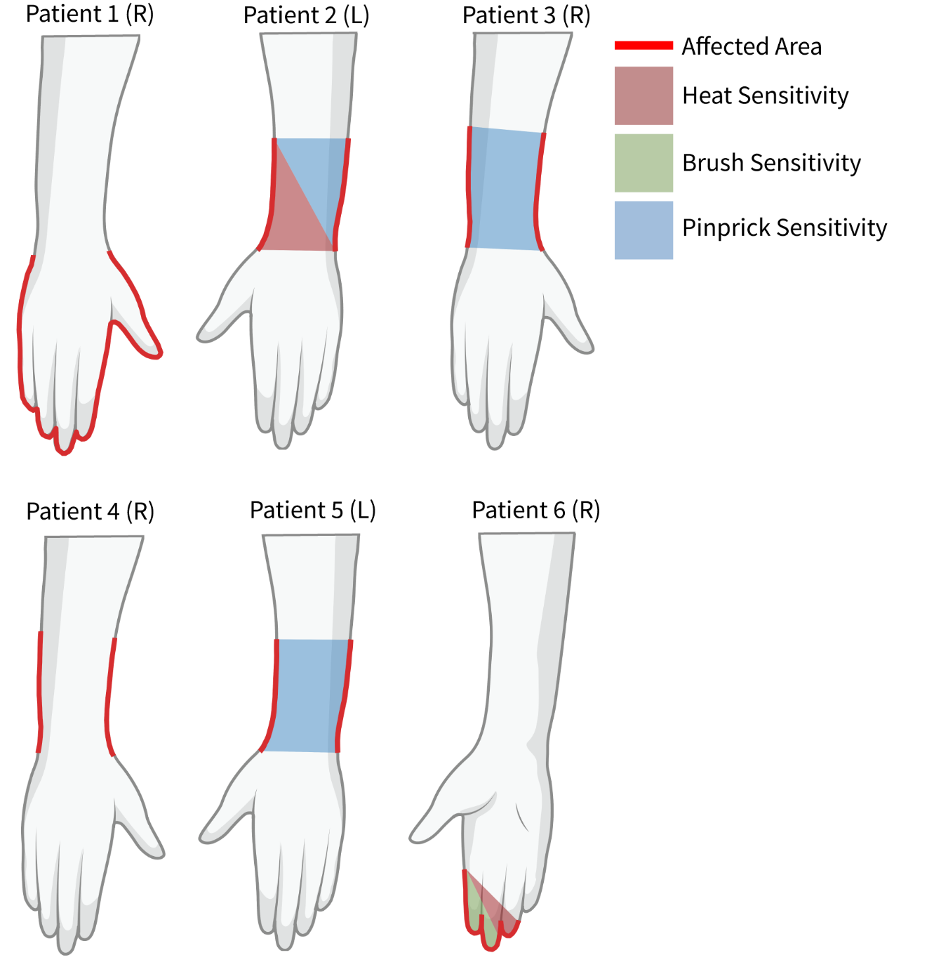

Supplemental Figure 1. Schematic of handedness, location, and hypersensitivity type of each patient’s affected area.
The affected region is shown in red. Heat sensitivity is shown in red shading. Brush sensitivity is shown in green shading. Pinprick sensitivity is shown in blue shading.

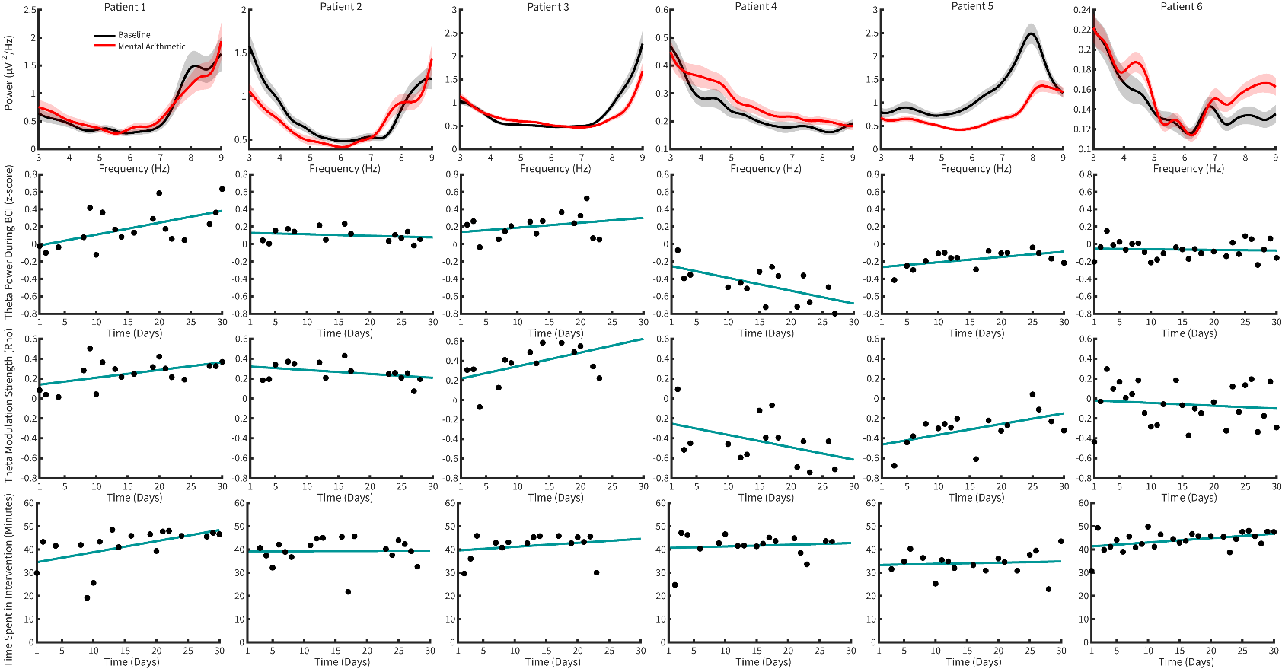
Supplemental Figure 2. Visualization of theta modulation.
(From top to bottom) Power spectral density plots showing differences in frontal theta modulation during a serial subtraction mental arithmetic task (shading represents standard error). Normalized theta power across BCI sessions over time. Theta modulation strength over time across BCI sessions. Total session time for each BCI training day. The blue line shows the overall trend by a line of best fit.

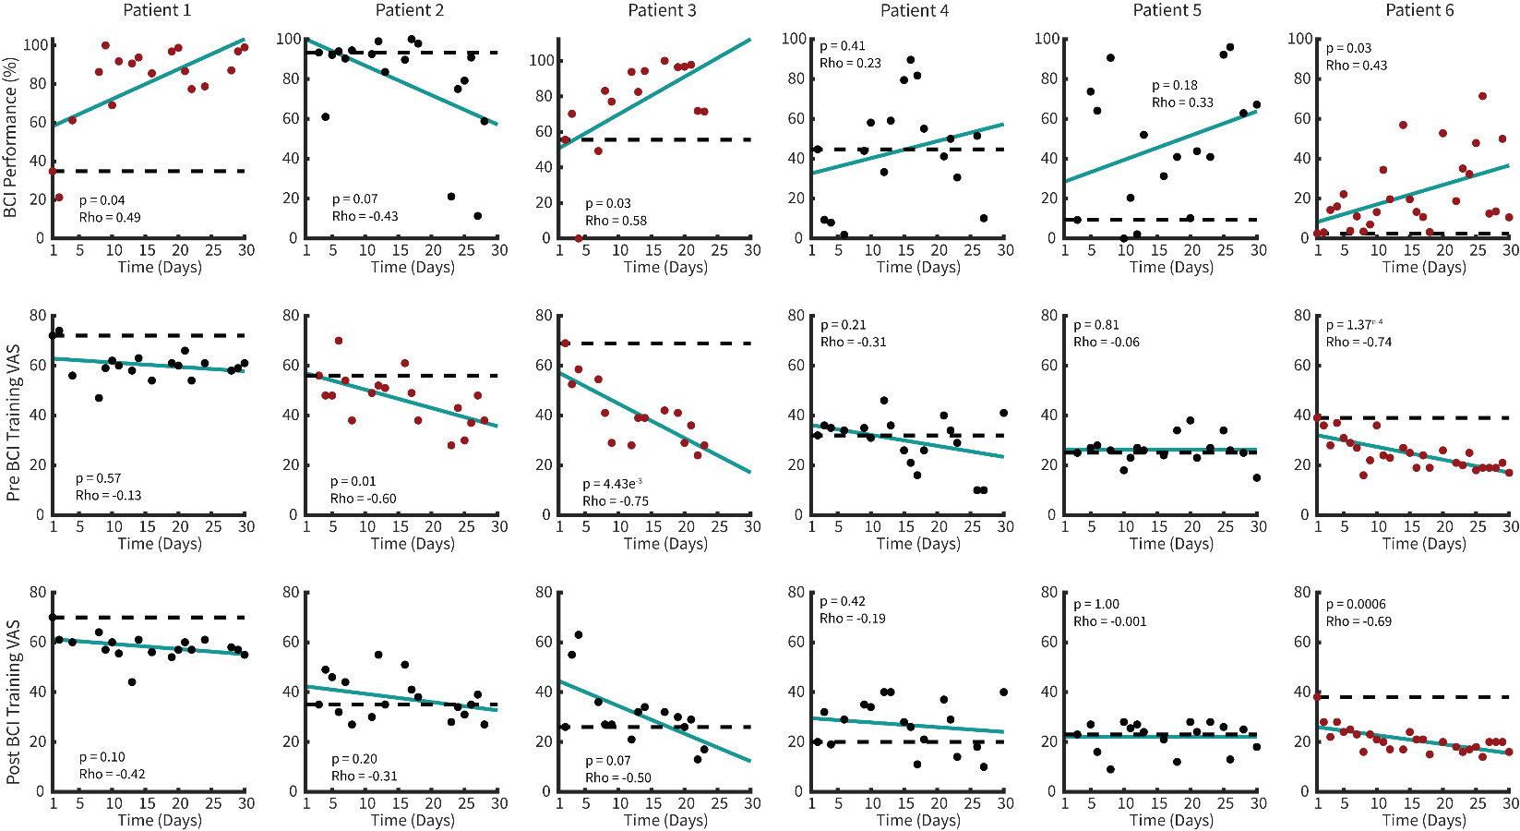
Supplemental Figure 3. Individual patient BCI performance and pain over BCI intervention.
(From top to bottom) Each BCI session performance, pre-session VAS, and post-session VAS on each day for each patient. Significant changes over time are shown by red data points (Spearman correlation). The blue line shows the overall trend by a line of best fit.

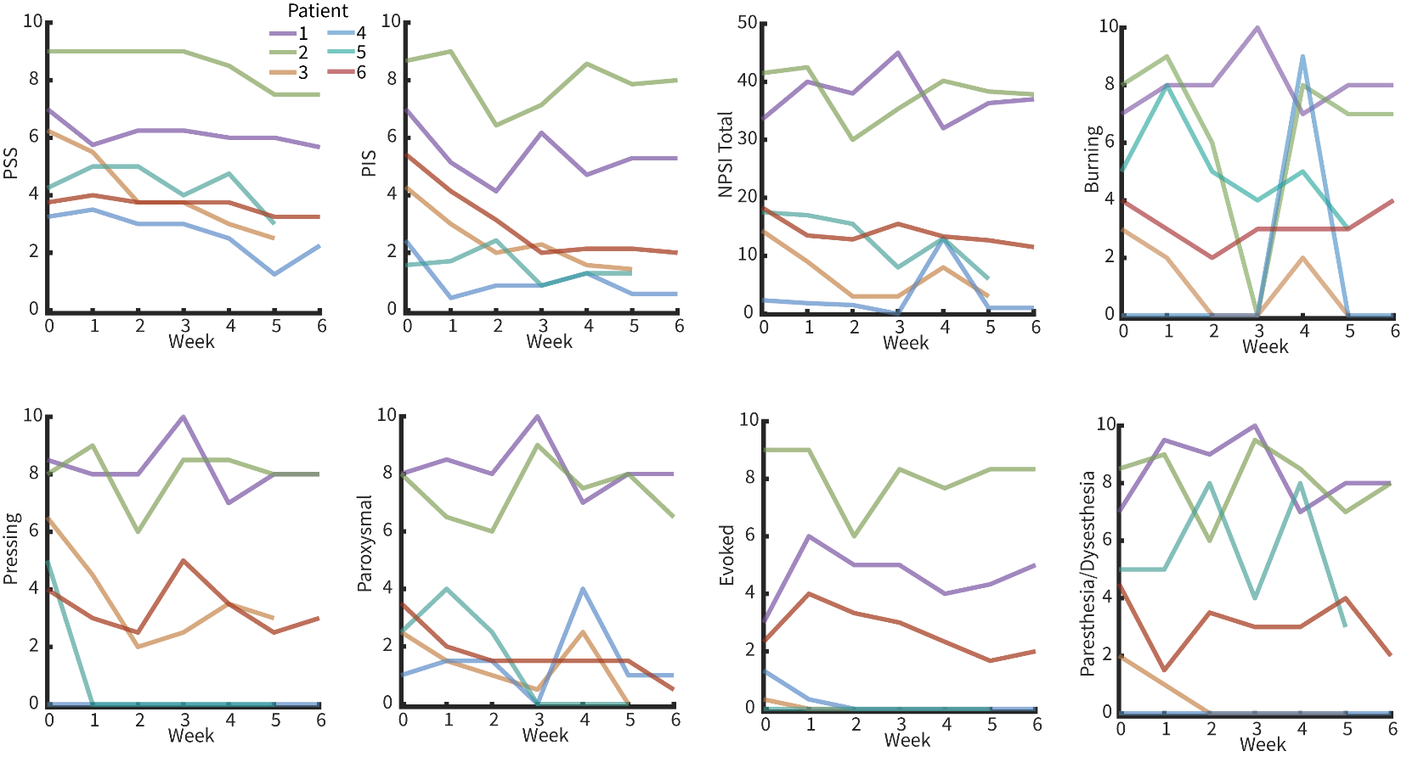
Supplemental Figure 4. Weekly BPI and NPSI scores over the intervention period for individual patients.
Clinical outcomes (NPSI, PSS, and PIS) over BCI therapy for each patient. Measures were taken via a patient-reported survey given at the end of each week. The first three graphs show PSS, PIS, and NPSI. The last five graphs show symptom scores for NPSI.

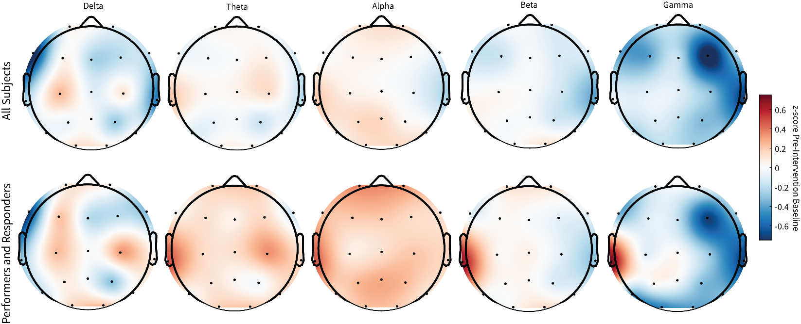
Supplemental Figure 5. Topography plots of brain activity across patients before and after BCI intervention.
Topography plots of baseline EEG activity for all frequency bands after BCI therapy for all subjects (Top) and for performers and VAS pain responders (Bottom) z-scored to pre-intervention baseline.

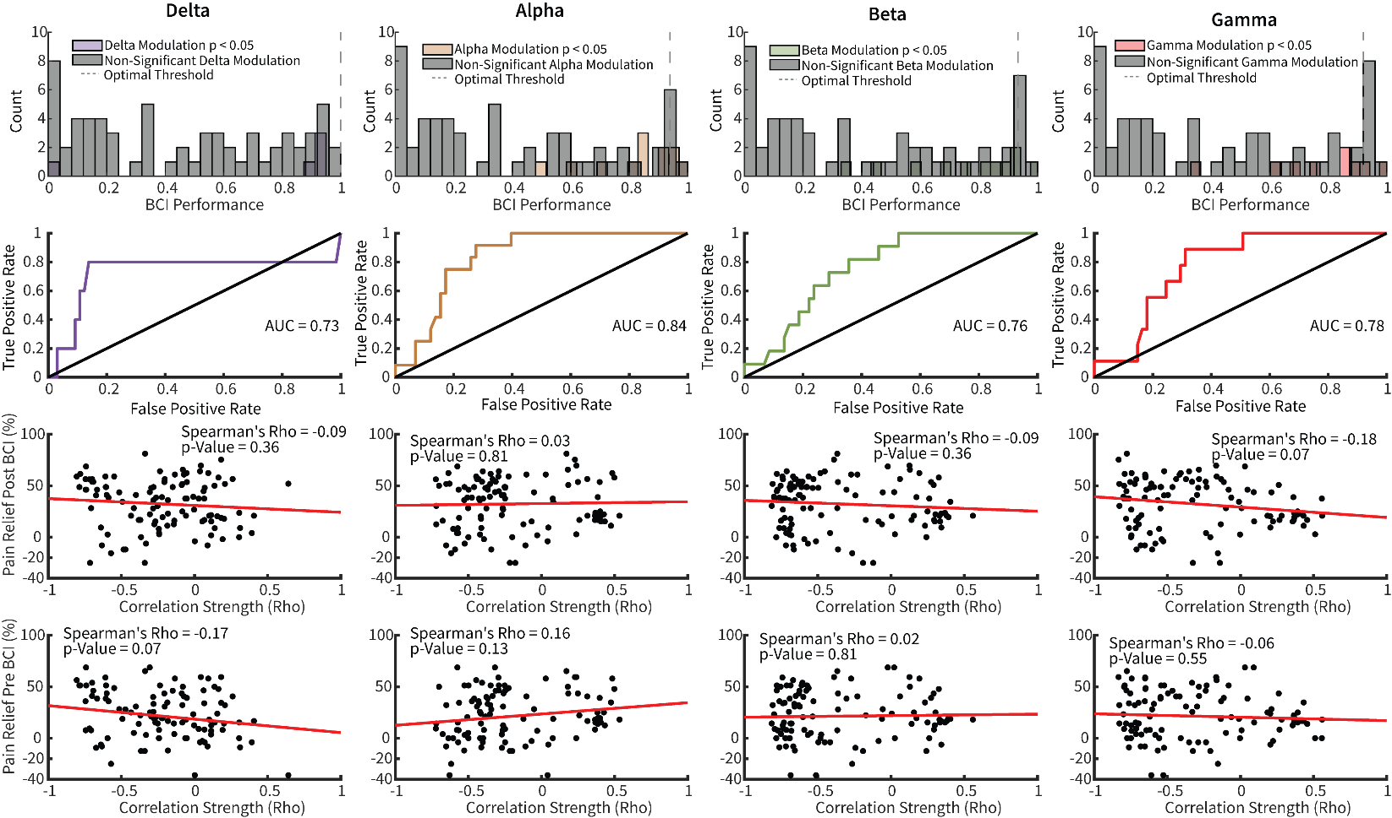
Supplemental Figure 6. Correlation analysis of non-theta frequencies with pain relief.
Secondary analysis of the relationship between (from left to right) delta, alpha, beta, and gamma modulation strength with BCI performance and pain relief. (First row) Distribution of all BCI sessions across all patients with and without significant modulation of respective frequency bands. The dotted line represents the optimal classification threshold calculated by ROC analysis. The shaded bars represent sessions with significant power modulation relative to the pre-intervention baseline (Spearman correlation, p < 0.05). (Second row) ROC curves demonstrating the true and false positive rates of correct classification of respective frequency modulation by performance value. (Third row) Relationship between respective frequency band modulation strength and pain relief using VAS obtained after each day’s BCI session (Spearman correlation). (Fourth row) Relationship between respective frequency band modulation strength and pain relief using VAS obtained before each day’s BCI session (Spearman correlation).

Supplementary Table 1. Patient primary and secondary outcome measures. Bottom set contains scores for all sub-scores of NPSI.

 | VAS |  | PSS |  | PIS |  | NPSI
Patient | Pre | Post | Pre | Post | Pre | Post | Pre | Post
1 | 72.00 | 61.00 | 7.00 | 5.67 | 7.00 | 5.29 | 33.50 | 37.00
2 | 56.00 | 38.00 | 9.00 | 7.50 | 8.67 | 8.00 | 41.50 | 37.83
3 | 69.00 | 28.00 | 6.35 | 2.50 | 4.29 | 1.43 | 14.33 | 3.00
4 | 32.00 | 41.00 | 3.25 | 2.25 | 2.43 | 0.57 | 2.33 | 1.00
5 | 25.00 | 15.00 | 4.25 | 3.00 | 1.57 | 1.29 | 24.33 | 26.66
6 | 39.00 | 17.00 | 3.75 | 3.25 | 5.43 | 2.00 | 12.33 | 13.33
 | Burning |  | Pressing |  | Paroxysmal |  | Evoked |  | Paresthesia/dysesthesia
 | Pre | Post | Pre | Post | Pre | Post | Pre | Post | Pre | Post
1 | 7.00 | 8.00 | 8.50 | 8.00 | 8.00 | 8.00 | 3.00 | 5.00 | 7.00 | 8.00
2 | 8.00 | 7.00 | 8.00 | 8.00 | 8.00 | 6.50 | 9.00 | 8.33 | 8.50 | 8.00
3 | 3.00 | 0.00 | 6.50 | 3.00 | 2.50 | 0.00 | 0.33 | 0.00 | 2.00 | 0.00
4 | 0.00 | 0.00 | 0.00 | 0.00 | 1.00 | 1.00 | 1.33 | 0.00 | 0.00 | 0.00
5 | 5.00 | 3.00 | 5.00 | 0.00 | 2.50 | 0.00 | 0.00 | 0.00 | 5.00 | 3.00
6 | 4.00 | 4.00 | 4.00 | 3.00 | 3.50 | 0.50 | 2.33 | 2.00 | 4.50 | 2.00
VAS = visual analog scale, PSS = pain severity score, PIS = pain interference score, NPSI = neuropathic pain symptom inventory score, Pre = pre-BCI intervention score, Post = post-BCI intervention score

SUPPLEMENTAL REFERENCES
1. Finnerup, N. B., Sørensen, L., Biering-Sørensen, F., Johannesen, I. L. & Jensen, T. S. Segmental hypersensitivity and spinothalamic function in spinal cord injury pain. Exp. Neurol. 207, 139–149 (2007).
2. Rolke, R. et al. Quantitative sensory testing in the German Research Network on Neuropathic Pain (DFNS): Standardized protocol and reference values. PAIN 123, 231–243 (2006).
3. Baumgärtner, U., Magerl, W., Klein, T., Hopf, H. C. & Treede, R. D. Neurogenic hyperalgesia versus painful hypoalgesia: two distinct mechanisms of neuropathic pain. Pain 96, 141–151 (2002).
4. Yarnitsky, D., Sprecher, E., Zaslansky, R. & Hemli, J. A. Heat pain thresholds: normative data and repeatability. Pain 60, 329–332 (1995).
5. Fruhstorfer, H., Lindblom, U. & Schmidt, W. C. Method for quantitative estimation of thermal thresholds in patients. J. Neurol. Neurosurg. Psychiatry 39, 1071–1075 (1976).
6. Magerl, W., Wilk, S. H. & Treede, R. D. Secondary hyperalgesia and perceptual wind-up following intradermal injection of capsaicin in humans. Pain 74, 257–268 (1998).
7. Goldberg, J. M. & Lindblom, U. Standardised method of determining vibratory perception thresholds for diagnosis and screening in neurological investigation. J. Neurol. Neurosurg. Psychiatry 42, 793–803 (1979).
8. Fagius, J. & Wahren, L. K. Variability of sensory threshold determination in clinical use. J. Neurol. Sci. 51, 11–27 (1981).
9. Schacter, D. L. EEG theta waves and psychological phenomena: a review and analysis. Biol. Psychol. 5, 47–82 (1977).
10. Inanaga, K. Frontal midline theta rhythm and mental activity. Psychiatry Clin. Neurosci. 52, 555–566 (1998).
11. Gärtner, M., Grimm, S. & Bajbouj, M. Frontal midline theta oscillations during mental arithmetic: effects of stress. Front. Behav. Neurosci. 9, 96 (2015).

