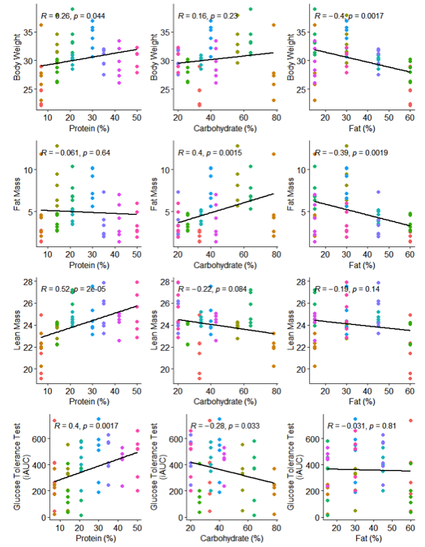
Supplementary Figure 1. Correlations of metabolic traits with each dietary macronutrient. Plots of the correlation of each dietary macronutrient with each metabolic trait in Figure 1.
Supplementary Figure 2. Gene regulatory changes relative to dietary carbohydrates. A. Volcano plot of differential splicing changes, plotting the log fold change between 20% dietary carbohydrates and 78% dietary carbohydrates. Blue dots are significant, black are non-significant. Extreme exons in terms of log fold change or p-value are labeled. B. Volcano plot of differential expression changes, plotting the log fold change per percent dietary carbohydrates. Red dots are significant, black are non-significant
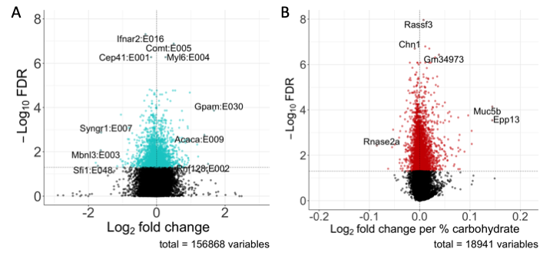
Supplementary Figure 3. Computationally estimated cell type proportions. Surfaces generated from the computationally estimated cell type proportions of each fat tissue sample. For the proportion of macrophages (mMac2), the data supported a null model with no impact of dietary macronutrients.
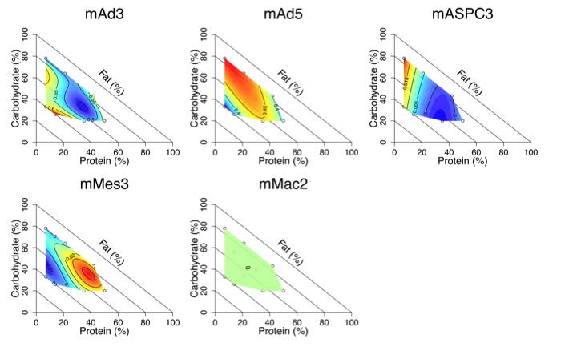
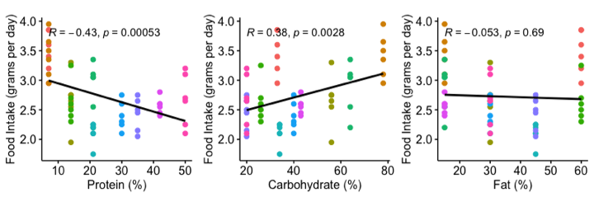
Supplementary Figure 4. Correlations of food intake with each dietary macronutrient. Plots of the correlation of each dietary macronutrient with food intake.

Supplementary Table 1. Metabolic trait values. Mean and standard deviation for the measurements of each metabolic trait in each diet.
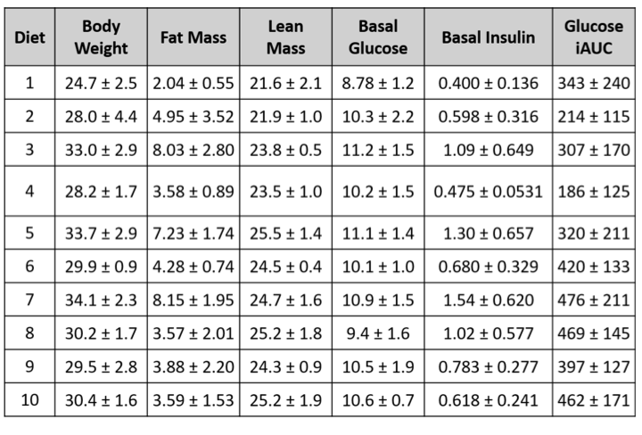
Supplementary Table 2. AIC values and mixture model summaries for all variables.

