‘EAT FIVE A DAY’ VS ‘EAT ONE MORE’: INCREASED FRUIT AND VEGETABLE CONSUMPTION WHEN GOALS ARE PROVIDED, AND WHEN GOALS ARE MORE ACHIEVABLE OR PERCEIVED TO BE EASIER
Katherine M Appleton & Zara Borgonha
Research Centre for Behaviour Change, Department of Psychology, Bournemouth University, UK.
SUPPLEMENTARY MATERIALS

STUDY 1: METHODS
Health Promotion Messages: The three magnets provided

Magnet ‘Eat 1 more …’ Magnet ‘Eat 5 …’

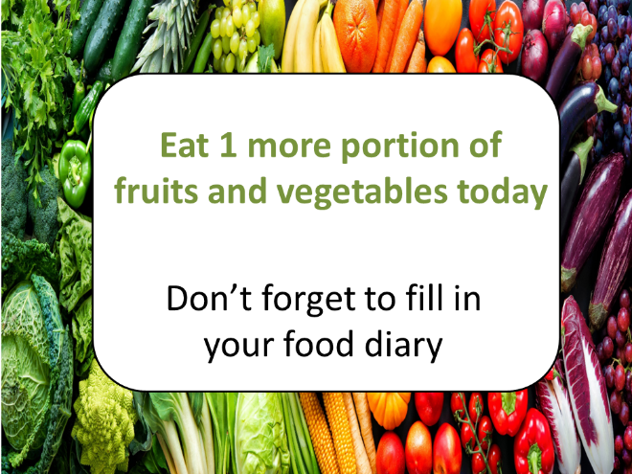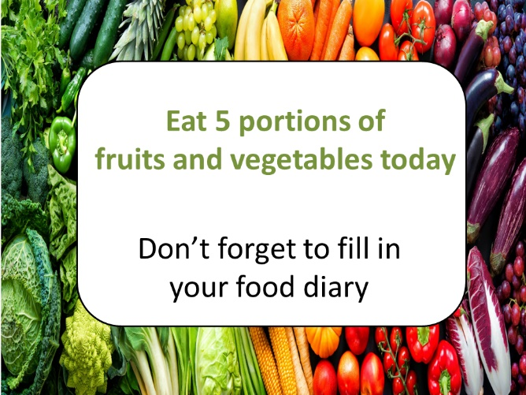

Control magnet



FV Consumption: Additional variables: Measures detail
Various characteristics of potential impact on fruit consumption were assessed using questionnaire items, and subsequently controlled for to prevent confounding. These characteristics were: gender; age; liking for fruit (‘How much do you like fruits and vegetables?’ (not at all – like very much)); perceived importance of FV (How important to you personally are fruits and vegetables in your diet?’ (very unimportant – very important)); perceived awareness of FV (‘Are you aware of the fruits and vegetables you eat? (no, unsure, yes); the perceived importance of other people (‘Do you feel that other people had an effect on your fruit and vegetable consumption? (no, maybe/unsure, yes); ease of adherence ‘How easy or difficult was it for you to adhere to the message on your magnet?’ (very difficult – very easy); effort applied (‘How much effort did you put I to adhere to the message on your magnet?’ (none at all – a lot indeed).
STUDY 1: RESULTS
Table SM1: Participant characteristics, per group (N=92)
 | Goal: Eat 1 more … (N=32) | Goal: Eat 5 … (N=33) | No goal  (N=27)
Baseline (FV portions) | 3.0 (1.5) | 3.2 (1.5) | 2.8 (1.1)
End (FV portions) | 3.5 (1.6) | 3.7 (1.5) | 2.7 (1.1)
Future FV intentions (-1 - +1) | 0.6 (0.7) | 0.7 (0.6) | 0.5 (0.8)
Gender (males: N (%)) | 12 (40%) | 13 (39%) | 12 (46%)
Age (years) | 20.1 (1.3) | 19.4 (1.2) | 21.9 (2.6)
FV Liking (-2 - +2) | 1.2 (0.7) | 1.0 (0.8) | 0.7 (0.8)
Awareness of FV (-1 - +1) | 0.7 (0.7) | 0.6 (0.8) | 0.7 (0.7)
Importance of the opinions and actions of others (-1 - +1) | -0.1 (0.9) | -0.2 (1.0) | -0.1 (1.0)
Ease (-2 - +2) | 0.3 (1.0) | 0.1 (1.1) | 0.1 (0.8)
Effort (-2 - +2) | 0.1 (0.9) | 0.4 (0.8) | -0.2 (1.2)
Importance of FV (-2 - +2) | 1.0 (0.8) | 0.9 (1.0) | 1.0 (0.9)

STUDY 1: RESULTS
Table SM2: Results of all regression analyses
 | Goal vs No Goal |  |  |  | Goal: Eat 1 more … vs Eat 5 …
 | FV consumption |  | Future FV intentions |  | FV consumption |  | Future FV intentions
 | R²=0.08, adj. R²=0.06, F(1,91)=7.27, p<0.01 |  | R²=0.01, adj. R²=0.01, F(1,91)=1.14, p=0.29 |  | R²=0.01, adj. R²=0.01, F(1,64)=0.29, p=0.59 |  | R²=0.01, adj. R²=0.01, F(1,64)=0.97, p=0.33
 | Beta | Sig. | Beta | Sig. | Beta | Sig. | Beta | Sig.
No goal vs goal | .273 | <.01 | .112 | .29
Goal: Eat 1 more … vs Eat 5 … |  |  |  |  | .068 | .59 | .123 | .33
 | R²=0.25, adj. R²=0.23, F(3,91)=9.98, p<0.01 |  | R²=0.03, adj. R²=0.01, F(3,91)=0.82, p=0.49 |  | R²=0.27, adj. R²=0.23, F(3,64)=7.44, p<0.01 |  | R²=0.07, adj. R²=0.02, F(3,64)=1.52, p=0.22
 | Beta | Sig. | Beta | Sig. | Beta | Sig. | Beta | Sig.
No goal vs goal | .264 | <.01 | .107 | .31
Goal: Eat 1 more … vs Eat 5 … |  |  |  |  | .107 | .34 | .134 | .28
Ease | .414 | <.01 | .119 | .27 | .524 | <.01 | .228 | .08
Importance of FV | .050 | .59 | -.044 | .68 | -.047 | .68 | -.131 | .31
 | R²=0.55, adj. R²=0.49, F(10,91)=9.87, p<0.01 |  | R²=0.30, adj. R²=0.21, F(10,91)=3.39, p<0.01 |  | R²=0.51, adj. R²=0.42, F(10,64)=5.72, p<0.01 |  | R²=0.38, adj. R²=0.26, F(10,64)=3.25, p<0.01
 | Beta | Sig. | Beta | Sig. | Beta | Sig. | Beta | Sig.
No goal vs goal | .212 | .02 | .059 | .61
Goal: Eat 1 more … vs Eat 5 … |  |  |  |  | .055 | .60 | .138 | .19
Ease | .235 | .01 | .101 | .35 | .345 | <.01 | .223 | .10
Importance of FV | .022 | .78 | -.064 | .52 | -.016 | .88 | -.112 | .35
Gender | .042 | .61 | -.036 | .72 | .084 | .45 | .023 | .85
Age | .110 | .23 | -.114 | .32 | .064 | .56 | -.105 | .40
Baseline FV consumption | .457 | <.01 | .128 | .24 | .448 | <.01 | .027 | .84
Liking | .069 | .47 | -.030 | .80 | -.006 | .96 | .009 | .95
Awareness | -.073 | .36 | .495 | <.01 | -.122 | .23 | .526 | <.01
Importance of the opinions of others | -.081 | .31 | .073 | .46 | -.025 | .81 | .007 | .95
Effort | .185 | .03 | .045 | .67 | .123 | .27 | -.112 | .38

STUDY 2: METHODS
Health Promotion Messages: The four posters provided

Message 1C Message 1F
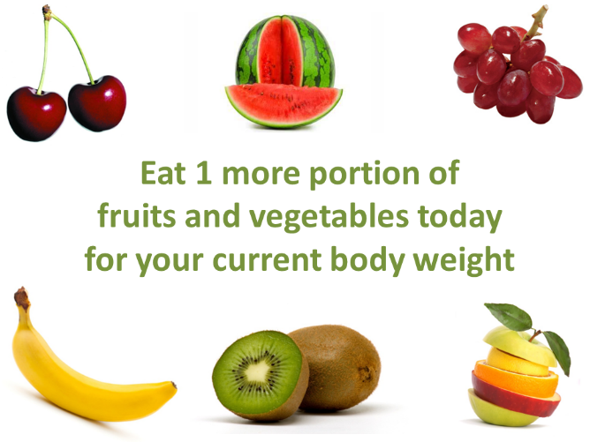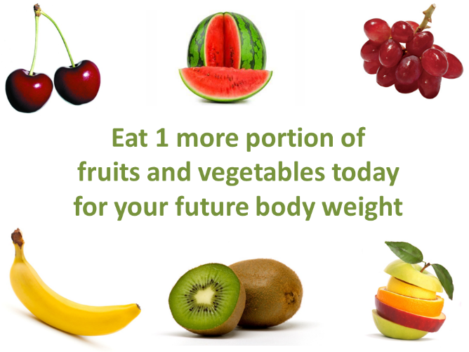

Message 5C Message 5F
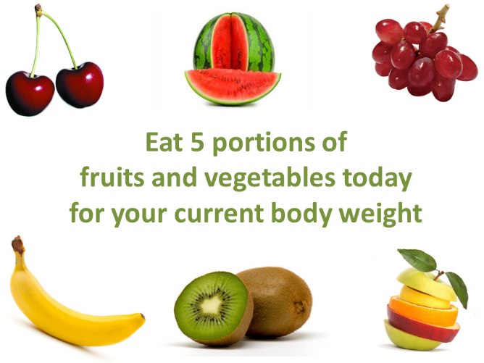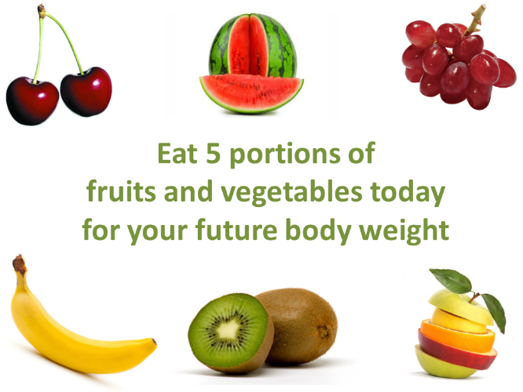

FV consumption: Participant characteristics of potential impact: Measures detail
Various characteristics of potential impact on fruit consumption were assessed using additional questionnaire items, and subsequently controlled for to prevent confounding. These characteristics were: gender; age; past FV consumption (‘Yesterday, how many portions of FV did you eat?’); usual FV consumption (‘On an average week day, how many portions of FV do you eat?’, ‘On an average weekend day, how many portions of FV do you eat?’); awareness of FV (‘I need to increase my intake of FV’ (strongly agree- strongly disagree)); liking for FV (‘I like FV’ (strongly disagree- strongly agree)); usual motivation towards health (‘How important is your health to you?’ (not at all – extremely important), ‘I try to keep in good health’ (strongly disagree - strongly agree), ‘I wish I was more healthy’ (strongly disagree – strongly agree)); usual motivation through body-weight based concerns (‘How important is your weight to you?’ (not at all – extremely important), ‘I try to keep a healthy body weight’ (strongly disagree - strongly agree), ‘I wish I had a different body weight’ (strongly disagree – strongly agree)); motivation towards future health (‘How important is your future health to you?’ (not at all – extremely important)’; motivation towards future body weight (‘How important is your future weight to you?’ (not at all – extremely important)’; perceived importance of the opinions of others (‘I would be affected if someone criticized my diet’ (strongly disagree – strongly agree), ‘What other people think of my diet matters to me’ (strongly disagree – strongly agree)); attitudes towards FV consumption (‘My snacking on FV later today [tomorrow] would be: unpleasant – pleasant; unenjoyable – enjoyable; worthless – valuable; harmful – beneficial’); self-efficacy over FV consumption (‘How easy will it be for you to snack on FV? (not at all – very easy)’, ‘If I wanted to, I would not have problems succeeding to snack on FV later today [tomorrow]’ (strongly disagree – strongly agree), ‘How confident are you that you could snack on FV later today [tomorrow]?’ (not at all – completely confident)); and perceived behavioural control (‘How much control do you feel over whether or not you snack on FV later today [tomorrow]?’ (none at all – complete control), ‘I feel in complete control of whether or not I snack on FV later today [tomorrow]’ (strongly disagree – strongly agree)).

STUDY 2: RESULTS
Table SM3: Participant characteristics, by message group (N=226).
Message | 1C (N=57) | 1F (N=61) | 5C (N=54) | 5F (N=54)
Gender | Male: 14 (25%) | Male: 19 (31%) | Male: 17 (32%) | Male: 14 (26%)
Age | 20.9 (6.1) | 20.7 (5.0) | 20.7 (3.6) | 21.6 (6.9)
Past FV consumption | 2.0 (1.6) | 2.2 (1.5) | 2.1 (1.5) | 2.3 (1.8)
Usual FV consumption | 2.8 (1.9) | 3.0 (1.8) | 3.3 (1.8) | 2.9 (2.0)
Liking for FV | 2.2 (1.2) | 1.9 (1.4) | 2.0 (1.3) | 1.8 (1.6)
Awareness of FV consumption | 1.3 (1.6) | 1.4 (1.6) | 1.2 (1.7) | 1.5 (1.9)
Past BB consumption | 0.6 (0.9) | 0.6 (1.0) | 0.5 (0.9) | 0.7 (1.3)
Usual BB consumption | 0.9 (1.0) | 1.5 (1.5) | 1.3 (1.0) | 1.3 (1.8)
Liking for BB | 1.1 (1.8) | 1.5 (1.3) | 1.1 (1.5) | 1.5 (1.5)
Health motivation | 1.8 (0.8) | 1.8 (0.8) | 1.7 (0.8) | 1.8 (0.9)
Weight motivation | 1.0 (1.6) | 1.0 (1.6) | 1.2 (1.3) | 1.0 (1.4)
Future health motivation | 2.4 (0.8) | 2.1 (1.0) | 2.4 (0.7) | 2.4 (0.9)
Future weight motivations | 1.8 (1.3) | 1.9 (1.1) | 2.0 (1.1) | 1.9 (1.2)
Perceived importance of others | -0.2 (0.8) | -0.3 (0.9) | -0.2 (0.8) | -0.3 (0.7)

Table SM4: Fruit: Intentions and Immediate consumption: Results of regression analyses
 | Intentions today |  | Intentions tomorrow |  | Immediate FV |  | FV 2 days |  | FV 7 days |  | Apples
 | R²=0.01, adj. R²=0.01, F(2,225)=0.85, p=0.43 |  | R²=0.01, adj. R²=0.01, F(2,225)=0.39, p=0.79 |  | R²=0.02 adj. R²=0.01, F(2,190)=2.31, p=0.10 |  | R²=0.01, adj. R²=0.01, F(2,104)=0.34, p=0.72 |  | R²=0.04, adj. R²=0.02, F(2,99)=2.12, p=0.13 |  | R²=0.03, adj. R²=0.02, F(2,99)=1.73, p=0.18
 | Beta | Sig. | Beta | Sig. | Beta | Sig. | Beta | Sig. | Beta | Sig. | Beta | Sig.
Message: 1 vs 5 | -.085 | .20 | .022 | .75 | -.154 | .03 | -.081 | .42 | -.096 | .34 | -.168 | .10
Message:  Current vs Future | .015 | .82 | -.054 | .42 | .013 | .86 | -.009 | .93 | .181 | .07 | .079 | .43
 | R²=0.46, adj. R²=0.43, F(15,225)=12.10, p<0.01 |  | R²=0.54, adj. R²=0.50, F(15,225)=16.16, p<0.01 |  | R²=0.07, adj. R²=0.02, F(15,190)=0.82, p=0.66 |  | R²=0.16, adj. R²=0.02, F(15,104)=1.16, p=0.32 |  | R²=0.30, adj. R²=0.18, F(15,99)=2.42, p<0.01 |  | R²=0.22, adj. R²=0.08, F(15,99)=1.61, p=0.09
 | Beta | Sig. | Beta | Sig. | Beta | Sig. | Beta | Sig. | Beta | Sig. | Beta | Sig.
Message: 1 vs 5 | -.086 | .10 | .021 | .66 | -.152 | .04 | .036 | .74 | .000 | .99 | -.230 | .04
Message:  Current vs Future | .052 | .32 | -.028 | .57 | .031 | .68 | -.010 | .92 | .169 | .08 | .068 | .50
Gender | -.041 | .47 | .027 | .61 | .042 | .63 | .061 | .61 | .246 | .03 | .031 | .79
Age | .006 | .91 | .030 | .54 | -.033 | .66 | -.085 | .47 | -.062 | .57 | -.139 | .22
Past FV | .084 | .22 | .125 | .05 | -.059 | .58 | -.002 | .99 | .032 | .79 | .190 | .13
Usual FV | .110 | .06 | .016 | .77 | .078 | .37 | .012 | .91 | -.021 | .84 | .112 | .32
Awareness of FV | -.078 | .23 | -.135 | .02 | -.081 | .41 | -.156 | .20 | -.090 | .43 | .177 | .15
Liking for FV | .094 | .16 | .203 | <.01 | .031 | .75 | .123 | .27 | .130 | .22 | -.107 | .34
Health motivation | .013 | .84 | .156 | .01 | -.039 | .69 | .073 | .58 | .194 | .12 | .066 | .62
Weight motivation | .046 | .51 | -.007 | .91 | -.207 | .04 | .024 | .87 | -.341 | .01 | -.281 | .05
Future health motivation | -.070 | .27 | .038 | .51 | .044 | .63 | -.172 | .18 | -.032 | .79 | .196 | .13
Future weight motivation | .036 | .61 | .035 | .59 | .131 | .20 | .015 | .92 | .165 | .24 | .175 | .24
Importance of the opinions of others | .087 | .14 | .033 | .55 | .004 | .96 | -.073 | .54 | -.060 | .60 | .024 | .84
FV: Attitudes | .218 | <.01 | -.027 | .60 | -.002 | .99 | .250 | .03 | .261 | .01 | .118 | .27
FV: self-efficacy | .355 | <.01 | .432 | <.01 | .011 | .91 | .086 | .44 | .084 | .42 | -.006 | .95
FV: fruit and vegetables

Table SM5: Biscuit bar outcomes (mean (SD), by message group (N=226)
Message | 1C (N=57) | 1F (N=61) | 5C (N=54) | 5F (N=54)
Biscuit bars: Intentions (-3 - +3) | -0.6 (1.9) | -0.6 (1.8) | -1.3 (1.6) | -0.6 (2.0)
Biscuit bars: Attitudes (-3 - +3) | 0.5 (1.0) | 0.3 (1.2) | 0.2 (1.2) | 0.3 (1.4)
Biscuit bars: Self-efficacy (-3 - +3) | 1.4 (1.3) | 1.4 (1.3) | 1.1 (1.3) | 1.2 (1.6)
Biscuit bars: PBC (-3 - +3) | 2.0 (1.4) | 1.9 (1.3) | 1.9 (1.5) | 1.8 (1.4)
Group | 1C (N=46) | 1F (N=53) | 5C (N=44) | 5F (N=48)
Immediate snack choice (Fruit; FBB (fruit-based biscuit bars); BB (Biscuit bars) | Fruit = 27;  FBB = 11;  BB = 8 | Fruit = 32;  FBB = 15;  BB = 6 | Fruit = 17;  FBB = 24;  BB = 3 | Fruit = 21;  FBB = 17;  BB = 10
Group | 1C (N=26) | 1F (N=27) | 5C (N=27) | 5F (N=25)
Biscuit bars: 2 days (portions) | 0.6 (0.7) | 0.7 (0.9) | 0.8 (1.2) | 0.3 (0.7)
Group | 1C (N=25) | 1F (N=24) | 5C (N=26) | 5F (N=25)
Biscuit bars: 7 days (portions) | 0.7 (0.6) | 0.6 (0.8) | 0.7 (0.8) | 0.5 (0.6)

Table SM6: Biscuit bars: Intentions and Subsequent consumption: Results of regression analyses
 | Biscuit bar Intentions |  | Biscuit bars  2 days |  | Biscuit bars  7 days
 | R²=0.02, adj. R²=0.01, F(2,225)=2.05, p=0.13 |  | R²=0.01, adj. R²=0.01, F(2,104)=0.57, p=0.57 |  | R²=0.01, adj. R²=0.01, F(2,99)=0.40, p=0.67
 | Beta | Sig. | Beta | Sig. | Beta | Sig.
Message: 1 vs 5 | -.102 | .13 | -.038 | .70 | -.010 | .92
Message: Current vs Future | .086 | .20 | -.099 | .32 | -.090 | .38
 | Biscuit bars  today |  | Biscuit bars  2 days |  | Biscuit bars  7 days
 | R²=0.39, adj. R²=0.34, F(16,225)=8.25, p<0.01 |  | R²=0.16, adj. R²=0.01, F(16,104)=1.08, p=0.39 |  | R²=0.18, adj. R²=0.02, F(16,99)=1.12, p=0.35
 | Beta | Sig. | Beta | Sig. | Beta | Sig.
Message: 1 vs 5 | -.049 | .38 | .010 | .92 | .047 | .67
Message: Current vs Future | .089 | .12 | -.037 | .72 | -.096 | .36
Gender | -.092 | .13 | -.008 | .95 | -.222 | .07
Age | -.010 | .86 | .016 | .90 | -.062 | .61
Past biscuit bars | .074 | .28 | .151 | .32 | .222 | .16
Usual biscuit bars | -.014 | .84 | -.148 | .32 | -.180 | .24
Liking for biscuit bars | -.087 | .13 | -.091 | .41 | .108 | .33
Awareness | -.050 | .42 | -.051 | .65 | .049 | .67
Health motivation | .012 | .86 | .071 | .60 | .204 | .16
Weight motivation | -.023 | .75 | -.300 | .05 | -.046 | .76
Future health motivation | -.034 | .60 | -.101 | .43 | -.265 | .05
Future weight motivation | .107 | .16 | .282 | .08 | .250 | .12
Importance of others | -.001 | .99 | .051 | .67 | -.071 | .57
Biscuit bars: Attitudes | .411 | <.01 | .155 | .20 | .112 | .36
Biscuit bars: Self-efficacy | .317 | <.01 | .187 | .11 | -.021 | .86
Biscuit bars: PBC | -.121 | .03 | -.227 | .04 | -.248 | .03

STUDY 3: RESULTS
Table SM7: Fruit and vegetable sales (mean (SD) dishes) per week by message type, as a percentage of baseline values. Data from all assessment periods in all canteens (N=21)
Message | Week 1  (baseline) | Week 2  (posters displayed) | Week 3  (follow-up) | Week 4  (follow-up)
1C (N=6) | 100 (0) | 112 (24) | 119 (20) | 109 (29)
1F (N=5) | 100 (0) | 114 (8) | 104 (15) | 98 (20)
5C (N=5) | 100 (0) | 113 (14) | 117 (20) | 128 (35)
5F (N=5) | 100 (0) | 113 (33) | 113 (22) | 107 (28)

