Supplementary information……..
Synthesizes, characterization, molecular modelling studies and bioactivity of a novel bicyclic compound of δ-lactam with oxazepine ring containing-sulphur substitute using an economic method
Rasim Farraj Muslim*¹, Manaf A. Guma¹, May F. Abedulrahman¹, Iqrar Ahmad*², Harun Patel³, Muwafaq A Rabeea¹
¹Department of Applied Chemistry, College of Applied Sciences-Hit, University of Anbar, Hit 31007, Anbar, Iraq
²Department of Pharmaceutical Chemistry, Prof. Ravindra Nikam College of Pharmacy, Gondur, Dhule,424002, Maharashtra, India
³Division of Computer Aided Drug Design, Department of Pharmaceutical Chemistry, R. C. Patel Institute of Pharmaceutical Education and Research, Shirpur,425405, Maharashtra, India
* Correspondence Email: Ansariiqrar50@gmail.com; dr.rasim92hmts@uoanbar.edu.iq

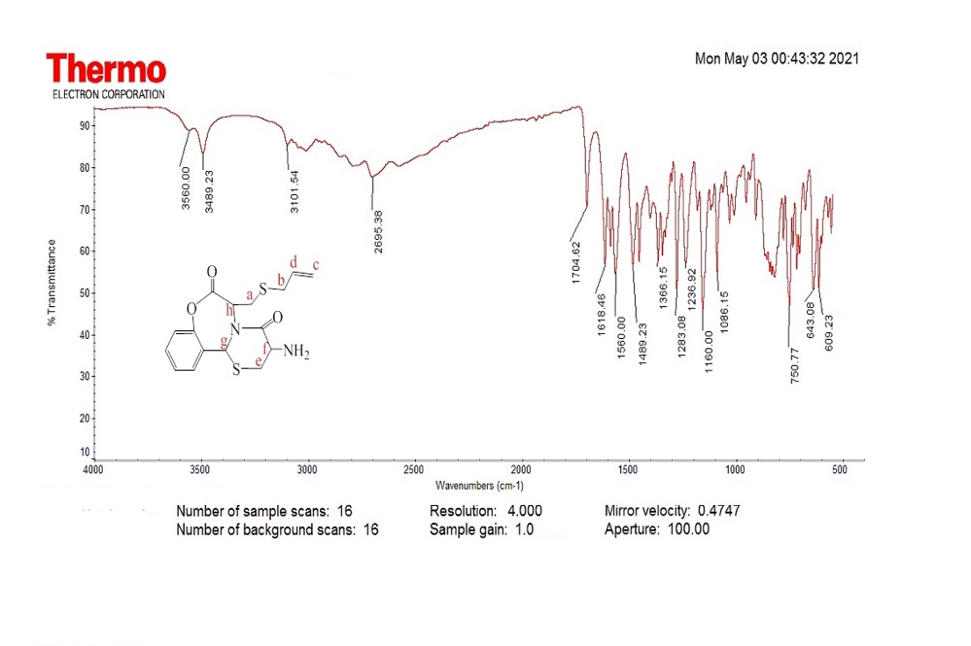
Fig. 1 The main FT-IR Spectrum of synthesized lactozepine
Fig. 2 The main ¹H-NMR Spectrum of synthesized lactozepine

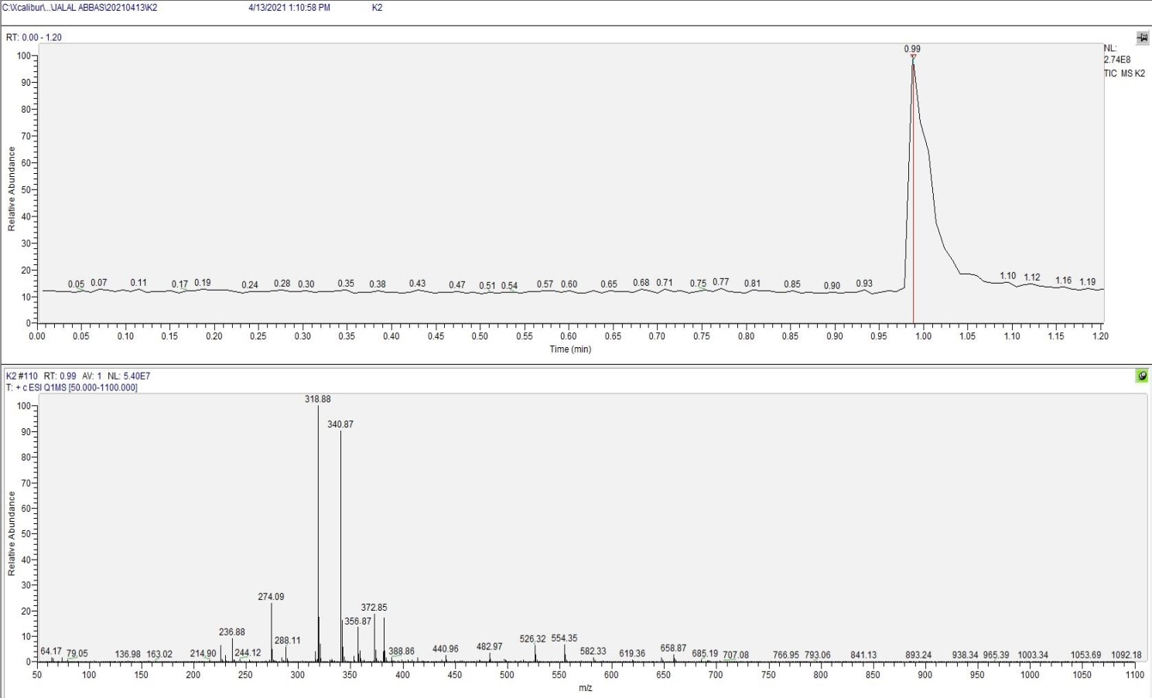
Fig. 3 Lc-mass fragments spectra of synthesized lactozepine

Table 1. The expanded spectrums for the main ¹H-NMR Spectrum of synthesized lactozepine

Table 2. LC-mass fragments of synthesized lactozepine and their m/z values.
Mass/Charge  (m/z) | The synthesized compound and its  Fragments
554.35 | C₂₆H₂₇N₄O₆S₂^{+•}
526.32 | C₂₄H₂₄N₄O₄S₃^{+•}
482.92 | C₂₃H₂₂N₄O₄S₂^{+•}
372.85 | C₂₀H₁₆NO₄S^{+•}
356.87 | C₁₆H₁₈N₂O₃S₂ (Synthesized Lactozepine)
340.87 | C₁₅H₁₆N₂O₃S₂^{+•}
318.88 | C₁₅H₁₄NO₃S₂^{+•}
288.11 | C₁₃H₁₁NO₃S₂^{+•}
274.09 | C₁₀H₁₂N₂O₃S₂^{+•}
236.88 | C₁₁H₁₁N₂O₂S^{+•}

