Supplementary Materials: Flexible control of vocal timing in bats enables escape from acoustic interference

Ava Kiai¹*, Jan Clemens², Manfred Kössl¹, David Poeppel^{3,4}, Julio Hechavarría¹*

Corresponding authors: ava.kiai@stud.uni-frankfurt.de, hechavarria@bio.uni-frankfurt.de

The file includes:
Figs. S1 to S7
Tables S1 to S17

Supplementary Figures

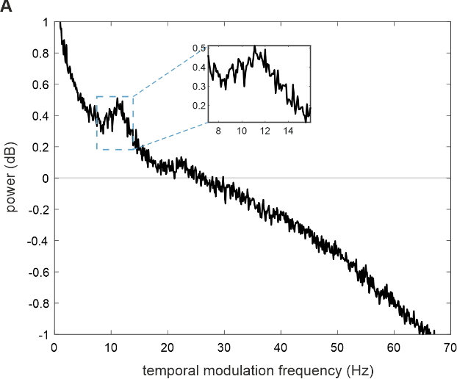

Fig. S1.
Temporal modulation rate of spontaneous vocalizations in C. perspicillata colony is ~ 11 Hz. (A) Audio recordings made in our colony of Carollia bats (160 minutes total) were highpass filtered (10 kHz) before amplitude envelopes were extracted via the secant method (interpolation over every 5,000 points). The power spectrum density (PSD) of the envelope was computed for each audio segment (10 s each) and averaged across segments. A “control” PSD was computed by randomly permuting sections of the amplitude envelopes in each segment and averaging the permuted-segment PSDs. The “control” PSD was subtracted from original average PSD to produce a power spectrum normalized for ambient noise/power in the signal. The peak of this power spectrum was at ~ 11 Hz (inset), indicating the temporal modulation rate of spontaneous calling in the colony.

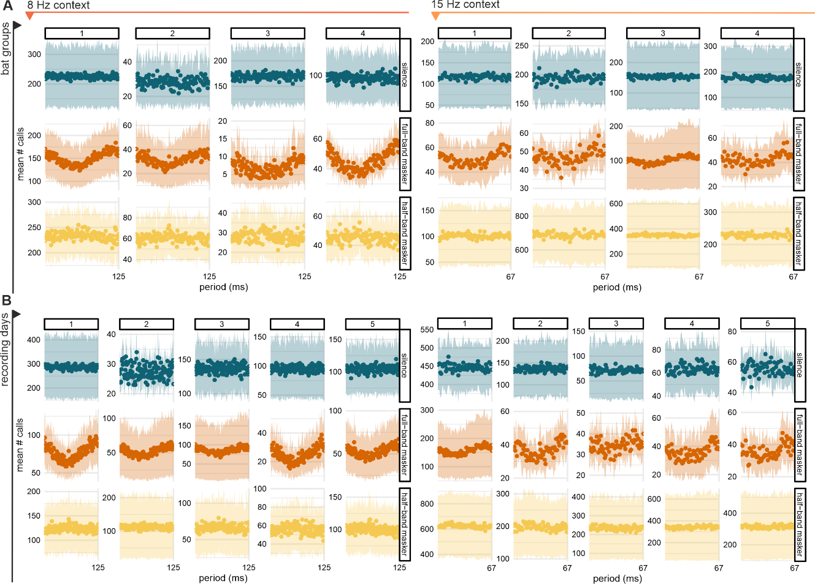

Fig. S2.
Experiment 1: Anti-phase calling is present in all groups and all recording days.

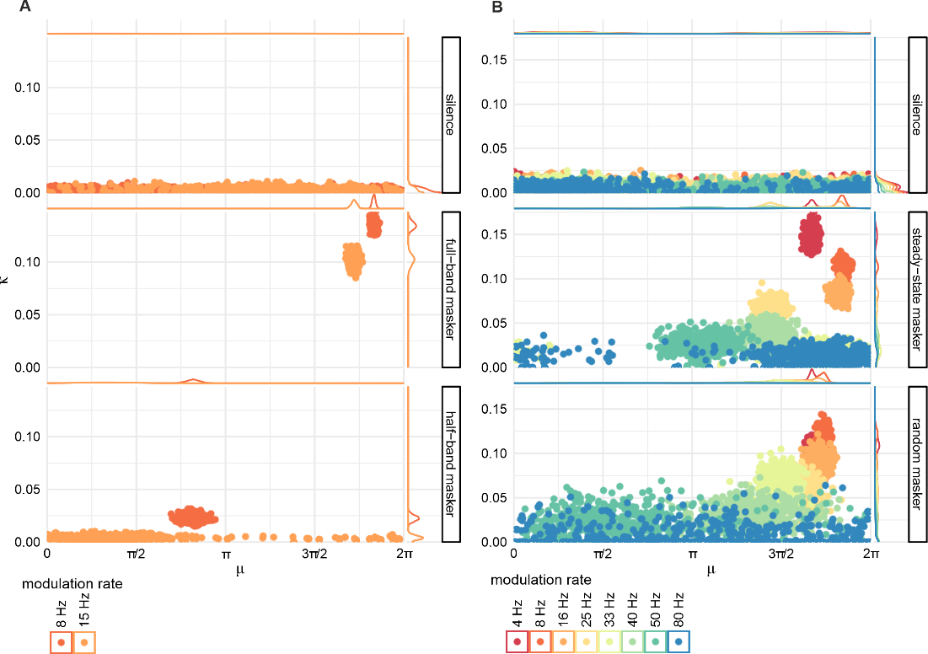

Fig. S3.
Bootstrapped von Mises parameters mean (μ) and concentration (κ) in the cartesian plane. (A) Parameters from experiment 1 data. (B) Parameters from experiment 2 data.

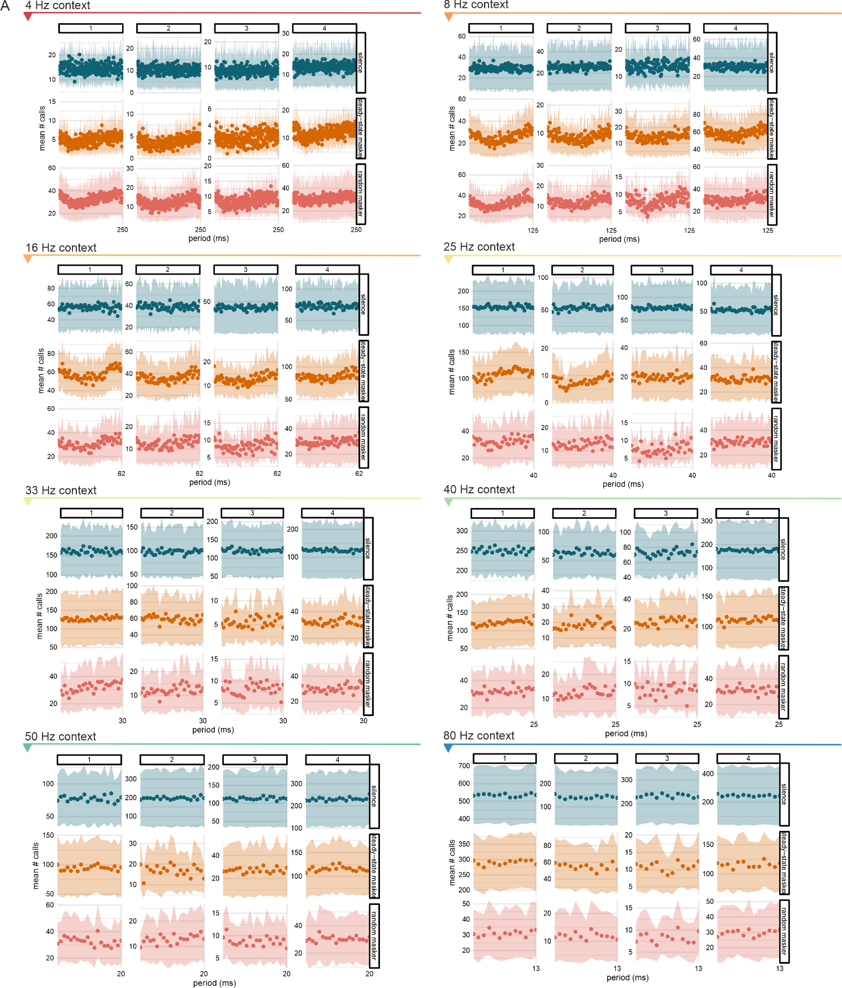

Fig. S4.
Experiment 2: Anti-phase calling is present in all groups for modulation rate conditions 4, 8 and 16. 25 Hz context reveals a slight modulation in calling pattern for some groups between the two masking conditions.
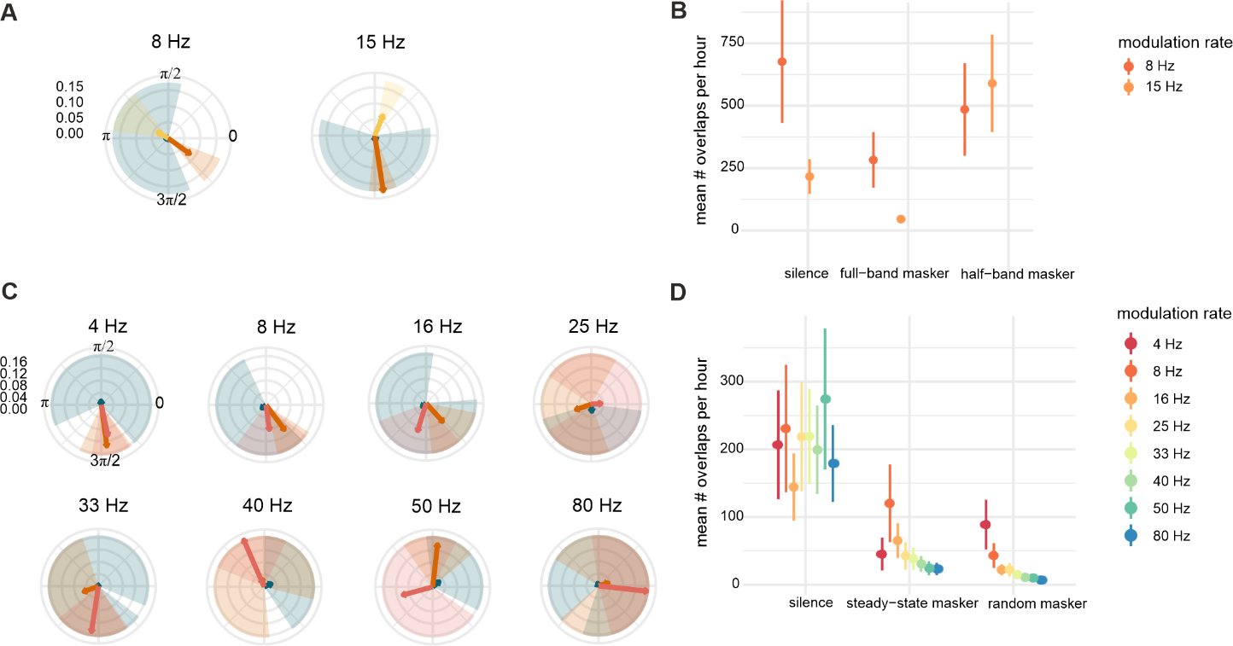

Fig. S5.
Temporal overlap between calls is reduced in the presence of noise. (A) Angular vectors indicate angular mean and concentration for overlapping calls. Shaded segments indicate 95% confidence intervals for angular means. Significant clustering is seen in the 8Hz full-band and 15Hz half-band masking condition. (B) For experiment 1, mean number of overlapping calls observed per hour are reduced in broadband masking noise compared to baseline. (C) For experiment 2, overlapping calls are significantly clustered only at 8 and 16Hz in the steady-state condition. (D) For experiment 2, mean overlapping calls dropped significantly between silent baseline and masking conditions for all modulation rates except 4 Hz.

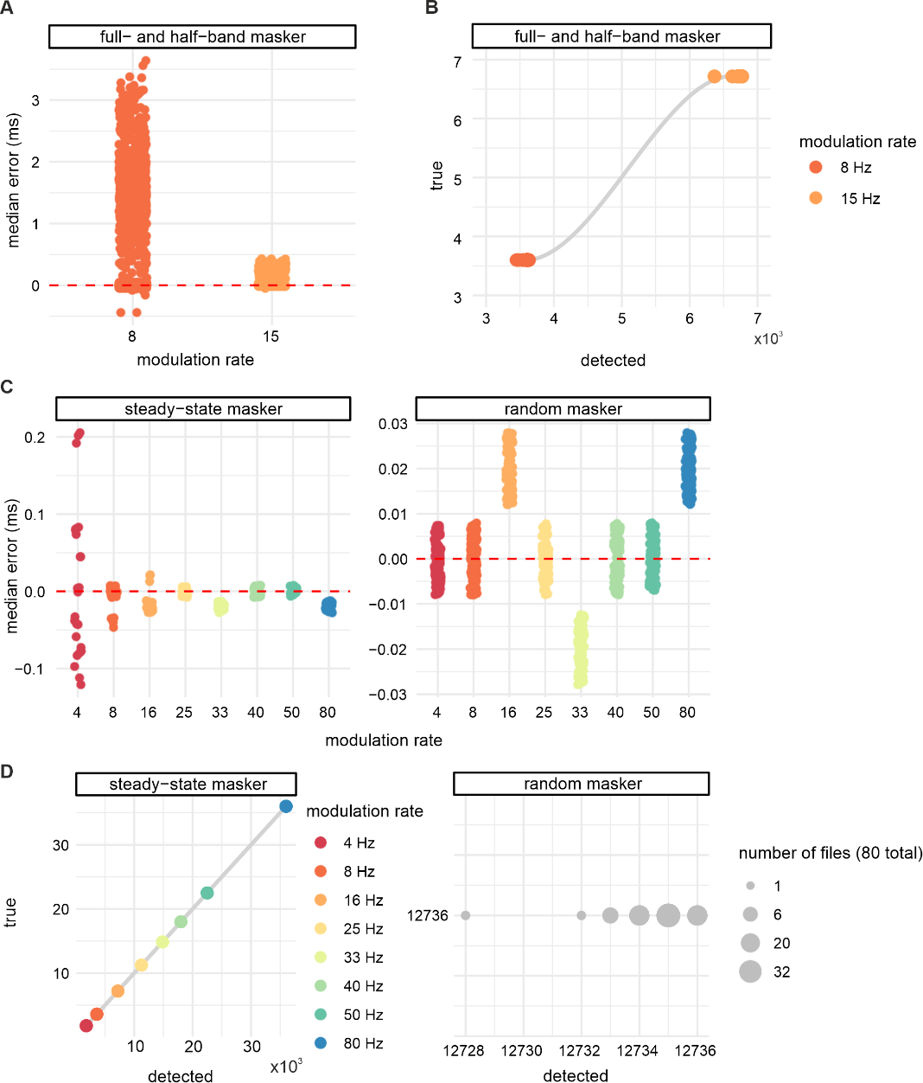

Fig. S6.
Temporal and cycle-wise accuracy of instantaneous phase models. (A) For experiment 1, the median deviation error between expected modulation periods (1/f) and derived periods in the instantaneous phase model for all cycles across the entire data set. Errors were mostly between 0 and 3 ms for both modulation rate contexts. (B) For experiment 1, the number of true cycles in each one-hour recording block vs. the number of detected cycles in the instantaneous phase model. On average, 5 more cycles were detected in recording blocks in the 8Hz context, and 19 fewer cycles were detected in the 15Hz contexts. (C) For experiment 2, median deviation error between expected and derived periods for each modulation rate were less than ±0.3 ms for all rates in both masking conditions. (D) For experiment 2, true vs. detected number of cycles were almost perfectly matched for the steady-state condition. On average, detected cycles were ± 2 cycles from expected values (estimated per 7.5 minute block). For the random condition, true vs. detected cycles were calculated irrespective of modulation rate, but were accurate to 0:-4 cycles per 15 minute block (file).
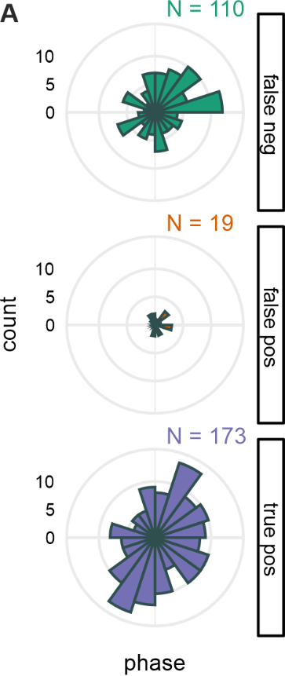

Fig. S7.
DAS-predicted call events by class, as a function of call onset phase. Phase tagging of detected call events from a representative test set (experiment 2: random masker) showed that DAS is not strongly biased to detect calls at particular phases in the amplitude modulation cycle.

Supplementary Tables

Table S1.
Estimated proportion of echolocation to communication calls. A total of 2,673 calls were classified as echolocation or communication calls by visual inspection of spectrograms from all four masking conditions used in both experiments (spectrogram segments sampled from randomly selected groups and files). A weighed average of the proportion of echolocation pulses to communication calls (weighted by the total duration of audio data inspected for each condition) was then computed.

Playback Condition
 | Silence | Full-band masker/Steady-state masker | Half-band masker | Random masker
Total duration scanned (s) | 180 | 240 | 90 | 90
Condition-wise mean prop. echo | 0.79 | 0.96 | 0.94 | 0.78
Weighted mean prop. echo | 0.88

Table S2.
Experiment 1: Circular statistics for call onsets with respect to the amplitude modulation cycle
Circular Statistics
 |  | Summary Statistics |  |  |  |  | Rayleigh's Test |  |  |  | MLE von Mises
modulation | condition | n | $$\overline{θ}$$ | $$\overline{r}$$ | Vm | sd |  | R | p | P_{Bonferroni} |  | $$μ_{MLE}$$ | CI_{lo} | CI_{hi} | $$κ_{MLE}$$
8Hz | silence | 325,333 | 0.738 | 0.001 | 0.999 | 3.722 |  | 0.001 | 0.279 | 1 |  | 0.738 | 4.534 | 4.327 | 0.002
8Hz | full-band masker | 146,187 | 5.752 | 0.067 | 0.933 | 2.324 |  | 0.058 | 0.000 | <0.001 |  | 5.752 | 5.698 | 5.808 | 0.135
8Hz | half-band masker | 229,311 | 2.579 | 0.012 | 0.989 | 2.989 |  | -0.010 | 1.000 | 1 |  | 2.579 | 2.295 | 2.836 | 0.023
15Hz | silence | 202,822 | 3.933 | 0.001 | 0.999 | 3.661 |  | -0.001 | 0.709 | 1 |  | 3.933 | 1.962 | 0.506 | 0.002
15Hz | full-band masker | 78,197 | 5.403 | 0.051 | 0.949 | 2.442 |  | 0.032 | 0.000 | <0.001 |  | 5.403 | 5.306 | 5.504 | 0.102
15Hz | half-band masker | 443,217 | 1.042 | 0.002 | 0.998 | 3.524 |  | 0.001 | 0.170 | 1 |  | 1.042 | 6.003 | 2.560 | 0.004
N = number of observations. $\overline{θ}$ = Mean resultant direction. $\overline{r}$ = Mean resultant length. Vm = circular variance. sd = circular standard deviation. R = test statistics for Rayleigh’s test of uniformity. p = p value. P_{Bonferroni} = Bonferroni corrected p-values for the family of all tests in the table. $μ_{MLE}$ = Mean parameter estimated from the maximum likelihood von Mises distribution. CI_{lo}, CI_{hi} = Boostrapped upper and lower thresholds for the 95% confidence interval for the MLE mean parameter. $κ_{MLE}$ = Concentration parameter estimated from the MLE von Mises distribution.

Table S3.
Experiment 1: Rao’s test for differences in angular means or dispersions in distributions of call onsets between playback conditions
Rao test for homogeneity of angular means & dispersions within mod rates
modulation | condition | test | statistic | df | p | P_{Bonferroni}
8Hz | Omnibus | polar vectors | 0.477 | 2 | 0.788 | 1.000
8Hz | Omnibus | dispersions | 346.680 | 2 | 0.000 | <0.001
15Hz | Omnibus | polar vectors | 2.708 | 2 | 0.258 | 0.516
15Hz | Omnibus | dispersions | 100.345 | 2 | 0.000 | <0.001
8Hz | silence vs. Full-band masker | polar vectors | 0.422 | 1 | 0.516 | 1.00
8Hz | silence vs. Full-band masker | dispersions | 332.013 | 1 | 0.000 | <0.001
8Hz | silence vs. Half-band masker | polar vectors | 0.444 | 1 | 0.505 | 1.00
8Hz | silence vs. Half-band masker | dispersions | 14.766 | 1 | 0.000 | <0.001
8Hz | full-band masker vs. Half-band masker | polar vectors | 0.054 | 1 | 0.817 | 1.00
8Hz | full-band masker vs. Half-band masker | dispersions | 307.346 | 1 | 0.000 | <0.001
15Hz | silence vs. Full-band masker | polar vectors | 0.739 | 1 | 0.390 | 0.78
15Hz | silence vs. Full-band masker | dispersions | 100.231 | 1 | 0.000 | <0.001
15Hz | silence vs. Half-band masker | polar vectors | 0.045 | 1 | 0.832 | 1.00
15Hz | silence vs. Half-band masker | dispersions | 0.193 | 1 | 0.660 | 1.00
15Hz | full-band masker vs. Half-band masker | polar vectors | 1.975 | 1 | 0.160 | 0.32
15Hz | full-band masker vs. Half-band masker | dispersions | 100.029 | 1 | 0.000 | <0.001

Table S4.
Experiment 1: Negative binomial model results for calls emitted both modulation rate contexts

Observed calls per hour in 8Hz modulated noise
Predictors | Incidence Rate Ratios | CI | p
(Intercept) | 16266.65 | 10048.04 – 28874.24 | <0.001
condition [full-band  masker] | 0.45 | 0.21 – 0.95 | 0.034
condition [half-band  masker] | 0.70 | 0.33 – 1.49 | 0.355
Observations | 60
R² Nagelkerke | 0.097
Deviance | 72.505
AIC | 1239.835

Observed calls per hour in 15Hz modulated noise
Predictors | Incidence Rate Ratios | CI | p
(Intercept) | 10674.84 | 6729.32 – 18413.99 | <0.001
condition [full-band  masker] | 0.39 | 0.19 – 0.79 | 0.008
condition [half-band  masker] | 2.19 | 1.07 – 4.46 | 0.030
Observations | 57
R² Nagelkerke | 0.395
Deviance | 67.547
AIC | 1171.104
Note that the p-values in the table above are not Bonferroni corrected, as they represent p-values for model coefficients.

Table S5.
Experiment 1: Incidence rate ratios derived from negative binomial models
Incidence Rate Ratios
modulation | coefficient | Estimate | 2.5 % | 97.5 %
8Hz | (Intercept) | 16266.65 | 10048.04 | 28874.24
8Hz | full-band masker | 0.45 | 0.21 | 0.95
8Hz | half-band masker | 0.70 | 0.33 | 1.49
15Hz | (Intercept) | 10674.84 | 6729.32 | 18413.99
15Hz | full-band masker | 0.39 | 0.19 | 0.79
15Hz | half-band masker | 2.19 | 1.07 | 4.46

Table S6.
Experiment 1: ANOVA Analysis of variance for the predictor of playback condition for each modulation rate model, separately.
 |  | Type II Analysis of Deviance
model | predictor |  | LR Chi-square | df | p
8Hz | condition |  | 4.37 | 2 | 0.11
15Hz | condition |  | 21.34 | 2 | <0.001

Table S7.
Experiment 2: Estimated marginal means of call incidence rates per condition
Estimated Marginal Means
modulation | contrast | IRR | se | CI_{lo} | CI_{hi} | Z ratio | p
8Hz | silence / (full-band masker) | 2.22 | 0.84 | 0.90 | 5.50 | 2.12 | 0.10
8Hz | silence / (half-band masker) | 1.42 | 0.54 | 0.57 | 3.51 | 0.92 | 1.00
8Hz | (full-band masker) / (half-band masker) | 0.64 | 0.24 | 0.26 | 1.58 | -1.19 | 0.70
15Hz | silence / (full-band masker) | 2.59 | 0.94 | 1.09 | 6.15 | 2.64 | 0.03
15Hz | silence / (half-band masker) | 0.46 | 0.16 | 0.19 | 1.08 | -2.17 | 0.09
15Hz | (full-band masker) / (half-band masker) | 0.18 | 0.06 | 0.07 | 0.42 | -4.81 | <0.001
IRR = Incidence rate ratios.

Table S8.
Experiment 2: Circular statistics for call onsets with respect to the amplitude modulation cycle
Circular Statistics
 |  | Summary Statistics |  |  |  | Rayleigh's Test |  |  |  | MLE von Mises
modulation | condition | n | $$\overline{θ}$$ | $$\overline{r}$$ | Vm | sd | R | p | P_{Bonferroni} | $$μ_{MLE}$$ | CI_{lo} | CI_{hi} | $$κ_{MLE}$$
4Hz | silence | 59,635 | 6.203 | 0.003 | 0.997 | 3.388 | 0.003 | 0.134 | 1 | 6.203 | 4.212 | 3.124 | 0.006
4Hz | steady-state masker | 28,938 | 5.246 | 0.074 | 0.926 | 2.282 | 0.038 | 0.000 | <0.001 | 5.246 | 5.140 | 5.358 | 0.148
4Hz | random masker | 105,990 | 5.245 | 0.054 | 0.946 | 2.416 | 0.027 | 0.000 | <0.001 | 5.245 | 5.170 | 5.319 | 0.108
8Hz | silence | 62,203 | 5.480 | 0.002 | 0.998 | 3.462 | 0.002 | 0.270 | 1 | 5.480 | 3.523 | 2.293 | 0.005
8Hz | steady-state masker | 65,446 | 5.795 | 0.057 | 0.943 | 2.395 | 0.050 | 0.000 | <0.001 | 5.795 | 5.702 | 5.891 | 0.114
8Hz | random masker | 51,939 | 5.459 | 0.061 | 0.939 | 2.366 | 0.041 | 0.000 | <0.001 | 5.459 | 5.356 | 5.554 | 0.122
16Hz | silence | 65,769 | 0.858 | 0.003 | 0.997 | 3.376 | 0.002 | 0.213 | 1 | 0.858 | 5.075 | 3.812 | 0.007
16Hz | steady-state masker | 60,482 | 5.732 | 0.042 | 0.958 | 2.520 | 0.036 | 0.000 | <0.001 | 5.732 | 5.603 | 5.871 | 0.084
16Hz | random masker | 25,543 | 5.376 | 0.046 | 0.955 | 2.486 | 0.028 | 0.000 | <0.001 | 5.376 | 5.178 | 5.575 | 0.091
25Hz | silence | 67,403 | 4.819 | 0.003 | 0.997 | 3.373 | 0.000 | 0.448 | 1 | 4.819 | 2.541 | 0.274 | 0.007
25Hz | steady-state masker | 32,743 | 4.535 | 0.032 | 0.968 | 2.618 | -0.006 | 0.928 | 1 | 4.535 | 4.299 | 4.766 | 0.065
25Hz | random masker | 16,600 | 5.056 | 0.027 | 0.973 | 2.689 | 0.009 | 0.050 | 1 | 5.056 | 4.653 | 5.478 | 0.054
33Hz | silence | 78,179 | 0.895 | 0.004 | 0.996 | 3.313 | 0.003 | 0.153 | 1 | 0.895 | 5.646 | 2.632 | 0.008
33Hz | steady-state masker | 34,843 | 5.359 | 0.008 | 0.992 | 3.093 | 0.005 | 0.092 | 1 | 5.359 | 4.466 | 0.165 | 0.017
33Hz | random masker | 12,830 | 4.688 | 0.034 | 0.966 | 2.599 | -0.001 | 0.552 | 1 | 4.688 | 4.358 | 5.069 | 0.068
40Hz | silence | 68,797 | 0.196 | 0.001 | 0.999 | 3.668 | 0.001 | 0.331 | 1 | 0.196 | 4.283 | 2.335 | 0.002
40Hz | steady-state masker | 34,176 | 4.486 | 0.020 | 0.980 | 2.801 | -0.004 | 0.877 | 1 | 4.486 | 4.063 | 4.874 | 0.040
40Hz | random masker | 10,531 | 4.241 | 0.015 | 0.985 | 2.891 | -0.007 | 0.844 | 1 | 4.241 | 3.404 | 5.347 | 0.031
50Hz | silence | 61,956 | 5.052 | 0.002 | 0.998 | 3.564 | 0.001 | 0.419 | 1 | 5.052 | 2.940 | 1.454 | 0.004
50Hz | steady-state masker | 25,425 | 3.302 | 0.013 | 0.987 | 2.937 | -0.013 | 0.999 | 1 | 3.302 | 2.584 | 4.017 | 0.027
50Hz | random masker | 8,487 | 1.776 | 0.009 | 0.991 | 3.055 | -0.002 | 0.599 | 1 | 1.776 | 5.797 | 3.788 | 0.019
80Hz | silence | 75,144 | 0.679 | 0.002 | 0.998 | 3.457 | 0.002 | 0.221 | 1 | 0.679 | 4.565 | 3.322 | 0.005
80Hz | steady-state masker | 30,675 | 5.427 | 0.007 | 0.993 | 3.166 | 0.004 | 0.139 | 1 | 5.427 | 3.897 | 0.352 | 0.013
80Hz | random masker | 5,260 | 4.324 | 0.002 | 0.998 | 3.561 | -0.001 | 0.527 | 1 | 4.324 | 1.952 | 2.322 | 0.004

Table S9.
Experiment 2: Watson-Wheeler tests for the circular homogeneity of distributions of call onsets
Watson-Wheeler test for homogeneity of groups (within modulation rates)
modulation | statistic | p | P_{Bonferroni}
4Hz | 281.693 | <0.001 | <0.001
8Hz | 273.637 | <0.001 | <0.001
16Hz | 143.040 | <0.001 | <0.001
25Hz | 45.416 | <0.001 | <0.001
33Hz | 32.695 | <0.001 | <0.001
40Hz | 20.606 | <0.001 | <0.001
50Hz | 8.775 | 0.067 | 0.536
80Hz | 2.286 | 0.683 | 1.000

Table S10.
Experiment 2: Rao’s test for differences in angular means or dispersions between playback conditions Omnibus tests were carried out for each modulation rate to test if differences existed between the three playback conditions. For all tests with significant differences in either polar vectors or polar dispersions, post-hoc tests were computed on pairs of playback conditions.
Rao test for homogeneity of angular means & dispersions
modulation | condition | test | statistic | df | p | P_{Bonferroni}
4Hz | Omnibus | polar vectors | 3.110 | 2 | 0.211 | 0.422
4Hz | Omnibus | dispersions | 232.370 | 2 | <0.001 | <0.001
8Hz | Omnibus | polar vectors | 18.883 | 2 | <0.001 | <0.001
8Hz | Omnibus | dispersions | 199.932 | 2 | <0.001 | <0.001
16Hz | Omnibus | polar vectors | 6.895 | 2 | 0.032 | 0.064
16Hz | Omnibus | dispersions | 77.400 | 2 | <0.001 | <0.001
25Hz | Omnibus | polar vectors | 3.853 | 2 | 0.146 | 0.292
25Hz | Omnibus | dispersions | 22.588 | 2 | <0.001 | <0.001
33Hz | Omnibus | polar vectors | 1.668 | 2 | 0.434 | 0.868
33Hz | Omnibus | dispersions | 7.870 | 2 | 0.020 | 0.040
40Hz | Omnibus | polar vectors | 0.897 | 2 | 0.639 | 1.000
40Hz | Omnibus | dispersions | 7.848 | 2 | 0.020 | 0.040
50Hz | Omnibus | polar vectors | 0.106 | 2 | 0.948 | 1.000
50Hz | Omnibus | dispersions | 2.521 | 2 | 0.284 | 0.568
80Hz | Omnibus | polar vectors | 0.806 | 2 | 0.668 | 1.000
80Hz | Omnibus | dispersions | 0.492 | 2 | 0.782 | 1.000
4Hz | silence vs. steady-state masker | polar vectors | 2.985 | 1 | 0.084 | 0.168
4Hz | silence vs. steady-state masker | dispersions | 79.850 | 1 | 0.000 | 0.000
4Hz | silence vs. random masker | polar vectors | 3.087 | 1 | 0.079 | 0.158
4Hz | silence vs. random masker | dispersions | 153.051 | 1 | 0.000 | 0.000
4Hz | steady-state masker vs. random masker | polar vectors | 0.000 | 1 | 0.983 | 1.000
4Hz | steady-state masker vs. random masker | dispersions | 15.231 | 1 | 0.000 | 0.000
8Hz | silence vs. steady-state masker | polar vectors | 0.046 | 1 | 0.830 | 1.000
8Hz | silence vs. steady-state masker | dispersions | 104.750 | 1 | 0.000 | 0.000
8Hz | silence vs. random masker | polar vectors | 0.000 | 1 | 0.985 | 1.000
8Hz | silence vs. random masker | dispersions | 95.520 | 1 | 0.000 | 0.000
8Hz | steady-state masker vs. random masker | polar vectors | 18.858 | 1 | 0.000 | 0.000
8Hz | steady-state masker vs. random masker | dispersions | 0.944 | 1 | 0.331 | 0.662
8Hz | silence vs. steady-state masker | polar vectors | 0.046 | 1 | 0.830 | 1.000
8Hz | silence vs. steady-state masker | dispersions | 104.750 | 1 | 0.000 | 0.000
8Hz | silence vs. random masker | polar vectors | 0.000 | 1 | 0.985 | 1.000
8Hz | silence vs. random masker | dispersions | 95.520 | 1 | 0.000 | 0.000
8Hz | steady-state masker vs. random masker | polar vectors | 18.858 | 1 | 0.000 | 0.000
8Hz | steady-state masker vs. random masker | dispersions | 0.944 | 1 | 0.331 | 0.662

Table S11.
Experiment 2: Incidence rate ratios derived from negative binomial models
Incidence Rate Ratios
modulation | coefficient | Estimate | 2.5 % | 97.5 %
4Hz | (Intercept) | 2981.75 | 1675.19 | 6085.74
4Hz | steady-state masker | 0.49 | 0.19 | 1.21
4Hz | random masker | 1.78 | 0.71 | 4.45
8Hz | (Intercept) | 3110.15 | 1655.22 | 6909.31
8Hz | steady-state masker | 1.11 | 0.40 | 3.12
8Hz | random masker | 0.83 | 0.30 | 2.31
16Hz | (Intercept) | 3288.45 | 1895.48 | 6456.38
16Hz | steady-state masker | 0.92 | 0.38 | 2.20
16Hz | random masker | 0.39 | 0.16 | 0.93
25Hz | (Intercept) | 3370.15 | 1815.43 | 7344.02
25Hz | steady-state masker | 0.51 | 0.19 | 1.41
25Hz | random masker | 0.25 | 0.09 | 0.67
33Hz | (Intercept) | 3908.95 | 2136.58 | 8324.83
33Hz | steady-state masker | 0.45 | 0.17 | 1.17
33Hz | random masker | 0.16 | 0.06 | 0.43
40Hz | (Intercept) | 3620.89 | 2003.11 | 7568.02
40Hz | steady-state masker | 0.50 | 0.19 | 1.28
40Hz | random masker | 0.15 | 0.06 | 0.37
50Hz | (Intercept) | 3097.80 | 1667.09 | 6760.91
50Hz | steady-state masker | 0.41 | 0.15 | 1.11
50Hz | random masker | 0.14 | 0.05 | 0.37
80Hz | (Intercept) | 3757.20 | 2122.84 | 7602.55
80Hz | steady-state masker | 0.41 | 0.16 | 1.01
80Hz | random masker | 0.07 | 0.03 | 0.17

Table S12.
Experiment 2: ANOVA. Analysis of variance for the predictor of playback condition for each negative binomial model, separately.
Type II Analysis of Deviance
model | predictor | LR Chi-square | df | p
4Hz | condition | 7.55 | 2 | 0.02
8Hz | condition | 0.31 | 2 | 0.86
16Hz | condition | 5.07 | 2 | 0.08
25Hz | condition | 7.55 | 2 | 0.02
33Hz | condition | 12.74 | 2 | <0.001
40Hz | condition | 15.16 | 2 | <0.001
50Hz | condition | 14.36 | 2 | <0.001
80Hz | condition | 27.63 | 2 | <0.001

Table S13.
Experiment 2: Estimated marginal means for incidence rates of calling
Estimated Marginal Means
modulation | contrast | IRR |  | se |  | CI_{lo} |  | CI_{hi} |  | Z ratio |  | p
4Hz | silence / (steady-state masker) | 2.06 | 0.95 |  | 0.69 |  | 6.20 |  | 1.57 |  | 0.35
4Hz | silence / random masker | 0.56 | 0.26 |  | 0.19 |  | 1.69 |  | -1.25 |  | 0.63
4Hz | (steady-state masker) / random masker | 0.27 | 0.13 |  | 0.09 |  | 0.82 |  | -2.82 |  | 0.01
8Hz | silence / (steady-state masker) | 0.90 | 0.47 |  | 0.26 |  | 3.10 |  | -0.20 |  | 1.00
8Hz | silence / random masker | 1.20 | 0.61 |  | 0.36 |  | 4.04 |  | 0.36 |  | 1.00
8Hz | (steady-state masker) / random masker | 1.33 | 0.68 |  | 0.39 |  | 4.55 |  | 0.55 |  | 1.00
16Hz | silence / (steady-state masker) | 1.09 | 0.48 |  | 0.38 |  | 3.10 |  | 0.19 |  | 1.00
16Hz | silence / random masker | 2.58 | 1.13 |  | 0.90 |  | 7.34 |  | 2.16 |  | 0.09
16Hz | (steady-state masker) / random masker | 2.37 | 1.04 |  | 0.83 |  | 6.75 |  | 1.97 |  | 0.15
25Hz | silence / (steady-state masker) | 1.96 | 0.99 |  | 0.58 |  | 6.54 |  | 1.33 |  | 0.55
25Hz | silence / random masker | 4.06 | 2.02 |  | 1.23 |  | 13.36 |  | 2.82 |  | 0.01
25Hz | (steady-state masker) / random masker | 2.08 | 1.05 |  | 0.62 |  | 6.94 |  | 1.45 |  | 0.44
33Hz | silence / (steady-state masker) | 2.24 | 1.09 |  | 0.70 |  | 7.16 |  | 1.67 |  | 0.29
33Hz | silence / random masker | 6.09 | 2.95 |  | 1.91 |  | 19.44 |  | 3.73 |  | <0.001
33Hz | (steady-state masker) / random masker | 2.72 | 1.32 |  | 0.85 |  | 8.66 |  | 2.06 |  | 0.12
40Hz | silence / (steady-state masker) | 2.01 | 0.95 |  | 0.65 |  | 6.26 |  | 1.48 |  | 0.42
40Hz | silence / random masker | 6.88 | 3.22 |  | 2.24 |  | 21.08 |  | 4.12 |  | <0.001
40Hz | (steady-state masker) / random masker | 3.42 | 1.60 |  | 1.11 |  | 10.47 |  | 2.62 |  | 0.03
50Hz | silence / (steady-state masker) | 2.44 | 1.22 |  | 0.74 |  | 8.04 |  | 1.79 |  | 0.22
50Hz | silence / random masker | 7.30 | 3.64 |  | 2.21 |  | 24.08 |  | 3.99 |  | <0.001
50Hz | (steady-state masker) / random masker | 3.00 | 1.49 |  | 0.91 |  | 9.88 |  | 2.20 |  | 0.08
80Hz | silence / (steady-state masker) | 2.45 | 1.11 |  | 0.82 |  | 7.28 |  | 1.97 |  | 0.15
80Hz | silence / random masker | 14.29 | 6.50 |  | 4.80 |  | 42.50 |  | 5.84 |  | <0.001
80Hz | (steady-state masker) / random masker | 5.83 | 2.66 |  | 1.96 |  | 17.35 |  | 3.87 |  | <0.001

Table S14.
Experiment 2: Estimated marginal means across modulation rates
Estimated Marginal Means
modulation | contrast | IRR | se | CI_{lo} | CI_{hi} | Z ratio | p
silence | 4Hz / 8Hz | 0.96 | 0.47 | 0.20 | 4.49 | -0.09 | 1.00
silence | 4Hz / 16Hz | 0.91 | 0.45 | 0.19 | 4.24 | -0.20 | 1.00
silence | 4Hz / 25Hz | 0.88 | 0.44 | 0.19 | 4.14 | -0.25 | 1.00
silence | 4Hz / 33Hz | 0.76 | 0.38 | 0.16 | 3.57 | -0.55 | 1.00
silence | 4Hz / 40Hz | 0.82 | 0.41 | 0.17 | 3.93 | -0.39 | 1.00
silence | 4Hz / 50Hz | 0.96 | 0.48 | 0.21 | 4.50 | -0.08 | 1.00
silence | 4Hz / 80Hz | 0.79 | 0.39 | 0.17 | 3.71 | -0.47 | 1.00
silence | 8Hz / 16Hz | 0.95 | 0.47 | 0.20 | 4.43 | -0.11 | 1.00
silence | 8Hz / 25Hz | 0.92 | 0.46 | 0.20 | 4.32 | -0.16 | 1.00
silence | 8Hz / 33Hz | 0.80 | 0.39 | 0.17 | 3.72 | -0.46 | 1.00
silence | 8Hz / 40Hz | 0.86 | 0.43 | 0.18 | 4.10 | -0.30 | 1.00
silence | 8Hz / 50Hz | 1.00 | 0.50 | 0.22 | 4.70 | 0.01 | 1.00
silence | 8Hz / 80Hz | 0.83 | 0.41 | 0.18 | 3.87 | -0.38 | 1.00
silence | 16Hz / 25Hz | 0.98 | 0.48 | 0.21 | 4.57 | -0.05 | 1.00
silence | 16Hz / 33Hz | 0.84 | 0.42 | 0.18 | 3.94 | -0.35 | 1.00
silence | 16Hz / 40Hz | 0.91 | 0.46 | 0.19 | 4.34 | -0.19 | 1.00
silence | 16Hz / 50Hz | 1.06 | 0.52 | 0.23 | 4.97 | 0.12 | 1.00
silence | 16Hz / 80Hz | 0.88 | 0.43 | 0.19 | 4.10 | -0.27 | 1.00
silence | 25Hz / 33Hz | 0.86 | 0.43 | 0.18 | 4.04 | -0.30 | 1.00
silence | 25Hz / 40Hz | 0.93 | 0.47 | 0.20 | 4.44 | -0.14 | 1.00
silence | 25Hz / 50Hz | 1.09 | 0.54 | 0.23 | 5.09 | 0.17 | 1.00
silence | 25Hz / 80Hz | 0.90 | 0.44 | 0.19 | 4.20 | -0.22 | 1.00
silence | 33Hz / 40Hz | 1.08 | 0.54 | 0.23 | 5.16 | 0.15 | 1.00
silence | 33Hz / 50Hz | 1.26 | 0.62 | 0.27 | 5.90 | 0.47 | 1.00
silence | 33Hz / 80Hz | 1.04 | 0.51 | 0.22 | 4.87 | 0.08 | 1.00
silence | 40Hz / 50Hz | 1.17 | 0.58 | 0.24 | 5.58 | 0.31 | 1.00
silence | 40Hz / 80Hz | 0.96 | 0.48 | 0.20 | 4.60 | -0.07 | 1.00
silence | 50Hz / 80Hz | 0.82 | 0.41 | 0.18 | 3.86 | -0.39 | 1.00
steady-state masker | 4Hz / 8Hz | 0.42 | 0.21 | 0.09 | 2.05 | -1.71 | 1.00
steady-state masker | 4Hz / 16Hz | 0.48 | 0.24 | 0.10 | 2.29 | -1.47 | 1.00
steady-state masker | 4Hz / 25Hz | 0.84 | 0.43 | 0.17 | 4.10 | -0.34 | 1.00
steady-state masker | 4Hz / 33Hz | 0.83 | 0.42 | 0.17 | 3.97 | -0.37 | 1.00
steady-state masker | 4Hz / 40Hz | 0.80 | 0.41 | 0.16 | 3.93 | -0.43 | 1.00
steady-state masker | 4Hz / 50Hz | 1.14 | 0.57 | 0.24 | 5.44 | 0.26 | 1.00
steady-state masker | 4Hz / 80Hz | 0.94 | 0.47 | 0.20 | 4.51 | -0.12 | 1.00
steady-state masker | 8Hz / 16Hz | 1.14 | 0.58 | 0.23 | 5.56 | 0.26 | 1.00
steady-state masker | 8Hz / 25Hz | 2.00 | 1.03 | 0.40 | 9.95 | 1.35 | 1.00
steady-state masker | 8Hz / 33Hz | 1.98 | 1.00 | 0.41 | 9.65 | 1.34 | 1.00
steady-state masker | 8Hz / 40Hz | 1.92 | 0.98 | 0.38 | 9.54 | 1.26 | 1.00
steady-state masker | 8Hz / 50Hz | 2.71 | 1.38 | 0.56 | 13.22 | 1.96 | 1.00
steady-state masker | 8Hz / 80Hz | 2.25 | 1.14 | 0.46 | 10.96 | 1.59 | 1.00
steady-state masker | 16Hz / 25Hz | 1.75 | 0.89 | 0.36 | 8.56 | 1.11 | 1.00
steady-state masker | 16Hz / 33Hz | 1.74 | 0.87 | 0.36 | 8.30 | 1.10 | 1.00
steady-state masker | 16Hz / 40Hz | 1.68 | 0.85 | 0.34 | 8.20 | 1.02 | 1.00
steady-state masker | 16Hz / 50Hz | 2.38 | 1.19 | 0.50 | 11.37 | 1.73 | 1.00
steady-state masker | 16Hz / 80Hz | 1.97 | 0.99 | 0.41 | 9.43 | 1.35 | 1.00
steady-state masker | 25Hz / 33Hz | 0.99 | 0.50 | 0.20 | 4.83 | -0.02 | 1.00
steady-state masker | 25Hz / 40Hz | 0.96 | 0.49 | 0.19 | 4.77 | -0.08 | 1.00
steady-state masker | 25Hz / 50Hz | 1.36 | 0.69 | 0.28 | 6.62 | 0.60 | 1.00
steady-state masker | 25Hz / 80Hz | 1.12 | 0.57 | 0.23 | 5.48 | 0.23 | 1.00
steady-state masker | 33Hz / 40Hz | 0.97 | 0.49 | 0.20 | 4.73 | -0.06 | 1.00
steady-state masker | 33Hz / 50Hz | 1.37 | 0.69 | 0.29 | 6.55 | 0.63 | 1.00
steady-state masker | 33Hz / 80Hz | 1.14 | 0.57 | 0.24 | 5.43 | 0.25 | 1.00
steady-state masker | 40Hz / 50Hz | 1.42 | 0.72 | 0.29 | 6.91 | 0.68 | 1.00
steady-state masker | 40Hz / 80Hz | 1.17 | 0.60 | 0.24 | 5.72 | 0.31 | 1.00
steady-state masker | 50Hz / 80Hz | 0.83 | 0.42 | 0.17 | 3.96 | -0.38 | 1.00
random masker | 4Hz / 8Hz | 2.04 | 0.88 | 0.53 | 7.82 | 1.66 | 1.00
random masker | 4Hz / 16Hz | 4.15 | 1.78 | 1.08 | 15.89 | 3.31 | 0.03
random masker | 4Hz / 25Hz | 6.38 | 2.74 | 1.67 | 24.46 | 4.31 | <0.001
random masker | 4Hz / 33Hz | 8.26 | 3.55 | 2.16 | 31.65 | 4.91 | <0.001
random masker | 4Hz / 40Hz | 10.06 | 4.33 | 2.63 | 38.56 | 5.37 | <0.001
random masker | 4Hz / 50Hz | 12.49 | 5.37 | 3.26 | 47.85 | 5.87 | <0.001
random masker | 4Hz / 80Hz | 20.15 | 8.67 | 5.26 | 77.22 | 6.98 | <0.001
random masker | 8Hz / 16Hz | 2.03 | 0.87 | 0.53 | 7.79 | 1.65 | 1.00
random masker | 8Hz / 25Hz | 3.13 | 1.34 | 0.82 | 11.98 | 2.65 | 0.22
random masker | 8Hz / 33Hz | 4.05 | 1.74 | 1.06 | 15.51 | 3.25 | 0.03
random masker | 8Hz / 40Hz | 4.93 | 2.12 | 1.29 | 18.90 | 3.71 | 0.01
random masker | 8Hz / 50Hz | 6.12 | 2.63 | 1.60 | 23.45 | 4.21 | <0.001
random masker | 8Hz / 80Hz | 9.87 | 4.25 | 2.58 | 37.84 | 5.32 | <0.001
random masker | 16Hz / 25Hz | 1.54 | 0.66 | 0.40 | 5.89 | 1.00 | 1.00
random masker | 16Hz / 33Hz | 1.99 | 0.86 | 0.52 | 7.63 | 1.60 | 1.00
random masker | 16Hz / 40Hz | 2.43 | 1.04 | 0.63 | 9.29 | 2.06 | 1.00
random masker | 16Hz / 50Hz | 3.01 | 1.29 | 0.78 | 11.53 | 2.56 | 0.29
random masker | 16Hz / 80Hz | 4.86 | 2.09 | 1.27 | 18.61 | 3.67 | 0.01
random masker | 25Hz / 33Hz | 1.29 | 0.56 | 0.34 | 4.96 | 0.60 | 1.00
random masker | 25Hz / 40Hz | 1.58 | 0.68 | 0.41 | 6.04 | 1.06 | 1.00
random masker | 25Hz / 50Hz | 1.96 | 0.84 | 0.51 | 7.50 | 1.56 | 1.00
random masker | 25Hz / 80Hz | 3.16 | 1.36 | 0.82 | 12.10 | 2.67 | 0.21
random masker | 33Hz / 40Hz | 1.22 | 0.52 | 0.32 | 4.67 | 0.46 | 1.00
random masker | 33Hz / 50Hz | 1.51 | 0.65 | 0.39 | 5.79 | 0.96 | 1.00
random masker | 33Hz / 80Hz | 2.44 | 1.05 | 0.64 | 9.35 | 2.07 | 1.00
random masker | 40Hz / 50Hz | 1.24 | 0.53 | 0.32 | 4.76 | 0.50 | 1.00
random masker | 40Hz / 80Hz | 2.00 | 0.86 | 0.52 | 7.68 | 1.61 | 1.00
random masker | 50Hz / 80Hz | 1.61 | 0.69 | 0.42 | 6.19 | 1.11 | 1.00

Table S15.
Number of temporally overlapping calls across both experiments in each condition
 | Silent | Full-band masker (Steady-state masker) | Half-band masker | Random masker
Experiment 1 | 17,645 | 5,627 | 19,346 | -
Experiment 2 | 24,903 | 4,093 | - | 2,946

Table S16.
Estimated marginal means for overlapping calls. Estimated marginal mean differences in call incidence rates calculated on negative binomial models for overlapping calls for each modulation rate, separately.
 | Estimated Marginal Means
experiment | modulation | contrast | IRR | se | CI_{lo} | CI_{hi} | Z ratio | p
1 | 8Hz | silence / (full-band masker) | 2.40 | 1.28 | 0.66 | 8.65 | 1.63 | 0.31
 | 8Hz | silence / (half-band masker) | 1.40 | 0.74 | 0.39 | 4.94 | 0.63 | 1.00
 | 8Hz | (full-band masker) / (half-band masker) | 0.58 | 0.32 | 0.16 | 2.17 | -0.98 | 0.98
 | 15Hz | silence / (full-band masker) | 4.73 | 2.19 | 1.56 | 14.36 | 3.35 | <0.001
 | 15Hz | silence / (half-band masker) | 0.37 | 0.17 | 0.12 | 1.11 | -2.17 | 0.09
 | 15Hz | (full-band masker) / (half-band masker) | 0.08 | 0.04 | 0.03 | 0.24 | -5.44 | <0.001
2 | 4Hz | silence / (steady-state masker) | 4.58 | 3.04 | 0.94 | 22.45 | 2.29 | 0.07
 | 4Hz | silence / random masker | 2.33 | 1.33 | 0.60 | 9.11 | 1.49 | 0.41
 | 4Hz | (steady-state masker) / random masker | 0.51 | 0.34 | 0.10 | 2.58 | -1.00 | 0.96
 | 8Hz | silence / (steady-state masker) | 1.92 | 1.21 | 0.43 | 8.65 | 1.04 | 0.90
 | 8Hz | silence / random masker | 5.36 | 3.16 | 1.31 | 21.96 | 2.85 | 0.01
 | 8Hz | (steady-state masker) / random masker | 2.79 | 1.78 | 0.60 | 12.88 | 1.61 | 0.32
 | 16Hz | silence / (steady-state masker) | 2.21 | 1.16 | 0.63 | 7.77 | 1.52 | 0.39
 | 16Hz | silence / random masker | 6.56 | 3.32 | 1.95 | 22.02 | 3.72 | 0.00
 | 16Hz | (steady-state masker) / random masker | 2.96 | 1.60 | 0.81 | 10.83 | 2.00 | 0.14
 | 25Hz | silence / (steady-state masker) | 5.14 | 3.10 | 1.21 | 21.80 | 2.71 | 0.02
 | 25Hz | silence / random masker | 9.89 | 5.80 | 2.43 | 40.26 | 3.91 | 0.00
 | 25Hz | (steady-state masker) / random masker | 1.93 | 1.27 | 0.40 | 9.37 | 0.99 | 0.96
 | 33Hz | silence / (steady-state masker) | 5.72 | 3.07 | 1.58 | 20.69 | 3.24 | 0.00
 | 33Hz | silence / random masker | 14.70 | 7.47 | 4.35 | 49.66 | 5.28 | 0.00
 | 33Hz | (steady-state masker) / random masker | 2.57 | 1.50 | 0.64 | 10.41 | 1.62 | 0.32
 | 40Hz | silence / (steady-state masker) | 6.48 | 3.29 | 1.92 | 21.87 | 3.68 | 0.00
 | 40Hz | silence / random masker | 18.39 | 9.20 | 5.55 | 60.93 | 5.82 | 0.00
 | 40Hz | (steady-state masker) / random masker | 2.84 | 1.53 | 0.78 | 10.35 | 1.93 | 0.16
 | 50Hz | silence / (steady-state masker) | 11.27 | 6.43 | 2.88 | 44.16 | 4.25 | 0.00
 | 50Hz | silence / random masker | 27.70 | 15.51 | 7.26 | 105.80 | 5.93 | 0.00
 | 50Hz | (steady-state masker) / random masker | 2.46 | 1.45 | 0.60 | 10.12 | 1.52 | 0.38
 | 80Hz | silence / (steady-state masker) | 7.69 | 3.88 | 2.30 | 25.73 | 4.04 | 0.00
 | 80Hz | silence / random masker | 26.34 | 13.56 | 7.68 | 90.35 | 6.35 | 0.00
 | 80Hz | (steady-state masker) / random masker | 3.43 | 1.94 | 0.89 | 13.24 | 2.18 | 0.09

Table S17.
Call timings relative to acoustic landmarks
Mean Call Onset Timings
 |  |  |  |  | time from peaks (ms) |  | time to trough (ms)
experiment | modulation |  | condition |  | median | iqr | median | iqr
1 | All |  | full-band masker |  | 37.7 | 27.9 | 10.1 | 1
 | 8Hz |  | full-band masker |  | 52.0 | 0.7 | 10.5 | 0.7
 | 15Hz |  | full-band masker |  | 24.1 | 0.7 | 9.6 | 0.7
2 | All |  | steady-state masker |  | 9.3 | 28.7 | 8.4 | 5.8
 | All |  | random masker |  | 9.6 | 26.5 | 9.0 | 8.4
 | 4Hz |  | steady-state masker |  | 83.7 | 2.8 | 41.3 | 2.8
 | 4Hz |  | random masker |  | 83.7 | 2.0 | 41.3 | 2.0
 | 8Hz |  | steady-state masker |  | 52.8 | 1.3 | 9.7 | 1.3
 | 8Hz |  | random masker |  | 46.1 | 1.4 | 16.4 | 1.4
 | 16Hz |  | steady-state masker |  | 25.8 | 0.9 | 5.0 | 0.9
 | 16Hz |  | random masker |  | 22.2 | 1.3 | 8.6 | 1.3
 | 25Hz |  | steady-state masker |  | 8.9 | 1.0 | 11.1 | 1.0
 | 25Hz |  | random masker |  | 12.2 | 1.7 | 7.8 | 1.7
 | 33Hz |  | steady-state masker |  | 10.5 | 2.9 | 4.3 | 2.9
 | 33Hz |  | random masker |  | 7.4 | 1.2 | 7.4 | 1.2
 | 40Hz |  | steady-state masker |  | 5.3 | 1.0 | 7.2 | 1.0
 | 40Hz |  | random masker |  | 4.4 | 2.5 | 8.1 | 2.5
 | 50Hz |  | steady-state masker |  | 0.5 | 1.4 | 9.5 | 1.4
 | 50Hz |  | random masker |  | -4.1 | 3.8 | 14.1 | 3.8
 | 80Hz |  | steady-state masker |  | 4.2 | 1.8 | 2.5 | 1.8
 | 80Hz |  | random masker |  | 0.5 | 5.8 | 6.2 | 5.8

