Supplementary Data 1:
- Planning goals and dose constraints used when 50Gy in 5 fractions SBRT regimen was used

Serial Tissue | Volume | Volume Max (Gy) | Max Point Dose (Gy)
Spinal Cord | 0.1cc  <0.35 cc  <1.2 cc | 25 Gy  23 Gy (4.6 Gy/fx)  14.5 Gy (2.9 Gy/fx) | 30 Gy (6 Gy/fx)
Esophagus* | <5 cc | 19.5 Gy (3.9 Gy/fx) | 35 Gy (7 Gy/fx)
Heart/Pericardium | <15 cc | 32 Gy (6.4 Gy/fx) | 38 Gy (7.6 Gy/fx)
Chest wall/Rib | <30 cc | 35 Gy (7 Gy/fx) | 43 Gy (8.6 Gy/fx)
Skin | <10 cc | 36.5 Gy (7.3 Gy/fx) | 39.5 Gy (7.9 Gy/fx)
Stomach | 0.1cc  <10 cc | 27.5 Gy  18 Gy (3.6 Gy/fx) | 32 Gy (6.4 Gy/fx)
Duodenum* | 0.1cc  <5 cc  <10 cc | 30 Gy  18 Gy (3.6 Gy/fx)  12.5 (2.5 Gy/fx) | 32 Gy (6.4 Gy/fx)
Small bowel* | <5 cc | 19.5 Gy (3.9 Gy/fx) | 35 Gy (7 Gy/fx)
Large Bowel* | <20 cc | 25 Gy (5 Gy/fx) | 38 Gy (7.6 Gy/fx)
Parallel Tissue | Critical Volume (cc) | Critical Volume Dose Max (Gy)
Lung_Total | 1500 cc | 12.5 Gy (2.5 Gy/fx)
Lung_Total | 1000 cc | 13.5 Gy (2.7 Gy/fx)
Liver-GTV | 700 cc | 15 Gy (3 Gy/fx) | 21 Gy (major dev)
Kidney_Total | 200 cc | 17.5 Gy (3.5 Gy/fx)

Stomach max (to 0.5cc) 30Gy
Duodenum max (to 0.5ccm) 30Gy
Small bowel max (to 0.5ccm) 30Gy
Large bowel max (to 0.5ccm) 30Gy

- Dose constraints to be met in planning when alternative dose fraction regimens were used.
PTV D95% > 95%

Liver OAR goal = Liver - GTV

Planned Dose (Gy) | Maximum Allowed Mean Liver Dose (Gy) | Optional constraint (Liver Veff) | If exceeding maximum allowed liver dose:
40 | 15 | 30-34% | Reduce prescription to 35 Gy and re-evaluate
35 | 15.5 | 35-44% | Reduce prescription to 30 Gy and re-evaluate
30 | 16 | 45-54% | Reduce prescription to 27.5Gy and re-evaluate
27.5 | 17 | 55-64% | Patient is ineligible for study

Non-Liver OAR Goals:
Spinal Cord + 5mm max (to 0.5cc) 25Gy
Stomach max (to 0.5cc) 30Gy
Duodenum max (to 0.5cc) 30Gy
Small bowel max (to 0.5cc) 30Gy
Large bowel max (to 0.5cc) 30Gy
Esophagus max (to 0.5 cc) 32Gy
Bilateral kidneys mean dose <10 Gy
Spared kidney (if unable to meet above) V10Gy < 10%
Gallbladder max (to 0.5 cc) 55Gy
Biliary Tree V26Gy < 37cc, V21Gy <45cc, V50Gy<0.5cc

If above constraints are not met, will consider the below mentioned constraints

Spinal Cord + 5mm max (to 0.5cc) 28Gy
Stomach max (to 0.5cc) 32Gy
Duodenum max (to 0.5cc) 32Gy
Small bowel max (to 0.5cc) 32Gy
Large bowel max (to 0.5cc) 34Gy
Esophagus max (to 0.5 cc) 34Gy
Bilateral kidneys mean dose <12 Gy
Spared kidney (in unable to meet above) V10Gy < 10%

Supplementary date 2:
Figure 1 is a representative case of an 87-year-old patient with metastatic esophageal cancer with three lesions of size 4.1cm,1 cm and 0.9cm. Gadoxetate was used to direct tumor therapy and tracking with real-time MRI-guided stereotactic body radiation therapy to a dose of 35Gy in 5 fractions.

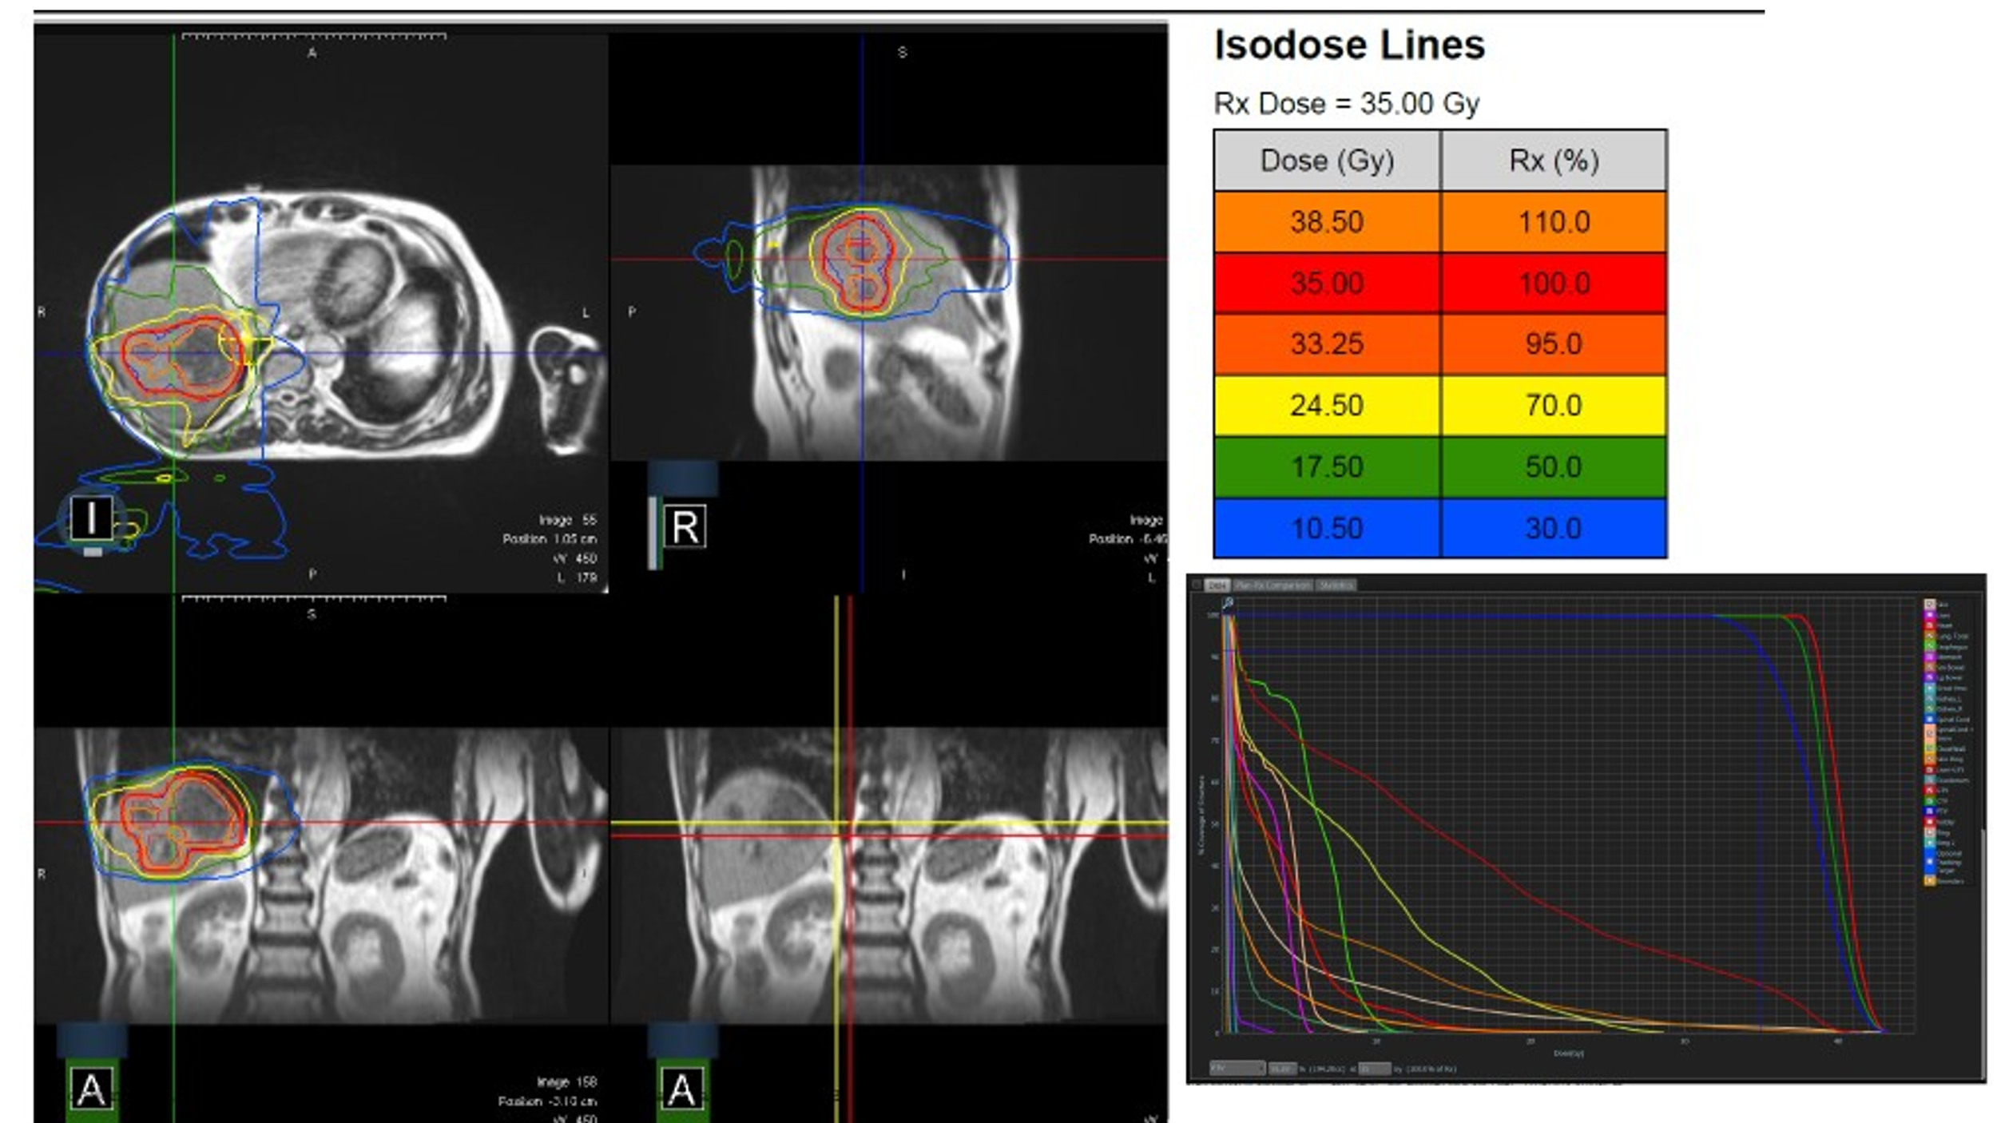

Supplementary date 2:
Figure 2 is a representative case of a 72-year-old patient with hepatocellular carcinoma with a 1.6cm lesion. Gadoxetate was used to direct tumor therapy and tracking with real-time MRI-guided stereotactic body radiation therapy to a dose of 40Gy in 5 fractions.

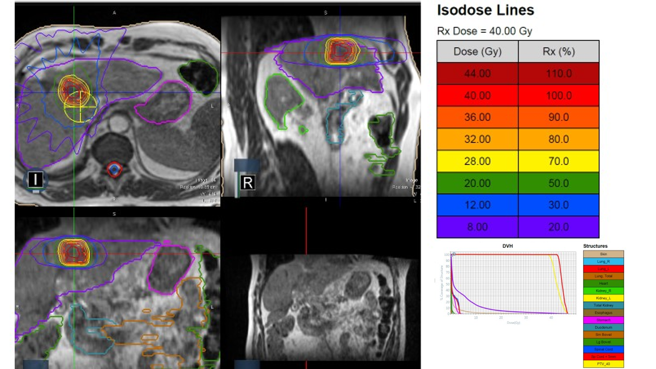

Supplementary data 3 shows the patient level details

Lesions | Age | Sex | Race | Diagnosis | Lesion size (cm) | Child Pugh baseline | RT dose | Prior local therapy | Cause of death
1 | 70 | F | White | Metastatic breast cancer | 3.7 | A | 50Gy/5 | No | Breast cancer
2 | 69 | M | White | Hepatocellular carcinoma | 1.4 | A | 50Gy/5 | Surgery
3 | 74 | M | White | Hepatocellular carcinoma | 3.5 | B | 50Gy/5 | Surgery, TACE, Y-90 | COVID-19
4 | 74 | M | White | Hepatocellular carcinoma | 1.6 | B | 50Gy/5 | Surgery, TACE, Y90 | COVID-19
5 | 72 | F | White | Hepatocellular carcinoma | 2.1 | A | 50Gy/5 | Y90 | Decompensated liver failure
6 | 61 | F | White | Metastatic anal cancer | 4.3 | A | 50Gy/5 | No
7 | 60 | M | Hispanic | Recurrent cholangiocarcinoma | 1 | A | 45Gy/3 | No
8 | 67 | M | Black | Leiomyosarcoma of liver | 3 | A | 50Gy/5 | Surgery
9 | 75 | M | Hispanic | Metastatic colorectal cancer | 1.2 | A | 45Gy/3 | Surgery
10 | 95 | F | White | Metastatic anal cancer | 6.8 | B | 50Gy/5 | No | Cardio-pulmonary death
11 | 61 | F | White | Metastatic breast cancer | 2.4 | A | 50Gy/5 | No | Disease progression
12 | 72 | F | White | Hepatocellular carcinoma | 4.5 | A | 50Gy/5 | Y90 | Unknown
13 | 72 | F | White | Hepatocellular carcinoma | 2.4 | A | 50Gy/5 | Y90 | Unknown
14 | 25 | F | Hispanic | Ewing sarcoma | 4.9 | A | 50Gy/5 | Surgery | Disease progression
15 | 49 | F | Asian | Metastatic breast cancer | 1.9 | A | 50Gy/5 | No
16 | 49 | F | Asian | Metastatic breast cancer | 1 | A | 50Gy/5 | No
17 | 70 | F | White | Metastatic breast cancer | 3.3 | A | 50Gy/5 | No
18 | 70 | F | White | Metastatic breast cancer | 2.8 | A | 50Gy/5 | No
19 | 67 | M | White | Metastatic rectal cancer | 2.6 | A | 50Gy/5 | No
20 | 62 | M | White | Metastatic lung cancer | 2.7 | A | 50Gy/5 | No
21 | 54 | F | White | Metastatic renal cancer | 2.4 | A | 50Gy/5 | Surgery
22 | 54 | F | White | Metastatic renal cancer | 1.9 | A | 50Gy/5 | Surgery
23 | 54 | F | White | Metastatic renal cancer | 1.2 | A | 50Gy/5 | Surgery
24 | 87 | M | Black | Esophageal cancer | 4.1 | A | 35Gy/5 | Chemo | Disease progression
25 | 87 | M | Black | Esophageal cancer | 0.9 | A | 35Gy/5 | Chemo | Disease progression
26 | 31 | M | Black | Metastatic breast cancer | 2.6 | B | 50Gy/5 | No | Disease progression
27 | 31 | M | Black | Metastatic breast cancer | 1.5 | B | 50Gy/5 | No
28 | 31 | M | Black | Metastatic breast cancer | 0.6 | B | 50Gy/5 | No
29 | 64 | M | White | Hepatocellular carcinoma | 1.8 | A | 50Gy/5 | Y90
30 | 64 | M | White | Hepatocellular Carcinoma | 1.1 | A | 50Gy/5 | Y90 | NA
31 | 75 | M | White | Hepatocellular Carcinoma | 1 | A | 50Gy/5 | Y-90, TACE
32 | 75 | M | White | Hepatocellular Carcinoma | 2.67 | A | 50Gy/5 | Y-90, TACE | Disease progression
33 | 62 | M | White | Hepatocellular Carcinoma | 2.7 | B | 50Gy/5 | Y90
34 | 84 | M | White | Hepatocellular Carcinoma | 2.6 | A | 40Gy/5 | No
35 | 84 | M | White | Hepatocellular Carcinoma | 2.4 | A | 50Gy/5 | No
36 | 74 | M | Hispanic | Metastatic Rectal Cancer | 3.7 | A | 50Gy/5 | Surgery | COVID-19
37 | 71 | M | White | Metastatic Colon Cancer | 4.6 | A | 45Gy/3 | Surgery
38 | 48 | M | Black | Metastatic Colon Cancer | 4.2 | A | 50Gy/5 | Surgery
39 | 48 | M | Black | Metastatic Colon Cancer | 2.9 | A | 50Gy/5 | Surgery
40 | 62 | M | White | Metastatic Esophagus | 2 | A | 45Gy/3 | No
41 | 71 | M | Asian | Hepatocellular Carcinoma | 2.1 | B | 50Gy/5 | Y90
42 | 71 | M | Asian | Hepatocellular Carcinoma | 2.4 | B | 50Gy/5 | Y90, 4 Times
43 | 84 | M | White | Hepatocellular Carcinoma | 1 | A | 54Gy/3 | Y90 | Disease progression
44 | 84 | M | White | Hepatocellular Carcinoma | 5 | A | 50Gy/3 | No | Stroke
45 | 71 | M | White | Metastatic Renal Cell Carcinoma | 0.7 | A | 50Gy/5 | No
46 | 73 | M | White | Hepatocellular Carcinoma | 1.5 | A | 50Gy/5 | Y90
47 | 56 | M | White | Hepatocellular Carcinoma | 8 | A | 50Gy/5 | No
48 | 69 | M | White | Hepatocellular Carcinoma | 1 | A | 40Gy/5 | Y90
49 | 72 | M | White | Hepatocellular Carcinoma | 4.6 | A | 50Gy/5 | Y90

Supplementary Data 4





