Supplementary Figures and Legends
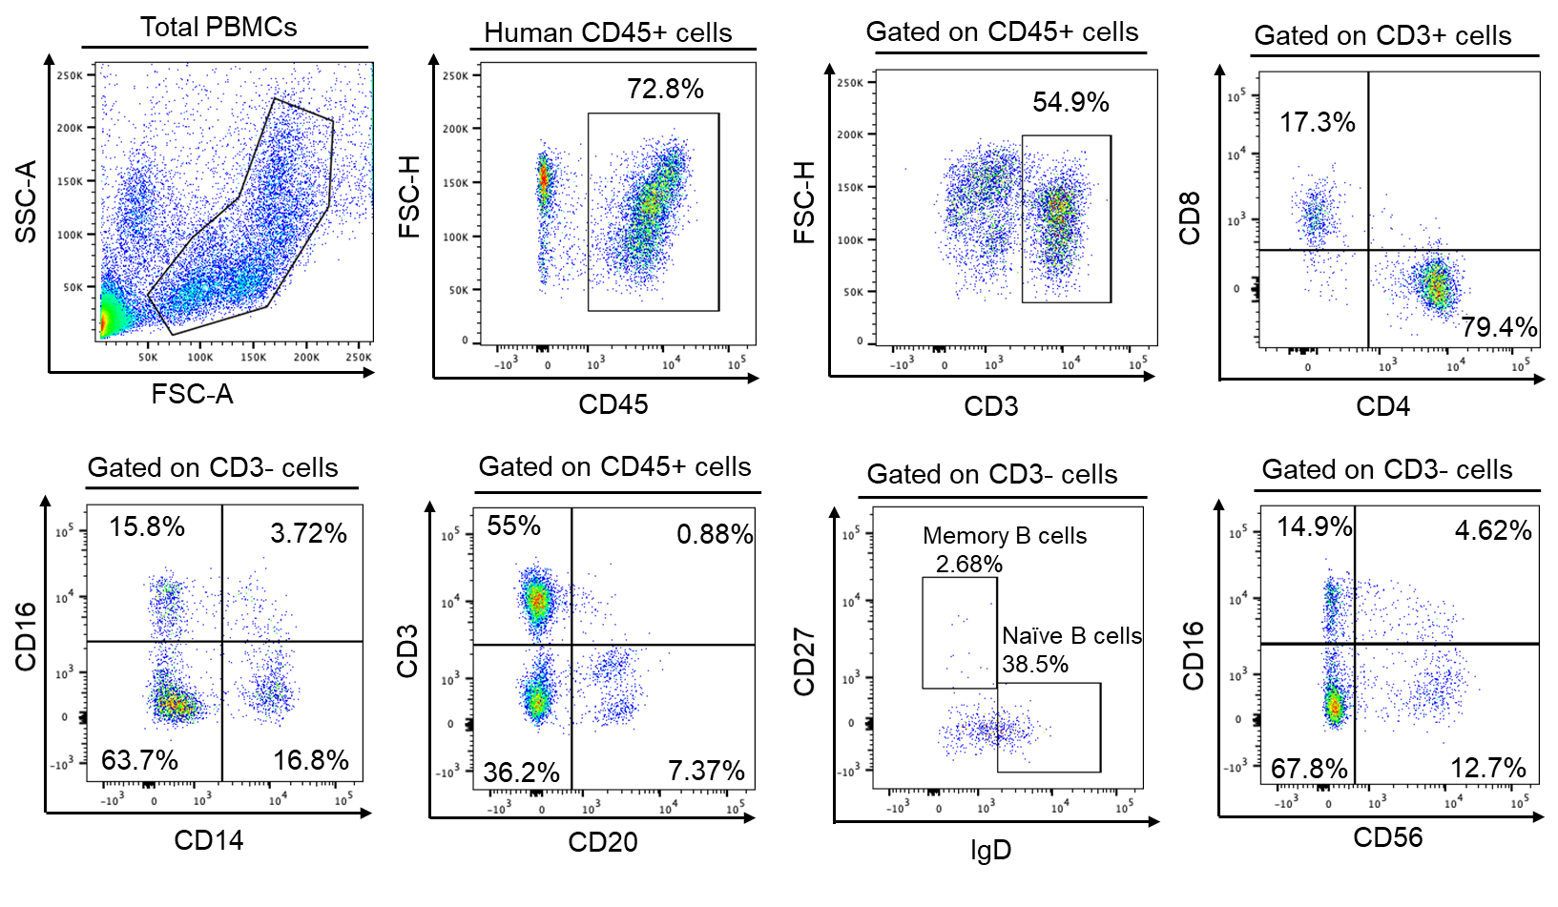
Supplementary Figure 1. Human peripheral blood cell reconstitution in BLTS-humanized mouse model. Flow cytometry analysis of the blood from representative BLTS-humanized mouse demonstrate the presence of human leukocytes (CD45+ cells), CD3+ T cells (CD4+ and CD8+ cells), monocytes (CD14+ CD16+ cells), (CD20+CD3-) B cells (memory and naive) and NK cells (CD56-CD16+).

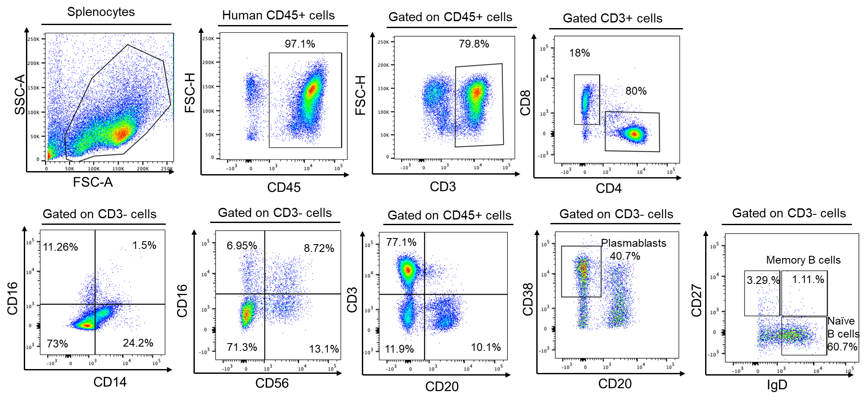
Supplementary Figure 2. Human immune cell reconstitution in the human spleen in the BLTS-humanized mouse model. Flow cytometry analysis of the human splenocytes from a representative BLTS-humanized mouse demonstrate the presence of human leukocytes (CD45+ cells), T cells (CD4+ and CD8+ cells), monocytes (CD14+ CD16+ cells), NK cells and B cells (including plasmablasts, naive and memory B cells).

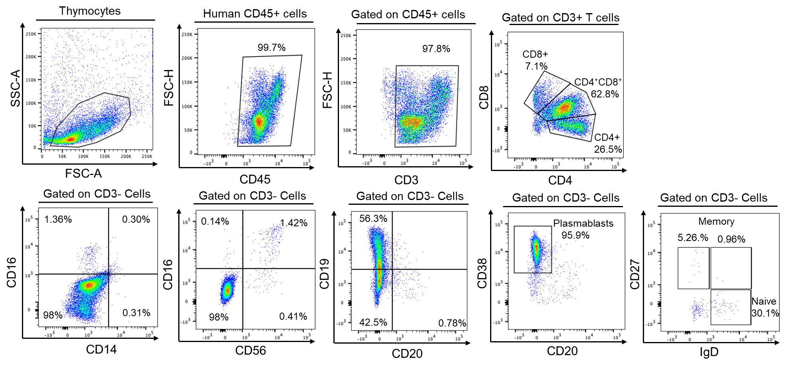
Supplementary Figure 3. Human immune cell reconstitution in the human thymus in the BLTS-humanized mouse model. Flow cytometry analysis of the human thymocytes from a representative BLTS-humanized mouse demonstrate the presence of human leukocytes (CD45+ cells), including T cells (CD4+ and CD8+ cells) and very low levels of human monocytes (CD14+ CD16+ cells), NK cells and B cells (including, plasmablasts, naive and memory B cells).

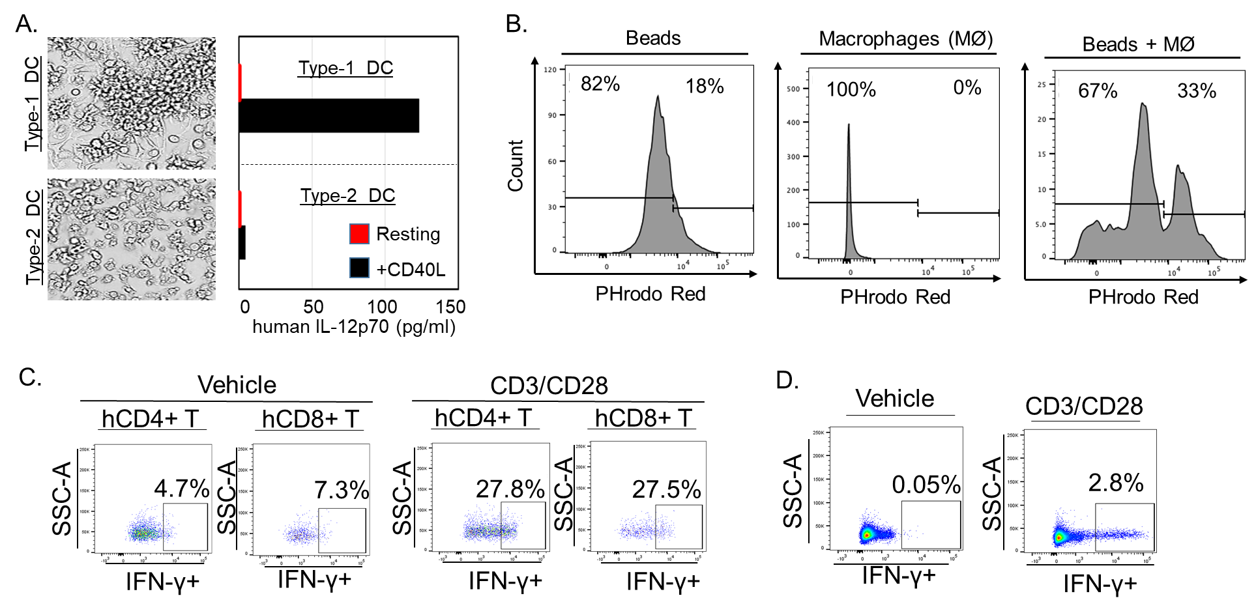
Supplementary Figure 4. The functionality of human antigen presenting cells and T cells in the BLTS-humanized mouse model. (A) Human CD34+ cells were differentiated into Type-1 and Type-2 dendritic cells (DC), and subsequently stimulated with CD40 ligand or vehicle, and human IL12p70 was measured. (B) Human CD163+ macrophages were immunoselected from human splenocytes and cultured with or without pHrodo™ Red E. coli BioParticles™ (ThernoFisher), and phagocytosis was measured using flow cytometry. (C-D) Human CD3+ T cells were selected from BLTS-humanized mice (human splenocytes) (C) and adult human PBMCs (D) and stimulated with CD3/28 beads, and human IFN-γ secretion was measured via flow cytometry.

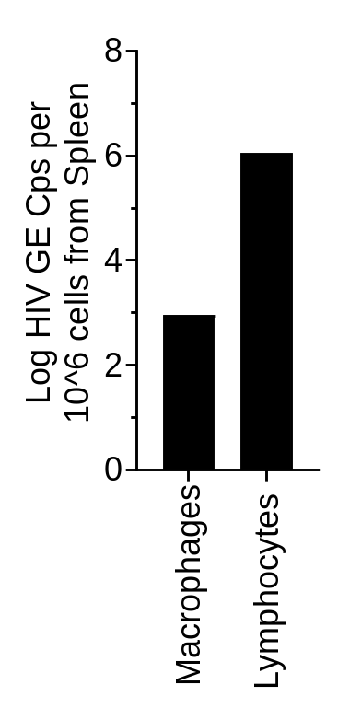
Supplementary Figure 5. Human CD163+ macrophages and lymphocytes support HIV replication in the human spleen xenograft. Human CD163+ macrophages and CD163- splenocytes were isolated via immunoselection (using human CD163+ immunomagnetic beads) from human splenocytes in BLTS-humanized infected with HIV (NL4) for 2 weeks. Total RNA was isolated from both CD163+ cells (macrophages) and CD163- cells (lymphocytes) and HIV viral load was measured using qPCR.

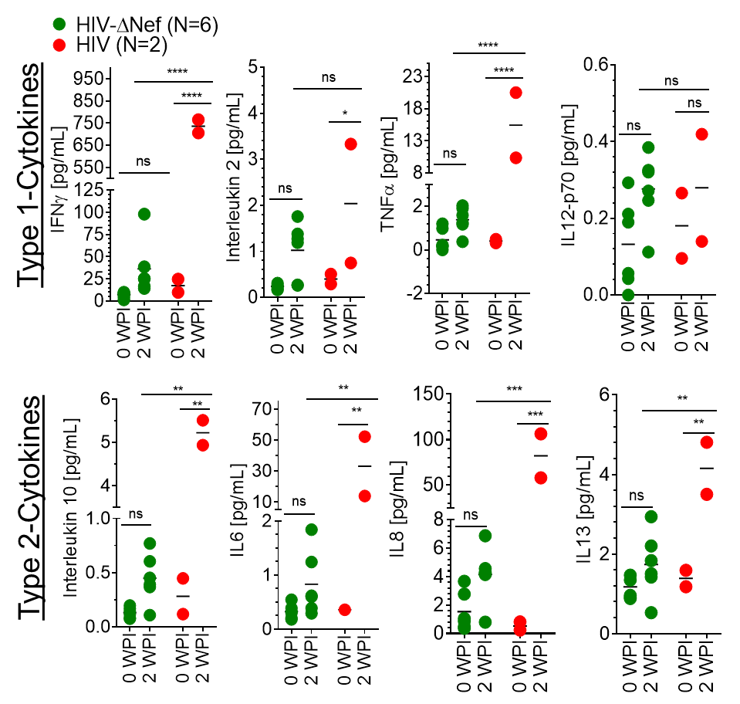
Supplementary Figure 6. The human-immune system in BLTS-humanized mice mediate a cytokine response to nef-deleted HIV and wildtype HIV transmission. Analysis of the human cytokine levels before and after inoculation with wild-type HIV and nef-deleted HIV (10 ng HIVp24 ≈ 1x10^6 infectious units per mouse) in BLTS-humanized mice (N=2-6 mice per group) demonstrate that both viruses induces Th1 and Th2 cytokines albeit, relatively higher levels with wild-type HIV replication. N=2-3 mice per group. ns = P>0.05, * = P≤ 0.05, ** = P≤ 0.01, *** = P≤ 0.001.

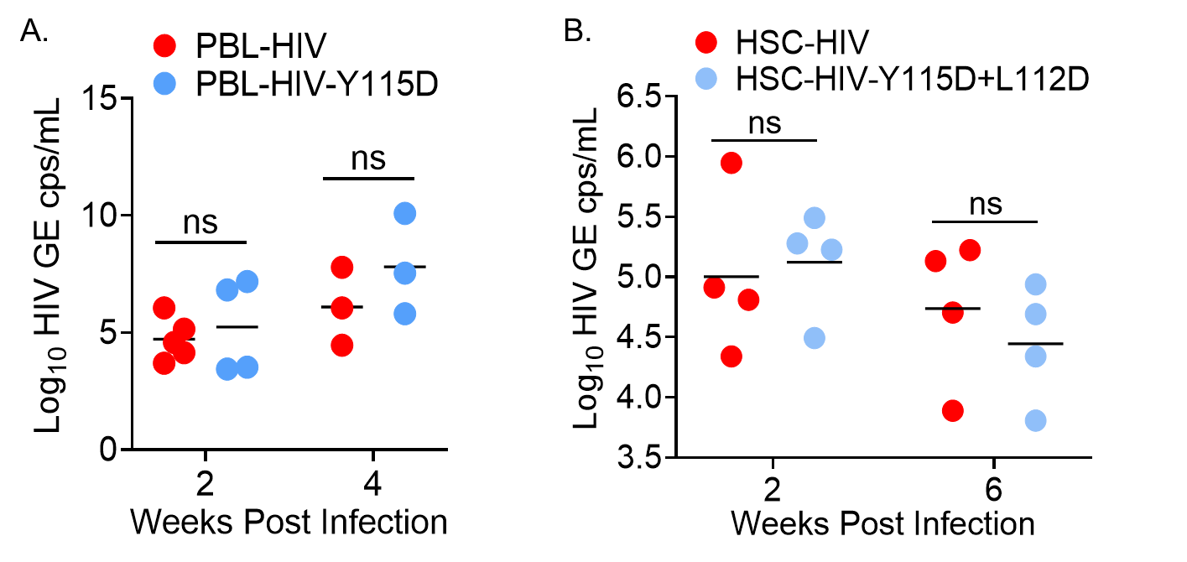
Supplementary Figure 7. Nef dimerization-defective HIV is replication competent in vivo. (A) The infectivity and replication (HIV genome copies/milliliter-GE cps/mL) of wild-type HIV and nef-dimerization defective HIV (A. Y115D and B. Y115D+L112D mutant; 2000 Median Tissue Culture Infectious Dose (TCID₅₀) per mouse) in peripheral blood lymphocytes (PBL)-humanized mice and hematopoietic stem cell (HSC)–humanized mice (HSC-Mice) are comparable. N=3-5 mice per group. Not significant (ns) = P>0.05.

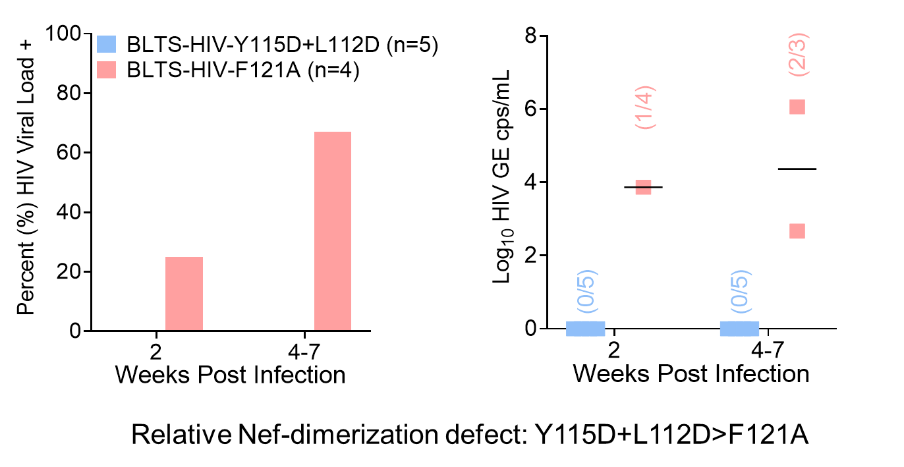
Supplementary Figure 8. The relative level of Nef-dimerization defect is associated with HIV viremia in the BLTS-humanized mouse model. BLTS-humanized mice (BLTS-Mice) exhibit immune-mediated viremic control of a HIV strain with a higher level of defect in Nef dimerization (Y115D+L112D mutant; 10 ng HIVp24 per mouse) as compared to a HIV strain with a lower level of defect in Nef dimerization (F121A mutant; 10 ng HIVp24 per mouse), which exhibited viremia in most of the mice (67%) at the sacrificed timepoint. N=4-5 mice per group. For BLTS-humanized mice groups, Nef dimerization-defective-Y115D+L112D (5 mice at 6 weeks post-inoculation) and Nef dimerization-defective-F121A (1 mouse at 7 weeks post-inoculation and 2 mice at 5 weeks post-inoculation). Not significant (ns) = P>0.05.

Supplementary Figure 9. Anti-HIVp24 antibody detection of HIV-infected human PBMCs-derived CD4+ T cells. CD4+ T cells were isolated from healthy human PBMCs using immunomagnetic selection, activated with Anti-CD3/CD28 for three days and subsequently infected with HIV (at multiplicity of infection = one). Ten days post infection, CD4+ T cells were harvested and stained for HIV-p24. HIV-p24 levels in CD4 T cells was analyzed by flow cytometry. HIV-infected human CD4+ T cells were determined based on comparison to fluorescent minus control (FMO).
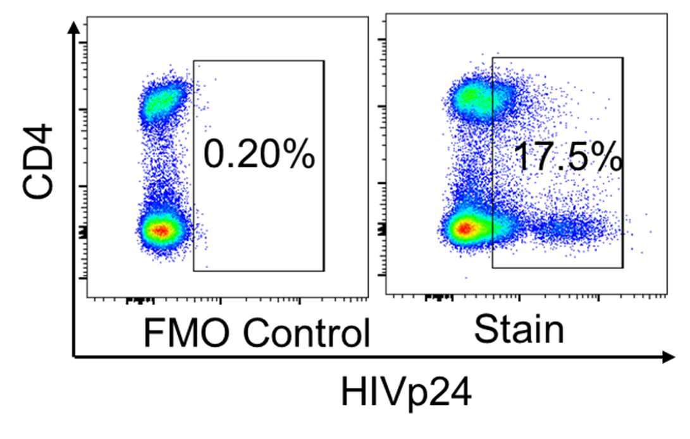

Supplementary Figure 10. Fluorescent minus staining control for flow cytometry gating of T cell activation and exhaustion. (A, B) Fluorescent minus staining control-flow cytometry analysis of human CD4+ T cells in the blood in BLTS-humanized mice validates the gating for T cell activation (CD25 FMO plus HLA-DR FMO) (A) and exhaustion (PD1-FMO) (B).
.

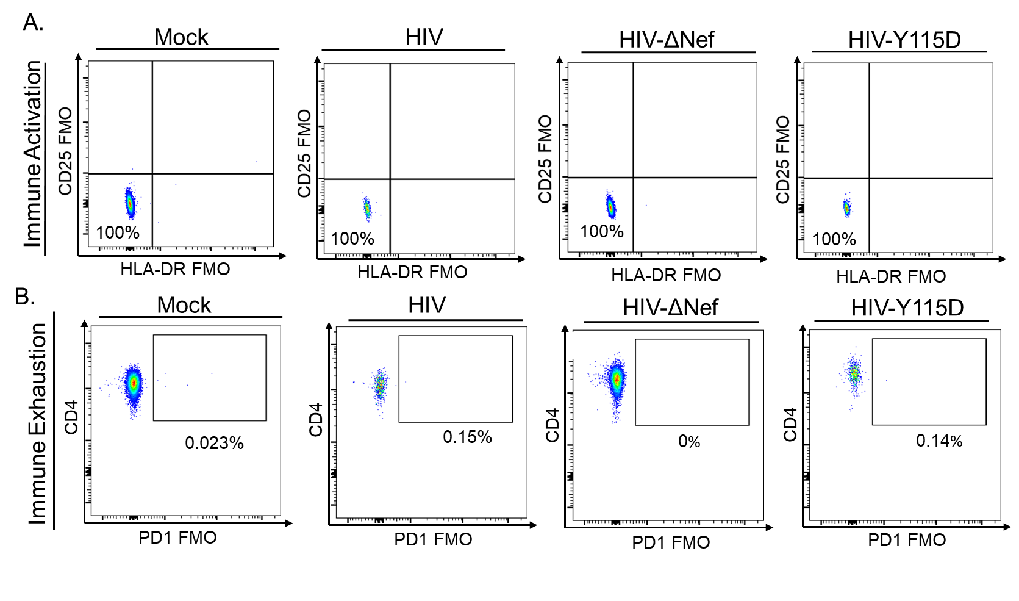
Supplementary Figure 10. Fluorescent minus staining control for flow cytometry gating of T cell activation and checkpoint inhibitor expression. (A, B) Fluorescent minus staining control-flow cytometry analysis of human CD4+ T cells in the blood in BLTS-humanized mice validates the gating for T cell activation (CD25 FMO plus HLA-DR FMO) (A) and checkpoint inhibitor expression (PD1-FMO) (B).
.

