Supplementary Materials for
Possible core symbiosis-related genes in early life stages of Acropora tenuis inoculated with Symbiodinium microadriaticum
Yuki Yoshioka ^{1, 2}, Yi-Ling Chiu ¹, Taiga Uchida ¹, Hiroshi Yamashita ³, Go Suzuki ³, and Chuya Shinzato ^{1*}

¹ Atmosphere and Ocean Research Institute, The University of Tokyo, Kashiwa, Chiba, Japan
² Graduate School of Frontier Sciences, The University of Tokyo, Kashiwa, Chiba, Japan
³ Fisheries Technology Institute, Japan Fisheries Research and Education Agency, Ishigaki, Okinawa, Japan
* Corresponding author: Yuki Yoshioka (y.yoshioka@oist.jp) and Chuya Shinzato (c.shinzato@aori.u-tokyo.ac.jp)

Supplementary Tables
Supplementary Tables S1 pp. 2
Supplementary Tables S2 pp. 3
Supplementary Figures
Supplementary Fig. S1 pp. 4
Supplementary Fig. S2 pp. 5
Supplementary Fig. S3 pp. 6
Supplementary Fig. S4 pp. 7
Supplementary Fig. S5 pp. 8
Supplementary Fig. S6 pp. 9
Supplementary Fig. S7 pp. 10
Supplementary Fig. S8 pp. 11
Supplementary Fig. S9 pp. 12
Supplementary Fig. S10 pp. 13
Supplementary Fig. S11 pp. 14
Supplementary Fig. S12 pp. 15
Supplementary Fig. S13 pp. 16
Supplementary Fig. S14 pp. 17

Supplementary Table S1. Summary of numbers of clean reads, mapped reads to Acropora tenuis gene models, and expressed genes.
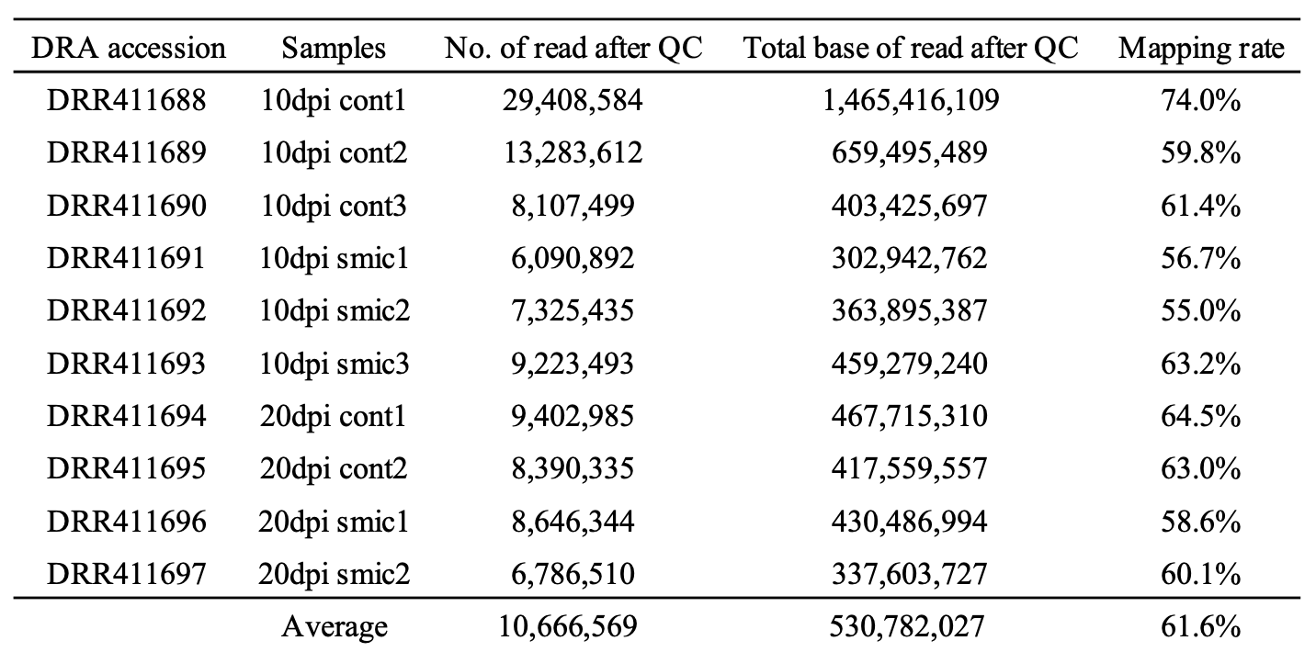

Supplementary Table S2. Summary of DEGs detected in planula larvae inoculated with Symbiodinium microadriaticum at 4, 8, and 12 dpi (Separately provided as Supplementary Table S2.xlsx due to file size).
Original RNA-seq data was from Yoshioka et al ¹ .

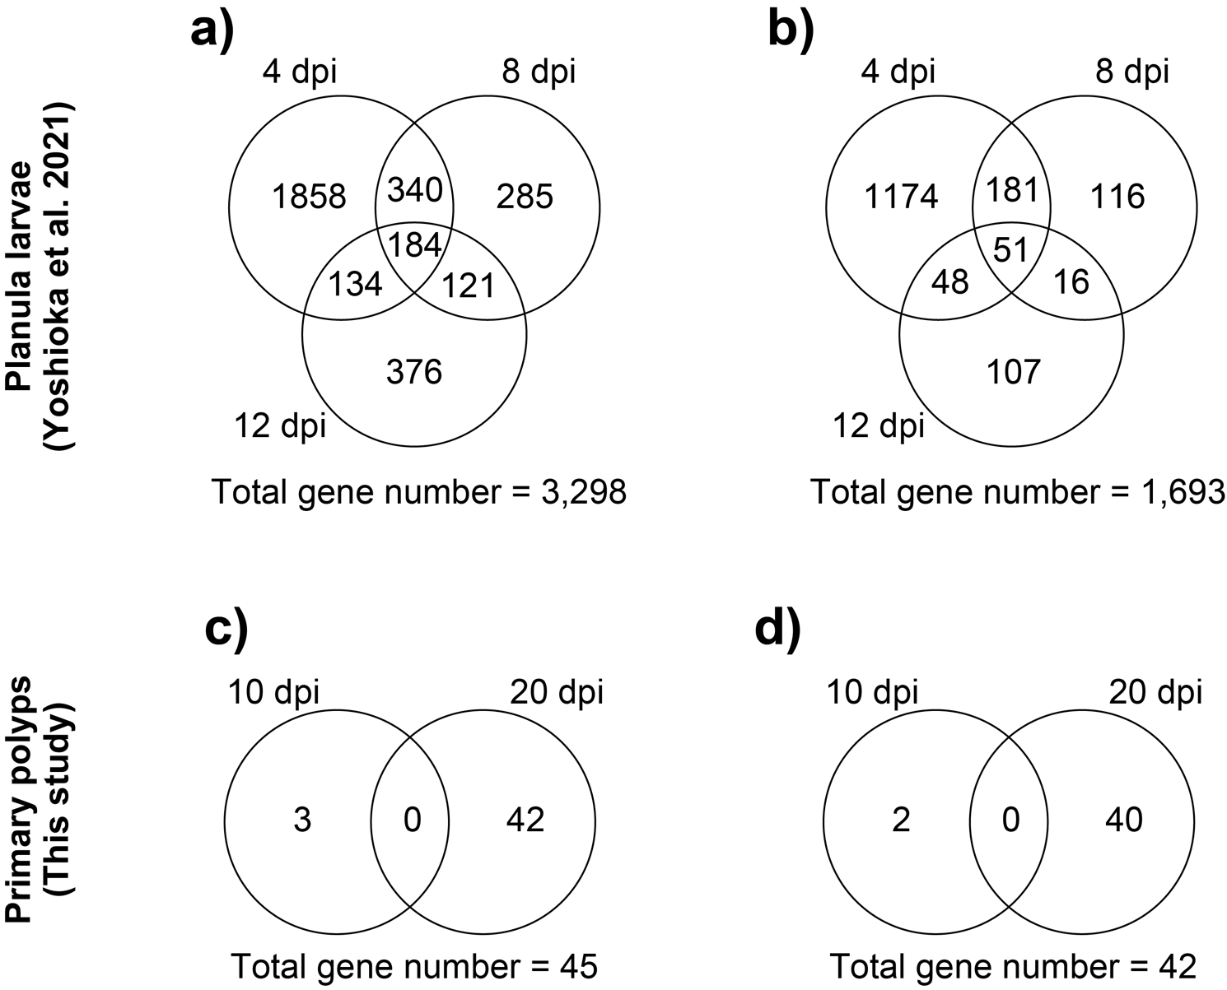
Supplementary Fig. S1. Summary of genes for which expression levels differed depending on age (days).
a) Venn-diagram of the number of DEGs restricted to planula larvae inoculated with Smic.
b) Venn-diagram of the number of DEGs restricted to planula larvae inoculated with Smic after removal of genes for which expression depends on age of planula larvae between 4, 8, and 12 dpi.
c) Venn-diagram of the number of DEGs restricted to primary polyps inoculated with Smic.
d) Venn-diagram of the number of DEGs restricted to primary polyps inoculated with Smic after removal of genes for which expression depends on age of primary polyps between 10 and 20 dpi.

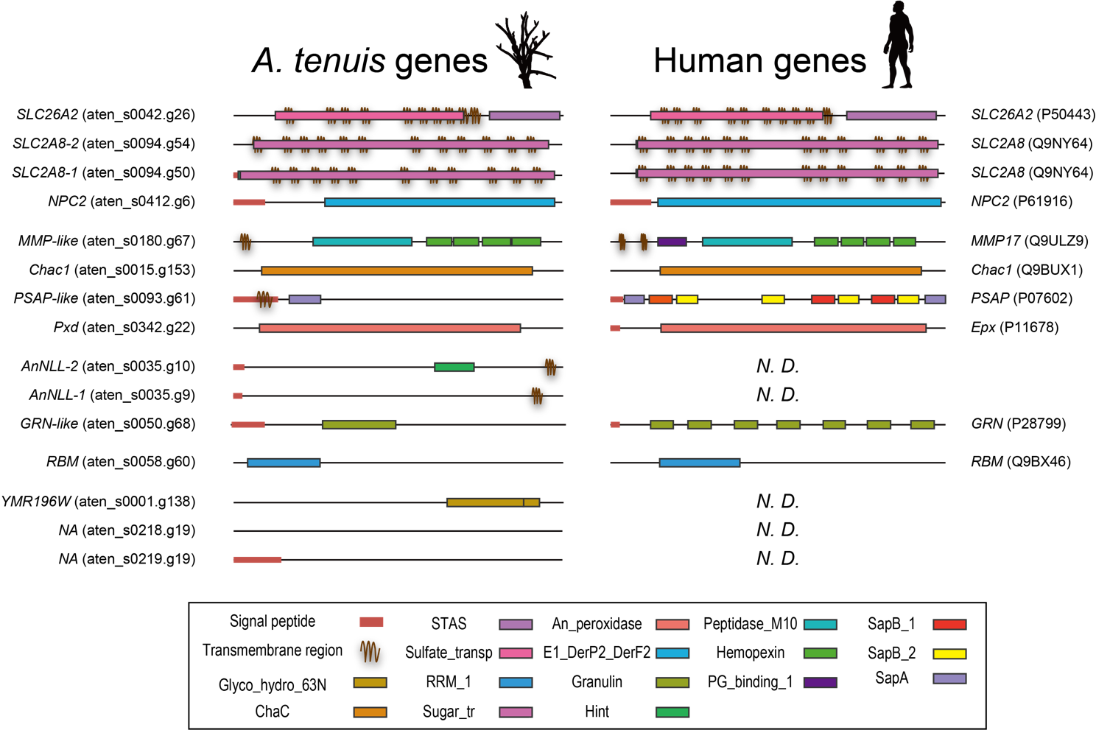
Supplementary Fig. S2. Comparison of domain composition of 15 core symbiosis-related genes with human genes.
Signal peptides, transmembrane regions, and evolutionally conserved protein domains are colored separately. Gene names and UniProt IDs for A. tenuis and human are provided at left and right, respectively.

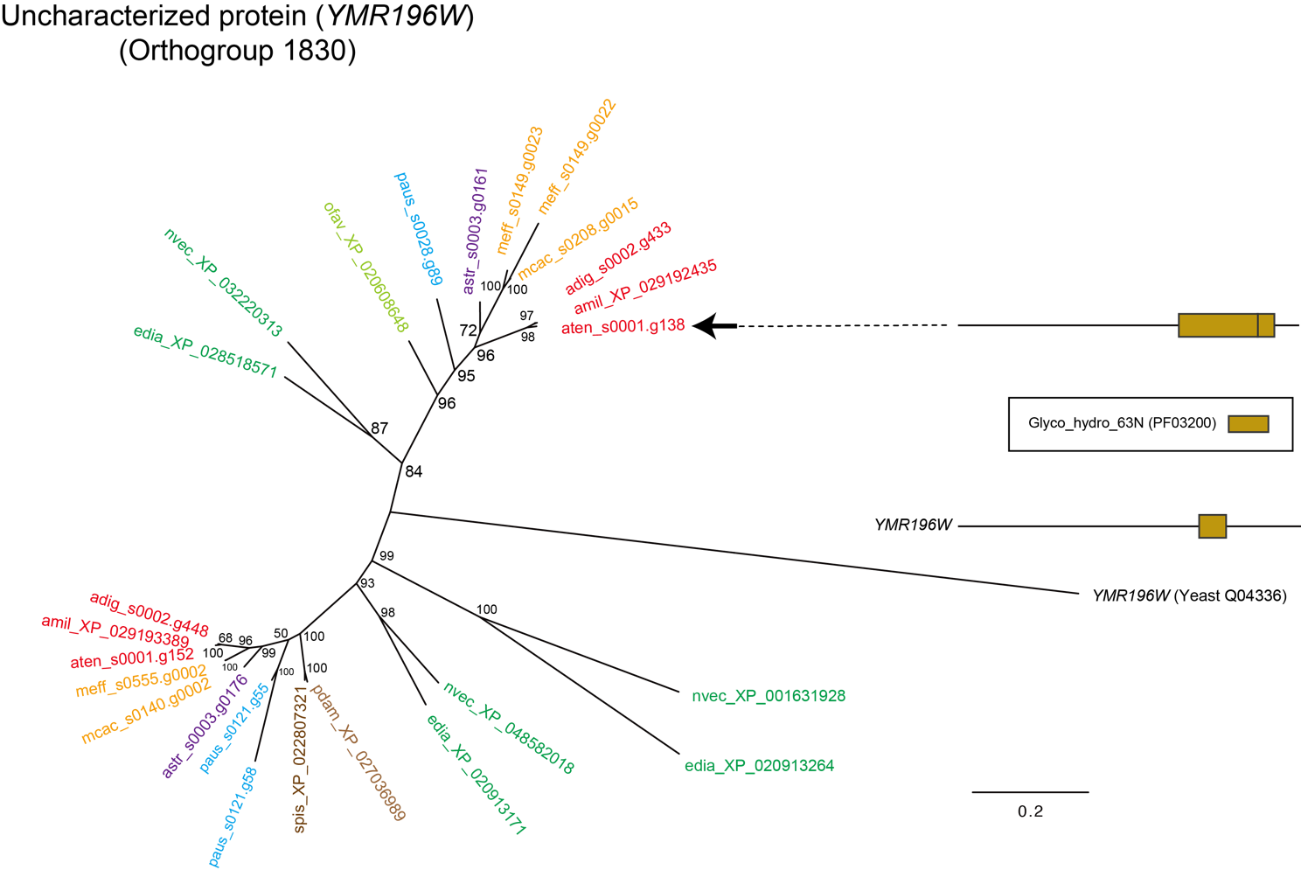
Supplementary Fig. S3. Molecular phylogenetic analysis of an uncharacterized protein (YMR196W).
897 gap-trimmed, aligned, amino acids were used for phylogenetic tree construction (LG model). Genes from Acropora (A. tenuis [aten], A. digitifera [adig], A. millepora [amil]), Montipora (M. cactus [mcac] and M. efflorescens [meff]), Astreopora myriophthalma (Astr), Porites australiensis (paus), S. pistillata (spis), O. faveolata (ofav), Pocillopora damicornis (pdam), sea anemones (Exaiptasia diaphana [edia] and Nematostella vectensis [nvec]), and yeast are colored red, yellow, purple, light-blue, brown, light-brown, light-green, green, and black, respectively. Gene IDs are shown following species names. A black arrow indicates the DEG. Sequence features of the DEG and the reference gene (Yeast YMR196W) is shown. Note that these sequence features do not reflect sequence lengths.
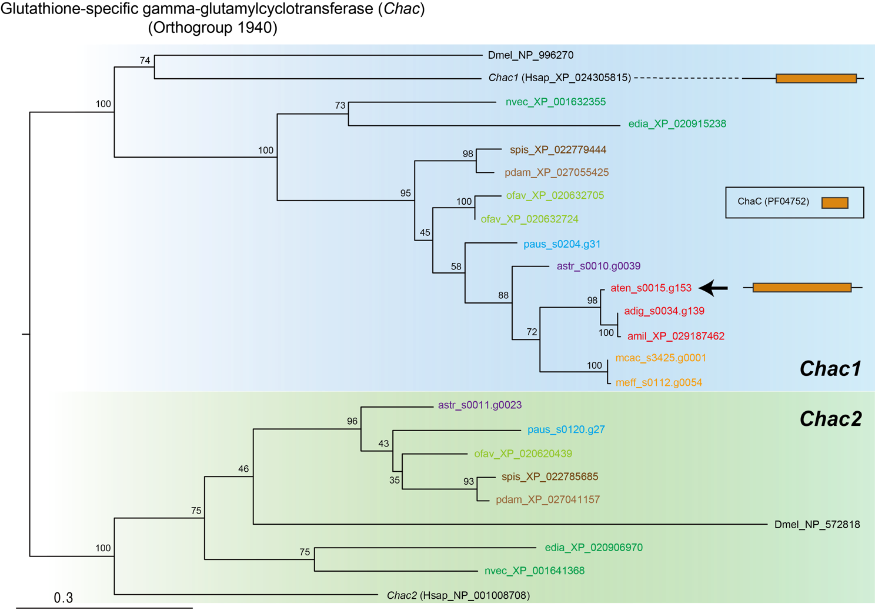
Supplementary Fig. S4. Molecular phylogenetic analysis of a glutathione-specific gamma-glutamylcyclotransferase (Chac).
179 gap-trimmed, aligned amino acids were used for phylogenetic tree construction (LG model). Genes from Acropora (A. tenuis [aten], A. digitifera [adig], A. millepora [amil]), Montipora (M. cactus [mcac] and M. efflorescens [meff]), Astreopora myriophthalma (Astr), Porites australiensis (paus), S. pistillata (spis), O. faveolata (ofav), Pocillopora damicornis (pdam), sea anemones (Exaiptasia diaphana [edia] and Nematostella vectensis [nvec]), and bilaterians (D. melanogaster [dmel] and H. sapiens [hsap]) are colored red, yellow, purple, light-blue, brown, light-brown, light-green, green, and black, respectively. Gene IDs are shown following species name. A black arrow indicates the DEG. The sequence feature of the DEG and the reference gene (Human Chac1) is shown. Note that these sequence features do not reflect the sequence lengths.

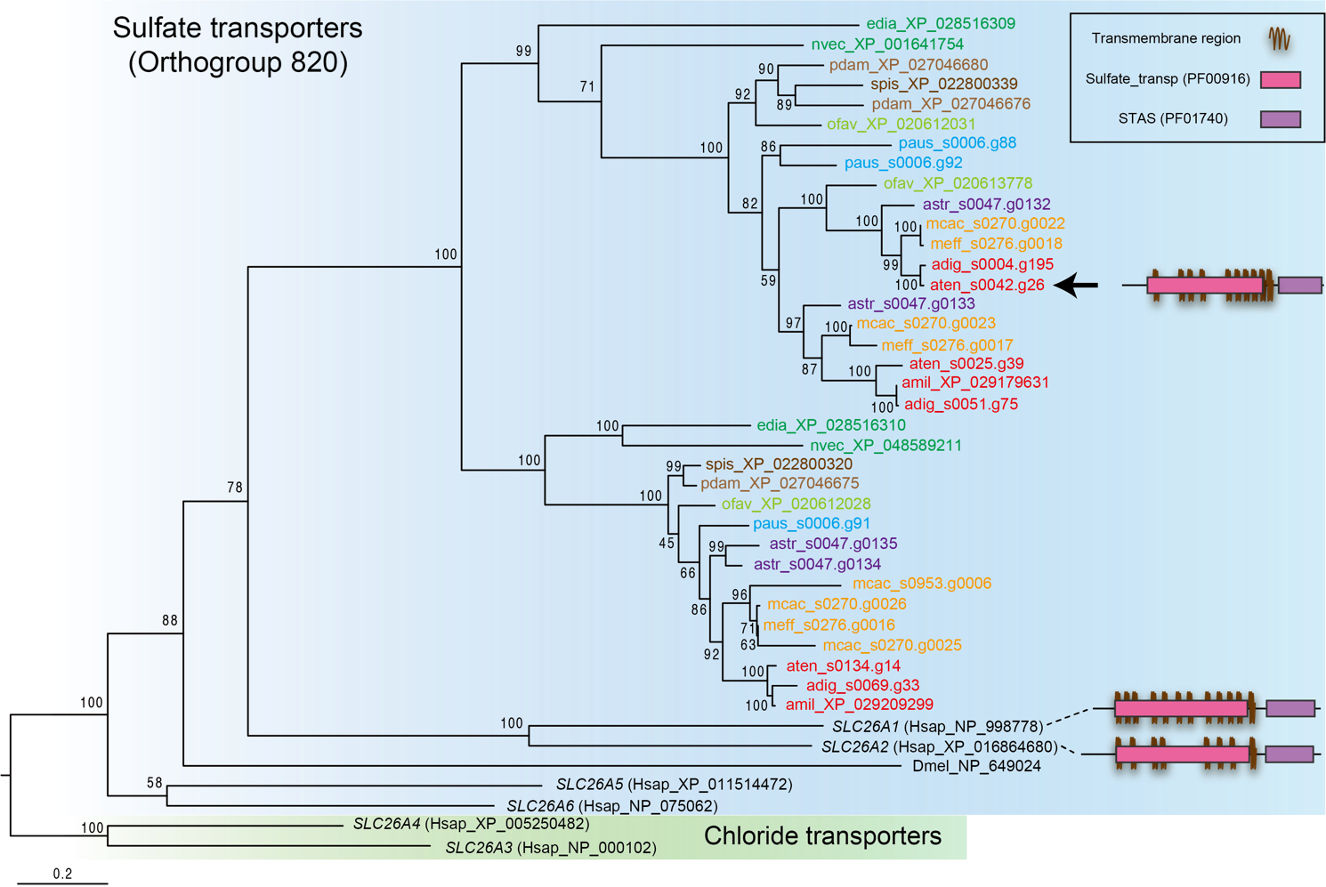
Supplementary Fig. S5. Molecular phylogenetic analysis of a sulfate transporters.
603 gap-trimmed, aligned amino acids were used for phylogenetic tree construction (LG model). Genes from Acropora (A. tenuis [aten], A. digitifera [adig], A. millepora [amil]), Montipora (M. cactus [mcac] and M. efflorescens [meff]), Astreopora myriophthalma (Astr), Porites australiensis (paus), S. pistillata (spis), O. faveolata (ofav), Pocillopora damicornis (pdam), sea anemones (Exaiptasia diaphana [edia] and Nematostella vectensis [nvec]), and bilaterians (D. melanogaster [dmel] and H. sapiens [hsap]) are colored red, yellow, purple, light-blue, brown, light-brown, light-green, green, and black, respectively. Gene IDs are shown following species name. A black arrow indicates the DEG. The sequence feature of the DEG and the reference genes (Human SLC26A1 and SLC26A2) is shown. The chloride transporters of H. sapiens were used as an outgroup. Note that these sequence features do not reflect the sequence lengths.

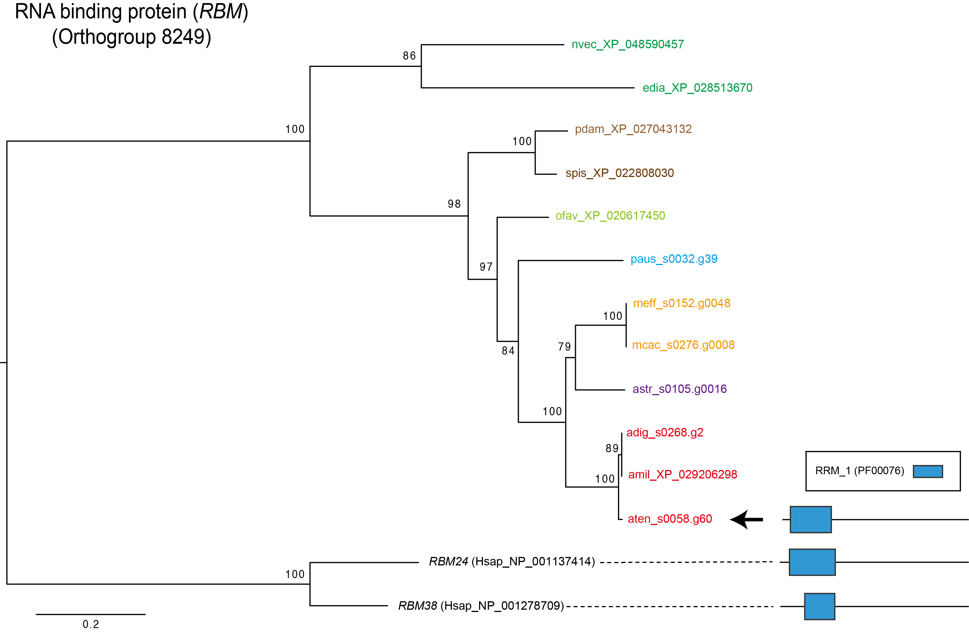
Supplementary Fig. S6. Molecular phylogenetic analysis of an RNA binding protein (RBM).
237 gap-trimmed, aligned amino acids were used for phylogenetic tree construction (JTT model). Genes from Acropora (A. tenuis [aten], A. digitifera [adig], A. millepora [amil]), Montipora (M. cactus [mcac] and M. efflorescens [meff]), Astreopora myriophthalma (Astr), Porites australiensis (paus), S. pistillata (spis), O. faveolata (ofav), Pocillopora damicornis (pdam), sea anemones (Exaiptasia diaphana [edia] and Nematostella vectensis [nvec]), and H. sapiens (hsap) are colored red, yellow, purple, light-blue, brown, light-brown, light-green, green, and black, respectively. Gene IDs are shown following species name. A black arrow indicates the DEG. The sequence feature of the DEG and the reference genes (Human RBM24 and RBM38) is shown. Note that these sequence features do not reflect the sequence lengths.
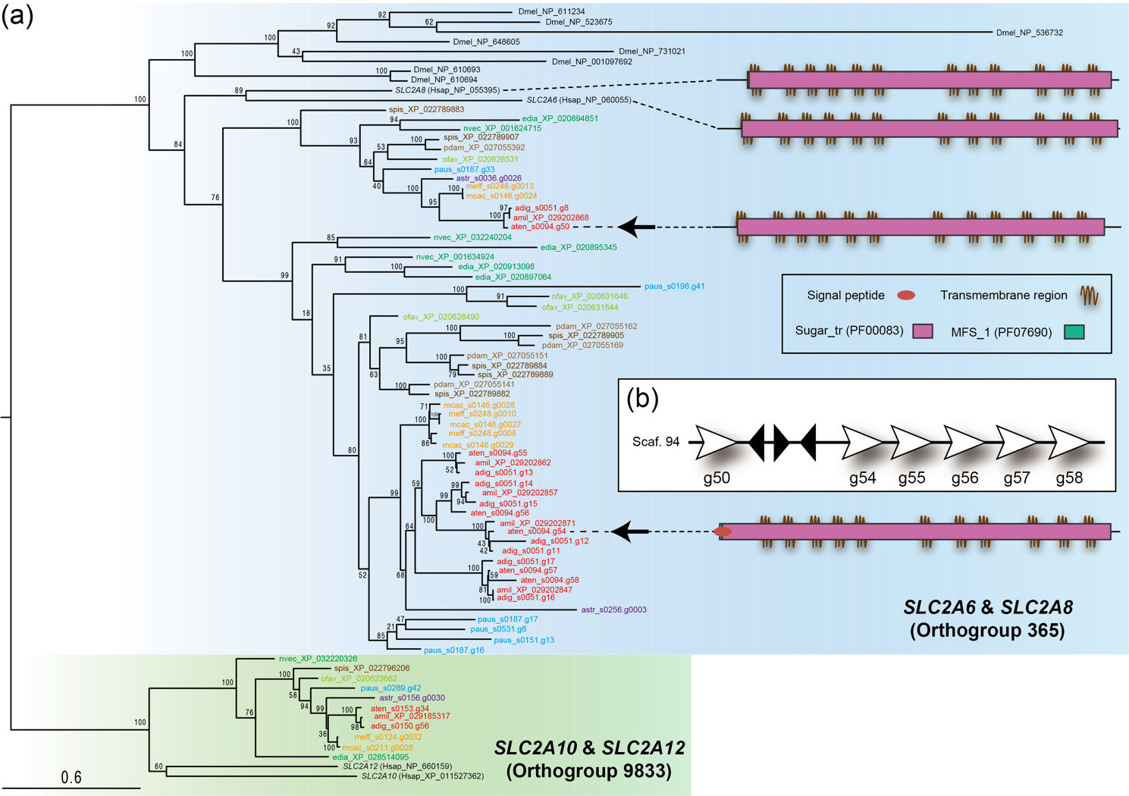
Supplementary Fig. S7. Molecular phylogenetic analysis of a sugar transporters.
(a) Phylogenetic tree of sugar transporters.
468 gap-trimmed, aligned amino acids were used for phylogenetic tree construction (LG model). Genes from Acropora (A. tenuis [aten], A. digitifera [adig], A. millepora [amil]), Montipora (M. cactus [mcac] and M. efflorescens [meff]), Astreopora myriophthalma (Astr), Porites australiensis (paus), S. pistillata (spis), O. faveolata (ofav), Pocillopora damicornis (pdam), sea anemones (Exaiptasia diaphana [edia] and Nematostella vectensis [nvec]), and bilaterians (D. melanogaster [dmel] and H. sapiens [hsap]) are colored red, yellow, purple, light-blue, brown, light-brown, light-green, green, and black, respectively. Gene IDs are shown following species name. Black arrows indicate the DEGs. The sequence feature of the DEGs and the reference gene (Human SLC2A6 and SLC2A8) is shown. Another sugar transporter genes (Orthogroup 9833) were used as an outgroup. Note that these sequence features do not reflect the sequence lengths.
(b) Tandem duplication of sugar transporter genes in A. tenuis genome.
White arrows indicate tandemly duplicated sugar transporter genes on scaffold 94 and their transcription direction.
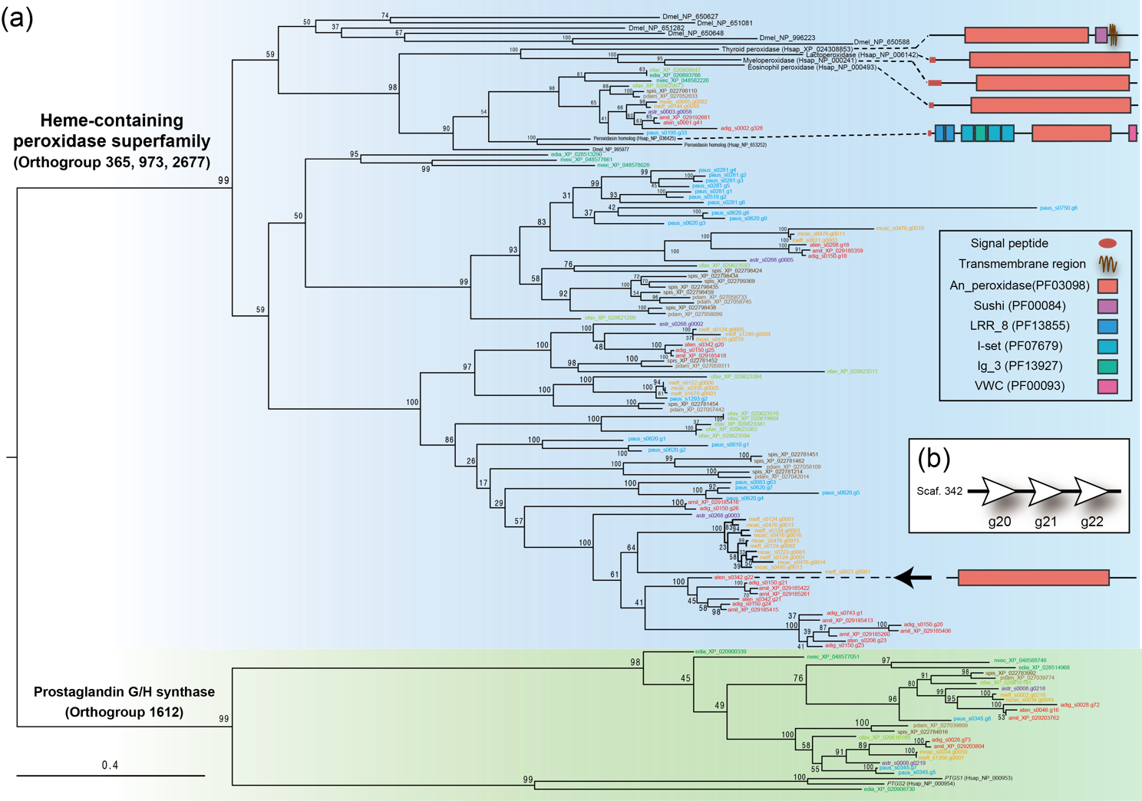
Supplementary Fig. S8. Molecular phylogenetic analysis of a heme-containing peroxidase (Pxd) superfamily.
(a) Phylogenetic tree of Pxd superfamily.
503 gap-trimmed, aligned amino acids were used for phylogenetic tree construction (WAG model). Genes from Acropora (A. tenuis [aten], A. digitifera [adig], A. millepora [amil]), Montipora (M. cactus [mcac] and M. efflorescens [meff]), Astreopora myriophthalma (Astr), Porites australiensis (paus), S. pistillata (spis), O. faveolata (ofav), Pocillopora damicornis (pdam), sea anemones (Exaiptasia diaphana [edia] and Nematostella vectensis [nvec]), and bilaterians (D. melanogaster [dmel] and H. sapiens [hsap]) are colored red, yellow, purple, light-blue, brown, light-brown, light-green, green, and black, respectively. Gene IDs are shown following species name. A black arrow indicates the DEG. The sequence feature of the DEG and the reference genes (Human TPO, LPO, MPO, EPO, and Peroxidasin-homologue) is shown. Prostaglandin G/H synthases (Orthogroup 1612) were used as an outgroup. Note that these sequence features do not reflect the sequence lengths.
(b) Tandem duplication of Pxd genes in A. tenuis genome.
White arrows indicate tandemly duplicated Pxd genes on scaffold 342 and their transcription direction, respectively.
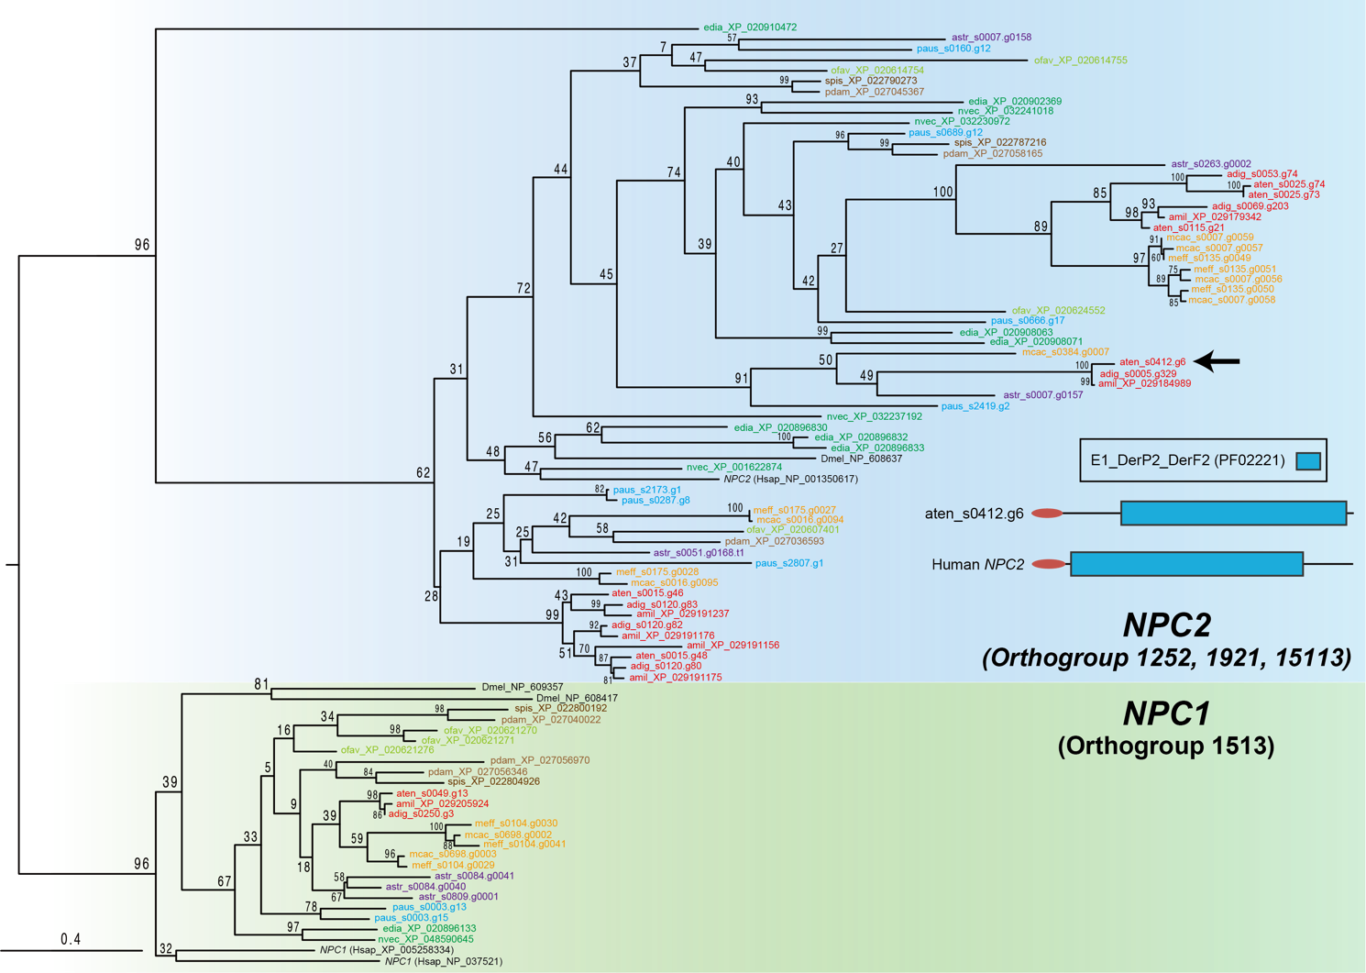
Supplementary Fig. S9. Molecular phylogenetic analysis of a Niemann-pick type C2 sterol transporters (NPC2)
148 gap-trimmed, aligned amino acids were used for phylogenetic tree construction (WAG model). Genes from Acropora (A. tenuis [aten], A. digitifera [adig], A. millepora [amil]), Montipora (M. cactus [mcac] and M. efflorescens [meff]), Astreopora myriophthalma (Astr), Porites australiensis (paus), S. pistillata (spis), O. faveolata (ofav), Pocillopora damicornis (pdam), sea anemones (Exaiptasia diaphana [edia] and Nematostella vectensis [nvec]), and H. sapiens (hsap) are colored red, yellow, purple, light-blue, brown, light-brown, light-green, green, and black, respectively. Gene IDs are shown following species name. A black arrow indicates the DEG. The sequence feature of the DEG and the reference gene (Human NPC2) is shown. NPC1 genes (Orthogroup 1513) were used as an outgroup. Note that these sequence features do not reflect the sequence lengths.

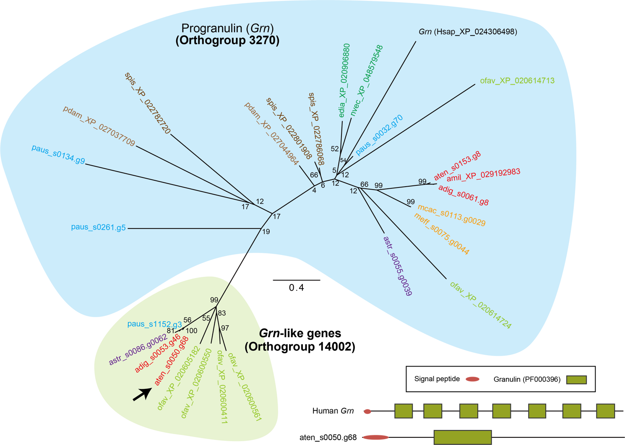
Supplementary Fig. S10. Molecular phylogenetic analysis of a progranulin-like genes (Grn).
177 gap-trimmed, aligned amino acids were used for phylogenetic tree construction (FLU model). Genes from Acropora (A. tenuis [aten], A. digitifera [adig], A. millepora [amil]), Montipora (M. cactus [mcac] and M. efflorescens [meff]), Astreopora myriophthalma (Astr), Porites australiensis (paus), S. pistillata (spis), O. faveolata (ofav), Pocillopora damicornis (pdam), sea anemones (Exaiptasia diaphana [edia] and Nematostella vectensis [nvec]), and H. sapiens (hsap) are colored red, yellow, purple, light-blue, brown, light-brown, light-green, green, and black, respectively. Gene IDs are shown following species name. A black arrow indicates the DEG. The sequence feature of the DEG and the reference gene (Human Grn) is shown. Note that these sequence features do not reflect the sequence lengths.

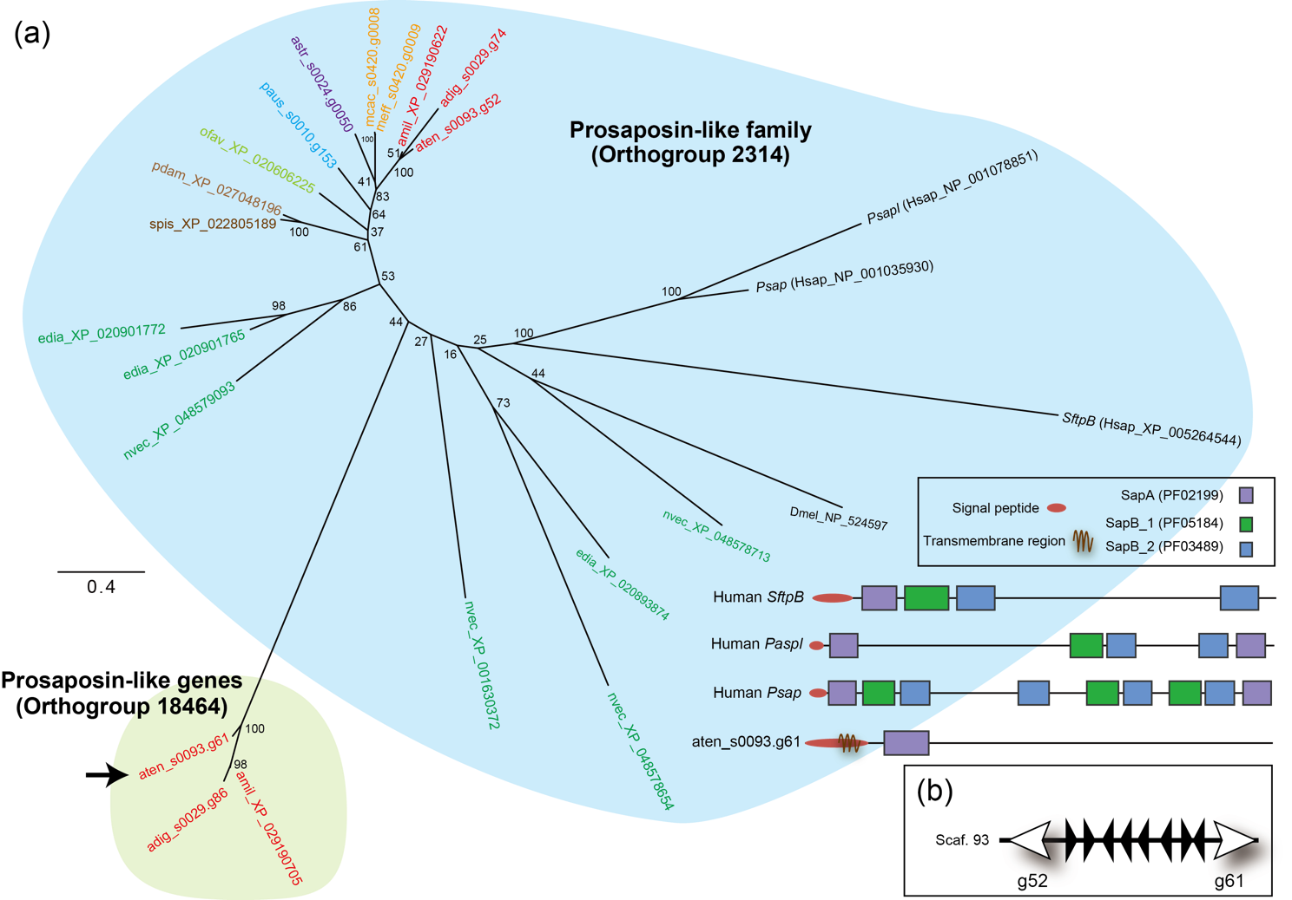
Supplementary Fig. S11. Molecular phylogenetic analysis of a prosaposin-like family.
(a) Phylogenetic tree of prosaposin-like genes.
385 gap-trimmed, aligned amino acids were used for phylogenetic tree construction (FLU model). Genes from Acropora (A. tenuis [aten], A. digitifera [adig], A. millepora [amil]), Montipora (M. cactus [mcac] and M. efflorescens [meff]), Astreopora myriophthalma (Astr), Porites australiensis (paus), S. pistillata (spis), O. faveolata (ofav), Pocillopora damicornis (pdam), sea anemones (Exaiptasia diaphana [edia] and Nematostella vectensis [nvec]), and bilaterians (D. melanogaster [dmel] and H. sapiens [hsap]) are colored red, yellow, purple, light-blue, brown, light-brown, light-green, green, and black, respectively. Gene IDs are shown following species name. A black arrow indicates the DEG. The sequence feature of the DEG and the reference genes (Human SftpB, Paspl, and Psap) is shown. Note that these sequence features do not reflect the sequence lengths.
(b) Tandem duplication of Psap-like genes in A. tenuis genome.
White arrows indicate tandemly duplicated Psap-like genes on scaffold 93 and their transcription direction.

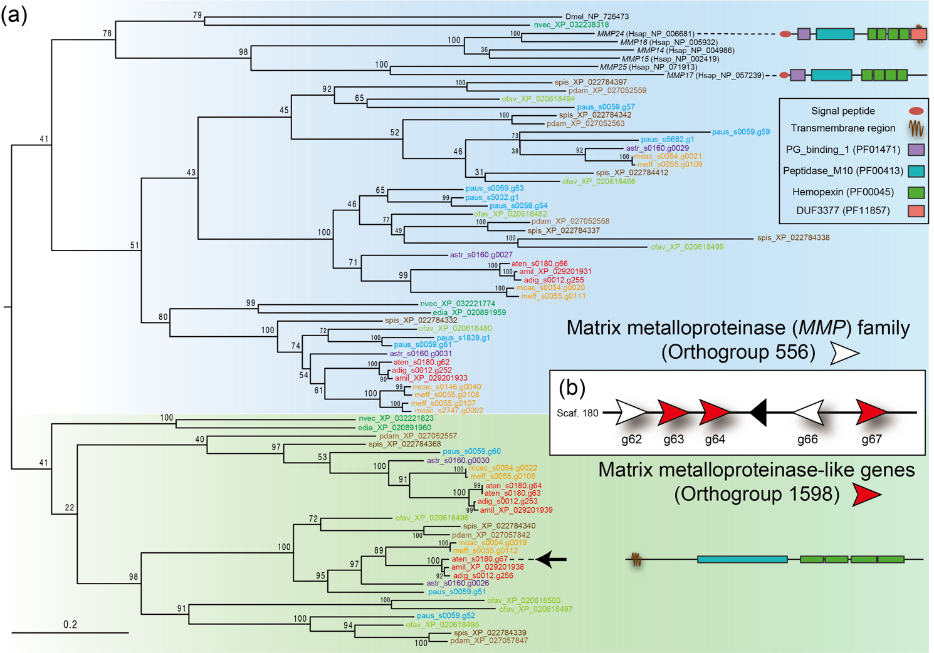
Supplementary Fig. S12. Molecular phylogenetic analysis of a matrix metalloproteinase (MMP) family.
(a) Phylogenetic tree of the MMP family.
409 gap-trimmed, aligned amino acids were used for phylogenetic tree construction (WAG model). Genes from Acropora (A. tenuis [aten], A. digitifera [adig], A. millepora [amil]), Montipora (M. cactus [mcac] and M. efflorescens [meff]), Astreopora myriophthalma (Astr), Porites australiensis (paus), S. pistillata (spis), O. faveolata (ofav), Pocillopora damicornis (pdam), sea anemones (Exaiptasia diaphana [edia] and Nematostella vectensis [nvec]), and bilaterians (D. melanogaster [dmel] and H. sapiens [hsap]) are colored red, yellow, purple, light-blue, brown, light-brown, light-green, green, and black, respectively. Gene IDs are shown following species name. A black arrow indicates the DEG. The sequence feature of the DEG and the reference genes (Human MMP24 and MMP25) is shown. Note that these sequence features do not reflect the sequence lengths.
(b) Tandem duplication of the MMP and MMP-like genes in A. tenuis genome.
Red and white arrows indicate tandemly duplicated MMP and MMP-like genes on scaffold 180, respectively, and their transcription direction.

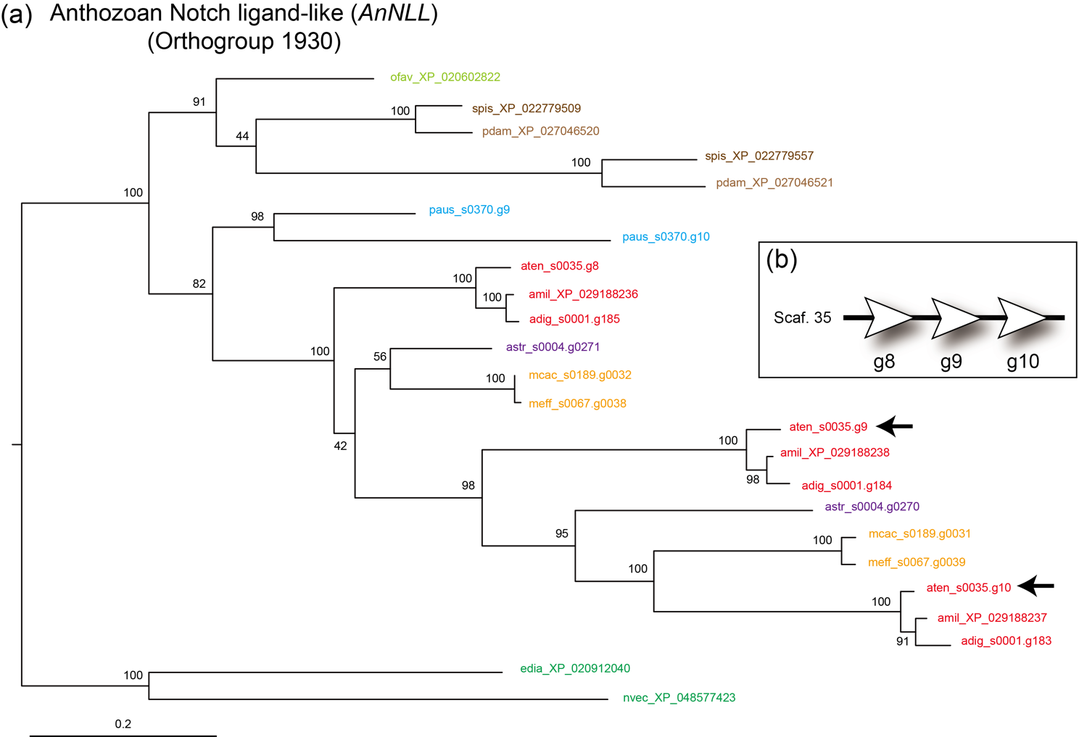
Supplementary Fig. S13. Molecular phylogenetic analysis of an anthozoan Notch ligand like (AnNLL).
(a) Phylogenetic tree of AnNLL.
573 gap-trimmed, aligned amino acids were used for phylogenetic tree construction (FLU model). Genes from Acropora (A. tenuis [aten], A. digitifera [adig], A. millepora [amil]), Montipora (M. cactus [mcac] and M. efflorescens [meff]), Astreopora myriophthalma (Astr), Porites australiensis (paus), S. pistillata (spis), O. faveolata (ofav), Pocillopora damicornis (pdam), and sea anemones (Exaiptasia diaphana [edia] and Nematostella vectensis [nvec]) are colored red, yellow, purple, light-blue, brown, light-brown, light-green, and green, respectively. Gene IDs are shown following species name. Black arrows indicate DEGs.
(b) Tandem duplication of AnNLL in A. tenuis genome.
White arrows indicate tandemly duplicated AnNLL on scaffold 35 and their transcription direction.
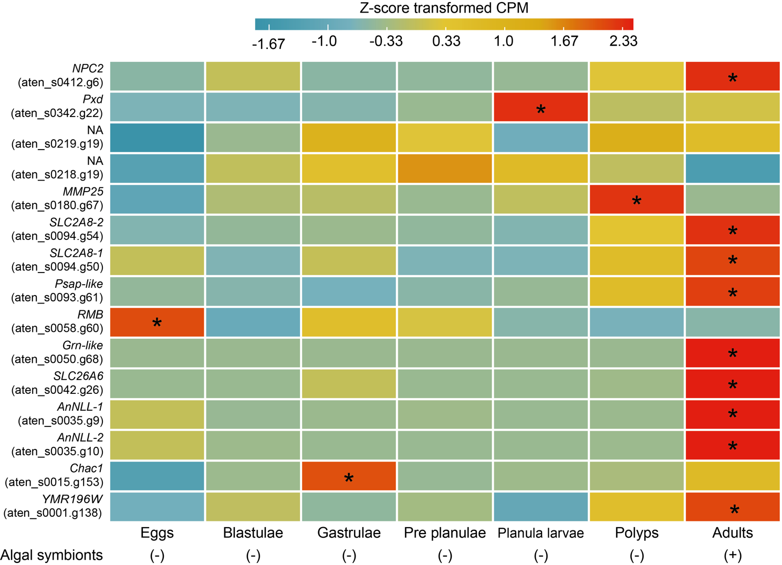
Supplementary Fig. S14. Comparison of expressions of the 15 genes in various samples from eggs to an adult colony in Acropora tenuis.
Minus and plus indicate the absence or presence of algal symbiont in samples, respectively. Asterisk indicates the significantly higher expression (Z-score > 1.96).

References
1 Yoshioka, Y. et al. Whole-genome transcriptome analyses of native symbionts reveal host coral genomic novelties for establishing coral-algae symbioses. Genome Biol Evol 13, doi:10.1093/gbe/evaa240 (2021).

