Self-assembled peptide/polymer hybrid nanoplatform for cancer immunostimulating therapies

Drug Delivery and Translational Research
Supplementary material

Saeedeh Khazaei^{1,2}, Ruben Varela-Calviño³, Mazda Rad-Malekshahi¹, Federico Quattrini², Safura Jokar⁴, Nima Rezaei⁵, Saeed Balalaie⁶, Ismaeil Haririan^{1,*}, Noemi Csaba², Marcos Garcia-Fuentes^{2,*}

¹ Department of Pharmaceutical Biomaterials and Medical Biomaterials Research center, Faculty of Pharmacy, Tehran University of Medical Sciences, Tehran, Iran.
² Department of Pharmacology, Pharmacy and Pharmaceutical Technology, CiMUS Research Center and Health Research Institute of Santiago de Compostela (IDIS), University of Santiago de Compostela, Santiago de Compostela, Spain.
³ Department of Biochemistry and Molecular Biology, School of Pharmacy, University of Santiago de Compostela, Spain.
⁴ Department of Nuclear Pharmacy, Faculty of Pharmacy, Tehran University of Medical Sciences, Tehran, Iran.
⁵ Department of Immunology, School of Medicine, Tehran University of Medical Sciences, Tehran, Iran.
⁶ Peptide Chemistry Research Center, K. N. Toosi University of Technology, Tehran, Iran.

*correspondence to: marcos.garcia@usc.es (MGF), haririan@tums.ac.ir

Table S1 List of the peptide sequences used in this study
Name | Sequence | Molecular weight  (g/mol) | Net weight  (%) | Function
TC | Ac-KVAELVHFL | 1055 | 83 | CD8+ T-cell epitope
SATC | Ac-AAVVLLLWAAYKVAELVHFL | 2268 | 81 | CD8+ T-cell epitope with  self-assembly properties
TH | Ac-AKFVAAWTLKA | 1205 | 76 | CD4+ T-cell epitope
SATH | Ac-AAVVLLLWKFERQAKFVAAWTLKA | 2808 | 69 | CD4+ T-cell epitope with  self-assembly properties

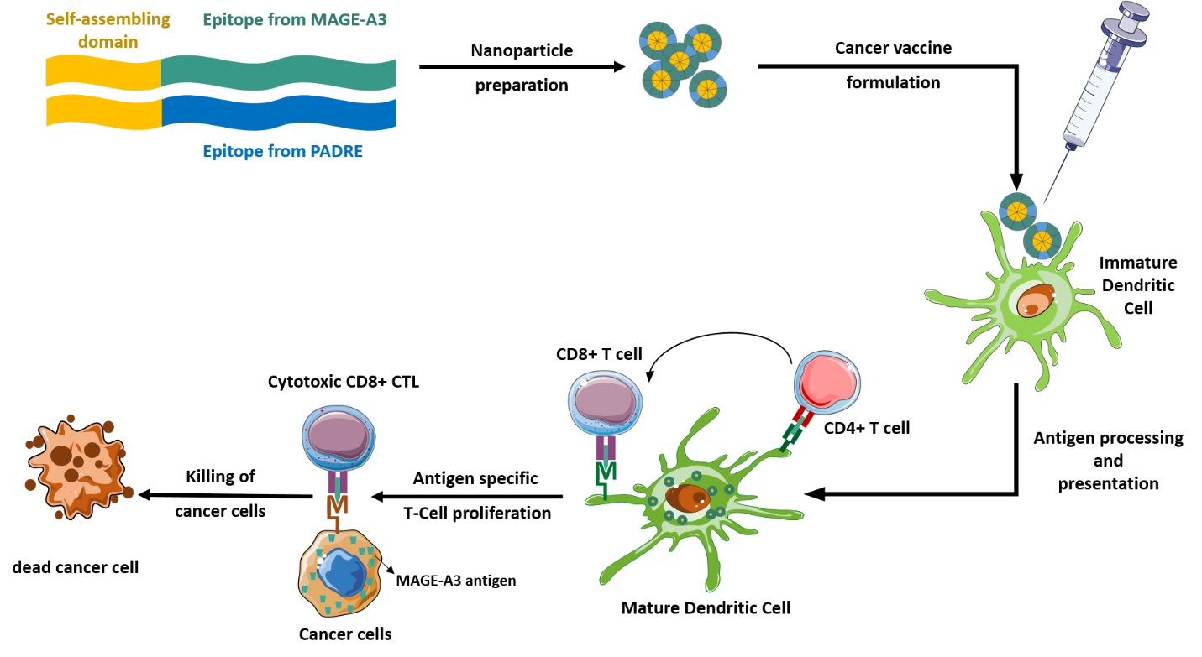
Fig. S1 Scheme of the technological strategy: peptide diblocks consisting of PADRE/MAGE-A3 are self-assembled as nanoparticles. These immunoactive nanoparticles can interact with dendritic cells to activate CD4+ and CD8+ T-cells capable of killing cancer cells

EtOH percentage | 10 | 5 | 20 | -- | -- | -- | --
mixing method | dropwise | -- | -- | At once | -- | -- | --
stirring time (min) | 30 | -- | -- | -- | 15 | -- | --
stirring speed (rpm) | 500 | -- | -- | -- | -- | 1000 | 1800

Fig. S2 Effect of different parameters on the particles size. Hyphens stand for the values that are set as in the optimized protocol

Fig. S3 (a) size, (b) PDI, (c) derived countrate and (d) pH of the peptide NPs prepared with different F127 concentrations (mean ± S.D., n ≥ 3). Data were analyzed with one-way ANOVA, Tukey test, P < 0.05. The asterisks in (c) express the statistical difference in the countrate of the formulations with 0.05 mM concentration of F127 with the other formulations

Fig. S4 (a) AF4 elution program, (b) Fractogram of different NPs recorded by UV detector at 280 nm. The small peak at 5-10 min is the void peak and it is given by non-separated particles, while the peak eluting between 20-27 min corresponds to the nanoparticles

Fig. S5 (a) Countrate and (b) PDI trends during 8 hours incubation of the NPs in RPMI supplemented with 10% FBS at 37˚C (mean ± S.D., n=3)

Fig. S6 (a) Phenotypic changes associated with the maturation of iDCs. (b) Induction of CD80-CD83 double-positive dendritic cell phenotype by incubation of iDCs with NPs at 10 µM for 48 h. Data are shown as the ratio (%) between the mean fluorescence intensity (MFI) of the CD80-CD83 marker in iDCs incubated with the different NPs versus the MFI of iDC incubated in culture media (mean ± S.D., n = 4]). Data were analyzed with one-way ANOVA, Sidak test, P < 0.05
Fig. S7 Optical densities (λ=405 nm) observed at 25X and 50X mice sera dilutions one week after receiving booster doses at 20000X dilution of the secondary antibody. Data were analyzed with two-way ANOVA, Tukey test, P < 0.05 (mean± S.E., n = 3 mice per group). All groups were statistically different from PBS and equal among them

