Supplementary material

Description
This supplementary material consist of the tables and figures that provide the reader with additional information about the performance of each hospital model on different test datasets.
Supplementary table 1 presents the mean accuracy, sensitivity, specificity, precision and F1 score over five folds metrics when tested with combined test dataset at the optimum threshold selected at Youden index. Additionally, we have added the or_mean and or_median that represent mean and median after removing outliers. Further, we have added majority and negative class weighted average results as well.
Supplementary figure S1 – S11 show the box plots that represent the performance of the models when tested with individual hospitals’ test data.
In the end, a heatmap is attached as supplemenetary figure 12 that shows an overview of the perfromance measure AUROC with 95% CI obtained from testing the each hospital model, general model and FL schemes along with mean and median after removing the outliers from prediction probabilties and two more FL sechemes, i.e weighted average based on majority and negative samples with each hospital test data and combined test data.

Model | Accuracy | Sensitivity | Specificity | Precision | F1
H01 | 0.711 (0.02) | 0.78 (0.011) | 0.681 (0.033) | 0.515 (0.024) | 0.62 (0.014)
H02 | 0.672 (0.013) | 0.721 (0.021) | 0.65 (0.012) | 0.471 (0.013) | 0.57 (0.015)
H03 | 0.663 (0.017) | 0.678 (0.053) | 0.657 (0.042) | 0.462 (0.017) | 0.548 (0.016)
H04 | 0.666 (0.017) | 0.714 (0.042) | 0.645 (0.04) | 0.466 (0.016) | 0.563 (0.008)
H05 | 0.662 (0.03) | 0.789 (0.028) | 0.606 (0.054) | 0.466 (0.028) | 0.585 (0.015)
H06 | 0.641 (0.012) | 0.755 (0.06) | 0.591 (0.032) | 0.444 (0.011) | 0.559 (0.021)
H07 | 0.662 (0.017) | 0.61 (0.106) | 0.685 (0.06) | 0.457 (0.017) | 0.519 (0.043)
H08 | 0.674 (0.019) | 0.707 (0.012) | 0.66 (0.028) | 0.474 (0.021) | 0.567 (0.015)
H09 | 0.585 (0.034) | 0.787 (0.109) | 0.497 (0.09) | 0.405 (0.017) | 0.532 (0.027)
H10 | 0.759 (0.006) | 0.717 (0.02) | 0.778 (0.014) | 0.583 (0.01) | 0.643 (0.006)
H11 | 0.593 (0.055) | 0.611 (0.125) | 0.586 (0.133) | 0.396 (0.032) | 0.473 (0.017)
GM | 0.772 (0.015) | 0.76 (0.038) | 0.777 (0.036) | 0.598 (0.027) | 0.668 (0.008)
mean | 0.702 (0.01) | 0.781 (0.017) | 0.668 (0.015) | 0.504 (0.011) | 0.613 (0.011)
median | 0.682 (0.011) | 0.741 (0.019) | 0.656 (0.019) | 0.483 (0.012) | 0.585 (0.01)
or_mean | 0.67 (0.013) | 0.764 (0.039) | 0.63 (0.033) | 0.472 (0.012) | 0.583 (0.009)
or_median | 0.675 (0.009) | 0.738 (0.017) | 0.648 (0.014) | 0.475 (0.009) | 0.578 (0.009)
samples | 0.744 (0.004) | 0.77 (0.025) | 0.733 (0.012) | 0.555 (0.007) | 0.645 (0.008)
positives | 0.762 (0.014) | 0.754 (0.027) | 0.765 (0.031) | 0.583 (0.022) | 0.657 (0.006)
negatives | 0.718 (0.016) | 0.792 (0.016) | 0.685 (0.03) | 0.522 (0.019) | 0.629 (0.01)
minority | 0.764 (0.01) | 0.748 (0.016) | 0.771 (0.02) | 0.586 (0.017) | 0.657 (0.008)
majority | 0.728 (0.019) | 0.797 (0.042) | 0.698 (0.043) | 0.535 (0.026) | 0.639 (0.009)
mpd | 0.756 (0.006) | 0.765 (0.019) | 0.751 (0.011) | 0.571 (0.009) | 0.654 (0.008)
supplementary table 1 Mean of accuracy, sensitivity, specificity, precision, and F1 score of all the models tested with the combined test dataset over 5 folds with standard deviation at the optimum threshold selected at Youden index.

Box Plots
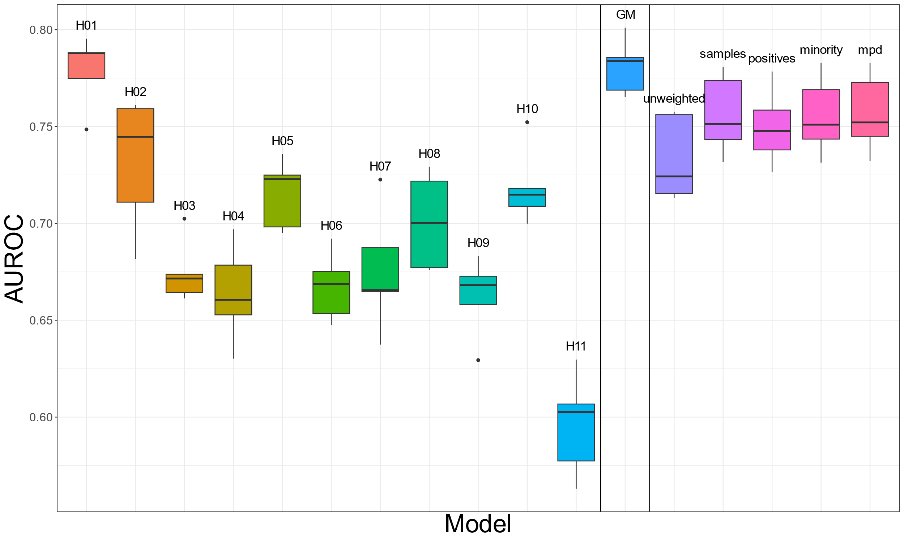
Supplementary figure S1 Models were tested using test data from Hospital H01
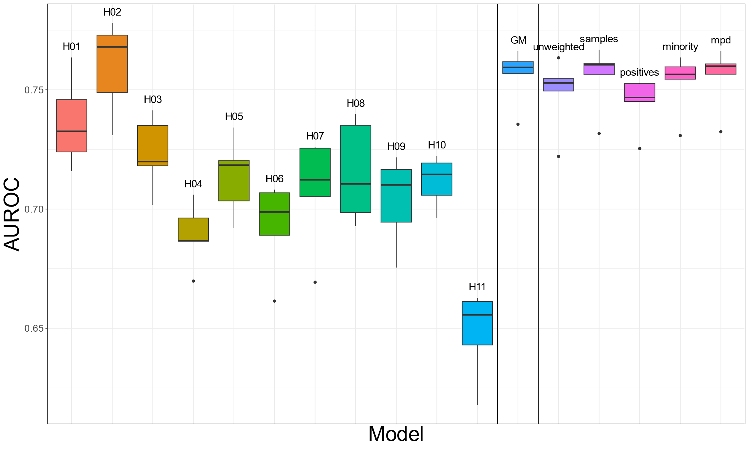
Supplementary figure S2 Models were tested using test data from Hospital H02
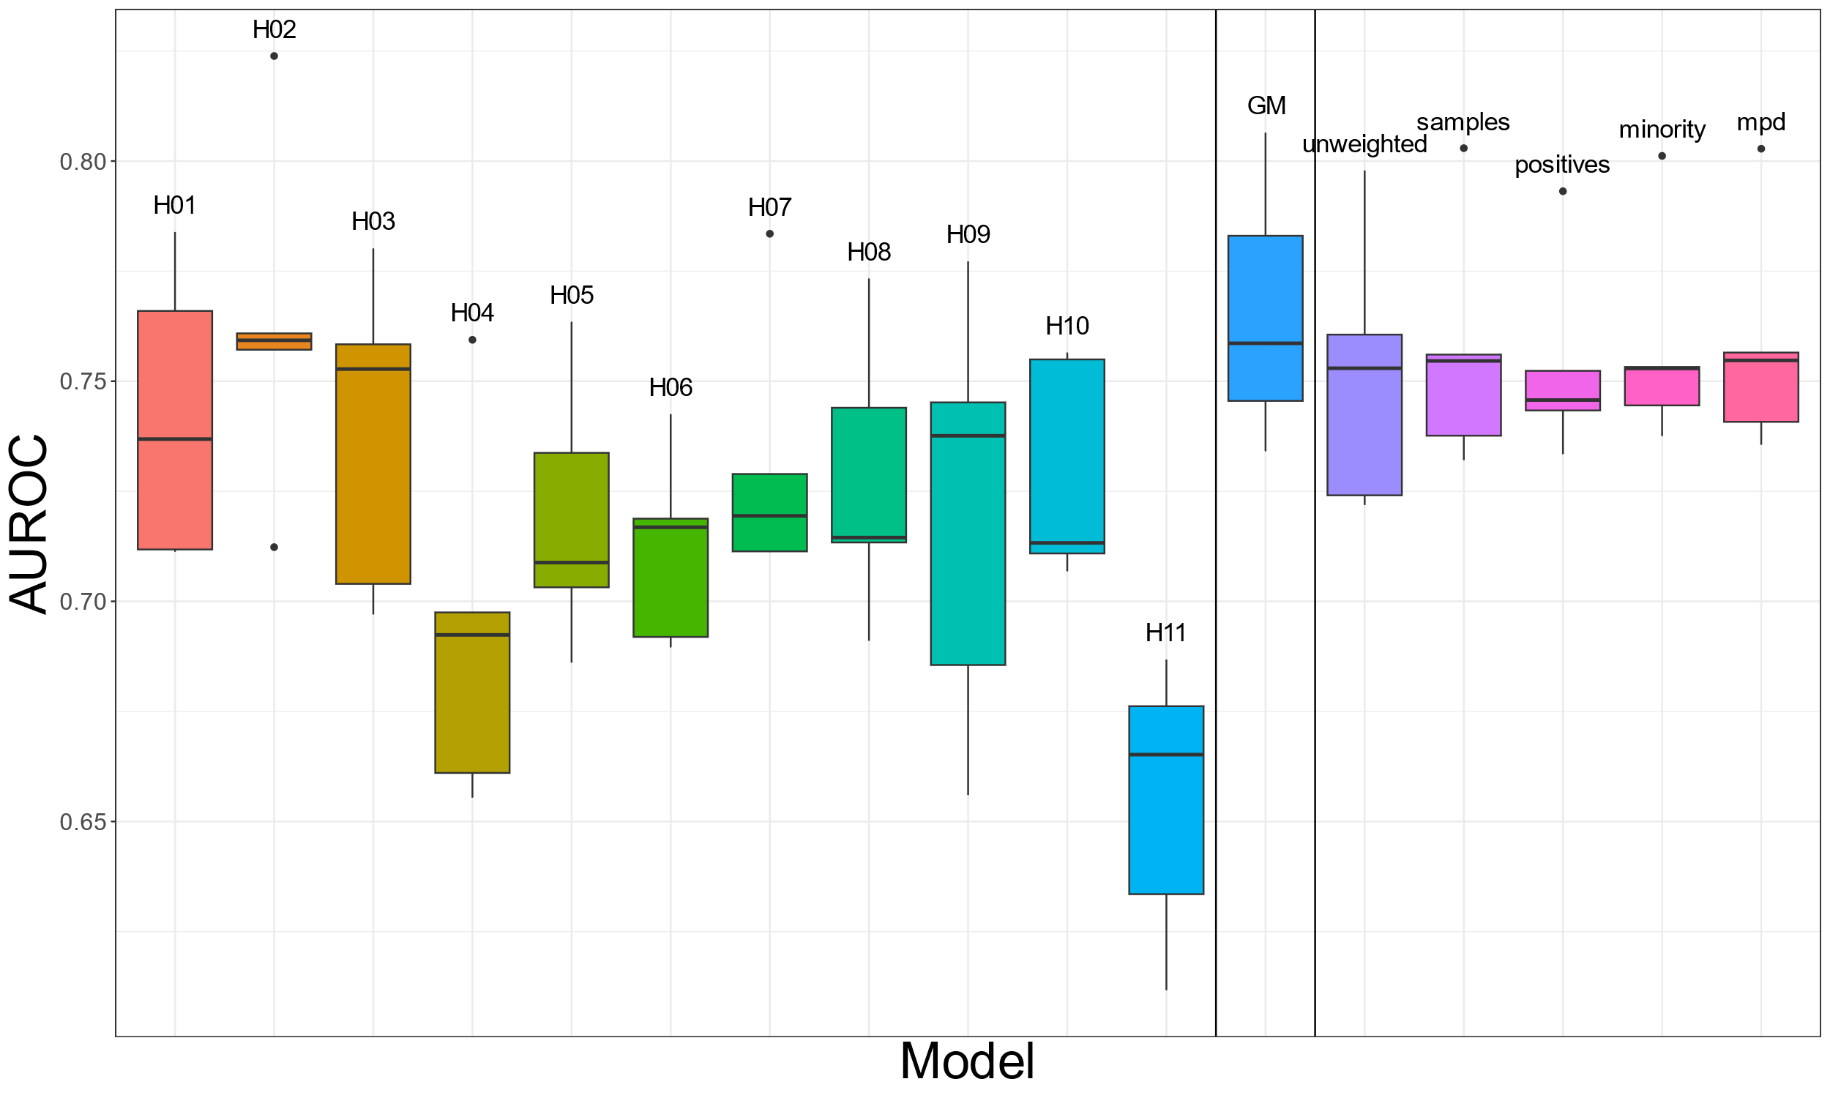
Supplementary figure S3 Models were tested using test data from Hospital H03
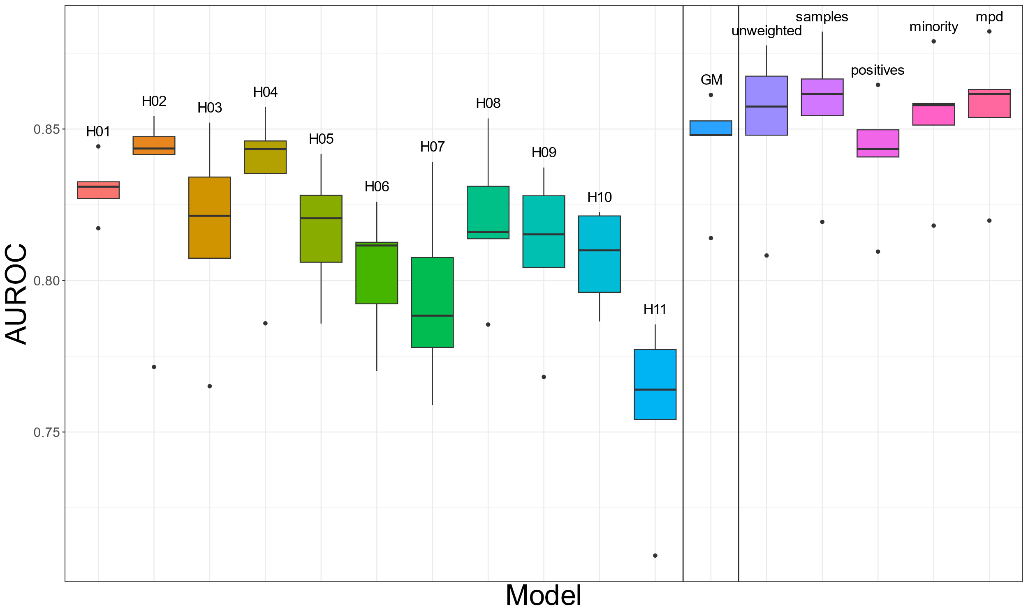
Supplementary figure S4 Models were tested using test data from Hospital H04
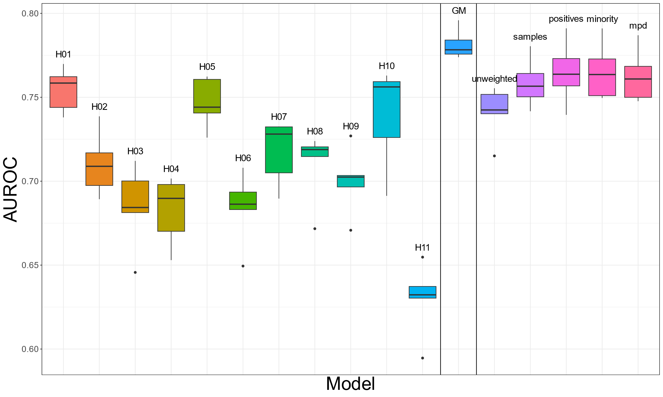
Supplementary figure S5 Models were tested using test data from Hospital H05
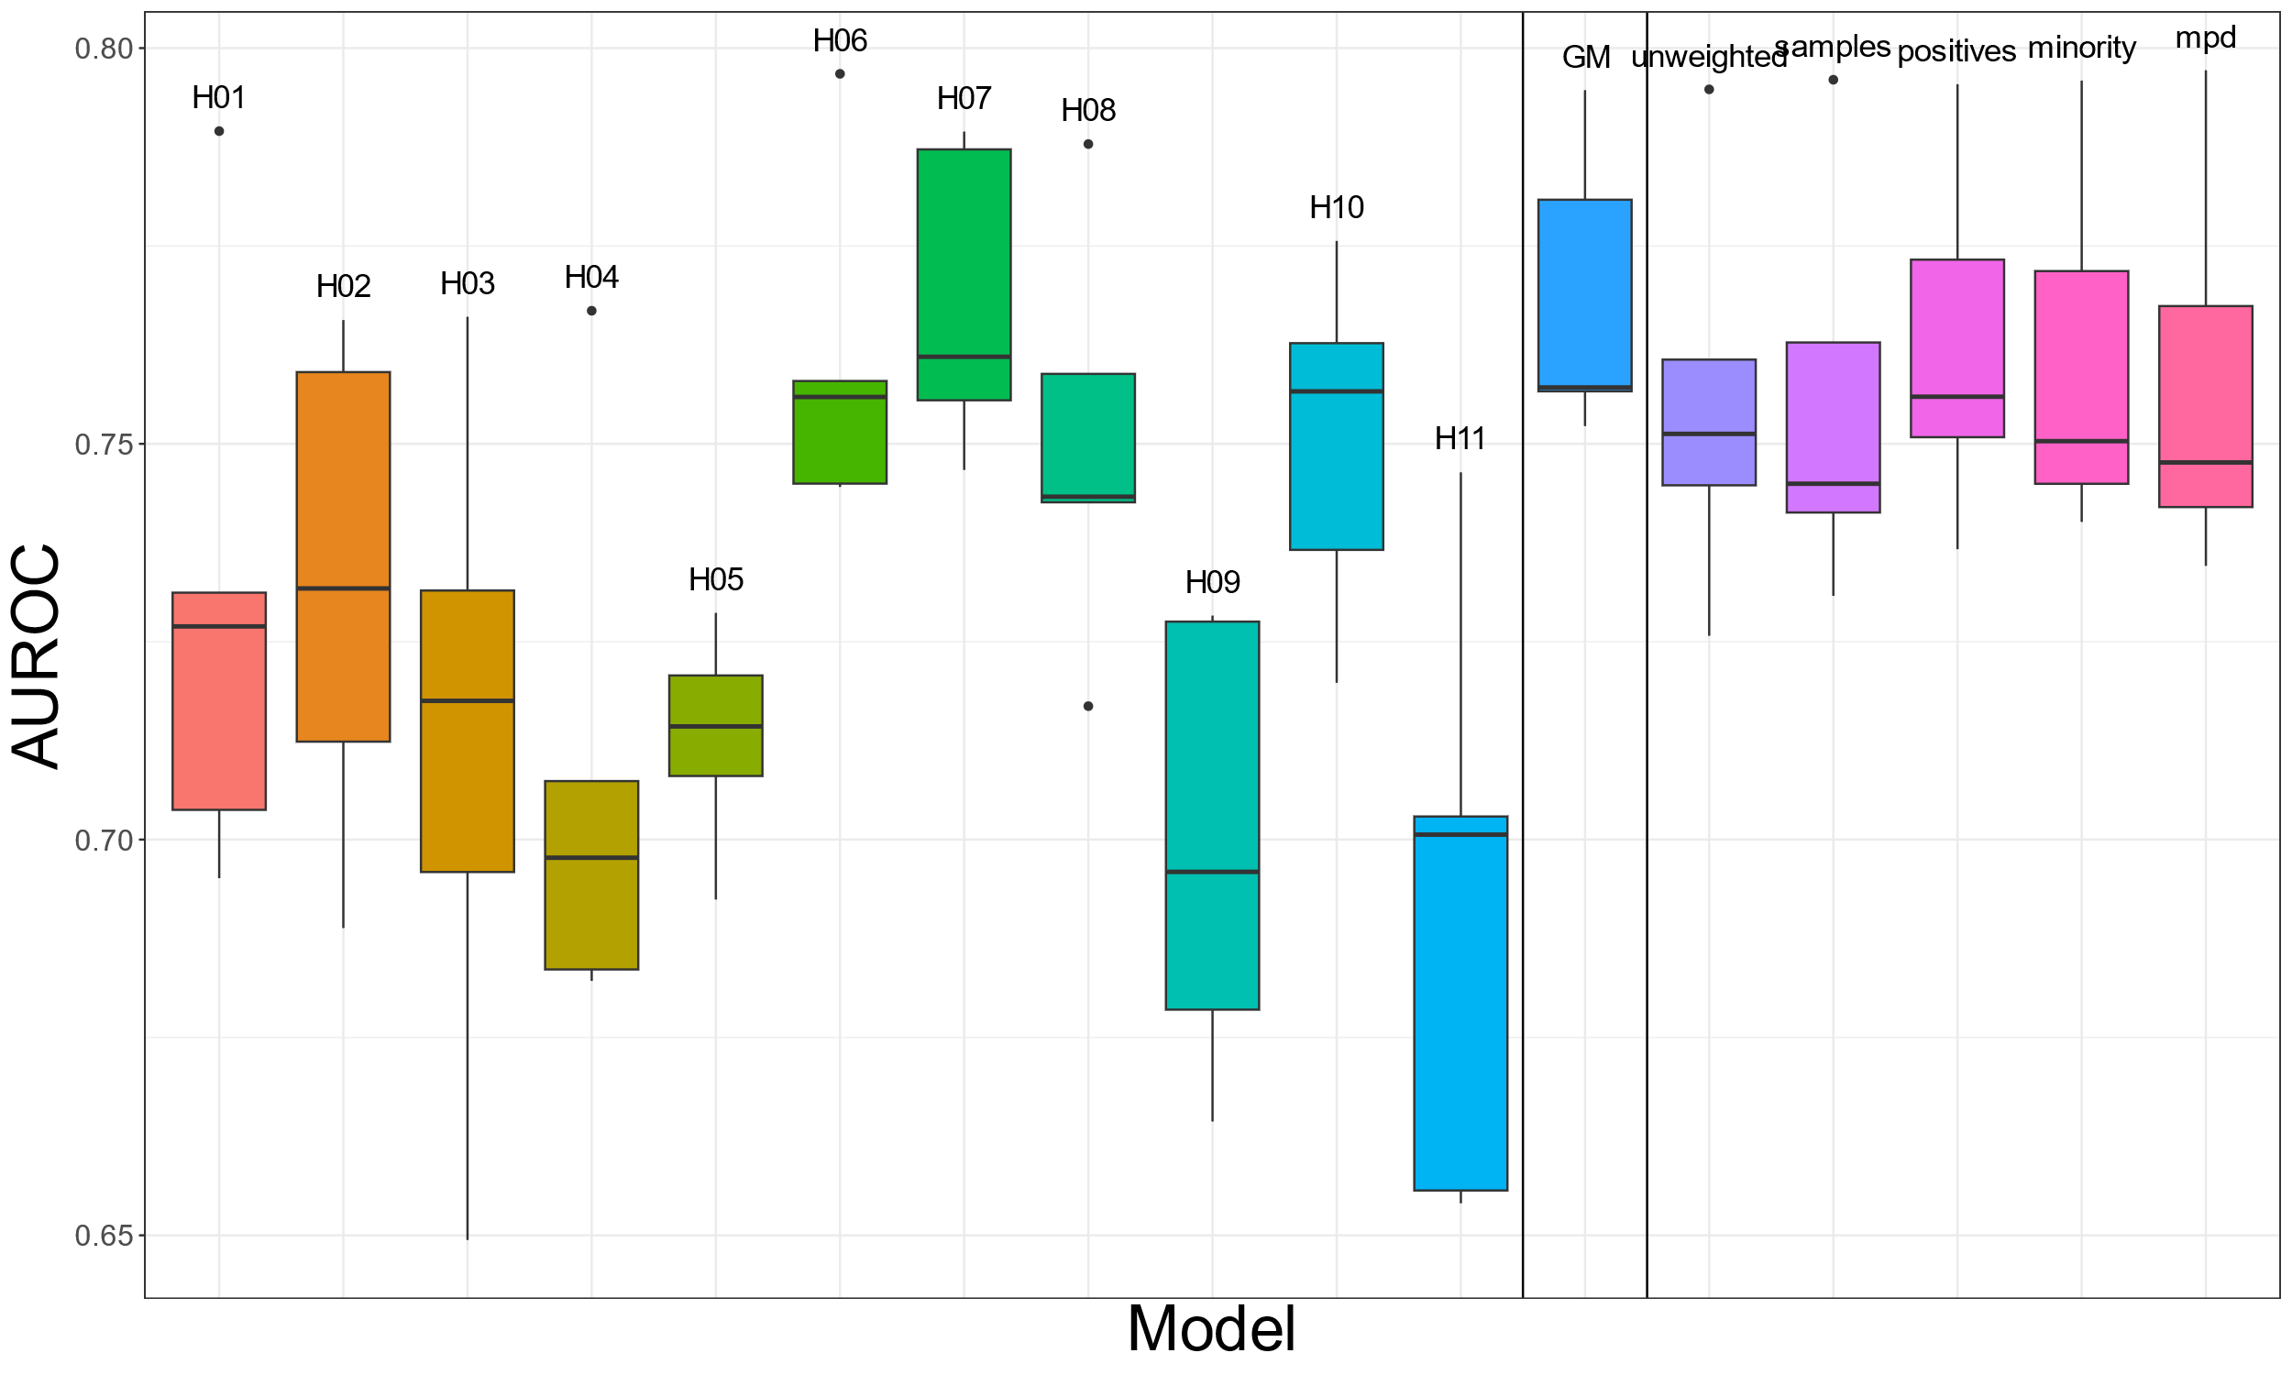
Supplementary figure S6 Models were tested using test data from Hospital H06
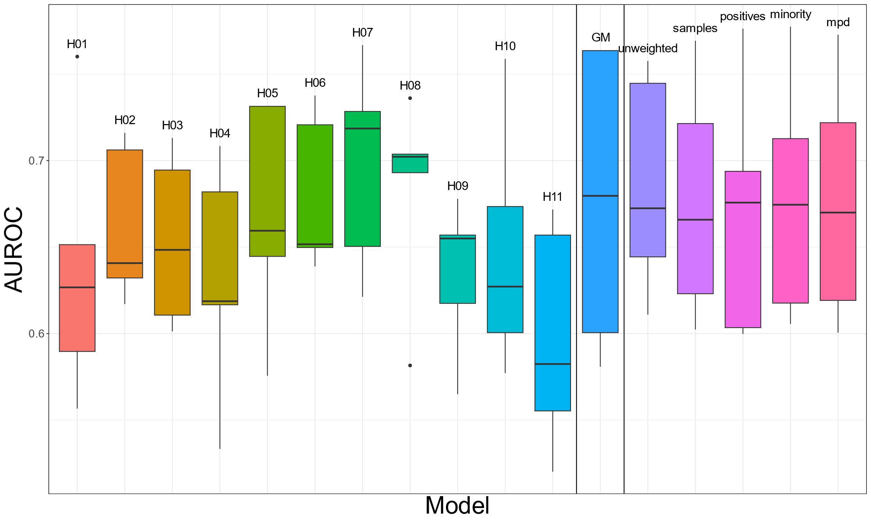
Supplementary figure S7 Models were tested using test data from Hospital H07
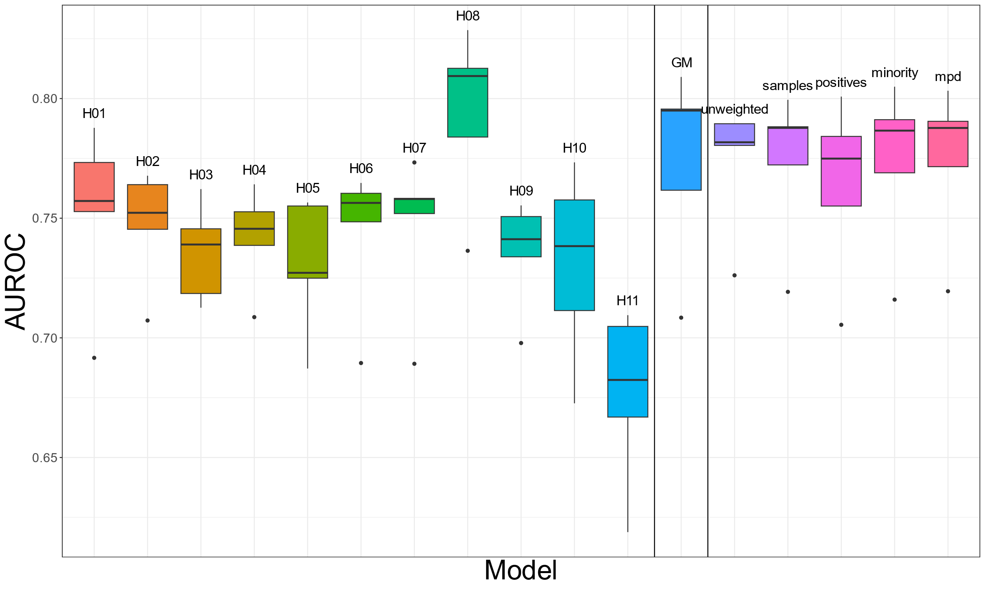
Supplementary figure S8 Models were tested using test data from Hospital H08
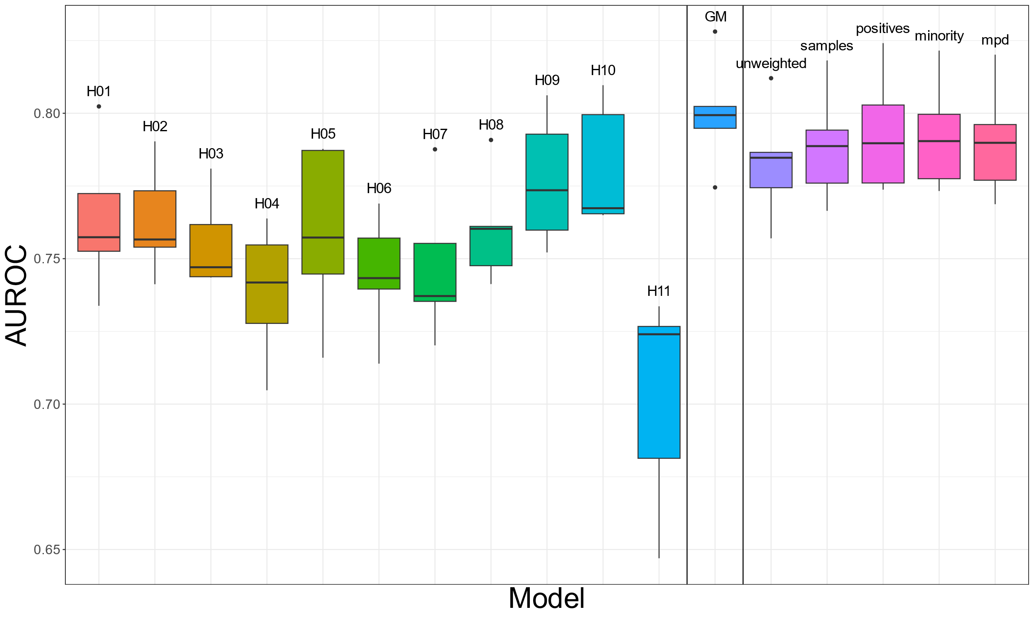
Supplementary figure S9 Models were tested using test data from Hospital H09
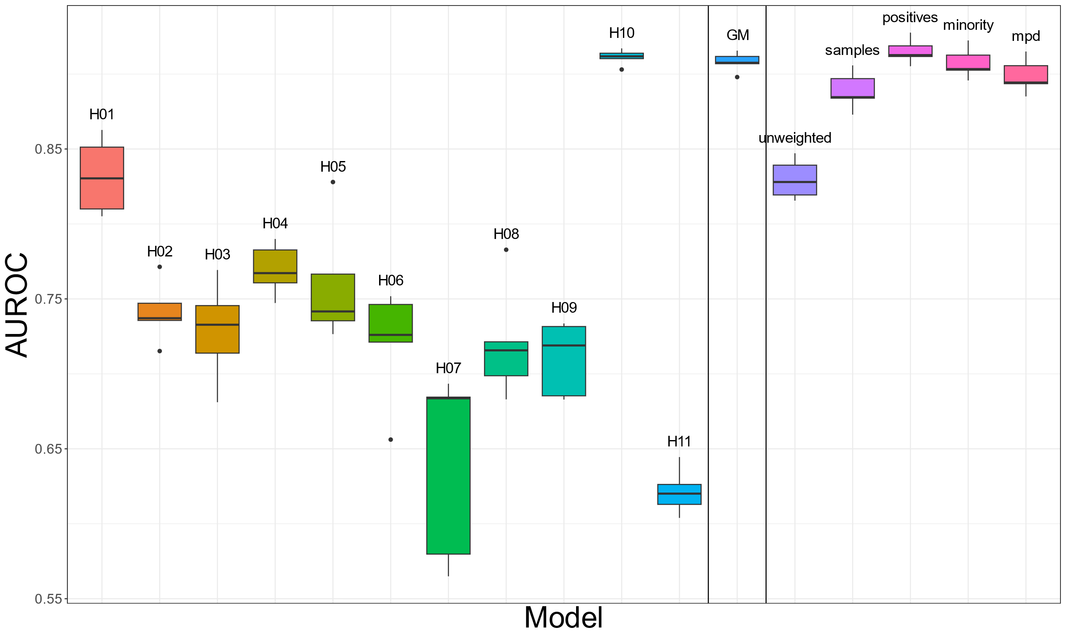
Supplementary figure S10 Models were tested using test data from Hospital H10

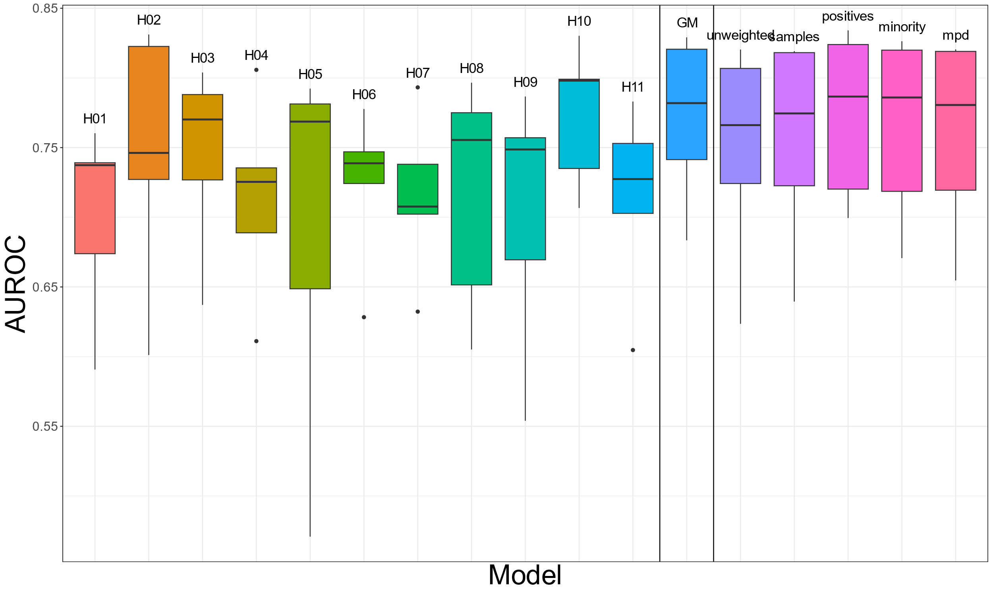
Supplementary figure S11 Models were tested using test data from Hospital H11

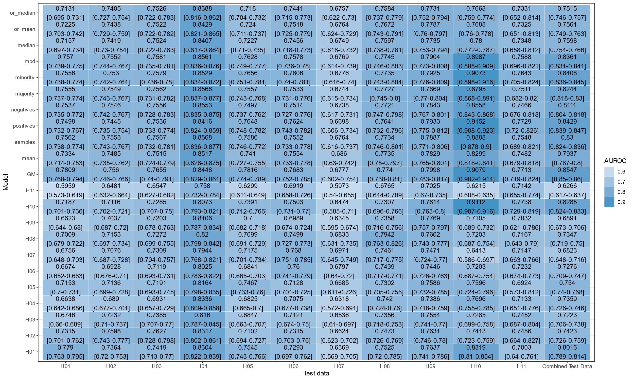
Supplementary fig S 12 Health map showing the Area Under Receiver Operation Characteristics (AUROC) along with 95% confidence interval. The performance of the hospital [H01-H10] models, general model [GM], federated learning weighted average models (unweighted (mean), samples, positives, negatives, majority, minority, mpd, median, mean after outlier removal and median after outlier removal) when tested with test data from individual hospital as well as the combined test dataset. Y-axis represents the models and X-axis represents test data.

