Supplementary Information
A Wide Temperature 10 V Solid-state Electrolyte with a Critical Current Density of over 20 mA cm⁻²
Yiqi Wei¹, Zhenglong Li², Zichong Chen¹, Panyu Gao^{3*}, Mingxi Gao¹, Chenhui Yan¹, Zhijun Wu², Qihang Ma¹, Yinzhu Jiang¹, Xuebin Yu³, Xin Zhang¹, Yongfeng Liu¹, Yaxiong Yang^{2*}, Mingxia Gao¹, Wenping Sun¹, Jian Chen^{2*}, Hongge Pan^{1,2*}
¹State Key Laboratory of Silicon Materials and School of Materials Science and Engineering, Zhejiang University, Hangzhou, 310027, China.
²Institute of Science and Technology for New Energy, Xi’an Technological University, Xi’an 710021, China
³ Department of Materials Science, Fudan University, Shanghai, 200433, China
*Corresponding authors: 21110300002@m.fudan.edu.cn; yangyaxiong@xatu.edu.cn; chenjian@xatu.edu.cn; honggepan@zju.edu.cn, hgpan@zju.edu.cn;

Supplementary Table 1. Summary of ex-situ XPS quantifications of HT150-0PMMA and HT150-5PMMA at the cut-off voltages of 2.8, 4.2 and 10 V during the 1st, 2nd and 3rd CV experiments.
Specimen | Cycle Number  /Voltage (V) | B1s (at %) |  |  |  |  | O1s (at %)
Specimen | Cycle Number  /Voltage (V) | B-O | Oxide BH₄⁻ | B-H | (OCH₃)_{x}BH_{4-x} | O-B |  | O-Al | O-C=O | C-O-CH₃ | Transition O | C=O(Li⁺•O=C)
HT150-0PMMA | 1/2.8 | 39.63 | 38.10 | 22.27 |  | 71.01 |  | 28.99
HT150-0PMMA | 1/4.2 | 36.24 | 44.66 | 19.10 |  | 68.48 |  | 31.52
HT150-0PMMA | 1/10 | 33.86 | 49.70 | 16.44 |  | 71.98 |  | 28.02
HT150-0PMMA | 2/2.8 | 48.30 | 36.72 | 14.97 |  | 72.03 |  | 27.97
HT150-0PMMA | 2/4.2 | 46.48 | 39.85 | 13.67 |  | 72.85 |  | 27.15
HT150-0PMMA | 2/10 | 43.24 | 44.77 | 11.99 |  | 72.91 |  | 29.09
HT150-0PMMA | 3/2.8 | 49.06 | 34.62 | 16.32 |  | 71.64 |  | 28.36
HT150-0PMMA | 3/4.2 | 41.57 | 46.46 | 11.97 |  | 72.73 |  | 27.27
HT150-0PMMA | 3/10 | 44.26 | 50.38 | 5.36 |  | 70.90 |  | 29.10
HT150-5PMMA | 1/2.8 | 64.81 | 1.56 | 21.19 | 12.43 | 42.39 |  | 10.77 | 23.52 | 11.02 | 1.17 | 11.13
HT150-5PMMA | 1/4.2 | 64.26 | 2.28 | 19.22 | 11.73 | 49.19 |  | 8.31 | 17.33 | 12.42 | 2.56 | 10.19
HT150-5PMMA | 1/10 | 66.29 | 2.52 | 18.62 | 13.78 | 46.33 |  | 7.65 | 21.45 | 13.13 | 1.39 | 10.05
HT150-5PMMA | 2/2.8 | 60.50 | 5.92 | 21.30 | 12.28 | 42.09 |  | 10.55 | 23.55 | 11.92 | 0.59 | 11.30
HT150-5PMMA | 2/4.2 | 60.81 | 7.38 | 20.57 | 11.24 | 49.69 |  | 8.01 | 17.69 | 12.92 | 1.58 | 10.10
HT150-5PMMA | 2/10 | 60.14 | 8.63 | 19.93 | 11.31 | 46.69 |  | 7.15 | 21.65 | 14.26 | 0.80 | 9.31
HT150-5PMMA | 3/2.8 | 61.01 | 8.16 | 20.36 | 10.47 | 51.43 |  | 9.66 | 16.78 | 10.69 | 0.77 | 10.74
HT150-5PMMA | 3/4.2 | 60.00 | 8.34 | 20.18 | 11.49 | 50.38 |  | 8.58 | 15.41 | 12.03 | 2.93 | 10.66
HT150-5PMMA | 3/10 | 60.28 | 8.91 | 19.16 | 11.65 | 47.33 |  | 10.04 | 16.59 | 12.21 | 2.73 | 11.21

Supplementary Table 2. Summary of the electrical properties and electrochemical performances of the most-studied SEs.
Typical SEs | Li-ion Conductivity  (S cm⁻¹) | Electronic Conductivity  (S cm⁻¹) | Voltage Windows  (V) | CCD  (mA cm⁻²) | Cycling performances | Capacity  (mAh cm⁻²) | Temperature  (℃)
This Work | 5.1×10⁻⁴ | 3.5×10⁻¹⁰ | -0.2 ~ 10 | 21.6 | 10.8 mA cm⁻² for 6000 h | 1.0 | 30
This Work | 2.6×10⁻² | 9.3×10⁻⁹ | -0.2 ~ 10 | 328.0 | 159.5 mA cm⁻² for 6000 h | 1.0 | 130
LiBH₄-LZO¹ | - | - | 1.7 ~ 2.5 | 13.0 | 3.0 mA cm⁻² for 120 h | 0.4 | 120
Li₄(BH₄)₃I@SBA-15² | 8.6×10⁻⁴ | - | -0.2 ~5.0 | 2.6 | 0.5 mA cm⁻² for 350 h | 0.1 | 55
LiBH₄-LiF³ | 1.0×10⁻³ | 3.7×10⁻⁸ | -0.3 ~ 3.0 | 6.6 | 5.0 mA cm⁻² for 500 h | - | 125
Li₂B₁₂H₁₂⁴ | 3.1×10⁻⁴ | 9.0×10⁻¹⁰ | -0.5 ~ 5.0 | 3.8 | - | 0.5 | 75
(LiBH₄)₂AB⁵ | 4.9×10⁻³ | 1.1×10⁻⁶ | 0 ~ 2.0 | 3.0 | 0.2 mA cm⁻² for 40 h | 0.2 | 50
NZSP⁶ | - | - | - | 2.5 | 0.5 mA cm⁻² for 500 h | 0.25 | 30
LPSCl⁷ | - | - | - | 1.0 | 1.0 mA cm⁻² for 500 h | 1.0 | 30
LLZO¹ | 1.0×10⁻³ | - | - | 2.4 | 1.0 mA cm⁻² for 300 h | 0.5 | 30
LPSCl⁸ | - | - | - | 10.0 | 0.25 mA cm⁻² for 1800 h | 0.25 | 30
LGPS⁹ | - | - | 0.1 ~ 2.5 | 11.0 | 0.5 mA cm⁻² for 3800 h | 0.5 | 30
YSZ@BASE¹⁰ | 2.7×10⁻³ | 6.0 10⁻¹² | 3.0 ~ 4.5 | 7.0 | 0.5 mA cm⁻² for 330 h | 3.5 | 80
β″-alumina¹¹ | 1.6×10⁻³ | 7.0 10⁻¹¹ | - | 14.0 | - | 0.25 | 30

Supplementary Table 3. Summary of XPS quantifications of HT150-0PMMA and HTy-5PMMA (y = 100, 110, 120, 130, 140 and 150) SEs.
Specimens | B1s (at %) |  |  | O1s (at %)
Specimens | B-O | B-H | (OCH₃)_{x}BH_{4-x} | O-B | O-Al | O-C=O | C-O-CH₃ | Transition O | C=O(Li⁺•O=C)
HT150-0PMMA | 46.27 | 53.73 | 0 | 68.30 | 15.00 | 6.67 | 9.07 | 0.86 | 0
HT100-5PMMA | 46.95 | 53.05 | 2.05 | 63.25 | 8.00 | 17.00 | 9.05 | 0.65 | 0
HT110-5PMMA | 47.55 | 52.45 | 3.06 | 60.77 | 7.88 | 16.90 | 9.95 | 0.22 | 1.22
HT120-5PMMA | 48.85 | 51.15 | 6.96 | 57.20 | 7.55 | 16.50 | 9.05 | 0.52 | 2.22
HT130-5PMMA | 48.44 | 43.63 | 7.93 | 52.52 | 7.90 | 16.69 | 8.66 | 0.34 | 5.96
HT140-5PMMA | 58.90 | 41.10 | 10.09 | 51.27 | 7.79 | 15.98 | 8.26 | 0.55 | 6.06
HT150-5PMMA | 49.15 | 39.40 | 11.45 | 48.23 | 7.31 | 15.04 | 10.24 | 0.44 | 7.29

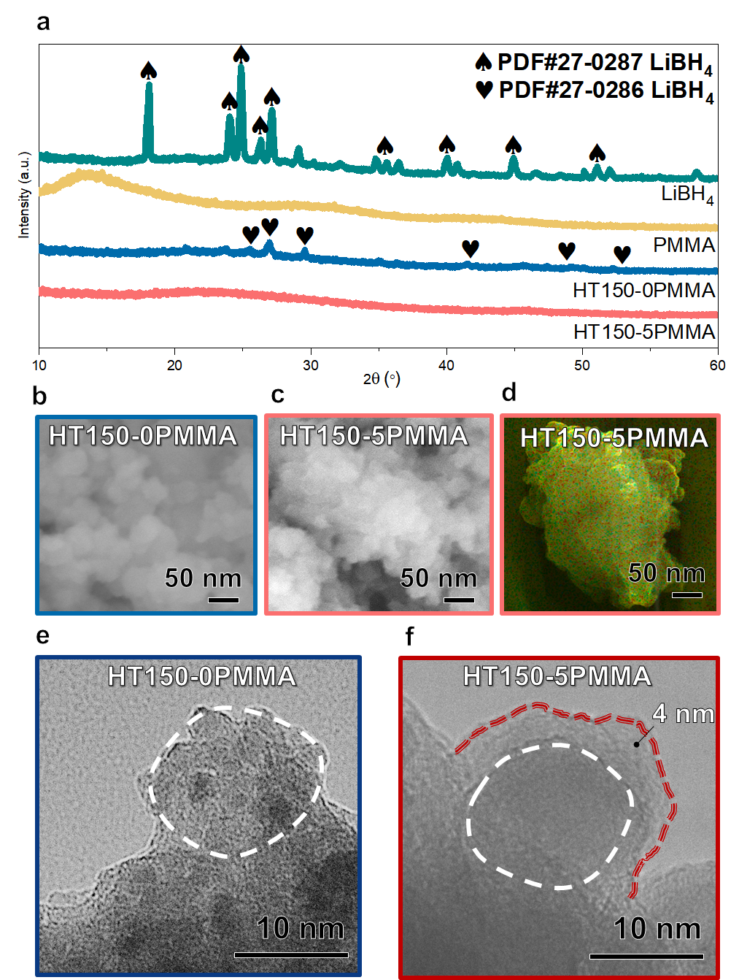

Supplementary Fig. 1. Structural characterizations of ISMR-modified SEs. a, XRD curves for LiBH₄, PMMA, HT150-0PMMA and HT150-5PMMA. SEM images of b, HT150-0PMMA and c, HT150-5PMMA. d, EDS of HT150-5PMMA secondary particle. Cryo-TEM images of e, HT150-0PMMA and f, HT150-5PMMA.

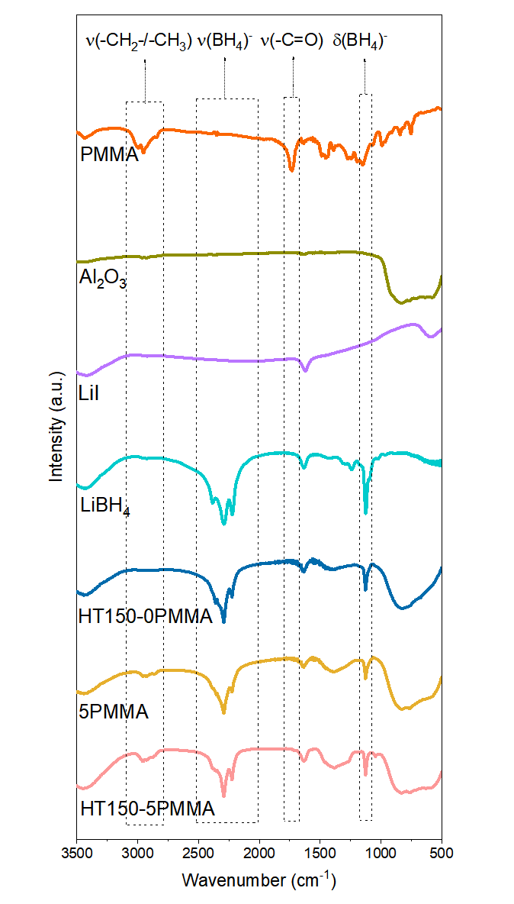

Supplementary Fig. 2. FTIR spectra of LiBH₄, LiI, Al₂O₃, PMMA, HT150-0PMMA, 5PMMA and HT150-5PMMA.

Supplementary Fig. 3. Ex situ XPS analyses over the CV cycles for HT150-0PMMA and HT150-5PMMA. a, B1s and b, O1s XPS data for HT150-0PMMA with cutoff voltages of 2.8, 4.2 and 10.0 V at the 2nd cycle. c, B1s and d, O1s XPS spectra for HT150-0PMMA with cutoff voltages of 2.8, 4.2 and 10.0 V at the 3rd cycle. e, B1s and f, O1s XPS spectra for HT150-5PMMA with cutoff voltages of 2.8, 4.2 and 10.0 V at the 2nd cycle. g, B1s and h, O1s XPS spectra for HT150-5PMMA with cutoff voltages of 2.8, 4.2 and 10.0 V at the 3rd cycle.

Supplementary Fig. 4. Extended CV measurement from 8.0 to 15.0 V for HT150-5PMMA.

Supplementary Fig. 5. CV curves over wide operational temperature ranges. Temperature-dependent CV curves for HT150-0PMMA at a, -30 ℃, b, 0 ℃ and c, 80 ℃. CV curves for the HT150-5PMMA at d, -30 ℃, e, 0 ℃ and f, 80 ℃. CV curves for HT150-0PMMA at g, 110 ℃, h, 130 ℃ and i, 150 ℃. CV curves for HT150-5PMMA at j, 110 ℃, k, 130 ℃ and l, 150 ℃.
Supplementary Fig. 6. Extended Dendrite suppression with the ISMR-modified SEs. CCDs of a, HT150-1PMMA, b, HT150-3PMMA, c, HT150-7PMMA and d, HT150-10PMMA measured at 25 ℃. CCDs of e, HT150-0PMMA, f, HT150-1PMMA, g, HT150-3PMMA, h, HT150-5PMMA, i, HT150-7PMMA, j, HT150-10PMMA measured at 130 ℃. Li plating and stripping performances of HT150-0PMMA and HT150-5PMMA measured at 130 ℃ at k, 32.00 mA cm⁻² and l, 164.00 mA cm⁻².
Supplementary Fig. 7. Cycling performances of the ISMR-modified SEs over the wide operational temperature range. Li plating and stripping curves for HT150-0PMMA and HT150-5PMMA at a, 0.1 CCD and at b, 0.5 CCD at -30 ℃. Li plating and stripping curves for HT150-0PMMA and HT150-5PMMA at c, 0.1 CCD and at d, 0.5 CCD at 80 ℃. Li plating and stripping curves for HT150-0PMMA and HT150-5PMMA at e, 0.1 CCD and at f, 0.5 CCD at 110 ℃. Li plating and stripping curves of HT150-0PMMA and HT150-5PMMA at g, 0.1 CCD and at h, 0.5 CCD at 150 ℃.

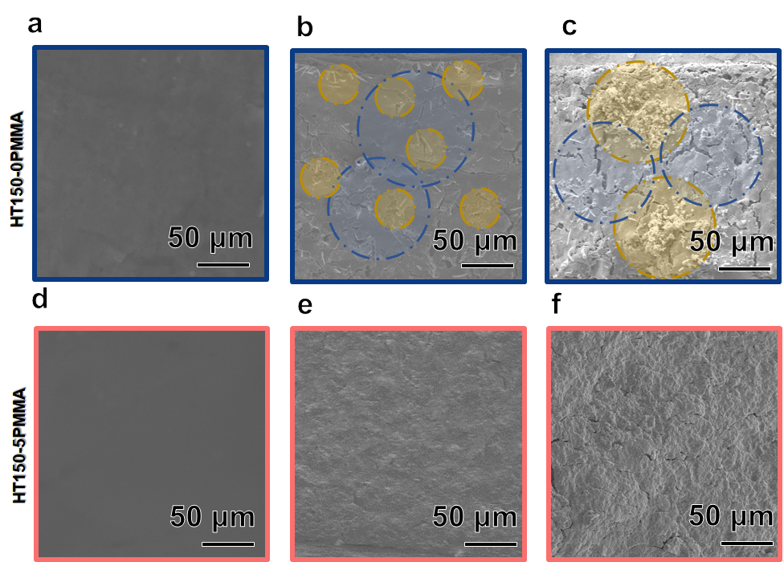

Supplementary Fig. 8. Failure mechanisms of the ISMR-modified SEs a, Cross-sectional SEM images determined before cycling, b, after 500 h and c, after 800 h for HT150-0PMMA. d, Cross-sectional SEM images determined before cycling, e, after 500 h and f, after 5000 h for HT150-5PMMA. The blue circles represent the cracks and flaws in SEs and the yellow ones represent Li depositions.

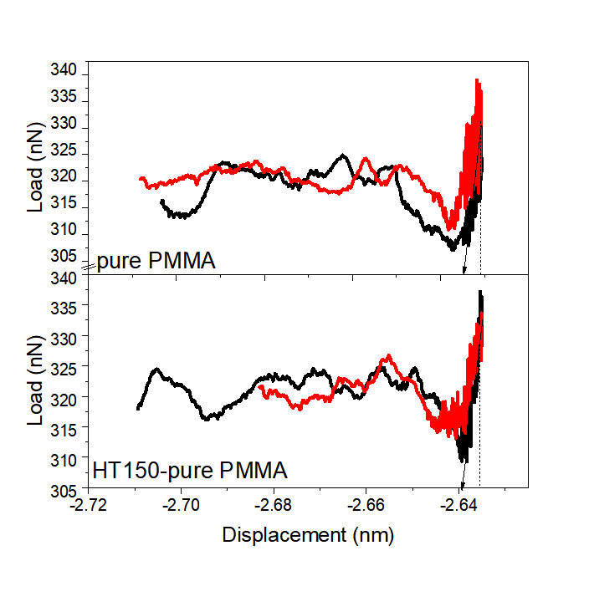

Supplementary Fig. 9. AFM nanoindentations of pure PMMA and HT150-pure PMMA.

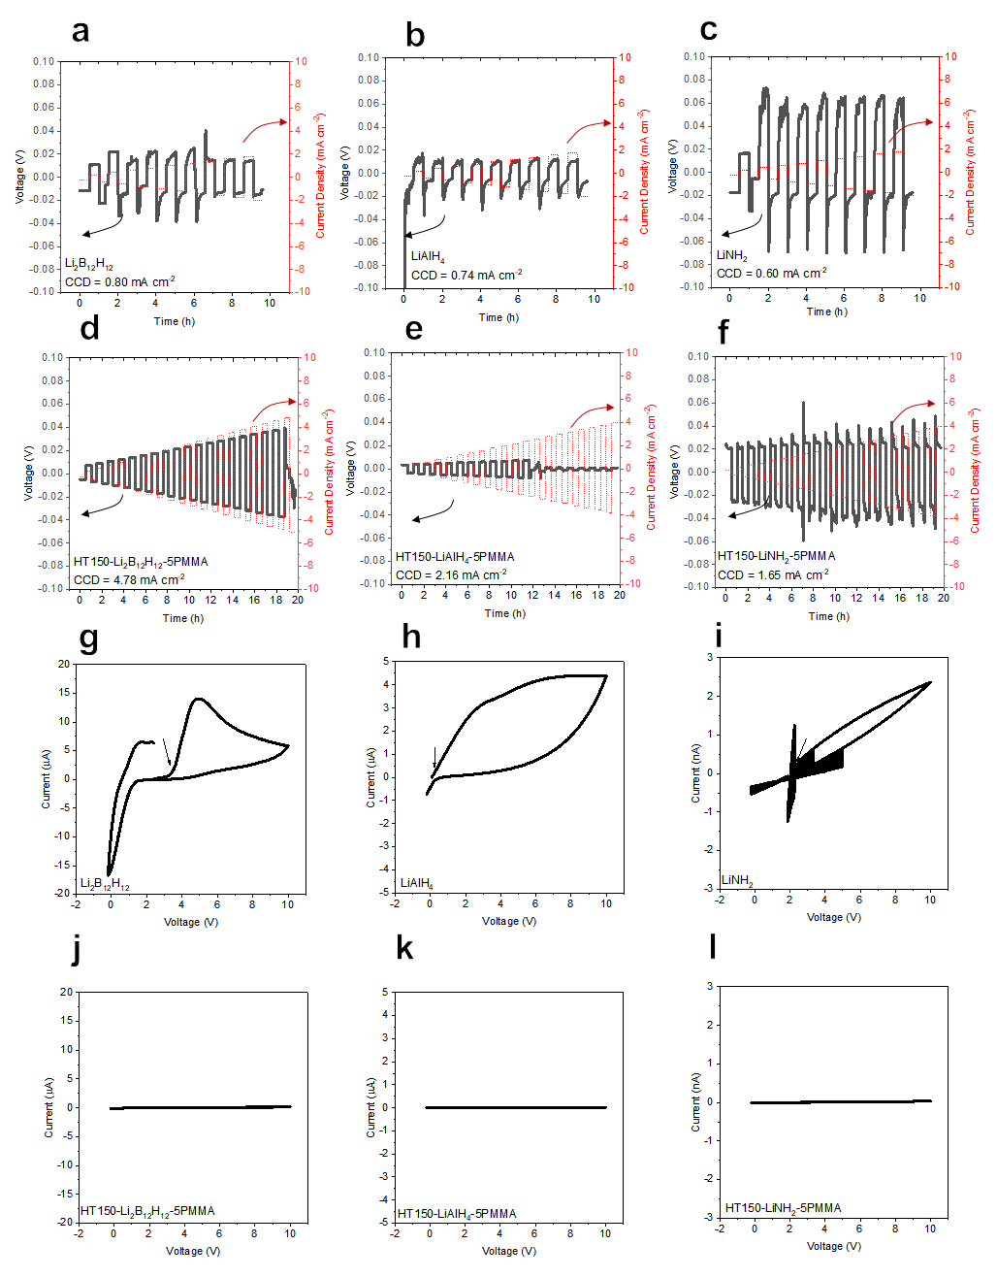
Supplementary Fig. 10. CCDs and voltage windows for other ISMR-modified hydride SEs. CCD for a, Li₂B₁₂H₁₂, b, LiAlH₄, c, LiNH₂, d, HT150-Li₂B₁₂H₁₂-5PMMA, e, HT150-LiAlH₄-5PMMA and f, HT150-LiNH₂-5PMMA. CV curves for g, Li₂B₁₂H₁₂, h, LiAlH₄, i, LiNH₂, j, HT150-Li₂B₁₂H₁₂-5PMMA, k, HT150-LiAlH₄-5PMMA and l, HT150-LiNH₂-5PMMA.
References
1 Takemoto, K. et al. Evaluation on hybrid-electrolyte structure using the liquid electrolyte interlayer containing LiBH4 at Li7La3Zr2O12 vertical bar Li interface at high operating temperature. J. Power Sources 478, doi:10.1016/j.jpowsour.2020.228751 (2020).
2 Lu, F. Q. et al. A High-Performance Li-B-H Electrolyte for All-Solid-State Li Batteries. Adv. Funct. Mater. 29, doi:10.1002/adfm.201809219 (2019).
3 Mo, F. et al. Inside or Outside: Origin of Lithium Dendrite Formation of All Solid‐State Electrolytes. Adv. Energy Mater. 9, doi:10.1002/aenm.201902123 (2019).
4 Shi, X. et al. In situ forming LiF nanodecorated electrolyte/electrode interfaces for stable all-solid-state batteries. Materials Today Nano 10, doi:10.1016/j.mtnano.2020.100079 (2020).
5 Liu, H. et al. Incorporation of Ammonia Borane Groups in the Lithium Borohydride Structure Enables Ultrafast Lithium Ion Conductivity at Room Temperature for Solid-State Batteries. Chem. Mater. 32, 671-678, doi:10.1021/acs.chemmater.9b03188 (2019).
6 Oh, J. A. S. et al. A Robust Solid-Solid Interface Using Sodium-Tin Alloy Modified Metallic Sodium Anode Paving Way for All-Solid-State Battery. Adv. Energy Mater. 11, doi:10.1002/aenm.202101228 (2021).
7 Hänsel, C., Singh, B., Kiwic, D., Canepa, P. & Kundu, D. Favorable Interfacial Chemomechanics Enables Stable Cycling of High-Li-Content Li–In/Sn Anodes in Sulfide Electrolyte-Based Solid-State Batteries. Chem. Mater. 33, 6029-6040, doi:10.1021/acs.chemmater.1c01431 (2021).
8 Ye, L. & Li, X. A dynamic stability design strategy for lithium metal solid state batteries. Nature 593, 218-222, doi:10.1038/s41586-021-03486-3 (2021).
9 Pan, H. et al. Carbon-free and binder-free Li-Al alloy anode enabling an all-solid-state Li-S battery with high energy and stability. Sci Adv 8, eabn4372, doi:10.1126/sciadv.abn4372 (2022).
10 Deng, T. et al. Interfacial-engineering-enabled practical low-temperature sodium metal battery. Nat Nanotechnol 17, 269-277, doi:10.1038/s41565-021-01036-6 (2022).
11 Bay, M. C. et al. Sodium Plating from Na‐β″‐Alumina Ceramics at Room Temperature, Paving the Way for Fast‐Charging All‐Solid‐State Batteries. Adv. Energy Mater. 10, doi:10.1002/aenm.201902899 (2019).

