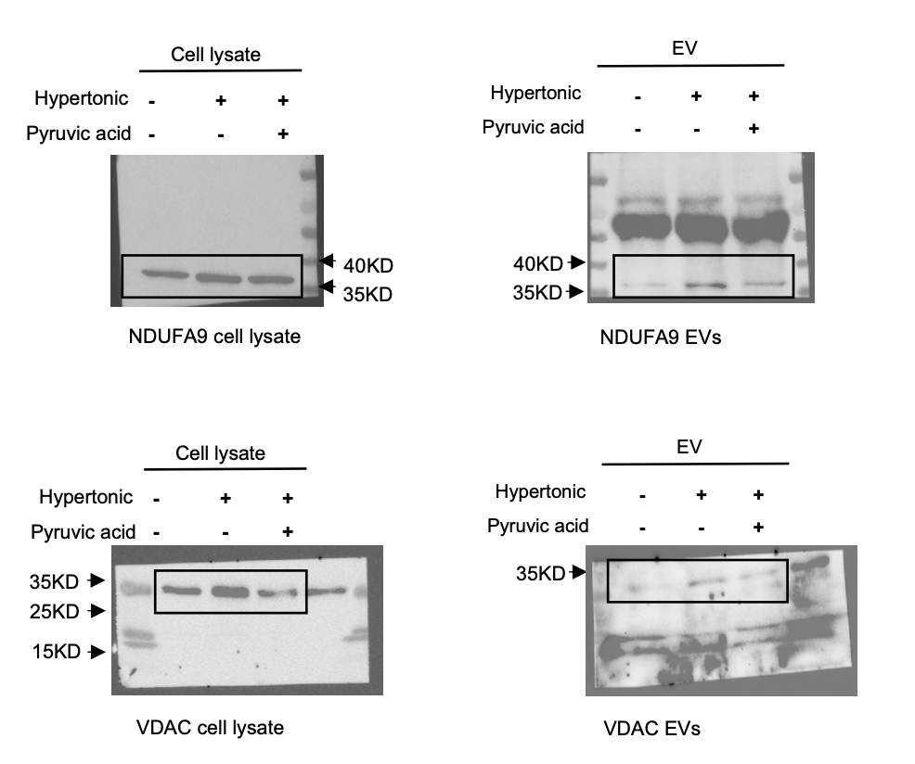
Full gel of western blot for figure 2H

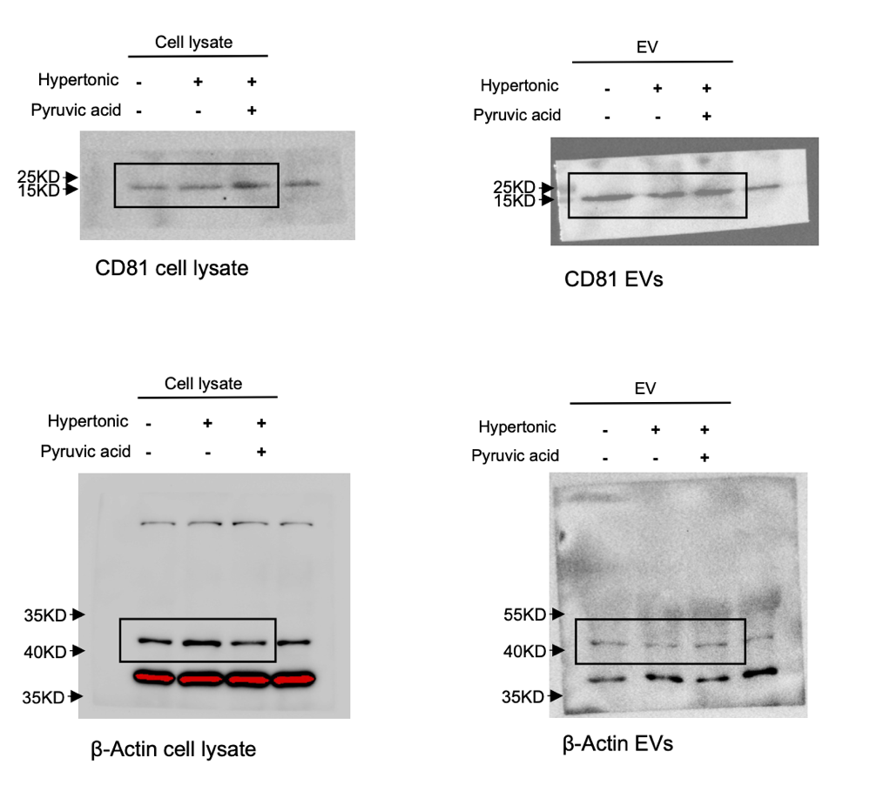

Full gel of western blot for figure 4B
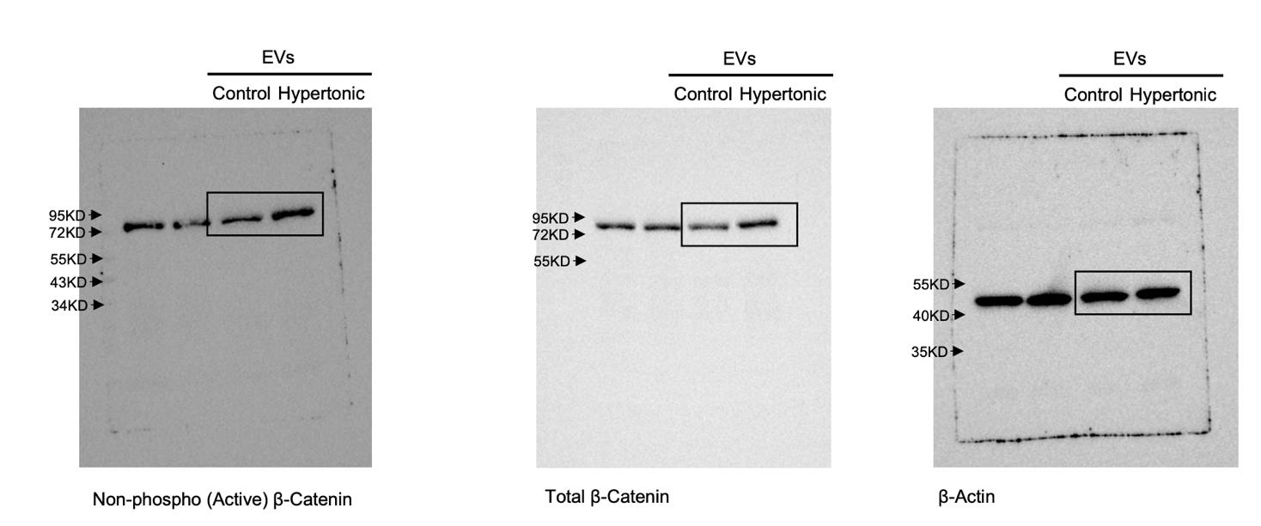

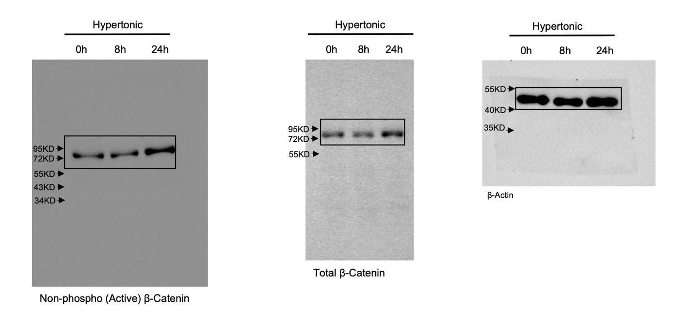
Full gel of western blot for figure 4C

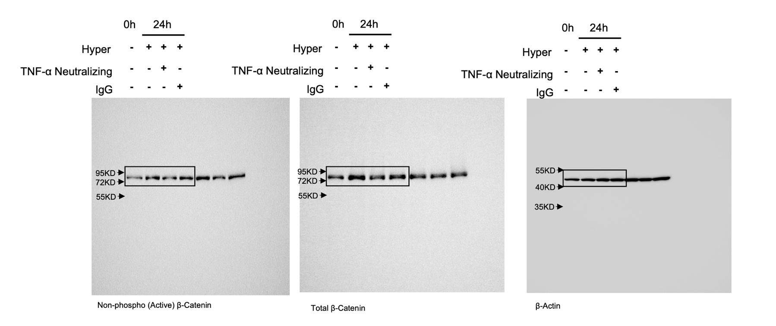
Full gel of western blot for figure 4F

SUPPLEMENTARY FIGURE
Full gel of western blot for figure 2H. Original western blot gels of Fig. 2H for cell lysates and EVs of 3T3-L1 adipocytes following indicated treatments were subject to immunoblot analyses of the indicated proteins, respectively.
Full gel of western blot for figure 4B. Original western blot gels of Fig. 4B for total cell lysates from 3T3-L1 adipocytes treated by EVs from isotonic or hypertonic adipocyte cultures were subject to western blot analyses of indicated proteins.
Full gel of western blot for figure 4C. Original western blot gels of Fig. 4C for total cell lysates from 3T3-L1 adipocytes in indicated culture conditions were subject to western blot analyses of indicated proteins.
Full gel of western blot for figure 4F. Original western blot gels of Fig. 4F for 3T3-L1 adipocytes were treated with the indicated conditions for 24 hours and the cell lysates were subject to western blot analysis of indicated proteins

