Ejection of mitochondria and TNF-α activation mediate hypertonicity-induced adipocytes dedifferentiation
Guopan Liu^{1,2}, Ying Wang^{1,2}, Yilin Pan^{1,2}, Li Tian^{1,2}, Ming Ho Choi¹, Li Wang¹,
Jin Young Kim¹, Shuk Han Cheng¹, Liang Zhang^{1,2}*
¹Department of Biomedical Sciences, College of Veterinary Medicine and Life Sciences, City University of Hong Kong, 83 Tat Chee Avenue, Kowloon, Hong Kong, China.
²Key Laboratory of Biochip Technology, Biotech and Health Centre, Shenzhen Research Institute of City University of Hong Kong, Shenzhen, 518057, China.

*Address correspondence to liangzhang.28@cityu.edu.hk

Table of content
1. Supplementary Methods 3
1.1 Immuno/fluorescent labeling and microscopy 3
1.2 qPCR gene expression analysis 3
2. Supplementary Figures 4
2.1 Supplementary Figure 1 4
2.2 Supplementary Figure 2 5
2.3 Supplementary Figure 3 6
3. Supplementary Table 7
2.1 Supplementary Table 1 7
2.2 Supplementary Table 2 7
2.3 Supplementary Table 3 8

Supplementary Methods

Immuno/fluorescent labeling and microscopy

Twelve hours before the experiment, cells were seeded onto cover slips in 12-well dishes and cultured overnight at 37°C and 5% CO₂. Cells were fixed with 2% paraformaldehyde/PBS for 10 min at 4°C. Next, the cells were either directly incubated with 1% BSA/PBS for 1 h or first permeabilized with 0.1% Triton X-100/PBS for 10 min at 4°C before blocking with 1% BSA/PBS. Subsequently, CD13 primary antibody (Santa Cruz, Product# sc-13536 1:100) or Endoglin primary antibody (Santa Cruz, Product# sc-18838 1:100) was incubated with cells overnight at 4°C. Following 3 times washing in 0.5% tween/PBS, cells were incubated with secondary antibody (CST, Product# 8890S) in 1% BSA/PBS (1:400) in darkness for 1.5 hours at room temperature. After further washing, cells were mounted with DAPI (Thermo Fisher, Product# 62247) and examined with a Nikon A1HD25 confocal microscope.

qPCR gene expression analysis
Total RNA was isolated using RNA Extraction Kit (Takara 9767) according to the manufacturer's recommended protocol. First-strand cDNA was synthesized using the PrimeScript RT Reagent Kit(Takara RR047A) for RT-PCR. Mix 2 μl of 5× PrimeScript RT Master Mix (Perfect Real Time) with RNase-Free Distilled Water and RNA solution until the total amount of RNA was 500 ng in a 10 μl system. Transferred the reaction solution to ABI ProFlex PCR System (2 × 96-well) to perform reverse transcription. RT-PCR was performed using the Ex-Taq PCR kit (Takara RR820A) according to the manufacturer's instructions.

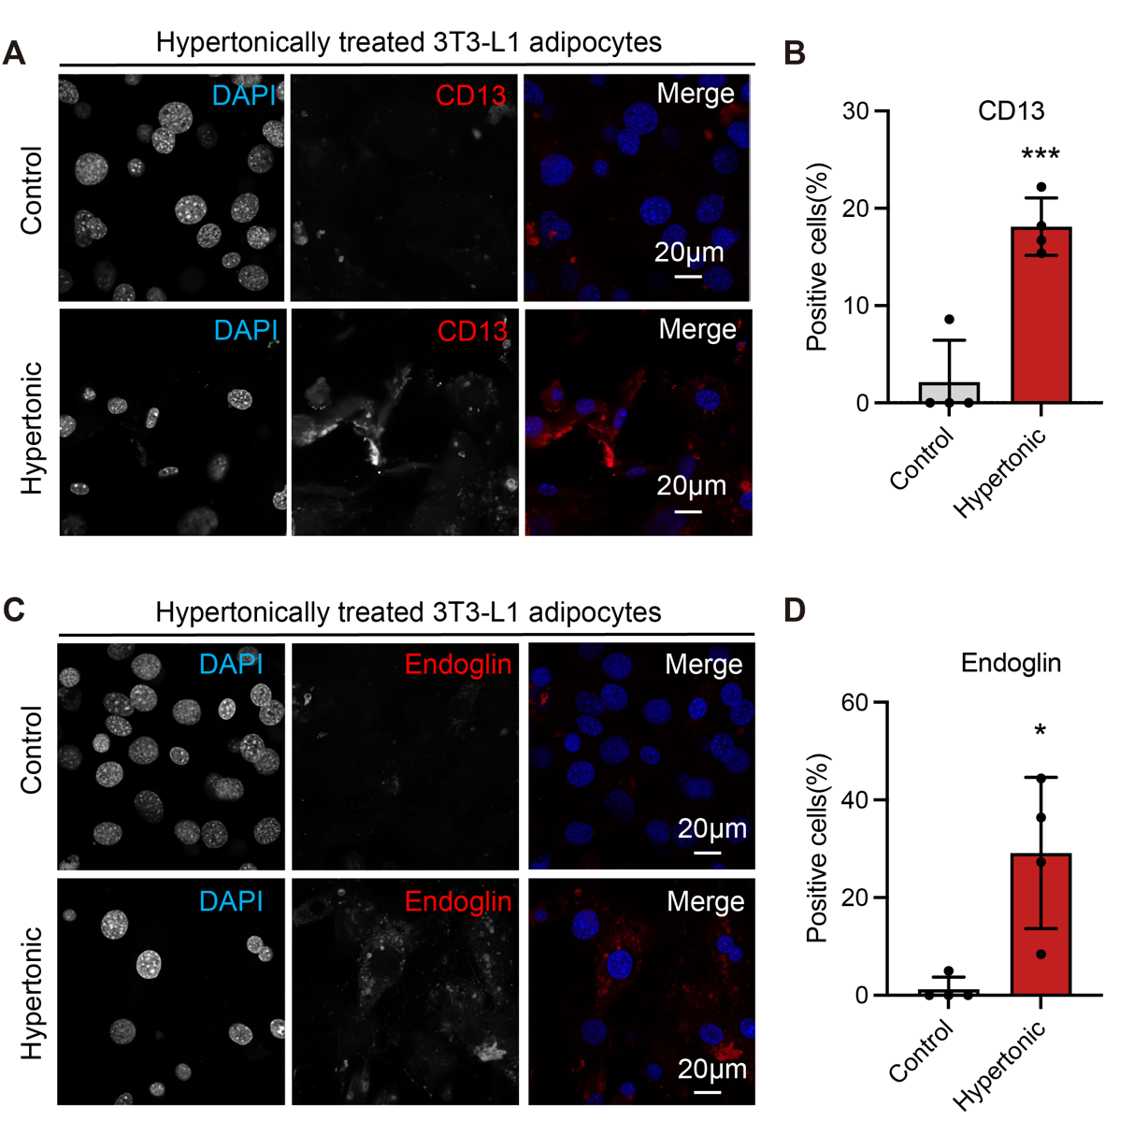
Supplementary Fig. 1. The surface markers of dedifferentiated adipocytes induce by hypertonic treatment. (A-B) Immunostaining of CD13 in control and hypertonic treated 3T3-L1 adipocytes. Percentage of cells with positive CD13 labeling are quantified in (B) Scale bar: 20 µm. (C-D) Immunostaining of Endoglin in control and hypertonic treated 3T3-L1 adipocytes. Percentage of cells with positive Endoglin labeling are quantified in (D) Scale bar: 20 µm.

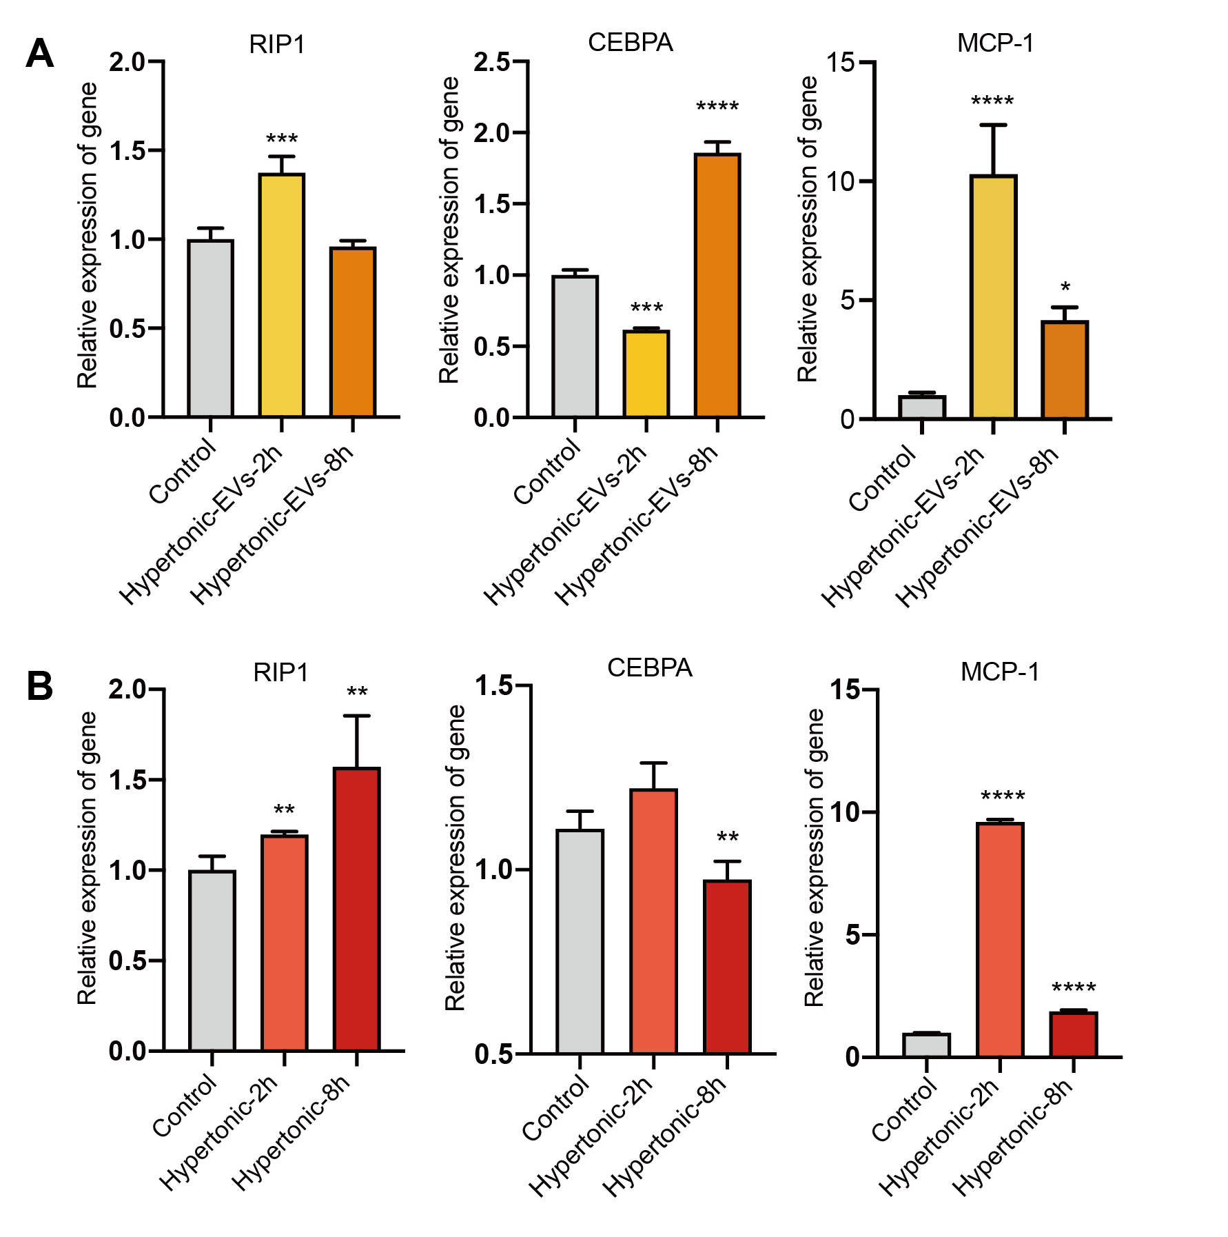
Supplementary Fig. 2. Hypertonicity and mitochondrial EVs (MEVs) activates TNF-α signaling in 3T3-L1 adipocytes. (A) RT-qPCR analysis of the expression of RIP1, CEBPA and MCP-1 in 3T3-L1 adipocytes treated with EVs isolated from the adipocytes from the indicated cultures. (B) RT-qPCR analysis of the expression of RIP1, CEBPA and MCP-1 in 3T3-L1 adipocytes receiving indicated treatments.

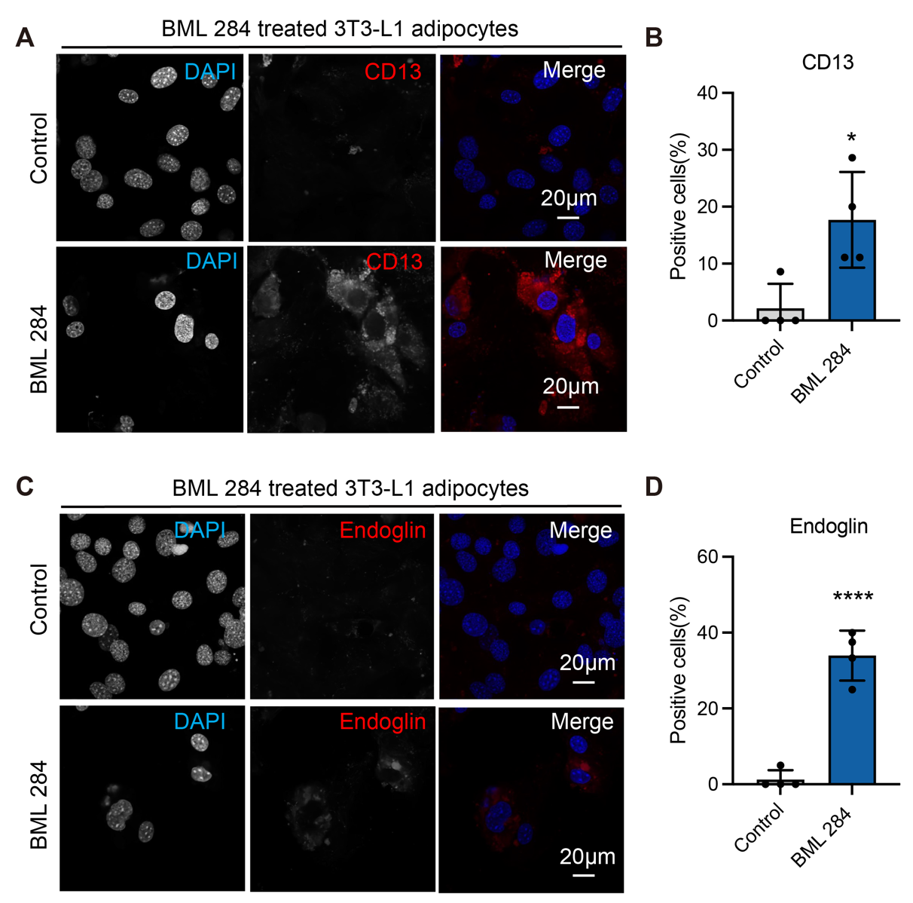
Supplementary Fig. 3. The surface markers of dedifferentiated adipocytes induce by BML 284. (A-B) Immunostaining of CD13 in control and BML 284 treated 3T3-L1 adipocytes. Percentage of cells with positive CD13 labeling are quantified in (B) Scale bar: 20 µm. (C-D) Immunostaining of Endoglin in control and BML 284 treated 3T3-L1 adipocytes. Percentage of cells with positive Endoglin labeling are quantified in (D) Scale bar: 20 µm.

Supplementary Table
Table S1. List of primer sequences used for qPCR validation
Primers qRT-PCR | Forward Primer 5′-3′ | Reverse primer 5′-3′
18SRNA | CTGAGAAACGGCTACCACATC | GCCTCGAAAGAGTCCTGTATTG
TNF-α | ATGGCCTCCCTCTCATCAGT | CTTGGTGGTTTGCTACGACG
RIP1 | CACTGCGATCATTCTCGTCCTG | GACTGTGTACCCTTACCTCCGA
IL-6 | GTTCTCTGGGAAATCGTGGA | GCATTGGAAATTGGGGTAGG
MCP-1 | AGCCAACTCTCACTGAAGCC | GGACCCATTCCTTCTTGGGG
Col2al | CCGCAGTCACTCCAGGAT | TGCAGTCTGCCCAGTTCA
Sox9 | AGCTCACCAGACCCTGAGAA | TCCCAGCAATCGTTACCTTC
Smad3 | GTCAACAAGTGGTGGCGTGTG | GCAGCAAAGGCTTCTGGGATAA
Esrrb | GTGCGCAGGTACAAGAAACT | CCAGGTTCTCAATGTACATCGA
Sox2 | GCGGAGTGGAAACTTTTGTCC | GGGAAGCGTGTACTTATCCTTCT
Smad9 | CGGATGAGCTTTGTGAAGG | GGGTGCTCGTGACATCCT
Runc2 | GCCGGGAATGATGAGAACTA | GGTGAAACTCTTGCCTCGTC
ALP | TGAGCGACACGGACAAGA | GGCCTGGTAGTTGTTGTGAG

Supplementary Table 1.
List of primer sequences used for qPCR validation

Table S2. The most represented GO terms of cellular component of hypertonic unique proteins
Gene Ontology | Cellular Component
No | GOID | Description | BCAP FDR
1 | GO:0005743 | Mitochondrial inner membrane | 1.03E-02
2 | GO:0005739 | Mitochondrion | 3.16E-02
3 | GO:0031967 | Organelle envelope | 4.29E-02

Supplementary Table 2.
The most represented GO terms of cellular components of unique proteins from hypertonic EVs

Table S3. The fold change between control and hypertonic group
Accession | Gene name | Control (Normalized abundance) | Hypertonic (Normalized abundance) | lg(control) | lg(hypertonic) | lg Fold change | Group
Q6NSP9 | Hmga2 | 8584594.5 | 1000 | 6.933719786 | 3 | -3.933719786 | Down-regulated (n=139)
P14131 | Rps16 | 7320493.5 | 1000 | 6.864540359 | 3 | -3.864540359 | Down-regulated (n=139)
P25444 | Rps2 | 6898404.625 | 1000 | 6.838748664 | 3 | -3.838748664 | Down-regulated (n=139)
Q8C266 | Rab5c | 5759487.5 | 1000 | 6.76038384 | 3 | -3.76038384 | Down-regulated (n=139)
Q8VED5 | Krt79 | 5167437 | 1000 | 6.713275191 | 3 | -3.713275191 | Down-regulated (n=139)
A0A1L1SV25 | Actn4 | 5002853 | 1000 | 6.699217742 | 3 | -3.699217742 | Down-regulated (n=139)
A0A140T8M7 |  | 4811706.875 | 1000 | 6.682299163 | 3 | -3.682299163 | Down-regulated (n=139)
P68040 | Rack1 | 3897300.25 | 1000 | 6.590763865 | 3 | -3.590763865 | Down-regulated (n=139)
P19324 | Serpinh1 | 3806003.5 | 1000 | 6.580469183 | 3 | -3.580469183 | Down-regulated (n=139)
P84104 | Srsf3 | 3514547.5 | 1000 | 6.545869417 | 3 | -3.545869417 | Down-regulated (n=139)
P62320 | Snrpd3 | 3417735.25 | 1000 | 6.533738418 | 3 | -3.533738418 | Down-regulated (n=139)
Q922Q8 | Lrrc59 | 3086186.125 | 1000 | 6.489422114 | 3 | -3.489422114 | Down-regulated (n=139)
P54116 | Stom | 3019815 | 1000 | 6.479980338 | 3 | -3.479980338 | Down-regulated (n=139)
Q9WTR5 | Cdh13 | 2909470.75 | 1000 | 6.463813995 | 3 | -3.463813995 | Down-regulated (n=139)
P62301 | Rps13 | 2566389 | 1000 | 6.409322485 | 3 | -3.409322485 | Down-regulated (n=139)
P32067 | Ssb | 2485558 | 1000 | 6.395423902 | 3 | -3.395423902 | Down-regulated (n=139)
Q9QXS1 | Plec | 2323585.563 | 1000 | 6.366158669 | 3 | -3.366158669 | Down-regulated (n=139)
Q9DCX2 | Atp5pd | 2290584.563 | 1000 | 6.35994633 | 3 | -3.35994633 | Down-regulated (n=139)
A0A0R4J1E2 | Eef1d | 2246978 | 1000 | 6.35159882 | 3 | -3.35159882 | Down-regulated (n=139)
Q6NXH9 | Krt73 | 2201763 | 1000 | 6.342770569 | 3 | -3.342770569 | Down-regulated (n=139)
P80316 | Cct5 | 1914071.625 | 1000 | 6.281958185 | 3 | -3.281958185 | Down-regulated (n=139)
Q9CYL5 | Glipr2 | 1717588 | 1000 | 6.234918997 | 3 | -3.234918997 | Down-regulated (n=139)
P67984 | Rpl22 | 1695660.719 | 1000 | 6.22933896 | 3 | -3.22933896 | Down-regulated (n=139)
F8WID5 | Tpm1 | 1633021 | 1000 | 6.21299177 | 3 | -3.21299177 | Down-regulated (n=139)
P61358 | Rpl27 | 1606448.875 | 1000 | 6.205866909 | 3 | -3.205866909 | Down-regulated (n=139)
Q9CQ22 | Lamtor1 | 1604461.875 | 1000 | 6.205329402 | 3 | -3.205329402 | Down-regulated (n=139)
A0A0R4J0I9 | Lrp1 | 1534512.875 | 1000 | 6.185970537 | 3 | -3.185970537 | Down-regulated (n=139)
P47753 | Capza1 | 1521776.375 | 1000 | 6.182350838 | 3 | -3.182350838 | Down-regulated (n=139)
Q3TLP8 | Rac1 | 1442923.625 | 1000 | 6.159243344 | 3 | -3.159243344 | Down-regulated (n=139)
F8WGL3 | Cfl1 | 1404188 | 1000 | 6.147425257 | 3 | -3.147425257 | Down-regulated (n=139)
Q9WVJ3 | Cpq | 1375430.25 | 1000 | 6.138438572 | 3 | -3.138438572 | Down-regulated (n=139)
P06801 | Me1 | 1335398.75 | 1000 | 6.125610965 | 3 | -3.125610965 | Down-regulated (n=139)
P12815 | Pdcd6 | 1254106.25 | 1000 | 6.098334332 | 3 | -3.098334332 | Down-regulated (n=139)
G5E902 | Slc25a3 | 1184277.125 | 1000 | 6.073453341 | 3 | -3.073453341 | Down-regulated (n=139)
P59108 | Cpne2 | 1112840.75 | 1000 | 6.04643302 | 3 | -3.04643302 | Down-regulated (n=139)
P80315 | Cct4 | 1074040.188 | 1000 | 6.031020532 | 3 | -3.031020532 | Down-regulated (n=139)
Q9D0F3 | Lman1 | 1057436.344 | 1000 | 6.024254233 | 3 | -3.024254233 | Down-regulated (n=139)
P62835 | Rap1a | 1017386.375 | 1000 | 6.007485917 | 3 | -3.007485917 | Down-regulated (n=139)
P42669 | Pura | 994102.625 | 1000 | 5.997431221 | 3 | -2.997431221 | Down-regulated (n=139)
Q6R0H7 | Gnas | 973654.875 | 1000 | 5.988405043 | 3 | -2.988405043 | Down-regulated (n=139)
Q640N1 | Aebp1 | 972075.3125 | 1000 | 5.987699914 | 3 | -2.987699914 | Down-regulated (n=139)
Q9Z1G4 | Atp6v0a1 | 960960 | 1000 | 5.982705311 | 3 | -2.982705311 | Down-regulated (n=139)
Q7TMM9 | Tubb2a | 927458.875 | 1000 | 5.967294661 | 3 | -2.967294661 | Down-regulated (n=139)
A2AE89 | Gstm1 | 910184.1875 | 1000 | 5.959129286 | 3 | -2.959129286 | Down-regulated (n=139)
O08547 | Sec22b | 899735.8125 | 1000 | 5.954115007 | 3 | -2.954115007 | Down-regulated (n=139)
P50428 | Arsa | 870805.5 | 1000 | 5.939921163 | 3 | -2.939921163 | Down-regulated (n=139)
Q8VDN2 | Atp1a1 | 857618.1094 | 1000 | 5.933293943 | 3 | -2.933293943 | Down-regulated (n=139)
A0A1L1SQU7 | Fat1 | 828608.9375 | 1000 | 5.918349613 | 3 | -2.918349613 | Down-regulated (n=139)
Q9JM62 | Reep6 | 812571.4375 | 1000 | 5.909861552 | 3 | -2.909861552 | Down-regulated (n=139)
O09061 | Psmb1 | 810664.5 | 1000 | 5.908841155 | 3 | -2.908841155 | Down-regulated (n=139)
P09103 | P4hb | 809642.625 | 1000 | 5.908293364 | 3 | -2.908293364 | Down-regulated (n=139)
Q8BL97 | Srsf7 | 803354.5625 | 1000 | 5.904907265 | 3 | -2.904907265 | Down-regulated (n=139)
P15532 | Nme1 | 771185.5 | 1000 | 5.887158855 | 3 | -2.887158855 | Down-regulated (n=139)
O54965 | Rnf13 | 716947.9375 | 1000 | 5.85548762 | 3 | -2.85548762 | Down-regulated (n=139)
O08992 | Sdcbp | 709786.5 | 1000 | 5.851127735 | 3 | -2.851127735 | Down-regulated (n=139)
Q62318 | Trim28 | 700194.4375 | 1000 | 5.845218656 | 3 | -2.845218656 | Down-regulated (n=139)
P08207 | S100a10 | 699769 | 1000 | 5.844954699 | 3 | -2.844954699 | Down-regulated (n=139)
P16460 | Ass1 | 697613.75 | 1000 | 5.843615032 | 3 | -2.843615032 | Down-regulated (n=139)
Q921F2 | Tardbp | 696275.6875 | 1000 | 5.842781231 | 3 | -2.842781231 | Down-regulated (n=139)
E9QP00 | Tra2a | 694917.375 | 1000 | 5.84193317 | 3 | -2.84193317 | Down-regulated (n=139)
P63325 | Rps10 | 680642.0625 | 1000 | 5.832918784 | 3 | -2.832918784 | Down-regulated (n=139)
P97384 | Anxa11 | 660499.9375 | 1000 | 5.819872781 | 3 | -2.819872781 | Down-regulated (n=139)
Q8CI43 | Myl6b | 655367.25 | 1000 | 5.816484735 | 3 | -2.816484735 | Down-regulated (n=139)
P05201 | Got1 | 638063 | 1000 | 5.804863561 | 3 | -2.804863561 | Down-regulated (n=139)
E9Q1G8 | Septin7 | 627734.4375 | 1000 | 5.797775955 | 3 | -2.797775955 | Down-regulated (n=139)
Q8C166 | Cpne1 | 618277.25 | 1000 | 5.791183267 | 3 | -2.791183267 | Down-regulated (n=139)
Q3TWW8 | Srsf6 | 607454.6875 | 1000 | 5.783513888 | 3 | -2.783513888 | Down-regulated (n=139)
O70378 | Emc8 | 605887.9375 | 1000 | 5.782392306 | 3 | -2.782392306 | Down-regulated (n=139)
O08749 | Dld | 589564.5 | 1000 | 5.770531325 | 3 | -2.770531325 | Down-regulated (n=139)
Q3TW96 | Uap1l1 | 581283.5625 | 1000 | 5.764388042 | 3 | -2.764388042 | Down-regulated (n=139)
O55029 | Copb2 | 558075.0625 | 1000 | 5.746692617 | 3 | -2.746692617 | Down-regulated (n=139)
P37804 | Tagln | 546013.5625 | 1000 | 5.73720343 | 3 | -2.73720343 | Down-regulated (n=139)
Q9R0P5 | Dstn | 532583.4375 | 1000 | 5.726387656 | 3 | -2.726387656 | Down-regulated (n=139)
E9PY39 | Gm20431 | 521401.5938 | 1000 | 5.717172354 | 3 | -2.717172354 | Down-regulated (n=139)
Q9R1Q7 | Plp2 | 509098.8438 | 1000 | 5.706802111 | 3 | -2.706802111 | Down-regulated (n=139)
A0A140T8T4 | Rpl9-ps6 | 508990.0938 | 1000 | 5.70670933 | 3 | -2.70670933 | Down-regulated (n=139)
P60335 | Pcbp1 | 505058.4063 | 1000 | 5.703341604 | 3 | -2.703341604 | Down-regulated (n=139)
Q8BML9 | Qars1 | 499788.4375 | 1000 | 5.698786205 | 3 | -2.698786205 | Down-regulated (n=139)
H7BX01 | Opa1 | 494756.7188 | 1000 | 5.694391701 | 3 | -2.694391701 | Down-regulated (n=139)
P01029 | C4b | 490821.5313 | 1000 | 5.690923606 | 3 | -2.690923606 | Down-regulated (n=139)
P35550 | Fbl | 473295.1875 | 1000 | 5.675132089 | 3 | -2.675132089 | Down-regulated (n=139)
Q8BGQ7 | Aars1 | 472780.8125 | 1000 | 5.674659843 | 3 | -2.674659843 | Down-regulated (n=139)
P08122 | Col4a2 | 445774.125 | 1000 | 5.649114856 | 3 | -2.649114856 | Down-regulated (n=139)
A0A087WQW8 | Fn1 | 444687.1563 | 1000 | 5.648054586 | 3 | -2.648054586 | Down-regulated (n=139)
P42932 | Cct8 | 439441 | 1000 | 5.642900574 | 3 | -2.642900574 | Down-regulated (n=139)
Q9JIK5 | Ddx21 | 428586.1875 | 1000 | 5.63203817 | 3 | -2.63203817 | Down-regulated (n=139)
D3Z722 | Rps19 | 414901.5313 | 1000 | 5.617945038 | 3 | -2.617945038 | Down-regulated (n=139)
Q8BG05 | Hnrnpa3 | 412027.5 | 1000 | 5.614926203 | 3 | -2.614926203 | Down-regulated (n=139)
E9Q3E1 | Aldh3b2 | 411143.5938 | 1000 | 5.613993528 | 3 | -2.613993528 | Down-regulated (n=139)
P28654 | Dcn | 407931.5938 | 1000 | 5.610587342 | 3 | -2.610587342 | Down-regulated (n=139)
P62827 | Ran | 403111.9063 | 1000 | 5.605425626 | 3 | -2.605425626 | Down-regulated (n=139)
Q91VH2 | Snx9 | 394732.75 | 1000 | 5.59630316 | 3 | -2.59630316 | Down-regulated (n=139)
Q8K4Z5 | Sf3a1 | 391994.1875 | 1000 | 5.593279627 | 3 | -2.593279627 | Down-regulated (n=139)
Q9CQV8 | Ywhab | 369977.6563 | 1000 | 5.568175497 | 3 | -2.568175497 | Down-regulated (n=139)
Q62167 | Ddx3x | 360194.0938 | 1000 | 5.556536587 | 3 | -2.556536587 | Down-regulated (n=139)
P63163 | Snrpn | 359407.0625 | 1000 | 5.555586607 | 3 | -2.555586607 | Down-regulated (n=139)
Q9Z1E4 | Gys1 | 352884.6563 | 1000 | 5.547632775 | 3 | -2.547632775 | Down-regulated (n=139)
E0CXB9 | Ctnna2 | 333323.9063 | 1000 | 5.522866463 | 3 | -2.522866463 | Down-regulated (n=139)
E9Q557 | Dsp | 328572.5313 | 1000 | 5.516631254 | 3 | -2.516631254 | Down-regulated (n=139)
P11983 | Tcp1 | 324146.4375 | 1000 | 5.510741253 | 3 | -2.510741253 | Down-regulated (n=139)
F8VPU2 | Farp1 | 323206.375 | 1000 | 5.509479918 | 3 | -2.509479918 | Down-regulated (n=139)
O54734 | Ddost | 309466.2813 | 1000 | 5.490613336 | 3 | -2.490613336 | Down-regulated (n=139)
P14901 | Hmox1 | 304527.7813 | 1000 | 5.483626918 | 3 | -2.483626918 | Down-regulated (n=139)
Q3UH59 | Myh10 | 301750.3125 | 1000 | 5.479647729 | 3 | -2.479647729 | Down-regulated (n=139)
P63101 | Ywhaz | 296965.25 | 1000 | 5.472705632 | 3 | -2.472705632 | Down-regulated (n=139)
Q9EST5 | Anp32b | 293687.8438 | 1000 | 5.467885971 | 3 | -2.467885971 | Down-regulated (n=139)
Q00612 | G6pdx | 292937.0625 | 1000 | 5.466774322 | 3 | -2.466774322 | Down-regulated (n=139)
Q9WVA4 | Tagln2 | 291106.4375 | 1000 | 5.464051809 | 3 | -2.464051809 | Down-regulated (n=139)
Q91V41 | Rab14 | 288433 | 1000 | 5.460044947 | 3 | -2.460044947 | Down-regulated (n=139)
P18872 | Gnao1 | 284469.4688 | 1000 | 5.454035662 | 3 | -2.454035662 | Down-regulated (n=139)
Q8BH95 | Echs1 | 269171.9063 | 1000 | 5.43002973 | 3 | -2.43002973 | Down-regulated (n=139)
Q9ESX5 | Dkc1 | 260158.1563 | 1000 | 5.415237446 | 3 | -2.415237446 | Down-regulated (n=139)
P45376 | Akr1b1 | 232747.25 | 1000 | 5.366884558 | 3 | -2.366884558 | Down-regulated (n=139)
P57716 | Ncstn | 232310.5781 | 1000 | 5.366068986 | 3 | -2.366068986 | Down-regulated (n=139)
Q8K2Y3 | Eva1b | 224756.2344 | 1000 | 5.351711747 | 3 | -2.351711747 | Down-regulated (n=139)
P80314 | Cct2 | 215186.7656 | 1000 | 5.332815558 | 3 | -2.332815558 | Down-regulated (n=139)
Q80X90 | Flnb | 203321.0469 | 1000 | 5.308182337 | 3 | -2.308182337 | Down-regulated (n=139)
Q91VD9 | Ndufs1 | 202838.5469 | 1000 | 5.307150491 | 3 | -2.307150491 | Down-regulated (n=139)
Q9JHU4 | Dync1h1 | 188149.375 | 1000 | 5.27450278 | 3 | -2.27450278 | Down-regulated (n=139)
P10922 | H1-0 | 83964977.31 | 450128.0052 | 7.924098175 | 5.653336034 | -2.270762141 | Down-regulated (n=139)
Q9Z1P8 | Angptl4 | 186305.0313 | 1000 | 5.270224583 | 3 | -2.270224583 | Down-regulated (n=139)
J3QNK8 | Abi1 | 173735.8281 | 1000 | 5.239889389 | 3 | -2.239889389 | Down-regulated (n=139)
Q8CGK3 | Lonp1 | 169412.4063 | 1000 | 5.228945211 | 3 | -2.228945211 | Down-regulated (n=139)
F8WHL2 | Copa | 155302.9844 | 1000 | 5.191179801 | 3 | -2.191179801 | Down-regulated (n=139)
P17809 | Slc2a1 | 145815.9844 | 1000 | 5.163805134 | 3 | -2.163805134 | Down-regulated (n=139)
Q91VE0 | Slc27a4 | 134064.8906 | 1000 | 5.127315058 | 3 | -2.127315058 | Down-regulated (n=139)
P15920 | Atp6v0a2 | 115438.2422 | 1000 | 5.062349705 | 3 | -2.062349705 | Down-regulated (n=139)
Q3U3J1 | Bckdha | 104937.3359 | 1000 | 5.020930034 | 3 | -2.020930034 | Down-regulated (n=139)
F2Z3U4 | Matn4 | 66911.48438 | 1000 | 4.825500664 | 3 | -1.825500664 | Down-regulated (n=139)
P43276 | H1-5 | 463790690.3 | 7201846.276 | 8.666322027 | 6.857443847 | -1.80887818 | Down-regulated (n=139)
Q9CY66 | Gar1 | 53491.60156 | 1000 | 4.728285601 | 3 | -1.728285601 | Down-regulated (n=139)
P43274 | H1-4 | 1114792380 | 44764751.01 | 9.047193991 | 7.650936173 | -1.396257818 | Down-regulated (n=139)
P62918 | Rpl8 | 6023896 | 253193.8235 | 6.779877465 | 5.403453107 | -1.376424358 | Down-regulated (n=139)
P08228 | Sod1 | 13285131.5 | 773255.8796 | 7.123365858 | 5.888323231 | -1.235042627 | Down-regulated (n=139)
A2AH85 | Eftud2 | 1302927.875 | 93062.18753 | 6.114920376 | 4.968773257 | -1.146147119 | Down-regulated (n=139)
Q5SXR6 | Cltc | 18899493.69 | 1396814.553 | 7.27645017 | 6.145138751 | -1.131311419 | Down-regulated (n=139)
P17095 | Hmga1 | 2300774.5 | 175500.9731 | 6.361874055 | 5.244279529 | -1.117594527 | Down-regulated (n=139)
Q9CQF9 | Pcyox1 | 3199351.031 | 277069.1835 | 6.505061893 | 5.442588225 | -1.062473668 | Down-regulated (n=139)
Q9DBJ1 | Pgam1 | 7092532.5 | 682207.5736 | 6.850801335 | 5.833916536 | -1.016884798 | Down-regulated (n=139)
P62908 | Rps3 | 8495979.938 | 858189.9559 | 6.929213478 | 5.933583427 | -0.995630051 | Normal
P15864 | H1-2 | 299224558 | 31713575.38 | 8.475997234 | 7.501245207 | -0.974752027 | Normal
Q07113 | Igf2r | 3759154.5 | 433892.5336 | 6.575090175 | 5.637382177 | -0.937707999 | Normal
P47911 | Rpl6 | 35186823 | 4105183.817 | 7.546380056 | 6.613332608 | -0.933047448 | Normal
P29391 | Ftl1 | 3777659.125 | 447826.4997 | 6.577222767 | 5.651109789 | -0.926112978 | Normal
P97429 | Anxa4 | 5779061.438 | 708112.8168 | 6.761857312 | 5.850102455 | -0.911754856 | Normal
P62960 | Ybx1 | 6744595.125 | 892674.203 | 6.828955884 | 5.950692984 | -0.8782629 | Normal
Q8BJ56 | Pnpla2 | 2435908.25 | 329704.4846 | 6.386660926 | 5.518124854 | -0.868536072 | Normal
P37889 | Fbln2 | 6896750.125 | 954982.9124 | 6.838644491 | 5.979995601 | -0.858648891 | Normal
P52480 | Pkm | 11834940.56 | 1647463.273 | 7.073166081 | 6.216815742 | -0.856350339 | Normal
Q91VA7 | Idh3b | 2523129.875 | 351390.9286 | 6.401939606 | 5.545790546 | -0.85614906 | Normal
P20152 | Vim | 49406042.75 | 6913512.575 | 7.69378007 | 6.839698757 | -0.854081313 | Normal
Q542V3 | Srsf4 | 2390570.5 | 336614.4776 | 6.378501556 | 5.527132791 | -0.851368765 | Normal
O88844 | Idh1 | 12876141.25 | 1908677.218 | 7.109785732 | 6.28073249 | -0.829053242 | Normal
Q8BH64 | Ehd2 | 3590403.188 | 532630.9794 | 6.555143221 | 5.726426423 | -0.828716798 | Normal
P18572 | Bsg | 5476944.25 | 819120.9243 | 6.73853832 | 5.91334802 | -0.8251903 | Normal
P47962 | Rpl5 | 17952850.06 | 2733926.106 | 7.254133404 | 6.436786772 | -0.817346632 | Normal
E9Q616 | Ahnak | 6673146.422 | 1029175.831 | 6.824330654 | 6.012489579 | -0.811841075 | Normal
P13020 | Gsn | 35055559.88 | 5610368.423 | 7.544756908 | 6.748991382 | -0.795765526 | Normal
P35700 | Prdx1 | 26906943.06 | 4359728.607 | 7.42986436 | 6.639459455 | -0.790404904 | Normal
Q61937 | Npm1 | 3275121.125 | 556174.7322 | 6.515227366 | 5.745211254 | -0.770016112 | Normal
Q9WV91 | Ptgfrn | 2827708.969 | 509879.2462 | 6.451434709 | 5.707467335 | -0.743967374 | Normal
P36536 | Sar1a | 544354.125 | 101503.3907 | 5.735881518 | 5.00648055 | -0.729400968 | Normal
P07091 | S100a4 | 16027707 | 3327716.326 | 7.204871395 | 6.522146297 | -0.682725097 | Normal
Q3TEA8 | Hp1bp3 | 3370081.5 | 782315.0626 | 6.527640404 | 5.893381692 | -0.634258712 | Normal
Q9D819 | Ppa1 | 11031760.5 | 2640208.47 | 7.042644825 | 6.42163822 | -0.621006605 | Normal
P48678 | Lmna | 21834297.31 | 5589800.942 | 7.33913922 | 6.747396343 | -0.591742877 | Normal
P14069 | S100a6 | 8639697 | 2226513.024 | 6.936498512 | 6.34762524 | -0.588873272 | Normal
Q99PT1 | Arhgdia | 5179611 | 1334855.913 | 6.714297145 | 6.12543439 | -0.588862755 | Normal
Q9JIZ9 | Plscr3 | 2350266.438 | 616506.3769 | 6.371117099 | 5.789937573 | -0.581179526 | Normal
A0A1Y7VKY1 | Rps18-ps5 | 5383245.625 | 1418892.076 | 6.731044196 | 6.151949363 | -0.579094833 | Normal
Q60692 | Psmb6 | 1800103.5 | 475372.3443 | 6.255297476 | 5.677033912 | -0.578263564 | Normal
Q9WTI7 | Myo1c | 9901997.813 | 2732454.977 | 6.995722826 | 6.436553015 | -0.559169811 | Normal
G3X977 | Itih2 | 1592603.375 | 442290.5558 | 6.202107632 | 5.645707666 | -0.556399966 | Normal
P10107 | Anxa1 | 13391512.67 | 3745716.098 | 7.126829637 | 6.573534857 | -0.553294779 | Normal
Q62261 | Sptbn1 | 1339276.375 | 383119.59 | 6.126870208 | 5.583334359 | -0.543535849 | Normal
Q9CRD2 | Emc2 | 1237235.875 | 354664.0021 | 6.092452504 | 5.54981711 | -0.542635394 | Normal
P62754 | Rps6 | 43699593.38 | 12546018.61 | 7.640477396 | 7.098505927 | -0.541971469 | Normal
P07901 | Hsp90aa1 | 1099440.063 | 315861.5441 | 6.041171558 | 5.499496754 | -0.541674804 | Normal
Q91XV3 | Basp1 | 860692.5 | 247782.021 | 5.934848019 | 5.394069791 | -0.540778228 | Normal
Q91VJ2 | Cavin3 | 585672.875 | 169331.5611 | 5.76765511 | 5.228737912 | -0.538917198 | Normal
Q05793 | Hspg2 | 16682053.88 | 4899264.231 | 7.22224952 | 6.690130863 | -0.532118657 | Normal
P24270 | Cat | 1736866.125 | 510379.128 | 6.239766345 | 5.707892906 | -0.531873439 | Normal
Q61753 | Phgdh | 7532471.5 | 2227751.401 | 6.876937497 | 6.347866725 | -0.529070772 | Normal
Q99LU0 | Chmp1b1 | 3491938.75 | 1044174.894 | 6.543066617 | 6.018773247 | -0.524293371 | Normal
Q9WU78 | Pdcd6ip | 5489247.688 | 1658542.264 | 6.739512828 | 6.219726543 | -0.519786285 | Normal
E9Q3X0 | Mvp | 73764418.34 | 22758165.59 | 7.867846922 | 7.357137253 | -0.510709669 | Normal
A0A0N4SW28 | Gng12 | 9360782.125 | 2958754.939 | 6.971312137 | 6.471108996 | -0.500203141 | Normal
Q64727 | Vcl | 3523260.391 | 1116248.401 | 6.546944741 | 6.04776085 | -0.499183892 | Normal
Q9QZQ8 | Macroh2a1 | 173124545.5 | 56881791.62 | 8.238358646 | 7.754973267 | -0.483385379 | Normal
P47963 | Rpl13 | 17611844.75 | 5792460.243 | 7.245804848 | 6.762863062 | -0.482941787 | Normal
A6ZI44 | Aldoa | 42307153.75 | 14092167.25 | 7.626413809 | 7.148977789 | -0.47743602 | Normal
O09167 | Rpl21 | 1807430 | 605509.5343 | 6.257061486 | 5.782120986 | -0.474940501 | Normal
A0A1B0GSX0 | Ldha | 2670294.25 | 894718.3123 | 6.426559121 | 5.951686326 | -0.474872794 | Normal
P70168 | Kpnb1 | 1920784.102 | 648584.4657 | 6.283478552 | 5.811966543 | -0.47151201 | Normal
P62702 | Rps4x | 15769841.55 | 5375288.323 | 7.19782733 | 6.730401764 | -0.467425566 | Normal
P09528 | Fth1 | 3826429.75 | 1313913.302 | 6.582793744 | 6.118566709 | -0.464227035 | Normal
P60710 | Actb | 124400806.6 | 43557702.41 | 8.094823196 | 7.639064963 | -0.455758233 | Normal
C0HKE6 | H2ac13 | 1742221451 | 616590676.9 | 9.241103357 | 8.789996954 | -0.451106403 | Normal
P46638 | Rab11b | 833764.5625 | 303344.1343 | 5.921043432 | 5.481935602 | -0.439107831 | Normal
P21956 | Mfge8 | 35572746.31 | 13047909.89 | 7.551117395 | 7.115540949 | -0.435576446 | Normal
Q6IRU2 | Tpm4 | 792972.6875 | 291601.1166 | 5.899258229 | 5.464789183 | -0.434469046 | Normal
P80318 | Cct3 | 1072019.125 | 395263.9336 | 6.030202533 | 5.596887188 | -0.433315345 | Normal
E9QAZ2 |  | 27130779.5 | 10488507.94 | 7.433462272 | 7.020713711 | -0.41274856 | Normal
P12970 | Rpl7a | 17670599.97 | 6931133.327 | 7.247251295 | 6.840804253 | -0.406447042 | Normal
P07356 | Anxa2 | 70697242.08 | 28373734.14 | 7.849402472 | 7.452916495 | -0.396485977 | Normal
Q60847 | Col12a1 | 3636092 | 1460874.207 | 6.560634863 | 6.164612821 | -0.396022042 | Normal
F8VQJ3 | Lamc1 | 9779310.75 | 3954090.955 | 6.990308247 | 6.597046655 | -0.393261592 | Normal
E9Q390 | Myof | 1381494.5 | 563619.7123 | 6.14034916 | 5.750986174 | -0.389362986 | Normal
Q99M71 | Epdr1 | 1405786.25 | 582962.4218 | 6.147919291 | 5.765640561 | -0.38227873 | Normal
Q9WUM3 | Coro1b | 1552802.25 | 647301.5064 | 6.191116152 | 5.811106618 | -0.380009534 | Normal
H7BX95 | Srsf1 | 5280135.75 | 2216611.314 | 6.722645088 | 6.345689546 | -0.376955543 | Normal
P35980 | Rpl18 | 49744787.94 | 21012043.15 | 7.696747584 | 7.322468284 | -0.3742793 | Normal
P62259 | Ywhae | 4716898.75 | 1994623.936 | 6.673656554 | 6.299861026 | -0.373795528 | Normal
P26645 | Marcks | 1490111.813 | 634592.1833 | 6.173218858 | 5.802494718 | -0.370724139 | Normal
P17182 | Eno1 | 16255074.31 | 7136202.957 | 7.210988959 | 6.853467193 | -0.357521766 | Normal
P62911 | Rpl32 | 23264386.38 | 10421043.43 | 7.366691602 | 7.017911206 | -0.348780396 | Normal
Q6P4T2 | Snrnp200 | 379790.9063 | 173776.3842 | 5.579544562 | 5.239990757 | -0.339553805 | Normal
Q8R5L1 | C1qbp | 2822536 | 1316401.511 | 6.45063949 | 6.119388372 | -0.331251118 | Normal
P62071 | Rras2 | 1050351.906 | 492289.0859 | 6.021334828 | 5.692220208 | -0.32911462 | Normal
P09405 | Ncl | 3963304.234 | 1857679.16 | 6.598057411 | 6.268970709 | -0.329086702 | Normal
P02535 | Krt10 | 61121240.67 | 29195568.77 | 7.786192161 | 7.46531694 | -0.320875221 | Normal
P14152 | Mdh1 | 5360241 | 2635332.831 | 6.729184316 | 6.420835473 | -0.308348844 | Normal
E9PZF0 | Gm20390 | 4495011.25 | 2223039.844 | 6.652730783 | 6.346947247 | -0.305783536 | Normal
Q6ZWZ7 | Rpl17 | 2325135.875 | 1153701.005 | 6.366448337 | 6.062093271 | -0.304355066 | Normal
A0A0A0MQF6 | Gapdh | 18953976.69 | 9606018.491 | 7.277700342 | 6.982543418 | -0.295156924 | Normal
P14869 | Rplp0 | 1134178.25 | 597234.8194 | 6.054681315 | 5.77614512 | -0.278536195 | Normal
Q9QZD8 | Slc25a10 | 673873.25 | 357256.6828 | 5.828578217 | 5.552980361 | -0.275597856 | Normal
A0A1W2P768 | H3c14 | 6661653349 | 3565125133 | 9.82358203 | 9.552074778 | -0.271507252 | Normal
Q04750 | Top1 | 4196348.5 | 2270905.828 | 6.622871548 | 6.356199125 | -0.266672424 | Normal
Q4VWZ5 | Dbi | 1791048.875 | 969662.1125 | 6.253107437 | 5.986620427 | -0.26648701 | Normal
Q9D8E6 | Rpl4 | 13153843.69 | 7279653.898 | 7.119052677 | 6.862110732 | -0.256941945 | Normal
D3Z1V4 | Pebp1 | 979697.75 | 545269.7069 | 5.991092111 | 5.736611371 | -0.25448074 | Normal
P27659 | Rpl3 | 39275392.94 | 22017433.62 | 7.594120539 | 7.342766696 | -0.251353843 | Normal
O54833 | Csnk2a2 | 937934.375 | 532903.6928 | 5.972172453 | 5.72664873 | -0.245523723 | Normal
O88322 | Nid2 | 7785993.313 | 4534318.563 | 6.891314026 | 6.656512029 | -0.234801998 | Normal
P09411 | Pgk1 | 10883873.88 | 6481545.25 | 7.036783501 | 6.811678557 | -0.225104943 | Normal
P11087 | Col1a1 | 108279405.5 | 64536263.51 | 8.034545863 | 7.809803817 | -0.224742045 | Normal
O54962 | Banf1 | 7053311.125 | 4210153.895 | 6.848393041 | 6.624297971 | -0.22409507 | Normal
P09055 | Itgb1 | 3389175.219 | 2086752.613 | 6.530094022 | 6.319470966 | -0.210623056 | Normal
P14115 | Rpl27a | 9001083 | 5544490.052 | 6.954294766 | 6.743861609 | -0.210433158 | Normal
E9PWQ3 | Col6a3 | 9849446.703 | 6081396.415 | 6.993411834 | 6.784003314 | -0.209408521 | Normal
P10493 | Nid1 | 17347174.69 | 10974269.36 | 7.239228752 | 7.040375616 | -0.198853136 | Normal
P11499 | Hsp90ab1 | 10357488.09 | 6984870.37 | 7.015254443 | 6.844158351 | -0.171096092 | Normal
P07724 | Alb | 68811832 | 46498527.58 | 7.83766312 | 7.667439201 | -0.17022392 | Normal
Q3UKW2 |  | 12127404.69 | 8199376.695 | 7.08376787 | 6.913780839 | -0.169987031 | Normal
Q6GSS7 | Hist2h2aa1 | 13608503.5 | 9252629.94 | 7.133810369 | 6.966265193 | -0.167545176 | Normal
Q99JR5 | Tinagl1 | 323139.0938 | 221774.2642 | 5.509389503 | 5.345911147 | -0.163478356 | Normal
P14824 | Anxa6 | 49557104.28 | 34497284.64 | 7.695105922 | 7.537784912 | -0.15732101 | Normal
P62962 | Pfn1 | 1112107.25 | 779507.065 | 6.046146672 | 5.891820056 | -0.154326616 | Normal
O35887 | Calu | 393383.8125 | 276643.3417 | 5.594816485 | 5.441920222 | -0.152896263 | Normal
Q61033 | Tmpo | 57171764 | 40333877.29 | 7.757181592 | 7.605669973 | -0.15151162 | Normal
P61089 | Ube2n | 625863.25 | 443343.0735 | 5.796479451 | 5.646739928 | -0.149739523 | Normal
Q03350 | Thbs2 | 458743.5938 | 325070.8393 | 5.661570013 | 5.511978013 | -0.149592 | Normal
P61982 | Ywhag | 1516330.625 | 1079635.073 | 6.180793906 | 6.033276985 | -0.147516922 | Normal
Q01853 | Vcp | 28259323.06 | 20565364.88 | 7.451161754 | 7.313136419 | -0.138025335 | Normal
Q8CGP1 | H2bc12 | 7287758654 | 5332926753 | 9.862593982 | 9.726965619 | -0.135628363 | Normal
P62855 | Rps26 | 38462829.13 | 28642585.94 | 7.585041226 | 7.457012225 | -0.128029001 | Normal
Q01149 | Col1a2 | 27550703.7 | 20648630.33 | 7.440132696 | 7.314891249 | -0.125241447 | Normal
P05213 | Tuba1b | 14620861.88 | 11236716.29 | 7.164972974 | 7.050639416 | -0.114333559 | Normal
Q9CYR0 | Ssbp1 | 2334178.75 | 1797263.249 | 6.368134111 | 6.254611694 | -0.113522417 | Normal
Q9R045 | Angptl2 | 1216550.375 | 941538.7522 | 6.085130097 | 5.9738382 | -0.111291897 | Normal
P53986 | Slc16a1 | 973747.5 | 764116.6026 | 5.988446356 | 5.883159636 | -0.10528672 | Normal
P06684 | C5 | 1587812.375 | 1260805.042 | 6.200799182 | 6.100647937 | -0.100151245 | Normal
Q8K354 | Cbr3 | 2696661.313 | 2168030.26 | 6.430826405 | 6.33606534 | -0.094761065 | Normal
P50516 | Atp6v1a | 1851680.25 | 1509266.664 | 6.267565994 | 6.17876598 | -0.088800015 | Normal
P97807 | Fh | 1625248.625 | 1335750.04 | 6.210919807 | 6.125725196 | -0.085194611 | Normal
P01942 | Hba | 26038031.75 | 21417720.64 | 7.415608152 | 7.33077325 | -0.084834903 | Normal
P41105 | Rpl28 | 14464067.69 | 11917942.07 | 7.160290446 | 7.07620127 | -0.084089175 | Normal
P48036 | Anxa5 | 78974881.25 | 65851105.77 | 7.897488982 | 7.818563072 | -0.07892591 | Normal
P31428 | Dpep1 | 1717826.125 | 1460005.238 | 6.234979203 | 6.164354414 | -0.070624789 | Normal
Q9DBL9 | Abhd5 | 1636659.75 | 1416299.909 | 6.213958402 | 6.151155227 | -0.062803175 | Normal
P17751 | Tpi1 | 1838793.563 | 1592733.804 | 6.264532975 | 6.202143198 | -0.062389777 | Normal
P40142 | Tkt | 8055444.563 | 6990952.297 | 6.906089513 | 6.844536339 | -0.061553174 | Normal
Q9WUM5 | Suclg1 | 1204380.125 | 1048039.516 | 6.08076358 | 6.020377658 | -0.060385922 | Normal
P08752 | Gnai2 | 3600981.313 | 3267920.823 | 6.556420868 | 6.514271526 | -0.042149342 | Normal
Q91VR2 | Atp5f1c | 1934046 | 1762665.964 | 6.286466799 | 6.246170019 | -0.040296781 | Normal
P10630 | Eif4a2 | 2582948.75 | 2385447.143 | 6.412115789 | 6.377569798 | -0.034545991 | Normal
E9PZ16 | Hspg2 | 221177404.8 | 205129086.8 | 8.344740758 | 8.312027247 | -0.032713511 | Normal
P62852 | Rps25 | 3823463.25 | 3584468.365 | 6.58245692 | 6.554424752 | -0.028032168 | Normal
P53026 | Rpl10a | 2036621.875 | 1926365.25 | 6.308910404 | 6.284738635 | -0.024171769 | Normal
P27773 | Pdia3 | 5885440.469 | 5575461.243 | 6.769778971 | 6.746280801 | -0.02349817 | Normal
Q3UXS0 | Scamp3 | 12375435.03 | 11858827.97 | 7.092560474 | 7.074041769 | -0.018518705 | Normal
Q80YQ1 | Thbs1 | 5124060.125 | 4962920.42 | 6.709614217 | 6.695737311 | -0.013876906 | Normal
E9QN70 | Lamb1 | 1254864.219 | 1217670.018 | 6.098596736 | 6.085529613 | -0.013067123 | Normal
E9QPR6 | Tmprss13 | 587413030.5 | 582395886.9 | 8.768943576 | 8.765218299 | -0.003725277 | Normal
A8DUK4 | Hbb-bs | 19511826 | 19594483.99 | 7.290297914 | 7.292133831 | 0.001835917 | Normal
Q02053 | Uba1 | 4163314 | 4209250.27 | 6.619439167 | 6.624204748 | 0.004765582 | Normal
Q99LP6 | Grpel1 | 1477563.5 | 1513980.574 | 6.169546154 | 6.180120303 | 0.010574148 | Normal
Q9CPQ1 | Cox6c | 1779484.438 | 1826372.725 | 6.250294194 | 6.261589413 | 0.011295218 | Normal
P13707 | Gpd1 | 32406050 | 33520474.79 | 7.510626098 | 7.525310161 | 0.014684064 | Normal
P62806 | H4c1 | 5491896911 | 5705177094 | 9.739722376 | 9.75626913 | 0.016546753 | Normal
Q04857 | Col6a1 | 4385774.688 | 4577833.092 | 6.642046317 | 6.660659954 | 0.018613637 | Normal
Q9CZ13 | Uqcrc1 | 1740086 | 1816398.536 | 6.240570713 | 6.259211143 | 0.01864043 | Normal
A0A087WR50 | Fn1 | 488083990.6 | 510560927.4 | 8.688494563 | 8.708047576 | 0.019553013 | Normal
Q8R1B4 | Eif3c | 1033900.719 | 1091875.769 | 6.014478837 | 6.038173228 | 0.023694391 | Normal
Q08857 | Cd36 | 15711117 | 16603663.03 | 7.196207063 | 7.220203911 | 0.023996848 | Normal
Q6ZWN5 | Rps9 | 7536154.969 | 7992498.21 | 6.87714982 | 6.902682548 | 0.025532727 | Normal
Q9WVB4 | Slit3 | 2455584.891 | 2619718.259 | 6.390154953 | 6.418254587 | 0.028099635 | Normal
P50247 | Ahcy | 554685.5625 | 592953.1258 | 5.744046862 | 5.773020363 | 0.028973501 | Normal
P11438 | Lamp1 | 2162011.5 | 2337205.205 | 6.334858 | 6.368696845 | 0.033838845 | Normal
P10852 | Slc3a2 | 3940887.188 | 4286148.587 | 6.595594003 | 6.632067223 | 0.03647322 | Normal
P35505 | Fah | 1924905.5 | 2125612.51 | 6.284409413 | 6.327484097 | 0.043074684 | Normal
P37040 | Por | 2243634.688 | 2534066.759 | 6.350952146 | 6.403818052 | 0.052865906 | Normal
P63017 | Hspa8 | 22897936.19 | 25897829.42 | 7.359796341 | 7.413263366 | 0.053467025 | Normal
P70372 | Elavl1 | 480488.4375 | 544458.3697 | 5.681682941 | 5.735964678 | 0.054281737 | Normal
P62264 | Rps14 | 447942.3125 | 509025.5944 | 5.651222088 | 5.70673962 | 0.055517532 | Normal
P17742 | Ppia | 8649651.375 | 9899792.266 | 6.936998604 | 6.995626082 | 0.058627478 | Normal
P10854 | H2bc14 | 63481566.25 | 74769692.84 | 7.802647633 | 7.873725597 | 0.071077963 | Normal
P62242 | Rps8 | 76252490.13 | 91777750.73 | 7.882254031 | 7.96273741 | 0.080483379 | Normal
Q99JY0 | Hadhb | 3827153.063 | 4636719.322 | 6.582875832 | 6.666210807 | 0.083334975 | Normal
P10639 | Txn | 1694934.75 | 2059286.777 | 6.229152984 | 6.313716831 | 0.084563847 | Normal
Q922U2 | Krt5 | 4090925.25 | 4983263 | 6.611821544 | 6.697513808 | 0.085692264 | Normal
Q68FL4 | Ahcyl2 | 143956.6719 | 181629.8033 | 5.158231798 | 5.259187113 | 0.100955315 | Normal
Q921K2 | Parp1 | 5349036 | 6813156.632 | 6.728275521 | 6.833348373 | 0.105072853 | Normal
Q8BKZ9 | Pdhx | 4823489.75 | 6226484.94 | 6.68336136 | 6.794242942 | 0.110881582 | Normal
G3UYX7 | Slit2 | 1143560.281 | 1476789.249 | 6.058259063 | 6.169318522 | 0.111059459 | Normal
O09159 | Man2b1 | 36534376.13 | 47565514.22 | 7.562701696 | 7.677292196 | 0.114590501 | Normal
P14206 | Rpsa | 27182477.5 | 35642258.99 | 7.434289037 | 7.551965222 | 0.117676184 | Normal
Q8CGN5 | Plin1 | 4893312.875 | 6426220.638 | 6.689602985 | 6.807955633 | 0.118352647 | Normal
Q62376 | Snrnp70 | 2046164.563 | 2697366.516 | 6.310940559 | 6.430939962 | 0.119999403 | Normal
P27661 | H2ax | 4454742078 | 5905283025 | 9.648822564 | 9.771240717 | 0.122418153 | Normal
P51660 | Hsd17b4 | 5996172.438 | 8004436.799 | 6.777874114 | 6.90333078 | 0.125456666 | Normal
P08121 | Col3a1 | 261199.4219 | 350651.9413 | 5.416972211 | 5.544876248 | 0.127904036 | Normal
A0A1D5RM85 | Rpl18a | 2604535.063 | 3505720.697 | 6.415730208 | 6.544777313 | 0.129047104 | Normal
A0A0R4J117 | Igsf8 | 1035891.063 | 1421382.201 | 6.015314086 | 6.152710873 | 0.137396786 | Normal
O88783 | F5 | 2220162.125 | 3197508.241 | 6.34638469 | 6.504811672 | 0.158426983 | Normal
P62267 | Rps23 | 1610673 | 2349381.681 | 6.207007379 | 6.370953578 | 0.163946199 | Normal
P0C0S6 | H2az1 | 27742137.36 | 41185499.02 | 7.443139918 | 7.614744332 | 0.171604415 | Normal
P51150 | Rab7a | 2366953.625 | 3586853.73 | 6.374189749 | 6.554713667 | 0.180523918 | Normal
Q60994 | Adipoq | 9369113.5 | 14225491.09 | 6.9716985 | 7.153067268 | 0.181368768 | Normal
P10126 | Eef1a1 | 4798228.281 | 7300222.384 | 6.681080906 | 6.86333609 | 0.182255184 | Normal
G5E866 | Sf3b1 | 1002057.375 | 1526427.838 | 6.000892589 | 6.183676278 | 0.182783689 | Normal
Q9Z331 | Krt6b | 14499173 | 22610319.45 | 7.161343232 | 7.354306698 | 0.192963467 | Normal
P84099 | Rpl19 | 5320040.125 | 8330835.223 | 6.725914908 | 6.920688545 | 0.194773637 | Normal
Q61335 | Bcap31 | 3076600.5 | 4943881.721 | 6.488071106 | 6.694068072 | 0.205996966 | Normal
Q99K41 | Emilin1 | 24671470.67 | 40510652.7 | 7.392195039 | 7.607569241 | 0.215374202 | Normal
G3X8R0 | Reep5 | 1789364.875 | 2952242.165 | 6.252698908 | 6.470151979 | 0.217453071 | Normal
Q8VEK3 | Hnrnpu | 18777702.72 | 30994479.88 | 7.273642459 | 7.491284353 | 0.217641894 | Normal
P19096 | Fasn | 4187557.484 | 6932036.46 | 6.621960782 | 6.840860838 | 0.218900056 | Normal
Q8VDD5 | Myh9 | 4130289.672 | 6882535.864 | 6.615980511 | 6.837748483 | 0.221767972 | Normal
P04104 | Krt1 | 29922297.89 | 50094901.89 | 7.475994942 | 7.69979353 | 0.223798588 | Normal
P04117 | Fabp4 | 50501923.81 | 84801952.46 | 7.703307922 | 7.928405851 | 0.225097929 | Normal
P68372 | Tubb4b | 4225335.297 | 7329669.713 | 6.625861178 | 6.865084405 | 0.239223227 | Normal
P35564 | Canx | 2724839.516 | 4736305.472 | 6.435340929 | 6.675439705 | 0.240098776 | Normal
P19221 | F2 | 2086478.938 | 3662051.846 | 6.319414005 | 6.563724489 | 0.244310484 | Normal
P86048 | Rpl10l | 2195747.805 | 3917212.53 | 6.341582457 | 6.592977135 | 0.251394678 | Normal
Q3TTY5 | Krt2 | 5297984.828 | 9689600.842 | 6.72411071 | 6.986305887 | 0.262195177 | Normal
E9QNP0 | Kxd1 | 16134695.75 | 29589284.55 | 7.20776078 | 7.471134464 | 0.263373684 | Normal
A0A0R4J1G5 | Erlin1 | 326909.5313 | 628861.4807 | 5.514427583 | 5.798554994 | 0.284127411 | Normal
P61750 | Arf4 | 301124.1875 | 587705.8541 | 5.478745641 | 5.769160017 | 0.290414376 | Normal
Q9D1R9 | Rpl34 | 1136328.75 | 2226672.015 | 6.055503995 | 6.347656251 | 0.292152256 | Normal
P14148 | Rpl7 | 16364220.88 | 32203388.4 | 7.213895333 | 7.50790157 | 0.294006237 | Normal
Q03265 | Atp5f1a | 40868611.39 | 81240961.92 | 7.611389882 | 7.909775057 | 0.298385175 | Normal
P19783 | Cox4i1 | 814995.75 | 1643866.914 | 5.911155344 | 6.215866655 | 0.304711311 | Normal
Q60930 | Vdac2 | 6351413.5 | 12887191.48 | 6.802870388 | 7.110158281 | 0.307287894 | Normal
P38647 | Hspa9 | 17584744.84 | 36305653.7 | 7.245136071 | 7.559974261 | 0.31483819 | Normal
Q64191 | Aga | 1232268.25 | 2602246.122 | 6.090705259 | 6.41534837 | 0.324643111 | Normal
P08113 | Hsp90b1 | 3672043.625 | 7858372.641 | 6.564907832 | 6.895332619 | 0.330424787 | Normal
P97857 | Adamts1 | 94865.51563 | 203882.2323 | 4.977108372 | 5.30937938 | 0.332271008 | Normal
Q792Y8 | Gm10334 | 3382459.281 | 7414427.343 | 6.529232577 | 6.870077614 | 0.340845037 | Normal
B1AQ77 | Krt15 | 12236655.59 | 27323844.46 | 7.087662737 | 7.436541804 | 0.348879068 | Normal
Q9CR57 | Rpl14 | 8817745.5 | 19743499.97 | 6.94535756 | 7.295424143 | 0.350066583 | Normal
Q9D6Z1 | Nop56 | 967394.9063 | 2177499.069 | 5.985603796 | 6.337957978 | 0.352354182 | Normal
O35129 | Phb2 | 1503624.906 | 3400485.008 | 6.177139511 | 6.531540864 | 0.354401354 | Normal
P20029 | Hspa5 | 29990546.13 | 69797511.63 | 7.476984374 | 7.84383994 | 0.366855565 | Normal
E9QPX1 | Col18a1 | 837590.125 | 1989753.517 | 5.923031548 | 6.298799281 | 0.375767733 | Normal
P17047 | Lamp2 | 2112896.781 | 5341837.084 | 6.324878281 | 6.727690639 | 0.402812357 | Normal
D3YUE2 | Pcolce | 1016930.469 | 2595238.578 | 6.00729126 | 6.414177288 | 0.406886029 | Normal
Q8BP67 | Rpl24 | 1288888.281 | 3456415.289 | 6.110215275 | 6.538625918 | 0.428410643 | Normal
Q3TML0 | Pdia6 | 1694647.625 | 4549362.23 | 6.229079407 | 6.657950518 | 0.42887111 | Normal
D3Z041 | Acsl1 | 47014617.19 | 127487291 | 7.672232904 | 8.105466893 | 0.433233989 | Normal
P62082 | Rps7 | 184450096 | 503598782.5 | 8.265878886 | 8.702084671 | 0.436205786 | Normal
E9Q4M2 | Lipe | 125972.7734 | 346312.9154 | 5.100276691 | 5.539468688 | 0.439191998 | Normal
H3BJQ7 | Prdx5 | 632882.9375 | 1746591.108 | 5.801323387 | 6.242191245 | 0.440867858 | Normal
Q02788 | Col6a2 | 1359676.5 | 3896130.513 | 6.133435591 | 6.590633496 | 0.457197905 | Normal
Q80YX1 | Tnc | 854146.6875 | 2472125.575 | 5.931532461 | 6.393070528 | 0.461538067 | Normal
P97351 | Rps3a | 8784158.031 | 25659343.79 | 6.94370014 | 7.409245546 | 0.465545405 | Normal
Q3THE2 | Myl12b | 98695.16406 | 290125.1316 | 4.994295873 | 5.46258535 | 0.468289477 | Normal
P01831 | Thy1 | 513337.25 | 1523980.777 | 5.71040278 | 6.182979489 | 0.472576709 | Normal
Q99JR1 | Sfxn1 | 1733137.938 | 5146380.256 | 6.238833129 | 6.711501872 | 0.472668743 | Normal
P56395 | Cyb5a | 3457268 | 10283474.4 | 6.538733046 | 7.012139871 | 0.473406825 | Normal
P97927 | Lama4 | 4003099.469 | 12093580.16 | 6.602396382 | 7.082554888 | 0.480158506 | Normal
P11152 | Lpl | 50164889.06 | 154374640.1 | 7.700399856 | 8.188575958 | 0.488176102 | Normal
E9Q600 | Loxl4 | 104327.6484 | 330721.5761 | 5.018399418 | 5.519462529 | 0.501063111 | Normal
Q99KI0 | Aco2 | 7838939.344 | 25515718.99 | 6.894257304 | 7.406807811 | 0.512550507 | Normal
O35988 | Sdc4 | 3885113.75 | 12988590.87 | 6.589403739 | 7.113562037 | 0.524158298 | Normal
E9QPD7 | Pcx | 24850914.32 | 86184483.17 | 7.395342372 | 7.935429082 | 0.54008671 | Normal
Q8BX10 | Pgam5 | 667970.375 | 2356112.874 | 5.824757202 | 6.372196092 | 0.547438891 | Normal
Q9DCZ4 | Apoo | 248981.0625 | 891742.1686 | 5.396166316 | 5.950239304 | 0.554072988 | Normal
Q9Z0X1 | Aifm1 | 209627.5469 | 760625.5808 | 5.321448352 | 5.881170927 | 0.559722575 | Normal
Q8BMF4 | Dlat | 24548893.75 | 94441933.07 | 7.390031926 | 7.975164868 | 0.585132942 | Normal
Q3V117 | Acly | 847785.875 | 3328393.531 | 5.928286176 | 6.522234669 | 0.593948493 | Normal
Q9D880 | Timm50 | 283271.8438 | 1112212.979 | 5.452203409 | 6.046187959 | 0.593984549 | Normal
Q07417 | Acads | 1202547.875 | 5083953.802 | 6.080102375 | 6.706201595 | 0.62609922 | Normal
P56382 | Atp5f1e | 3083781.75 | 13055367.39 | 6.489083634 | 7.115789098 | 0.626705464 | Normal
Q00623 | Apoa1 | 2254890.75 | 9571884.763 | 6.353125505 | 6.980997461 | 0.627871956 | Normal
Q64433 | Hspe1 | 1287120.625 | 5742912.755 | 6.10961925 | 6.759132219 | 0.649512969 | Normal
P05202 | Got2 | 2209000.875 | 9883930.352 | 6.344195888 | 6.994929676 | 0.650733789 | Normal
Q9D2G2 | Dlst | 2361485.5 | 10685385.58 | 6.373185283 | 7.028790198 | 0.655604915 | Normal
E9Q0F0 | Krt78 | 9835902 | 45250027.24 | 6.992814193 | 7.655618845 | 0.662804652 | Normal
O55143 | Atp2a2 | 3969393.5 | 18600915.43 | 6.598724154 | 7.269534318 | 0.670810164 | Normal
Q02105 | C1qc | 901486.875 | 4400733.886 | 5.954959408 | 6.643525107 | 0.688565699 | Normal
P12787 | Cox5a | 2651056 | 13192761.17 | 6.423418902 | 7.1203357 | 0.696916799 | Normal
P26041 | Msn | 625248651 | 3248979534 | 8.796052763 | 9.511746976 | 0.715694212 | Normal
P70452 | Stx4 | 859336.625 | 4492900.898 | 5.934163322 | 6.652526839 | 0.718363517 | Normal
O70503 | Hsd17b12 | 3106061.063 | 16928241.88 | 6.492209989 | 7.228611856 | 0.736401866 | Normal
Q8VCT4 | Ces1d | 12073022.38 | 66479221.58 | 7.081816006 | 7.822685926 | 0.74086992 | Normal
Q9DCW4 | Etfb | 5180304.563 | 28901374.21 | 6.714355294 | 7.460918493 | 0.746563199 | Normal
A0A1L1STE6 | Idh3a | 3170993.469 | 17972746.13 | 6.501195348 | 7.25461444 | 0.753419092 | Normal
Q91YQ5 | Rpn1 | 362402.4375 | 2057765.033 | 5.55919111 | 6.313395783 | 0.754204673 | Normal
Q60932 | Vdac1 | 1275585.281 | 7588749.272 | 6.105709499 | 6.880170204 | 0.774460705 | Normal
Q9WTM5 | Ruvbl2 | 242371.5781 | 1450611.132 | 5.384481691 | 6.161551006 | 0.777069315 | Normal
O35855 | Bcat2 | 884476.5625 | 5578342.96 | 5.946686329 | 6.746505211 | 0.799818882 | Normal
Q60597 | Ogdh | 1829495.5 | 11856433.83 | 6.262331346 | 7.073954082 | 0.811622736 | Normal
P08249 | Mdh2 | 14381576.25 | 93917000.88 | 7.157806488 | 7.972744215 | 0.814937727 | Normal
P41731 | Cd63 | 825872.8125 | 5451643.952 | 5.916913169 | 6.736527484 | 0.819614315 | Normal
Q5SWU9 | Acaca | 548163.75 | 3942515.228 | 5.738910312 | 6.595773379 | 0.856863067 | Normal
Q920S1 | Gzmn | 38694145.5 | 281114044.9 | 7.58764526 | 8.448882544 | 0.861237284 | Normal
P62897 | Cycs | 415482.6875 | 3204413.099 | 5.618552932 | 6.505748498 | 0.887195566 | Normal
Q9CZU6 | Cs | 3746296.656 | 30931456.02 | 6.573602165 | 7.490400364 | 0.916798199 | Normal
P32020 | Scp2 | 244402.4844 | 2041366.079 | 5.388105616 | 6.309920894 | 0.921815278 | Normal
P03930 | Mtatp8 | 1747142.625 | 14806298.29 | 6.242328359 | 7.170446494 | 0.928118135 | Normal
P45952 | Acadm | 6847287.063 | 60728024.1 | 6.835518535 | 7.783389151 | 0.947870615 | Normal
Q9EQ20 | Aldh6a1 | 530732.75 | 5028058.434 | 5.724875888 | 6.701400316 | 0.976524429 | Normal
Q99P88 | Nup155 | 1435889.125 | 13687038.23 | 6.157120906 | 7.13630948 | 0.979188574 | Normal
Q8JZR0 | Acsl5 | 762465.625 | 7511957.918 | 5.882220269 | 6.875753146 | 0.993532878 | Normal
P56480 | Atp5f1b | 7208335.516 | 73705005.51 | 6.857834993 | 7.867496983 | 1.00966199 | Up-regulated (n=47)
Q9QZF2 | Gpc1 | 1135269.875 | 11792810.2 | 6.055099114 | 7.071617309 | 1.016518195 | Up-regulated (n=47)
Q99LC5 | Etfa | 600654.4375 | 6726948.923 | 5.77862469 | 6.82781813 | 1.04919344 | Up-regulated (n=47)
P51881 | Slc25a5 | 5039710.047 | 57426069.6 | 6.702405551 | 7.759109093 | 1.056703542 | Up-regulated (n=47)
P67778 | Phb1 | 3918989.188 | 45195236.25 | 6.593174065 | 7.655092661 | 1.061918596 | Up-regulated (n=47)
P51655 | Gpc4 | 598249.9375 | 7333571.388 | 5.776882662 | 6.865315524 | 1.088432862 | Up-regulated (n=47)
Q9CRB9 | Chchd3 | 76904.42969 | 945044.1498 | 4.885951356 | 5.975452098 | 1.089500742 | Up-regulated (n=47)
P50544 | Acadvl | 1002069.125 | 12817573.33 | 6.000897681 | 7.107805811 | 1.10690813 | Up-regulated (n=47)
P35486 | Pdha1 | 288440.8906 | 3775526.096 | 5.460056828 | 6.576977476 | 1.116920649 | Up-regulated (n=47)
Q9CQ65 | Mtap | 189012.7656 | 2535672.063 | 5.276491137 | 6.404093086 | 1.127601949 | Up-regulated (n=47)
Q8BWT1 | Acaa2 | 626527.3438 | 8434394.799 | 5.79694003 | 6.926053926 | 1.129113896 | Up-regulated (n=47)
Q3UV17 | Krt76 | 8987431 | 132948115 | 6.953635569 | 8.123682184 | 1.170046615 | Up-regulated (n=47)
Q99LD8 | Ddah2 | 319225.9375 | 4924614.934 | 5.504098171 | 6.692372278 | 1.188274107 | Up-regulated (n=47)
Q9CQQ7 | Atp5pb | 510010.0313 | 8181823.351 | 5.707578718 | 6.912850099 | 1.20527138 | Up-regulated (n=47)
Q9CQ69 | Uqcrq | 169198.8125 | 2825450.227 | 5.228397311 | 6.451087661 | 1.222690351 | Up-regulated (n=47)
Q62425 | Ndufa4 | 439492.3125 | 8294000.182 | 5.642951283 | 6.918764041 | 1.275812758 | Up-regulated (n=47)
Q9D051 | Pdhb | 646371.4688 | 12311174 | 5.810482178 | 7.090299469 | 1.279817291 | Up-regulated (n=47)
P26443 | Glud1 | 247766.9688 | 5596381.66 | 5.394043408 | 6.747907325 | 1.353863917 | Up-regulated (n=47)
A0A0U1RP81 | Immt | 166531.8438 | 3790659.248 | 5.22149729 | 6.578714746 | 1.357217456 | Up-regulated (n=47)
Q9DB77 | Uqcrc2 | 124904.2969 | 2881833.005 | 5.096577379 | 6.459668811 | 1.363091432 | Up-regulated (n=47)
Q8BTM8 | Flna | 4103329.875 | 142454473.1 | 6.613136432 | 8.153676091 | 1.540539659 | Up-regulated (n=47)
Q8BMS1 | Hadha | 1219408.391 | 56277694.34 | 6.086149179 | 7.750336296 | 1.664187117 | Up-regulated (n=47)
P63038 | Hspd1 | 1213965.563 | 68073389.12 | 6.084206367 | 7.832977373 | 1.748771006 | Up-regulated (n=47)
P48758 | Cbr1 | 32054728 | 2366851031 | 7.505892096 | 9.374170924 | 1.868278828 | Up-regulated (n=47)
Q8R2Q8 | Bst2 | 1000 | 84566.01597 | 3 | 4.927195871 | 1.927195871 | Up-regulated (n=47)
P43406 | Itgav | 1000 | 123282.2509 | 3 | 5.090900555 | 2.090900555 | Up-regulated (n=47)
Q9D7N9 | Apmap | 163345.25 | 37968426.45 | 5.21310651 | 7.579422599 | 2.366316089 | Up-regulated (n=47)
P18654 | Rps6ka3 | 1000 | 650047.2514 | 3 | 5.812944926 | 2.812944926 | Up-regulated (n=47)
A0A0A0MQM7 | Matn2 | 1000 | 687391.4375 | 3 | 5.837204118 | 2.837204118 | Up-regulated (n=47)

Supplementary Table 3.
The fold change between control and hypertonic group (XLSX).

