Supplement fig 1 Sequence information on the conserved structural domains of CitHAT
Twelve conserved motif in order, the letter size reflects the degree of conservation.

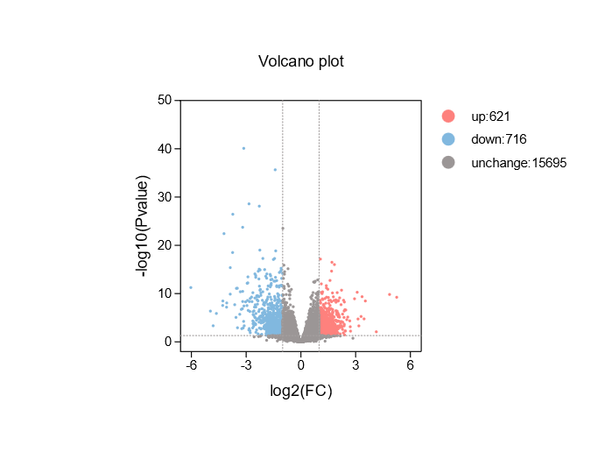
Supplement fig 2 Volcano plots for differentially expressed genes (DEGs) in citrus callus
The blue dots represent DEGs with down-regulated gene expression in the inhibitor treatment compared to the mock treatment in citrus callus, and the pink plot represents DEGs with up-regulated gene expression.

