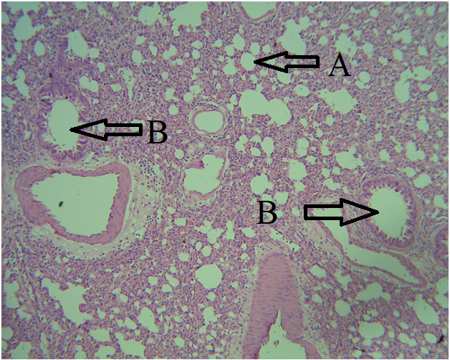
Plate 1: Representative photomicrograph of the cytoarchitecture of the lungs H&E stain Magnification:×100 ( A-Alveoli; B-Bronchiole)
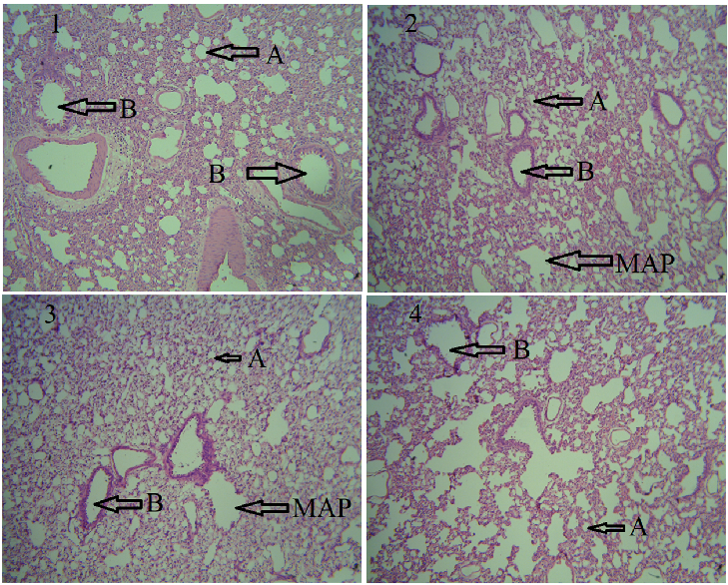
Plate 2: Representative photomicrograph of the cytoarchitecture of the Lungs. Group 1 (General control), Group 2 (Group B), Group 3 (Group C), Group 4 (Group D) for Day 3 post Soot exposure. H&E stain, Magnification: ×100. (A-Alveoli; B-Bronchiole, MAP- mild emphysematous air spaces).

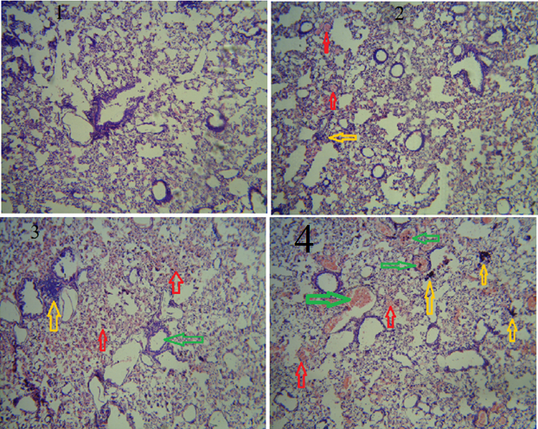
Plate 3: Representative photomicrograph of the cytoarchitecture of the Lungs. Group 1 (General control), Group 2 (Group B) Group 3 (Group C), Group 4 (Group D) for day 28 post Soot exposure. H&E stain, Magnification:×100. (The red arrows indicate sites of hyperaemia, the yellow arrow indicates site of inflammatory cell infiltration, and the green arrow indicates site of bronchial stenosis and mucus secretion).
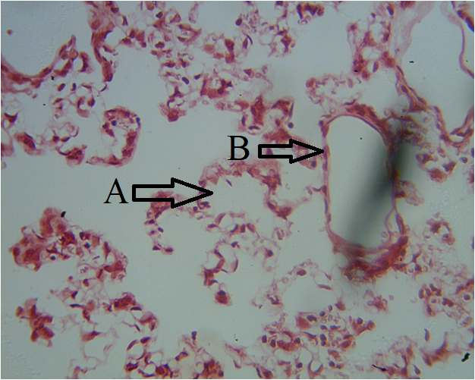
Plate 4: Representative photomicrograph of the cytoarchitecture of the Lungs. Group A (General control), for Day 7 post Soot exposure. Tissue stained negative to Prussian blue stain, Magnification:×100. (A-Alveoli, B-Brochial wall)
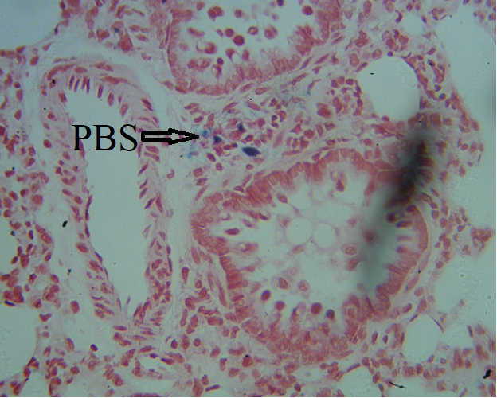
Plate 5: Representative photomicrograph of the cytoarchitecture of the Lungs. Group B for Day 7 post Soot exposure. Tissue stained positive to Prussian blue stain, Magnification:×100. (PBS- Prussian Blue Stain reaction).
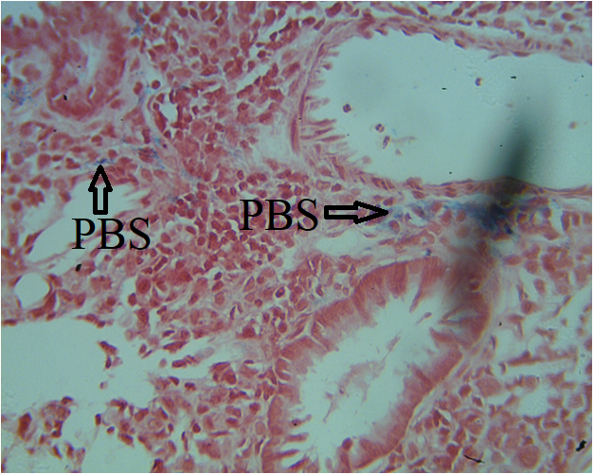
Plate 6: Representative photomicrograph of the cytoarchitecture of the Lungs. Group C for Day 7 post Soot exposure. Tissue stained positive to Prussian blue stain, Magnification:×100. (PBS- Prussian Blue Stain reaction).
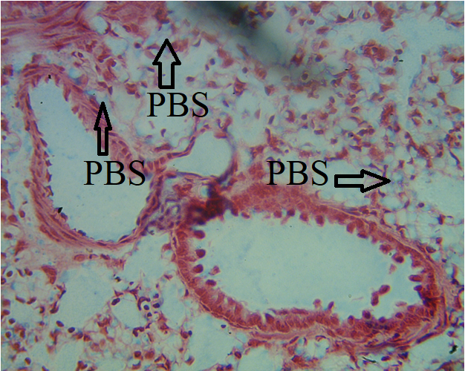
Plate 7: Representative photomicrograph of the cytoarchitecture of the Lungs. Group D for Day 7 post Soot exposure. Tissue stained positive to Prussian blue stain, Magnification: ×100. (PBS- Prussian Blue Stain reaction).

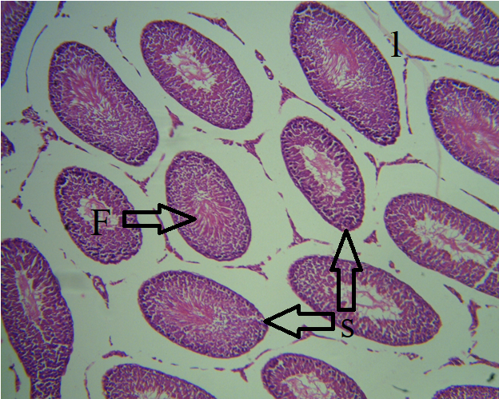
Plate 8: Representative photomicrograph of the cytoarchitecture of the Testis H&E stain Magnification:×100 (S-Seminiferous tubules, F-flagella sperm cells in the lumen).
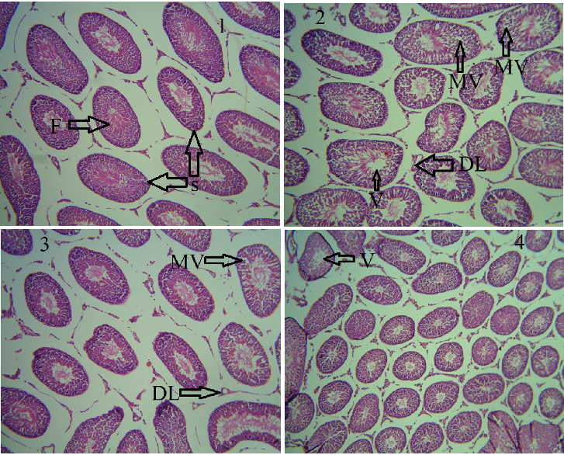
Plate 9: Representative photomicrograph of the cytoarchitecture of the Testis. Group 1(General control), Group (Group B), Group 3 (Group C), Group 4 (Group D) for Day 3 post soot exposure. H&E stain, Magnification: ×100. (V-Vacuolation, MV-Mild Vacuolation, DL-Distortion of Leydig cell, F- Flagella of spermatozoa in the lumen of Testis).

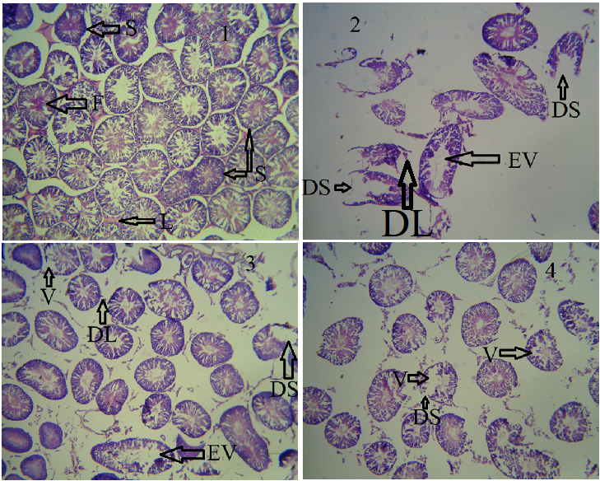
Plate 10: Representative photomicrograph of the cytoarchitecture of the Testis. Group 1(General control), Group 2(Group B) Group3 (Group), Group4 (Group D) for day 3 post Soot exposure. H&E stain, Magnification: ×100. (EV-Excessive Vacuolation, V- Vacuolation, DL-Distortion of Leydig cell, F- Flagella of spermatozoa in the lumen of Testis, S-Seminiferous Tubule, DS- Distortion of Seminiferous Tubule).

